수치 해석학 과제3

1. About code

I made the Assignment3 class to solve each exercise. In both Exercise2_3_7 and Exercise2_4_5, the problem is to interpolate the Runge function f(x) = 1 / (1+x^2) on the interval [-5, 5]. The Assignmetn3 class has some functions to solve Exercise2_3_7 and Exercise2_4_5. Also the class has functions **void** **Exercise2_3_7(double(*f)(double x) = Runge)** and **void Exercise2_4_5(double(*f)(double x) = Runge)**which solves each exercise.

First, **double LagrangeInterpolation(double(*f)(double x), const vector<double>& points, double input)** is the Lagrange Interpolation of a function f with given points ‘points’. More precisely, this function returns a value of Lagrange interpolating function at the point ‘input’.

Second, **void ChebyshevPoint(int num_pt, const vector<double>& interval, vector<double>& cheby_pt)** update the input ‘cheby_pt’ into a set of Cehbyshev points in the input interval with n=num_pt.

Next, **double L_infinite_error(const vector<double>& realValue, const vector<double>& estimate)** returns the $L_{∞}$-norm of the difference between two inputs, ‘reelValue’ and ‘estimate’. Here, ‘reelValue’ is a vector of values of a given function and ‘estimate’ is a vector of values of an approximation.

Finally, **void draw_graph(const vector<double>& points, const vector<double>& data, const vector<double>& axes, char* filename)** is a function to save my result as an m-file for plotting graphs by MATLAB.

For each approximation, I used 1001 points with uniform mesh size(=0.01) in [-5, 5] to plot the approximation graph and to calculate $L_{∞}$-norm of the error.

1. Exercise 2.3.7 : Lagrange Interpolation

There are 4 Lagrange Interpolation with the polynomial degree = 5,10,20,40.

The $L_{∞}$-norm of the errors are as follow:

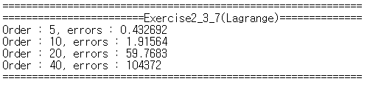

As the polynomial order is bigger, the $L_{∞}$-norm of the error is extremely increasing.

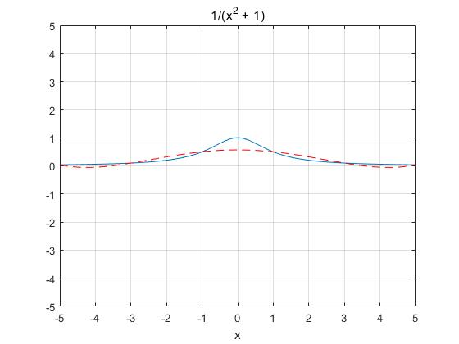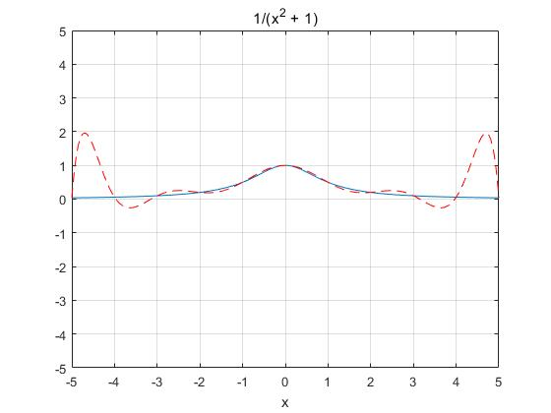The graphs of interpolations are as follow:

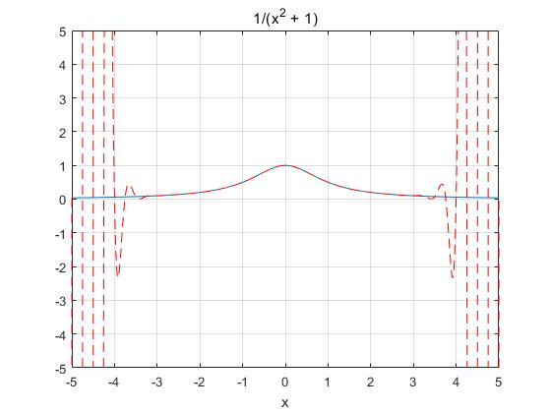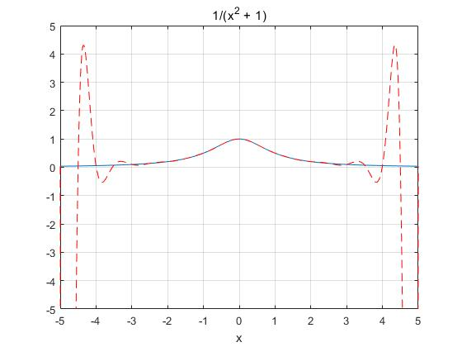

Order = 40

Order = 10

Order = 5

Order = 20

As the polynomial order is bigger, the Lagrange interpolation in [-3, 3] becomes better approximation. However, the interpolation has more oscillation in boundary of the interval [-5, 5]. The reason of this phenomenon is that a polynomial of degree n has the tendency of n-1 oscillation. Thus the $L_{∞}$-norm of the error increases as the polynomial order increases.

1. Exercise 2.4.5 : Chebychev polynomial

There are 4 Chebychev polynomial with the polynomial degree = 5,10,20,40.

The $L_{∞}$-norm of the errors are as follow:

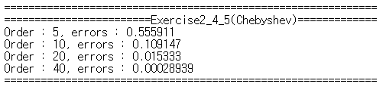

Unlike the Laplace interpolation, Chebychev polynomial has less $L_{∞}$-norm of the error as the polynomial order increases.

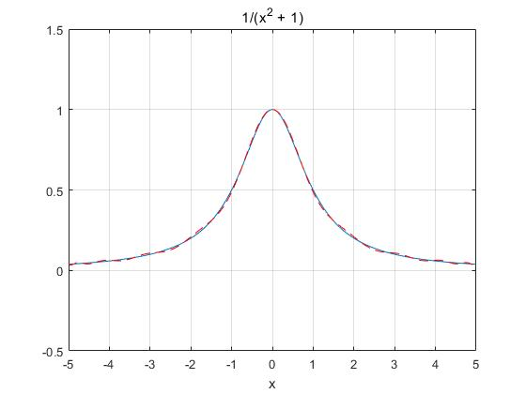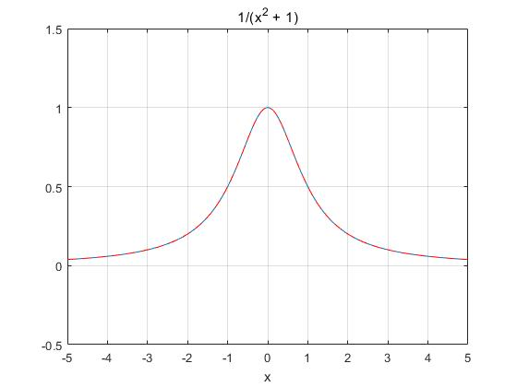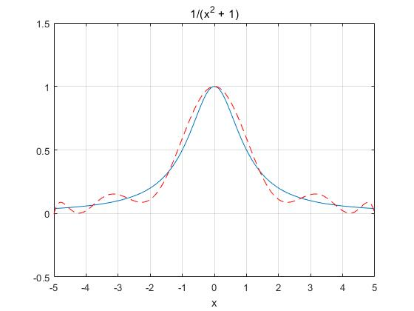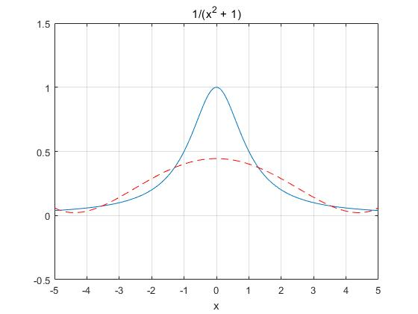The graphs of Cheybychev polynomials are as follow:

Order = 40

Order = 20

Order = 5

Order = 10