Windchill 10.0 Update – Packages

# Customer Exercise Scenario - Detailed Steps

### Scenario:

<Customer scenario summary>

### Objectives:

* <objective 1>
* <objective 1>
* <objective 1>

### Exercise Steps

1. <Step>

<Information>

* 1. <sub-step>

<Tutorial information>

<Sub-step result, image optional>

* 1. <sub-step>  
     <tutorial information>

<Sub-step result, image optional>

<Step result, image optional>

1. <step>

Windchill 10.0 Update – Packages

# Customer Exercise Scenario - Detailed Steps

### Scenario:

The Design Team Lead for an Aerospace and Defense contractor will create a package of contents to delivery to the customer to meet contract requirements for a Contract Delivery Requirements List (CDRL).

### Objectives:

* Initiate CDRL/SDRL process
* Define Package Attributes
* Add content to a Package

### Exercise Steps

1. Initiate CDRL/SDRL process
   1. Log into Windchill as a user who is a Package Creator (s.a. Design Team Lead)
   2. Navigate to the Packages sub-tab for the Product related to the contract
2. Create a new Package

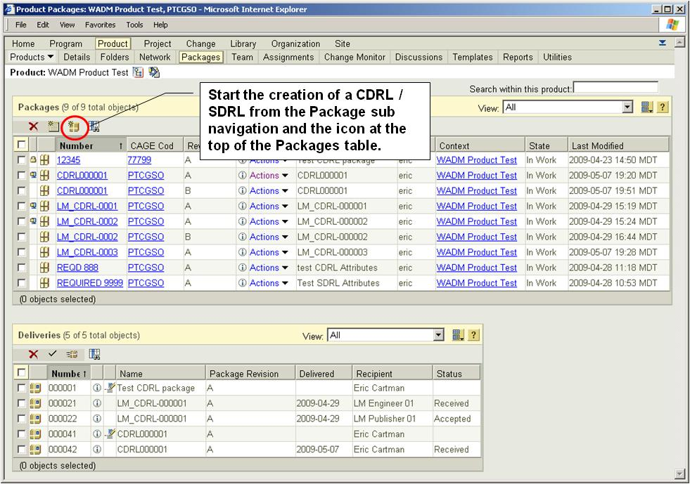

1. Use the steps in the New Package UI as guidance for inputting attributes for the package.
   1. In step 3 of the wizard, enter attributes for the CDRL/SDRL contract.

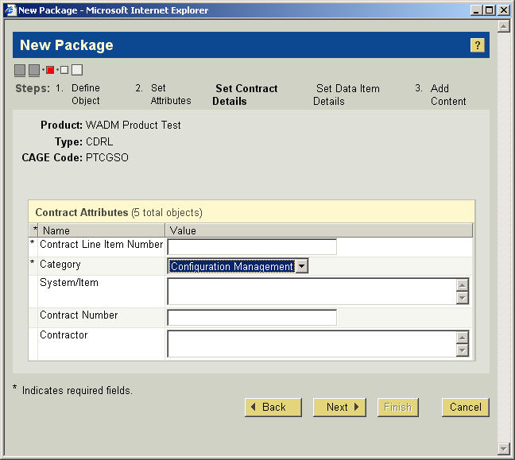

* 1. In step 4 of the wizard, enter attributes for the package.

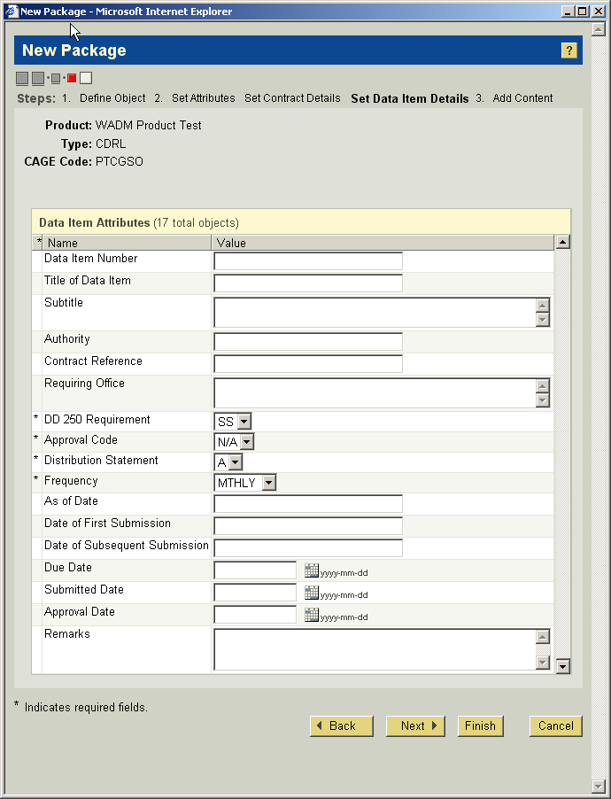

1. Add contents to package
2. Create and manage delivery
   1. Lock package
   2. Create a delivery Label
   3. Record a delivery