[ 19 ] 회원인증, fileUpload, MyBatis

1. 요구사항 : 회원가입, 로그인, 로그아웃, 회원정보수정 가능

책이미지를 파일첨부하여 책등록, 책상세보기, 책정보수정, 책리스트(페이징처리)

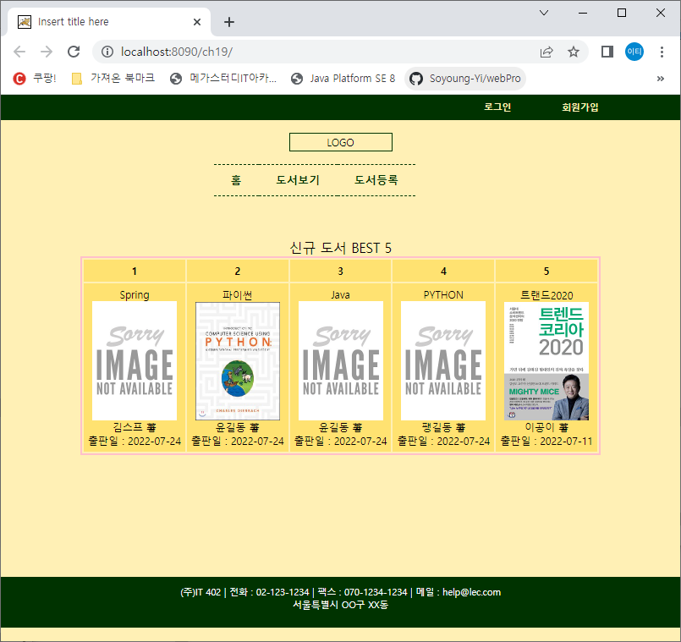 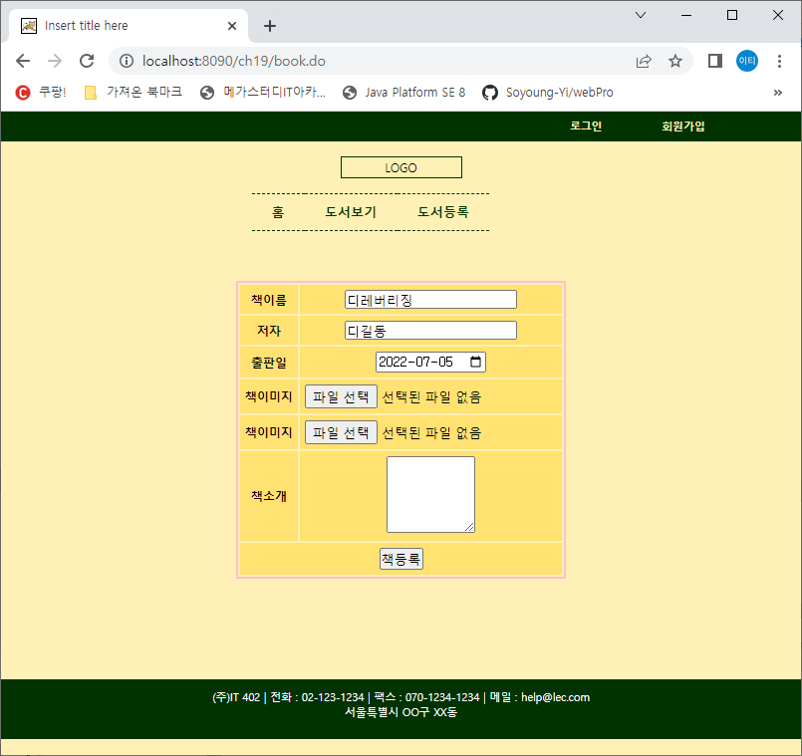

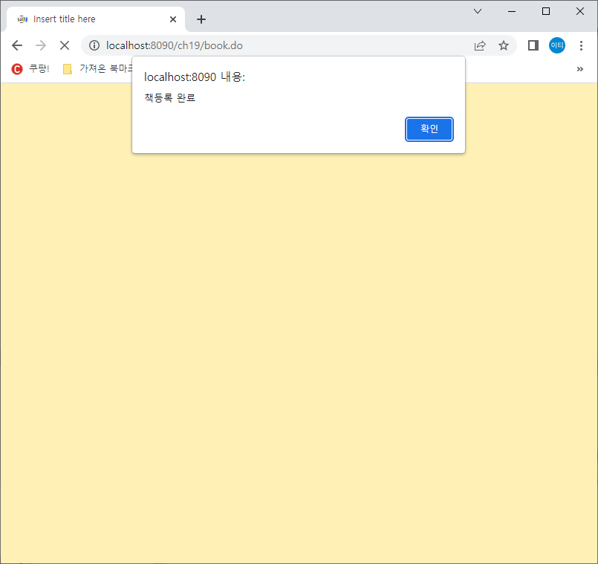 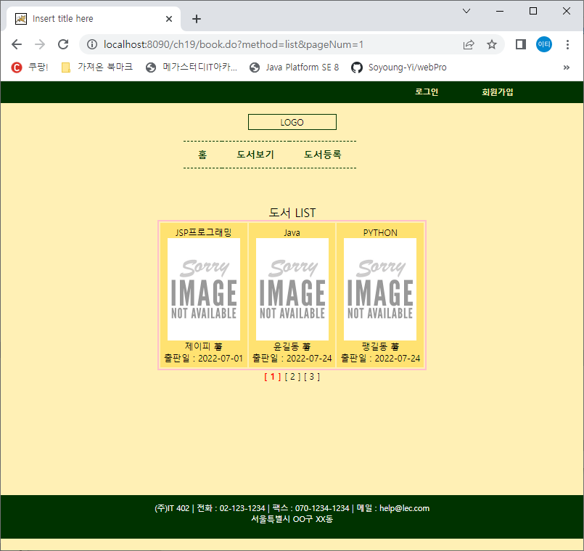

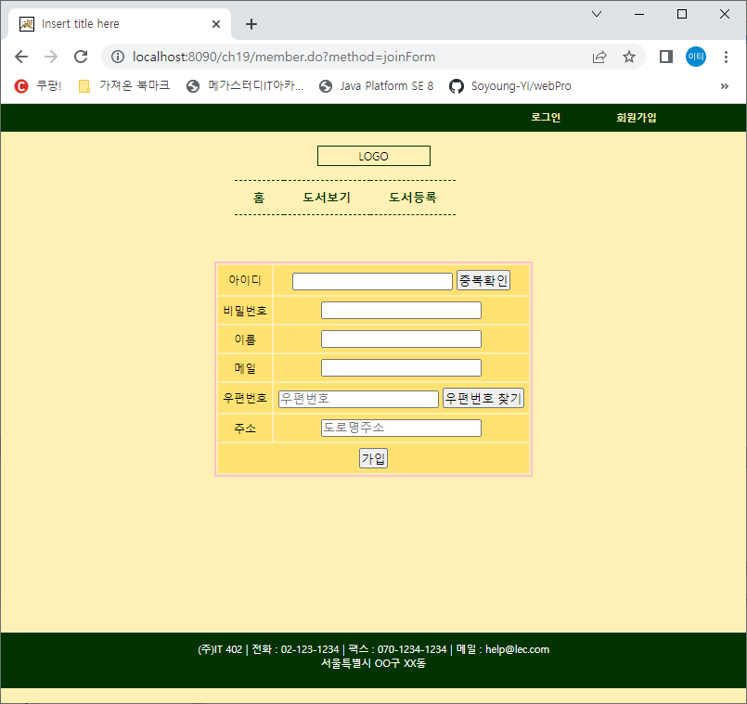 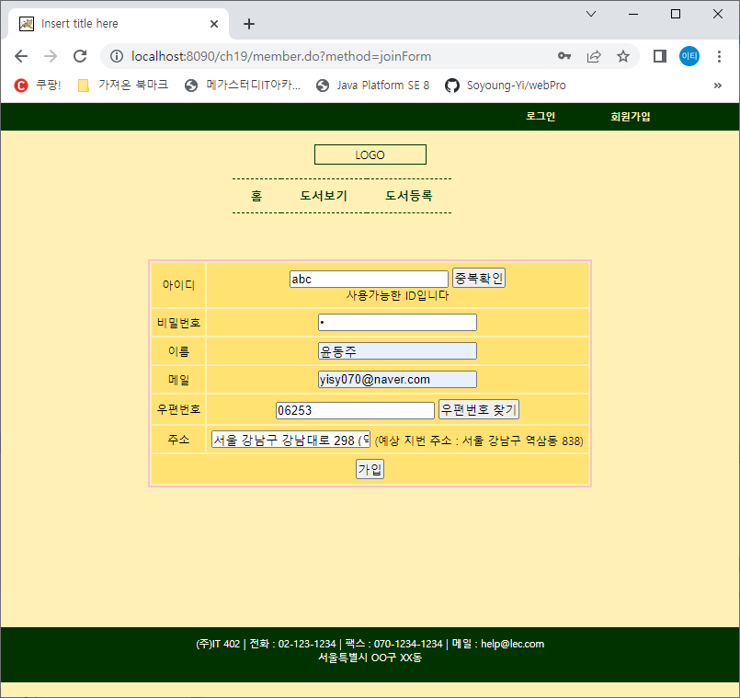

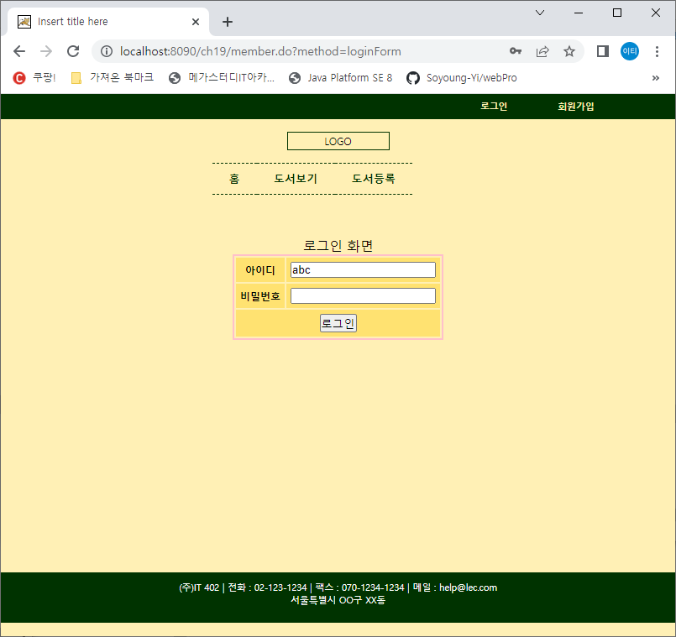 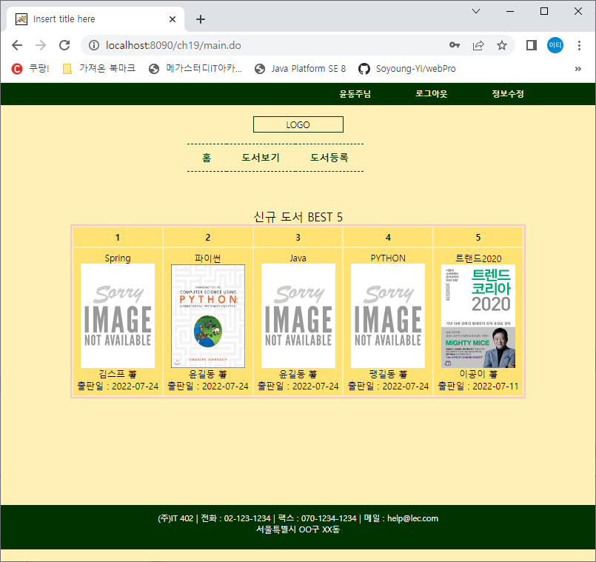

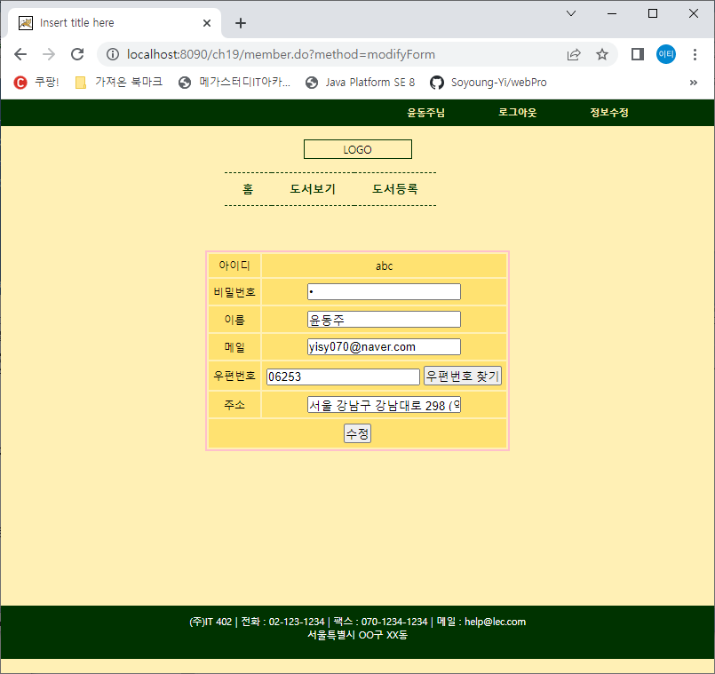 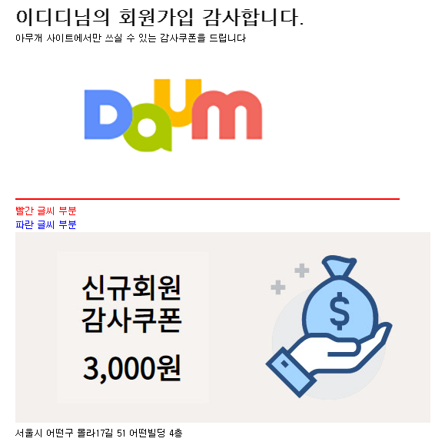

1. 테이블생성 ; src/main/resources/META-INF/db/initDB.sql

DROP TABLE BOOK CASCADE CONSTRAINTS;

DROP TABLE MEMBER CASCADE CONSTRAINTS;

DROP SEQUENCE BOOK_SQ;

CREATE SEQUENCE BOOK_SQ MAXVALUE 99999999 NOCYCLE NOCACHE;

CREATE TABLE BOOK(

bNUM NUMBER(8) PRIMARY KEY,

bTITLE VARCHAR2(100) NOT NULL,

bWRITER VARCHAR2(100) NOT NULL,

bRDATE DATE DEFAULT SYSDATE NOT NULL,

bIMG1 VARCHAR2(100) DEFAULT 'noImg.png' NOT NULL,

bIMG2 VARCHAR2(100) DEFAULT 'noImg.png' NOT NULL,

bINFO VARCHAR2(1000)

);

CREATE TABLE MEMBER(

mID VARCHAR2(100) PRIMARY KEY,

mPW VARCHAR2(100) NOT NULL,

mNAME VARCHAR2(100) NOT NULL,

mMAIL VARCHAR2(100) NOT NULL,

mPOST VARCHAR2(100), -- 우편번호

mADDR VARCHAR2(100) -- 주소

);

1. 더미데이터 입력 ; src/main/resources/META-INF/db/dummyData.sql

-- Book 테이블

INSERT INTO BOOK VALUES

(BOOK_SQ.NEXTVAL, 'Spring','김스프',sysdate, 'noImg.png','noImg.png','좋은스프링책');

-- Member 테이블

INSERT INTO MEMBER VALUES ('aaa','1','홍길동','yisy0703@naver.com','12345','서울');

commit;

1. Mapper에 들어갈 sql ; src/main/resources/META-INF/db/mappers.sql
2. pom.xml에 의존추가 부분

<!-- JDBC -->

<dependency>

<groupId>org.springframework</groupId>

<artifactId>spring-jdbc</artifactId>

<version>5.2.8.RELEASE</version>

</dependency>

<!-- mybatis -->

<dependency>

<groupId>org.mybatis</groupId>

<artifactId>mybatis</artifactId>

<version>3.5.5</version>

</dependency>

<!-- mybatis-spring -->

<dependency>

<groupId>org.mybatis</groupId>

<artifactId>mybatis-spring</artifactId>

<version>2.0.5</version>

</dependency>

<!-- lombok -->

<dependency>

<groupId>org.projectlombok</groupId>

<artifactId>lombok</artifactId>

<version>1.18.8</version>

<scope>provided</scope>

</dependency>

<!-- Mail sender -->

<dependency>

<groupId>javax.mail</groupId>

<artifactId>mail</artifactId>

<version>1.4.7</version>

</dependency>

<!-- file upload -->

<dependency>

<groupId>commons-fileupload</groupId>

<artifactId>commons-fileupload</artifactId>

<version>1.3.1</version>

</dependency>

1. web.xml에 한글처리부분 및 *.do처리 부분

<servlet-mapping>

<servlet-name>appServlet</servlet-name>

<url-pattern>*.do</url-pattern>

</servlet-mapping>

<!-- 한글처리 -->

<filter>

<filter-name>encodingFilter</filter-name>

<filter-class>org.springframework.web.filter.CharacterEncodingFilter</filter-class>

<init-param>

<param-name>encoding</param-name>

<param-value>UTF-8</param-value>

</init-param>

<init-param>

<param-name>forceEncoding</param-name>

<param-value>true</param-value>

</init-param>

</filter>

<filter-mapping>

<filter-name>encodingFilter</filter-name>

<url-pattern>/*</url-pattern>

</filter-mapping>

1. index.jsp의 body

<body><jsp:forward page=*"main.do"*/></body>

1. MainController.java

@Controller

**public** **class** MainController {

@RequestMapping(value="main")

**public** String main() {

**return** "main/main";

}

}

1. main/main.jsp

<%@ page language=*"java"* contentType=*"text/html; charset=UTF-8"*

pageEncoding=*"UTF-8"*%>

<%@taglib prefix=*"c"* uri=*"http://java.sun.com/jsp/jstl/core"*%>

<%@taglib prefix=*"fmt"* uri=*"http://java.sun.com/jsp/jstl/fmt"*%>

<c:set var=*"conPath"* value=*"*${pageContext.request.contextPath }*"*/>

<!DOCTYPE html PUBLIC "-//W3C//DTD HTML 4.01 Transitional//EN" "http://www.w3.org/TR/html4/loose.dtd">

<html>

<head>

<meta http-equiv=*"Content-Type"* content=*"text/html; charset=UTF-8"*>

<title>Insert title here</title>

<link href=*"*${conPath }*/css/style.css"* rel=*"stylesheet"*>

<style>

*#content* {

width: *800px*; height:*350px*;

margin: *50px auto*;

}

**img**{width: *100px*;}

</style>

</head>

<body>

<c:if test=*"*${**not empty** modifyResult }*"*>

<script> alert("정보 수정이 돤료 되었습니다");</script>

</c:if>

<jsp:include page=*"header.jsp"*/>

<div id=*"content"*>

<table>

<caption>신규 도서 BEST 5</caption>

<tr><th>1</th><th>2</th><th>3</th><th>4</th><th>5</th></tr>

<tr>

<c:forEach var=*"book"* items=*"*${main }*"* begin=*"0"* end=*"4"*>

<td>

${book.btitle }<br>

<a href=*"*${conPath }*/book.do?method=detail&bnum=*${book.bnum}*&pageNum=1"*>

<img src=*"*${conPath }*/bookImgFileUpload/*${book.bimg1}*"*></a><br>

${book.bwriter } 著 <br>

출판일 : ${book.brdate }

</td>

</c:forEach>

</tr>

</table>

</div>

<jsp:include page=*"footer.jsp"*/>

</body>

</html>

1. main/heard.jsp

<%@ page language=*"java"* contentType=*"text/html; charset=UTF-8"*

pageEncoding=*"UTF-8"*%>

<%@taglib prefix=*"c"* uri=*"http://java.sun.com/jsp/jstl/core"*%>

<%@taglib prefix=*"fmt"* uri=*"http://java.sun.com/jsp/jstl/fmt"*%>

<c:set var=*"conPath"* value=*"*${pageContext.request.contextPath }*"* />

<!DOCTYPE html>

<html>

<head>

<meta http-equiv=*"Content-Type"* content=*"text/html; charset=UTF-8"*>

<title>Insert title here</title>

<style>

* { padding: *0*; margin: *0*; }

**body** {background-color: *#FFF0B5*; font-size: *9pt*;}

**header** **a** {text-decoration: *none*; font-weight: *bold*;}

**header** **li** { list-style: *none*;}

**header** *.gnb* {width: *100%*; background-color: *#003300*;}

**header** *.gnb* **ul** {

overflow: *hidden*;

width: *700px*;

height: *30px*;

line-height: *30px*;

margin: *0 auto*;

}

**header** *.gnb* **ul** **li** {float: *right*; margin-right: *30px*;}

**header** *.gnb* **a** {

color: *#FFF0B5*;

font-size: *0.9em*;

display: *block*;

padding-left: *15px*;

padding-right: *15px*;

}

**header** *.logo* {

width: *120px*;

height: *20px*;

line-height: *20px*;

text-align: *center*;

margin: *15px auto*;

border: *1px solid #003300*;

cursor: *pointer*;

}

**header** *.lnb* { width: *100%*;}

**header** *.lnb* **ul** {overflow: *hidden*; width: *300px*; margin: *0 auto*;}

**header** *.lnb* **ul** **li** {

float: *left*;

padding: *5px 20px*;

line-height: *25px*;

border-top: *1px dashed #003300*;

border-bottom: *1px dashed #003300*;

}

**header** *.lnb* **a** {

height: *1.1em*;

color: *#003300*;

font-size: *1.1em*;

margin-bottom: *20px*;

}

</style>

</head>

<body>

<header>

<div class=*"gnb"*>

<c:if test=*"*${**empty** member}*"*>

<ul>

<li><a href=*"*${conPath }*/member.do?method=joinForm"*>회원가입</a></li>

<li><a href=*"*${conPath }*/member.do?method=loginForm"*>로그인</a></li>

</ul>

</c:if>

<c:if test=*"*${**not empty** member}*"*>

<ul>

<li><a href=*"*${conPath }*/member.do?method=modifyForm"*>정보수정</a></li>

<li><a href=*"*${conPath }*/member.do?method=logout"*>로그아웃</a></li>

<li><a>${member.mname }님</a></li>

</ul>

</c:if>

</div>

<div class=*"logo"* onclick=*"location.href='*${conPath}*/main.do'"*>LOGO</div>

<div class=*"lnb"*>

<ul>

<li><a href=*"*${conPath}*/main.do"*>홈</a></li>

<li><a href=*"*${conPath }*/book.do?method=list&pageNum=1"*>도서보기</a></li>

<li><a href=*"*${conPath }*/book.do?method=registerForm"*>도서등록</a></li>

</ul>

</div>

</header>

</body>

</html>

1. main/footer.jsp

<%@ page language=*"java"* contentType=*"text/html; charset=UTF-8"*

pageEncoding=*"UTF-8"*%>

<!DOCTYPE html>

<html>

<head>

<meta http-equiv=*"Content-Type"* content=*"text/html; charset=UTF-8"*>

<title>Insert title here</title>

</head>

<style>

**footer** {

height:*60px*; background-color: *#003300*;

}

**footer** *#footer_conts* {

color:*white*;

font-weight: *blod*;

margin:*0 auto*;

height: *60px*;

padding:*10px 30px 0*;

font-size:*0.9em*;

text-align: *center*;

}

</style>

<body>

<footer>

<div id=*"footer_conts"*>

(주)IT 402 | 전화 : 02-123-1234 | 팩스 : 070-1234-1234 | 메일 : help@lec.com

<br>

서울특별시 OO구 XX동 **빌딩 4층

</div>

</footer>

</body>

</html>

1. src/main/resources/META-INF/property/db.properties

db.driverClassName=oracle.jdbc.driver.OracleDriver

db.url=jdbc:oracle:thin:@localhost:1521:xe

db.username=scott

db.password=tiger

1. src/main/resources/META-INF/property/mail.properties

mail.host=smtp.gmail.com

mail.port=587

mail.username=comlec0703

mail.passwoard=frzhjyatpdeoaksk

1. servlet-context.xml

<?xml version=*"1.0"* encoding=*"UTF-8"*?>

<beans:beans xmlns=*"http://www.springframework.org/schema/mvc"*

xmlns:xsi=*"http://www.w3.org/2001/XMLSchema-instance"*

xmlns:beans=*"http://www.springframework.org/schema/beans"*

xmlns:context=*"http://www.springframework.org/schema/context"*

xmlns:mybatis-spring=*"http://mybatis.org/schema/mybatis-spring"*

xsi:schemaLocation=*"http://www.springframework.org/schema/mvc https://www.springframework.org/schema/mvc/spring-mvc.xsd*

*http://mybatis.org/schema/mybatis-spring http://mybatis.org/schema/mybatis-spring-1.2.xsd*

*http://www.springframework.org/schema/beans https://www.springframework.org/schema/beans/spring-beans.xsd*

*http://www.springframework.org/schema/context https://www.springframework.org/schema/context/spring-context.xsd"*>

<!-- DispatcherServlet Context: defines this servlet's request-processing infrastructure -->

<!-- Enables the Spring MVC @Controller programming model -->

<annotation-driven />

<!-- Handles HTTP GET requests for /resources/** by efficiently serving up static resources in the ${webappRoot}/resources directory -->

<resources mapping=*"/resources/**"* location=*"/resources/"* />

<resources mapping=*"/css/**"* location=*"/css/"* />

<resources mapping=*"/js/**"* location=*"/js/"* />

<resources mapping=*"/bookImgFileUpload/**"* location=*"/bookImgFileUpload/"* />

<!-- Resolves views selected for rendering by @Controllers to .jsp resources in the /WEB-INF/views directory -->

<beans:bean class=*"org.springframework.web.servlet.view.InternalResourceViewResolver"*>

<beans:property name=*"prefix"* value=*"/WEB-INF/views/"* />

<beans:property name=*"suffix"* value=*".jsp"* />

</beans:bean>

<context:component-scan base-package=*"com.lec.ch19"* />

<mybatis-spring:scan base-package=*"com.lec.ch19.dao"*/>

<context:property-placeholder location=*"classpath:META-INF/property/mail.properties"*/>

<!-- 메일발송 빈 -->

<beans:bean id=*"mailSender"*

class=*"org.springframework.mail.javamail.JavaMailSenderImpl"*>

<beans:property name=*"host"* value=*"${mail.host}"*/>

<beans:property name=*"port"* value=*"${mail.port}"*/>

<beans:property name=*"username"* value=*"${mail.username}"*/>

<beans:property name=*"password"* value=*"${mail.passwoard}"*/>

<beans:property name=*"javaMailProperties"*>

<beans:props>

<beans:prop key=*"mail.smtp.auth"*>true</beans:prop>

<beans:prop key=*"mail.smtp.starttls.enable"*>true</beans:prop>

<beans:prop key=*"mail.debug"*>true</beans:prop>

<beans:prop key=*"mail.transport.protocol"*>smtp</beans:prop>

<beans:prop key=*"mail.smtp.ssl.trust"*>smtp.gmail.com</beans:prop>

<beans:prop key=*"mail.smtp.ssl.protocols"*>TLSv1.2</beans:prop>

</beans:props>

</beans:property>

</beans:bean>

<!-- 파일첨부 -->

<beans:bean id=*"multipartResolver"* class=*"org.springframework.web.multipart.commons.CommonsMultipartResolver"*>

<beans:property name=*"maxUploadSize"* value=*"10485760"*/>

</beans:bean>

</beans:beans>

1. root-context.xml

<?xml version=*"1.0"* encoding=*"UTF-8"*?>

<beans xmlns=*"http://www.springframework.org/schema/beans"*

xmlns:xsi=*"http://www.w3.org/2001/XMLSchema-instance"*

xmlns:context=*"http://www.springframework.org/schema/context"*

xmlns:p=*"http://www.springframework.org/schema/p"*

xsi:schemaLocation=*"http://www.springframework.org/schema/beans https://www.springframework.org/schema/beans/spring-beans.xsd*

*http://www.springframework.org/schema/context http://www.springframework.org/schema/context/spring-context-3.1.xsd"*>

<!-- Root Context: defines shared resources visible to all other web components -->

<context:property-placeholder

location=*"classpath:META-INF/property/db.properties"* />

<bean id=*"dataSource"*

class=*"org.springframework.jdbc.datasource.DriverManagerDataSource"*>

<property name=*"driverClassName"* value=*"${db.driverClassName}"* />

<property name=*"url"* value=*"${db.url}"* />

<property name=*"username"* value=*"${db.username}"* />

<property name=*"password"* value=*"${db.password}"* />

</bean>

<!-- <bean class="org.mybatis.spring.SqlSessionFactoryBean" id="sqlSessionFactory">

<property name="dataSource" ref="dataSource" />

<property name="configLocation" value="classpath:META-INF/sqlmap/config/mybatis-config.xml" />

</bean>

<bean id="sqlSessionTemplate" class="org.mybatis.spring.SqlSessionTemplate">

<constructor-arg index="0" ref="sqlSessionFactory"/>

</bean> -->

</beans>

1. 여기까지 하고 index.jsp 나 프로젝트를 실행한다. 실행되면 다음을 진행
2. Book.java(DTO)
3. Member.java(DTO)
4. Book.xml
5. Member.xml
6. mybatis-config.xml
7. root-context.xml

<?xml version=*"1.0"* encoding=*"UTF-8"*?>

<beans xmlns=*"http://www.springframework.org/schema/beans"*

xmlns:xsi=*"http://www.w3.org/2001/XMLSchema-instance"*

xmlns:context=*"http://www.springframework.org/schema/context"*

xsi:schemaLocation=*"http://www.springframework.org/schema/beans https://www.springframework.org/schema/beans/spring-beans.xsd*

*http://www.springframework.org/schema/context http://www.springframework.org/schema/context/spring-context-3.1.xsd"*>

<context:property-placeholder

location=*"classpath:META-INF/property/db.properties"* />

<bean id=*"dataSource"*

class=*"org.springframework.jdbc.datasource.DriverManagerDataSource"*>

<property name=*"driverClassName"* value=*"${db.driverClassName}"* />

<property name=*"url"* value=*"${db.url}"* />

<property name=*"username"* value=*"${db.username}"* />

<property name=*"password"* value=*"${db.password}"* />

</bean>

<bean class=*"org.mybatis.spring.SqlSessionFactoryBean"* id=*"sqlSessionFactory"*>

<property name=*"dataSource"* ref=*"dataSource"* />

<property name=*"configLocation"* value=*"classpath:META-INF/sqlmap/config/mybatis-config.xml"* />

</bean>

<bean id=*"sqlSessionTemplate"* class=*"org.mybatis.spring.SqlSessionTemplate"*>

<constructor-arg index=*"0"* ref=*"sqlSessionFactory"*/>

</bean>

</beans>

1. BookDao.java
2. MemberDao.java
3. MemberService.java

**public** **interface** MemberService {

**public** Member getMember(String mid);

**public** **int** idConfirm(String mid);

**public** **int** joinMember(Member member, HttpSession httpSession);

**public** String loginCheck(String mid, String mpw, HttpSession httpSession);

**public** **int** modifyMember(Member member);

}

1. MemberServiceImpl.java
2. BookService.java

**public** **interface** BookService {

**public** List<Book> mainList();

**public** List<Book> bookList(String pageNum);

**public** Book getBook(**int** bnum);

**public** **int** registerBook(MultipartHttpServletRequest mRequest, Book book);

//public int registerBook(MultipartHttpServletRequest mRequest); 위나 아래 둘중에 하나

//public int modifyBook(MultipartHttpServletRequest mRequest, Book book);

**public** **int** modifyBook(MultipartHttpServletRequest mRequest);

**public** **int** cntBook();

}

1. BookServiceImpl.java
2. Paging.java

**public** **class** Paging {

**private** **int** currentPage = 1;

**private** **int** pageSize = 10;

**private** **int** blockSize= 10;

**private** **int** startRow;

**private** **int** endRow;

**private** **int** total;

**private** **int** pageCnt;

**private** **int** startPage;

**private** **int** endPage;

**public** Paging(**int** total, String pageNum) {

**this**.total = total;

**if**(pageNum!=**null**) {

currentPage = Integer.*parseInt*(pageNum);

}

startRow = (currentPage-1)*pageSize +1;

endRow = startRow + pageSize -1;

pageCnt = (**int**)Math.*ceil*((**double**)total/pageSize);

startPage = ((currentPage-1)/blockSize)*blockSize+1;

//startPage = currentPage - (currentPage-1)%blockSize;

endPage = startPage + blockSize -1;

**if**(endPage>pageCnt) {

endPage = pageCnt;

}

}// 생성자

**public** Paging(**int** total, String pageNum, **int** pageSize, **int** blockSize) {

**this**.total = total;

**if**(pageNum!=**null**) {

currentPage = Integer.*parseInt*(pageNum);

}

**this**.pageSize = pageSize;

**this**.blockSize = blockSize;

startRow = (currentPage-1)*pageSize +1;

endRow = startRow + pageSize -1;

pageCnt = (**int**)Math.*ceil*((**double**)total/pageSize);

startPage = ((currentPage-1)/blockSize)*blockSize+1;

//startPage = currentPage - (currentPage-1)%blockSize;

endPage = startPage + blockSize -1;

**if**(endPage>pageCnt) {

endPage = pageCnt;

}

}// 생성자

**Getters & Setters**

@Override

**public** String toString() {

**return** "Paging [currentPage=" + currentPage + ", pageSize=" + pageSize + ", blockSize=" + blockSize

+ ", startRow=" + startRow + ", endRow=" + endRow + ", total=" + total + ", pageCnt=" + pageCnt

+ ", startPage=" + startPage + ", endPage=" + endPage + "]";

}

}

1. 요청경로들

main.do (메인페이지에서)

book.do?method=registerForm (도서등록폼으로 가기)

book.do?method=register (도서등록 = 파일첨부)

book.do?method=list (도서 리스트보기)

book.do?method=detail (한 도서 상세보기)

book.do?method=modifyForm (도서수정폼)

book.do?method=modify (도서수정 = 파일첨부)

member.do?method=joinForm (회원가입폼)

member.do?method=idConfirm (id중복체크)

member.do?method=join (회원가입)

member.do?method=loginForm (로그인폼)

member.do?method=login (로그인)

member.do?method=modifyForm (정보수정폼)

member.do?method=modify (정보수정)

member.do?method=logout (로그아웃)

1. MainController.java

@Controller

**public** **class** MainController {

@Autowired

**private** BookService bookService;

@RequestMapping(value="main")

**public** String main(Model model) {

model.addAttribute("main", bookService.mainList());

**return** "main/main";

}

}

1. MemberController.java
2. member/joinForm.jsp

<%@ page language=*"java"* contentType=*"text/html; charset=UTF-8"*

pageEncoding=*"UTF-8"*%>

<%@taglib prefix=*"c"* uri=*"http://java.sun.com/jsp/jstl/core"*%>

<%@taglib prefix=*"fmt"* uri=*"http://java.sun.com/jsp/jstl/fmt"*%>

<c:set var=*"conPath"* value=*"*${pageContext.request.contextPath }*"*/>

<!DOCTYPE html>

<html>

<head>

<meta http-equiv=*"Content-Type"* content=*"text/html; charset=UTF-8"*>

<link href=*"*${conPath }*/css/style.css"* rel=*"stylesheet"*>

<style>

*#content* {width: *800px*; height:*350px*;margin: *50px auto*;}

</style>

<script src=*"http://dmaps.daum.net/map_js_init/postcode.v2.js"*></script>

<script src=*"*${conPath }*/js/address.js"*></script>

<script src=*"https://code.jquery.com/jquery-3.4.1.min.js"*></script>

<script>

$(document).ready(**function**(){

$('.idconfirm').click(**function**(){

$.ajax({

url : '${conPath}/member.do',

datatype : 'html',

data : "method=idConfirm&mid="+$('#mid').val(),

success : **function**(data, status){

$('#idConfirmMsg').html(data);

}

});

});

$('form').submit(**function**(){

**var** idConfirmResult = $('#idConfirmMsg').text().trim();

**if**(idConfirmResult!='사용가능한 ID입니다'){

alert('사용가능한 ID인지 중복확인후 가입가능');

$('input[name="mid"]').focus();

**return** **false**;

}

});

});

</script>

<title>Insert title here</title>

</head>

<body>

<jsp:include page=*"../main/header.jsp"*/>

<div id=*"content"*>

<form action=*"*${conPath }*/member.do?method=join"* method=*"post"*>

<table>

<tr><td>아이디</td><td><input type=*"text"* name=*"mid"* id=*"mid"*>

<input type=*"button"* class=*"idconfirm"* value=*"중복확인"*><br>

<span id=*"idConfirmMsg"*></span>

</td></tr>

<tr><td>비밀번호</td><td><input type=*"password"* name=*"mpw"*></td></tr>

<tr><td>이름</td><td><input type=*"text"* name=*"mname"*></td></tr>

<tr><td>메일</td><td><input type=*"text"* name=*"mmail"*></td></tr>

<tr><td>우편번호</td><td>

<input type=*"text"* id=*"sample4_postcode"* name=*"mpost"* class=*"text_box"* placeholder=*"우편번호"*>

<input type=*"button"* onclick="sample4_execDaumPostcode()" value=*"우편번호 찾기"*></td></tr>

<tr><td>주소</td><td>

<input type=*"text"* id=*"sample4_roadAddress"* name=*"maddr"* placeholder=*"도로명주소"*>

<input type=*"hidden"* id=*"sample4_jibunAddress"* placeholder=*"지번주소"*>

<span id=*"guide"*></span>

</td></tr>

<tr><td colspan=*"2"*>

<input type=*"submit"* value=*"가입"*>

</td></tr>

</table>

</form>

</div>

<jsp:include page=*"../main/footer.jsp"*/>

</body>

</html>

1. member/idConfirm.jsp
2. member/loginForm.jsp

<%@ page language=*"java"* contentType=*"text/html; charset=UTF-8"*

pageEncoding=*"UTF-8"*%>

<%@taglib prefix=*"c"* uri=*"http://java.sun.com/jsp/jstl/core"*%>

<%@taglib prefix=*"fmt"* uri=*"http://java.sun.com/jsp/jstl/fmt"*%>

<c:set var=*"conPath"* value=*"*${pageContext.request.contextPath }*"*/>

<!DOCTYPE html>

<html>

<head>

<meta http-equiv=*"Content-Type"* content=*"text/html; charset=UTF-8"*>

<title>Insert title here</title>

<link href=*"*${conPath }*/css/style.css"* rel=*"stylesheet"*>

<style>

*#content* {

width: *800px*; height:*350px*;

margin: *50px auto*;

}

</style>

</head>

<body>

<c:if test=*"*${**not empty** result}*"*>

<script>alert('${result}');</script>

</c:if>

<jsp:include page=*"../main/header.jsp"*/>

<div id=*"content"*>

<form action=*"*${conPath }*/member.do"* method=*"post"*>

<input type=*"hidden"* name=*"method"* value=*"login"*>

<table>

<caption>로그인 화면</caption>

<tr><th>아이디</th><td><input type=*"text"* name=*"mid"* required=*"required"* value=*"*${mid }*"*></td></tr>

<tr><th>비밀번호</th><td><input type=*"password"* name=*"mpw"* required=*"required"* value=*"*${mpw }*"*></td></tr>

<tr><td colspan=*"2"*>

<input type=*"submit"* value=*"로그인"*>

</td></tr>

</table>

</form>

</div>

<jsp:include page=*"../main/footer.jsp"*/>

</body>

</html>

1. member/modifyForm.jsp

<%@ page language=*"java"* contentType=*"text/html; charset=UTF-8"*

pageEncoding=*"UTF-8"*%>

<%@taglib prefix=*"c"* uri=*"http://java.sun.com/jsp/jstl/core"*%>

<%@taglib prefix=*"fmt"* uri=*"http://java.sun.com/jsp/jstl/fmt"*%>

<c:set var=*"conPath"* value=*"*${pageContext.request.contextPath }*"*/>

<!DOCTYPE html>

<html>

<head>

<meta http-equiv=*"Content-Type"* content=*"text/html; charset=UTF-8"*>

<title>Insert title here</title>

<link href=*"*${conPath }*/css/style.css"* rel=*"stylesheet"*>

<style>

*#content* {width: *800px*; height:*350px*;margin: *50px auto*;}

</style>

<script src=*"http://dmaps.daum.net/map_js_init/postcode.v2.js"*></script>

<script src=*"*${conPath }*/js/address.js"*></script>

</head>

<body>

<c:if test=*"*${modifyResult==0 }*"*>

<script> alert("정보 수정이 실패되었습니다");</script>

</c:if>

<jsp:include page=*"../main/header.jsp"*/>

<div id=*"content"*>

<form action=*"*${conPath }*/member.do"* method=*"post"*>

<input type=*"hidden"* name=*"method"* value=*"modify"*>

<input type=*"hidden"* name=*"mid"* value=*"*${member.mid }*"*>

<table>

<tr><td>아이디</td><td>${member.mid }</td></tr>

<tr><td>비밀번호</td><td><input type=*"password"* name=*"mpw"* value=*"*${member.mpw }*"*></td></tr>

<tr><td>이름</td><td><input type=*"text"* name=*"mname"* value=*"*${member.mname }*"*></td></tr>

<tr><td>메일</td><td><input type=*"text"* name=*"mmail"* value=*"*${member.mmail }*"*></td></tr>

<tr><td>우편번호</td><td>

<input type=*"text"* id=*"sample4_postcode"* name=*"mpost"* class=*"text_box"* value=*"*${member.mpost }*"*>

<input type=*"button"* onclick="sample4_execDaumPostcode()" value=*"우편번호 찾기"*></td></tr>

<tr><td>주소</td><td>

<input type=*"text"* id=*"sample4_roadAddress"* name=*"maddr"* value=*"*${member.maddr }*"*>

<input type=*"hidden"* id=*"sample4_jibunAddress"* name=*"X"* placeholder=*"지번주소"*>

<span id=*"guide"*></span>

</td></tr>

<tr><td colspan=*"2"*>

<input type=*"submit"* value=*"수정"*>

</td></tr>

</table>

</form>

</div>

<jsp:include page=*"../main/footer.jsp"*/>

</body>

</html>

1. BookController.java
2. book/detail.jsp

<%@ page language=*"java"* contentType=*"text/html; charset=UTF-8"*

pageEncoding=*"UTF-8"*%>

<%@taglib prefix=*"c"* uri=*"http://java.sun.com/jsp/jstl/core"*%>

<%@taglib prefix=*"fmt"* uri=*"http://java.sun.com/jsp/jstl/fmt"*%>

<c:set var=*"conPath"* value=*"*${pageContext.request.contextPath }*"*/>

<!DOCTYPE html PUBLIC "-//W3C//DTD HTML 4.01 Transitional//EN" "http://www.w3.org/TR/html4/loose.dtd">

<html>

<head>

<meta http-equiv=*"Content-Type"* content=*"text/html; charset=UTF-8"*>

<title>Insert title here</title>

<link href=*"*${conPath }*/css/style.css"* rel=*"stylesheet"*>

<style>

*#content* {

width: *800px*; height:*350px*;

margin: *50px auto*;

}

**img**{width: *100px*;}

</style>

</head>

<body>

<jsp:include page=*"../main/header.jsp"*/>

<div id=*"content"*>

</div>

<jsp:include page=*"../main/footer.jsp"*/>

</body>

</html>

1. book/list.jsp

<%@ page language=*"java"* contentType=*"text/html; charset=UTF-8"*

pageEncoding=*"UTF-8"*%>

<%@taglib prefix=*"c"* uri=*"http://java.sun.com/jsp/jstl/core"*%>

<%@taglib prefix=*"fmt"* uri=*"http://java.sun.com/jsp/jstl/fmt"*%>

<c:set var=*"conPath"* value=*"*${pageContext.request.contextPath }*"*/>

<!DOCTYPE html PUBLIC "-//W3C//DTD HTML 4.01 Transitional//EN" "http://www.w3.org/TR/html4/loose.dtd">

<html>

<head>

<meta http-equiv=*"Content-Type"* content=*"text/html; charset=UTF-8"*>

<title>Insert title here</title>

<link href=*"*${conPath }*/css/style.css"* rel=*"stylesheet"*>

<style>

*#content* {width: *800px*; height:*350px*;margin: *50px auto*; }

**img**{width: *100px*;}

**a** {text-decoration: *none*; color:*black*;}

**b** {color:*red*;}

</style>

</head>

<body>

<jsp:include page=*"../main/header.jsp"*/>

<div id=*"content"*>

<div>

<jsp:include page=*"../main/footer.jsp"*/>

</body>

</html>

1. book/modifyForm.jsp

<%@ page language=*"java"* contentType=*"text/html; charset=UTF-8"*

pageEncoding=*"UTF-8"*%>

<%@taglib prefix=*"c"* uri=*"http://java.sun.com/jsp/jstl/core"*%>

<%@taglib prefix=*"fmt"* uri=*"http://java.sun.com/jsp/jstl/fmt"*%>

<c:set var=*"conPath"* value=*"*${pageContext.request.contextPath }*"*/>

<!DOCTYPE html>

<html>

<head>

<meta http-equiv=*"Content-Type"* content=*"text/html; charset=UTF-8"*>

<title>Insert title here</title>

<link href=*"*${conPath }*/css/style.css"* rel=*"stylesheet"*>

<style>

*#content* {

width: *800px*; height:*350px*;

margin: *50px auto*;

}

</style>

<script src=*"https://code.jquery.com/jquery-1.12.4.js"*></script>

<!-- jquery-ui 이용한 캘런더api -->

<link rel=*"stylesheet"* href=*"//code.jquery.com/ui/1.12.1/themes/base/jquery-ui.css"*>

<script src=*"https://code.jquery.com/ui/1.12.1/jquery-ui.js"*></script>

<script>

$( **function**() {

$("#datepicker").datepicker({

dateFormat : 'yy-mm-dd',

monthNames : [ '1월', '2월', '3월', '4월', '5월', '6월', '7월', '8월', '9월', '10월', '11월', '12월'],

dayNamesMin : [ '일', '월', '화', '수', '목', '금', '토'],

showMonthAfterYear : **true**,

showOtherMonths : **true**,

selectOtherMonths : **false**,

yearSuffix : '년',

});

} );

</script>

</head>

<body>

<jsp:include page=*"../main/header.jsp"*/>

<div id=*"content"*>

</div>

<jsp:include page=*"../main/footer.jsp"*/>

</body>

</html>

1. book/registerForm.jsp

<%@ page language=*"java"* contentType=*"text/html; charset=UTF-8"*

pageEncoding=*"UTF-8"*%>

<%@taglib prefix=*"c"* uri=*"http://java.sun.com/jsp/jstl/core"*%>

<%@taglib prefix=*"fmt"* uri=*"http://java.sun.com/jsp/jstl/fmt"*%>

<c:set var=*"conPath"* value=*"*${pageContext.request.contextPath }*"*/>

<!DOCTYPE html>

<html>

<head>

<meta http-equiv=*"Content-Type"* content=*"text/html; charset=UTF-8"*>

<title>Insert title here</title>

<link href=*"*${conPath }*/css/style.css"* rel=*"stylesheet"*>

<style>

*#content* {

width: *800px*; height:*350px*;

margin: *50px auto*;

}

</style>

</head>

<body>

<jsp:include page=*"../main/header.jsp"*/>

<div id=*"content"*>

</div>

<jsp:include page=*"../main/footer.jsp"*/>

</body>

</html>

1. 다음의 화면과 같이 검색기능을 추가할 경우

