**PROG1780 Fall 2015 Assignment 2**

**Due Week of Oct. 19, 2015 last class that week**

[Total: 30 Marks]

**Part 1: Tuition Computation App. [14 Marks]**

Create a WPF Application project to compute the tuition fee a student should pay.

**Instructions**

* In this part of the assignment, you are required to create a C# WPF Application project.
* Project name should be A2<FirstName><LastName>P1. For example a student with first name John and Last name Smith would name the project A2JohnSmithP1.

**Step 1**: Ask if a student is a Canadian Citizen or an International Student. Also ask for their age. You *must* use an If-Else-Elseif statement to get full marks.

**Logic**:

* If the student's age is 18 or below, they must pay $300 + 13% HST
* If the student is aged 19 to 49, they must pay $500 + 13% HST
* If the student is aged 50 or above, they must pay $400 + 13% HST
* If the student is an international student, they must pay an extra $100 before tax is applied.

**Step 2**: Ask for the month the student registered. You *must* use a switch statement to get full marks.

**Logic**:

* If they registered in any of the Fall months (Sept., Oct., Nov., or Dec.), add $250 + 13% HST
* If they registered in any of the Winter months (Jan., Feb., Mar. or Apr.), add $220 + 13% HST
* If they registered in any of the Summer months (May, Jun., Jul. or Aug.), add $150 + 13% HST

Calculate the total tuition a student owes by adding up the value obtained in Step 1 and Step 2.

Show the total tuition fee on the WPF application.

**Part 2: Volume of 3D Objects App. [16 Marks]**

Create at least three methods to calculate areas of three objects: sphere, cylinder, and rectangular prism. Use the formulas provided below to do the calculation.

* Volume of a sphere = 4/3 × pi × radius3
* Volume of a cylinder = pi × radius2 × height
* Volume of a rectangular prism = length × width × height / 3
* pi can be estimated as 3.14159

**Instructions**

1. In this part of the assignment, you are required to create a C# Console Application project.
2. Project name should be A2<FirstName><LastName>P2. For example a student with first name John and Last name Smith would name the project A2JohnSmithP2.
3. On the console, ask what type of shape a user wants to make.
4. Then, show a menu that shows three options 1, 2, and 3.
5. The user should be able to select one option.

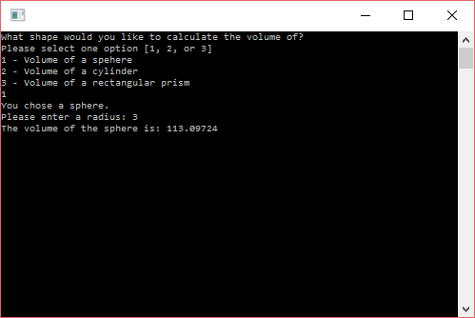

1. On the console, ask for the appropriate parameter values to calculate the volume of the selected shape as follows:
   1. A sphere needs only the radius
   2. A cylinder needs a radius and a height
   3. A rectangular prism requires a length, a width and a height
2. The values should allow for numbers with decimal places for all the shapes.
3. Using the values as parameters, create three methods to calculate the three volumes.
4. All three methods should have the same name (Method Overloading). You should follow the appropriate naming conventions.

The format for submitting the assignment is as follows:

1. **Printouts handed in class**: Assignment Cover sheet properly filled, followed by the marking rubric, and attached to the printout of c# source code.
2. **eConestoga submission**: A single compressed (.zip format) archive file containing the entire project folder for each of the programs (1 & 2) submitted to eConestoga.
3. **Demonstration of program in class**: Please have both programs running on your desktop when you are ready to demonstrate your work.