PROG1800, Assignment #4, Yoonsuk Cho, ID# 7135551

* Normal Process

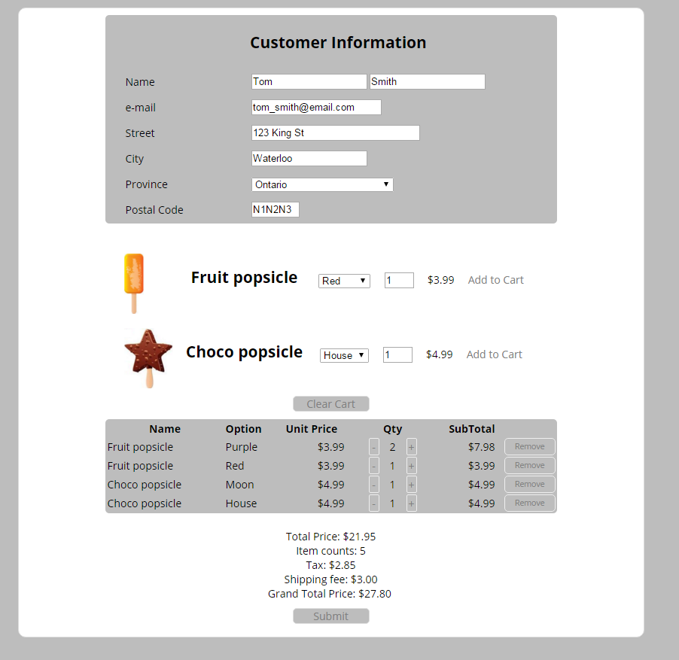

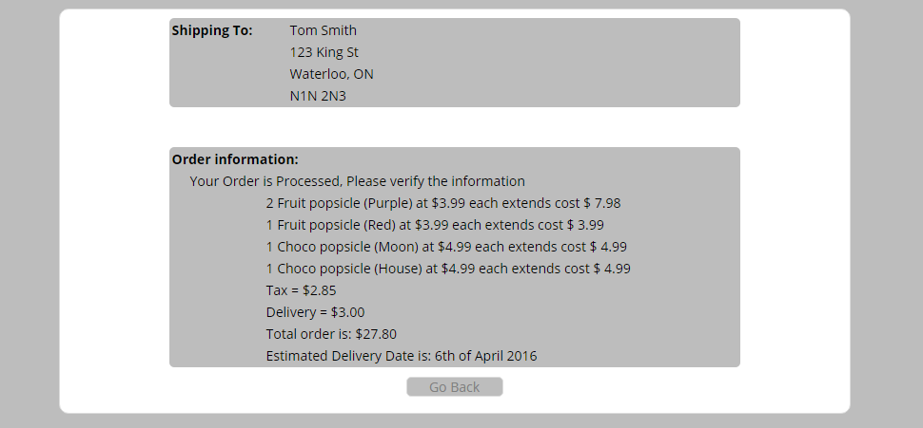

* Error screen

