## Ms Web Tech Assignment 1 – MVC Basics

In this assignment, you are working on a site for a town’s bus service. You need to import the database, generate the models and create views to display and maintain the *busRoute* & *busStop* tables. In this assignment and all subsequent assignments, whenever you see “XX”, replace it with your initials.

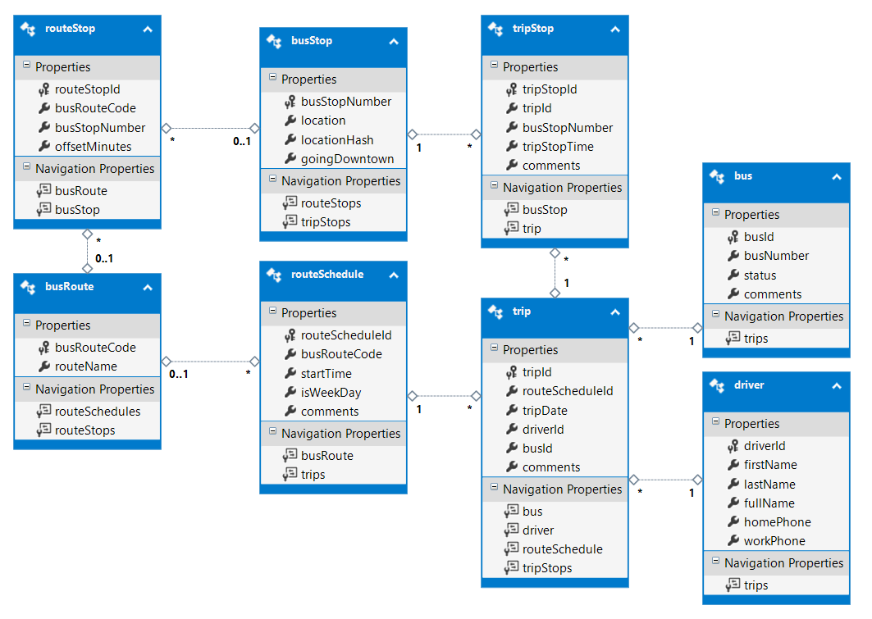

**XXBusService project**

1. Create an ASP.NET Core project based on .NET Core and using the MVC technique. Call it ***XXBusService*** (where XX are your initials).
2. Load the database to SQL, then generate the models & context for Entity Framework:
   1. Download the ***BusService.sql*** database script from the course site
   2. Use SQL Server Management Studio Express to execute the script and build the database.
   3. Generate the Entity Framework classes for the database in the project’s Models folder. Name the context ***BusServiceContext***.
   4. Add the connection string to *appsettings.json*, add a service to Starup.cs to support the dependency injection for the context, and add a constructor in the context to load the connection string via a DbContextOptions collection.
   5. Pray I do all this for you on the exams.
3. Modify the default layout’s footer:
   1. Put your name and section on the left side of the footer. Your name should be a hyperlink causing the user’s e-mail client to create an email to your college e-mail account.
   2. Move the menu’s hyperlinks for “About” and “Contact” to the right side of the footer, retaining the horizontal alignment.

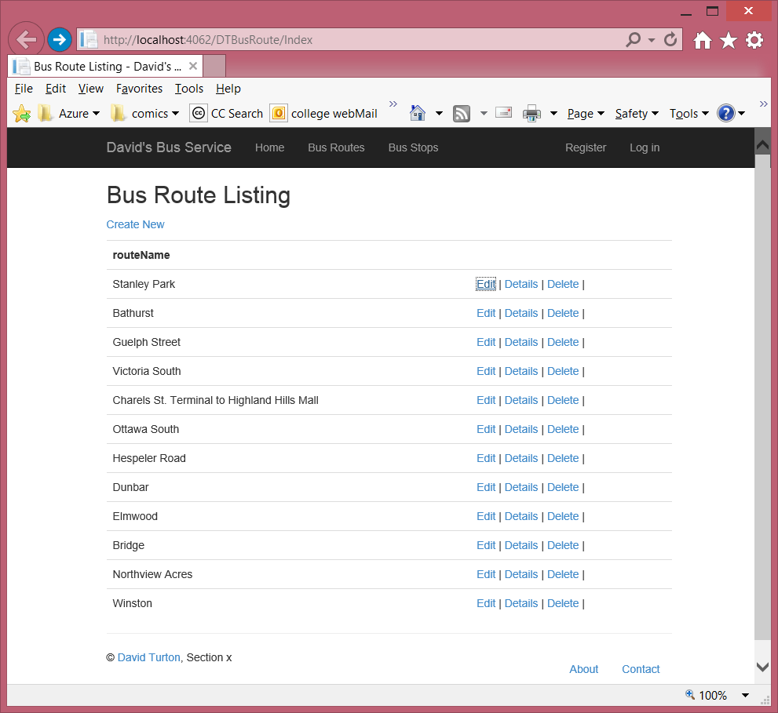

**XXBusRouteController**

1. Generate a controller called XXBusRouteController along with the required Views to enable full CRUD maintenance on the busRoute table. Add a link to it on the menu.
   1. Ensure all views & hyperlinks function correctly:
      1. Index, Details and Delete views should show the bus route code and the route name
      2. Create should allow the user to specify the *busRouteCode*
      3. ???????Edit should display the *busRouteCode* but not permit the user to change it.
         1. Watch this … Edit still needs to work afterwards!
   2. Change the browser window title and the heading on the Index view to “Bus Route Listing” instead of “Index”. Less generated-code ambiguity for the user this way.

**XXBusStopController**

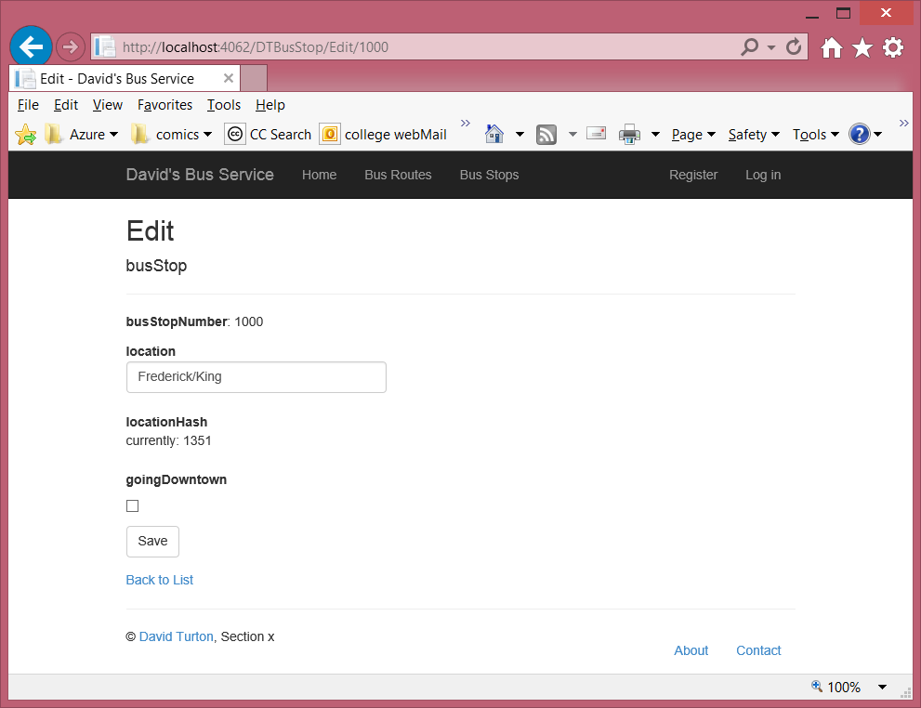

(optional display of original hash)

(Required: notice it’s not an input field on Edit)

1. Generate a controller called XXBusStopController along with the required Views to enable full CRUD maintenance on the busStop table. Add a link to this controller to the menu.
   1. Edit should display the key, *busStopNumber,* as shown, but not permit the user to change it.
   2. You need to calculate a hash value for the location name before writing the record out in Edit and Create. I’d suggest a method that sums the byte value of each letter in the stop’s location field. It should produce the same value for “Cedar/King” and “King/Cedar” … meaning these two stops are for the same intersection … one travelling on Cedar approaching King, and the other travelling on King approaching Cedar.
      1. Do not permit the user to enter the *locationHash* value on Create or Edit, but you can show them the current value on Edit, if you like.
2. Ensure the controllers (and their menu entries) both work … I certainly will check.

**Both Controllers**

1. Comments are required to describe what the program does and what each of the actions do. Generated controllers have 9 methods/actions: at 1% penalty each, that’s a 10% loss for each controller … two controllers in the assignment … get the picture? Max standards penalty in two programs. Uh … what did you call the field accumulating the hash value … did you use full words and Camel notation?

### Hand In

1. Zip and upload your project folder to the [eConestoga drop-box](http://econestoga.ca/) for this assignment.
2. If submitting during the class period, print and hand in the marking sheet with your name on it.
   1. If submitting outside of class, print the [CP2A Cover Sheet](http://acms1.conestogac.on.ca/itschool/wp-content/uploads/IT-Assignment-Coversheet2.pdf), flag your instructor’s name, staple it to the marking sheet and drop into the slot in your instructor’s office door.