Student: _____________________________ /32

Assignment 3 – Egrets Marking

(7) Tables:
- (1) An egret can have multiple activities in a day
- (1) Egret activities validated by activity relationship
- (1) Egrets can have multiple mating records
  - (1) Mating record refers to two egrets
- (1) each tree can have many nests
- (1) each tree can have many tree-health records
- (1) 1-1 relationship between egrets & egret death
- possible lookup tables for quality and tree type

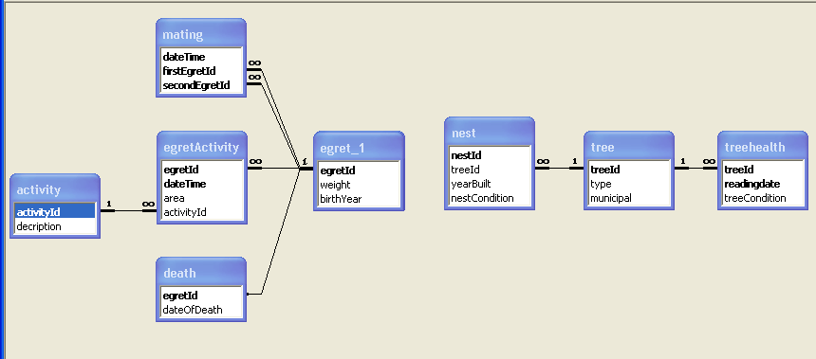

(25)
Queries
- (1) Dead egrets
  - Ascending by date of death
- (1) Not dead egrets
  - Doesn’t include dead egrets
- (2) Number of nests
  - Count of nests
  - Type word (pecan…..)
  - Trees without nests show zero count
- (3) Activity for an egret
  - Requires an egret ID
  - Activity by word, not code
  - Most recent activity first
  - (1) Bonus: requires year, filters activity date.
Forms:
- max -5, one per each violation instance:
  - record selector on a form
  - dividing lines on a form
  - no title on a form
  - dates display 4 digit year
  - no dates in the future
  - tab order of controls is top to bottom
- Switchboard:
  - (1) Buttons for forms work (check two)
  - (1) Buttons for queries work (check two)
  - (1) no navigation bar
  - (1) Exit button works
- Egrets form
  - (1) Scrolls through egrets
  - (1) Can add/change egrets
  - (1) Cannot delete egrets
  - (1) birth year not in future and not more than 10 years past
  - (1) egrets weigh between .5 and 3.5 inclusive
- Trees form
  - (1) Can add trees
  - (1) Combo box for tree type
  - (1) Check box for municipal
- Mating form:
  - (1) Combo boxes show only not-dead egrets
  - (1) Can only input a valid not-dead egret ID
  - (1) Egret cannot mate with self
- Tree Health form:
  - (1) display pick list of trees
  - (1) Option group for tree health
- Deaths form
  - (1) Combo box shows only not-dead egrets
  - (1) Date and time of death mandatory
  - (2) Combo box refreshed after update event, dead egret not an option
- Nest form:
  - (1) Option group for tree health

