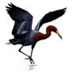

Assignment #3

This assignment is to be done individually, not in pairs

After successfully completing this assignment, you will be able to:
- Design and create tables within a database
- Establish relationships between tables
- Define fields and their properties within a table
- Establish data validation for fields
- Create select queries
- Create forms for entering data into tables and controlling the application

The Egret Monitoring System studies influx of egrets to the area each spring in hopes of determining solutions to the problems the excess bird population brings with it. Tables, queries and forms need to be developed for the system.

The following list represents possible tables supporting the project. Underlined attributes represent the primary keys. The data type of NestQuality, ActivityType and TreeHealth are small integers (see next page).

Tree(TreeID, Type, Municipal)

TreeHealth(TreeID, Date, Health)

Egret(EgretID, Weight, BirthYear)

Nest(NestID, TreeID, BuiltYear, NestQuality)

Activity(EgretID, Date,Time, Area, ActivityType)

Mating(Date,Time, FirstEgretId, SecondEgretID)

Death(EgretID, DateOfDeath)

- Develop the table and relationship according to the following specifications.
- A Tree can have many Nests.
- A Tree can have many TreeHealth entries.
- An Egret can be spotted doing Activities many different times.
- Two relationships exist between Egret and Mating. The Foreign key of FirstEgretID is EgretID in Egret. Similarly, the foreign key for SecondEgretID is EgretID in Egret.
- An Egret can only die once.

- Include the appropriate validation rules that are apparent from the case. The following must be included, but you may add more.
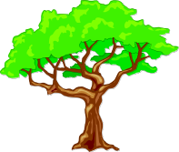
- a tree type can be pecan, oak, or elm.
- egrets weigh between .5 and 3.5 kg inclusive
- activity area is a text field 20 long (sample data – Riverside Park, College Pond, etc.)
- egrets can’t mate with themselves
- dead egrets can’t do anything!
- Municipal is a logical field indicating if the tree is on municipal property or private (True for municipal owned, False if private).
- Valid values for Nest Quality and Tree Health are 1, 2, and 3 only.
1 to represent good, 2 to reesent adequate, and 3 to represent unsatisfactory.
- The valid values for ActivityType are 1 - Nesting and 2 - Food gathering.
- Ensure that the BirthYear in the egret table and BuiltYear in the nest table are numeric, 4 digits long, and are not a year in the future or more than 10 years past. (hint: use the year function to extract the year portion of the current date – do not hardcode the valid year)
- dates in the future are not allowed
- all dates should display 4 digit years

- Develop the following queries. Ensure that all queries sort the data in a meaningful order.

- A query of Egret Deaths listing all egrets that have died. Sort this by date of death in ascending order.

- A query of Not Dead Egrets. Hint: use and outer join to include all egrets even if not dead, and add selection criteria to select only those with empty death dates.

- A query of Number of Nests that counts the number of nests per tree. Include trees with no nests and specifically show a count of 0 (zero) for these trees. For each tree include tree id, the type word (i.e. pecan oak elm), and number of nests.

- A query of all the Activity for a given Egret. Show the EgretID, Date, Time, Activity (by word - either Nesting or Food Gathering), and the area. Sort in descending time sequence – the most recent activity first.
- The user is to enter the egret id as a parameter at query run time
- Optional – advanced: Also have the user enter the year as a parameter at query run time.

- Develop the following forms. All forms should have a common background colour, no dividing lines, no record selector and a descriptive title in large font in the form header area.

- A form for Egrets that allows the user to add new Egrets. The form should contain all Egret data. Do not allow deletion of egrets on this form. Use this form to add data to the Egret Table.

- A form for Trees that allows the user to add trees. Use combo box for tree type, and a check box for municipal.

- 4 more forms; Nest, Activity, Tree Health and Mating. Use combo boxes that will display the EgretIDs from the query of non-dead egrets, and the TreeIDs from the Tree table. Limit the users input to match one of the valid values in the list. Use option groups for the Nest Quality, Tree Health, and Activity.

- A form for recording Egret Deaths. This form should be bound to the Death table. Use a combo box or list box to select EgretID. The row source for the box should be the qryNotDeadEgrets. The date and time of death are mandatory fields. The form should be refreshed on the AfterUpdate event. This will cause the now dead Egret to be removed from the list box.

- Build a simple opening form with buttons in 3 columns. The first column should contain buttons to direct the user to each table maintenance form built in #4. The second column should contain buttons for output directing the user to queries a through d from #3. The third column should contain an exit button to make the opening form disappear and exit to Access.

Ensure that there are at least 5 records in each table except death (don’t kill off more than 2 Egrets).
Ensure that several trees contain more than 1 nest, and at least 1 tree contains no nests.

Hand in (In the order shown below):
standard title page with…
- A printout of relationships. Ensure that all fields in all tables are visible.
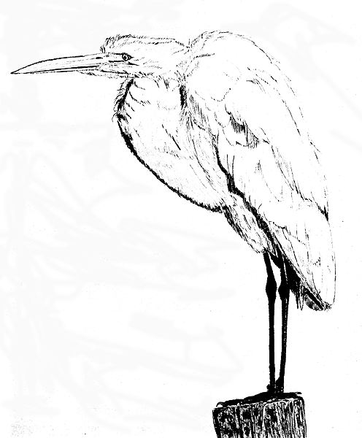
- a copy of your compressed .accdb file uploaded to your instructors drop box
plus

Demo the system to your instructor

