Assignment #4

After successfully completing this assignment, you will be able to:
- Develop a process typically used in Master Table Maintenance
- Control the enabling/disabling of tasks available to the user
- Use VBA with ADO commands to manipulate database records
- include simple validation rules at the program level

Users will be allowed to browse through the records in a table (in Description order) with no chance of the data being accidentally damaged.

If the user finds a record that requires editing (changing), the Edit button will be pressed, and the state of the form will be changed to allow editing. When the user is finished editing the data, either the Save or Cancel button will be pressed to save/ignore the changes and return the form to the browse mode.

If the user decides to add a record to the table, the Add button is pressed, and the state of the form will be changed to allow a complete record to be added. As above, the user can select the Save or Cancel button.

The database Assign4.accdb is supplied on eConestoga, (under databases) containing Parts and Vendor information.

Browse State:
- When in the browse state, all data controls are “locked”, not allowing any modifications to the data.
- Disable the Save and Cancel buttons and enable the Edit, Add and Exit buttons.
- Notice the record navigation bar is visible, allowing the user to move through the table to select a part, but not allowing adds to the table.
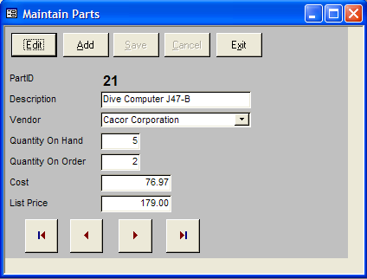

Modify State:
When the user selects either “Edit” or “Add” place your form in Modify state. Disable the Edit, Add and Exit buttons; enable the Save and Cancel buttons; and hide the record navigation bar.

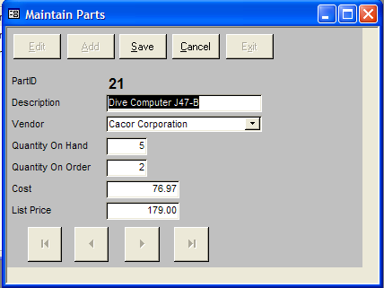
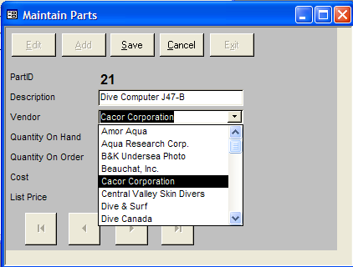

Edit - all data in the current record, excluding PartID (primary key), can be changed.

- all fields must be filled in
- note error in data
Add - display an empty record to be completed and added to the table

- PartID is an autonumber
- note order of Vendor combo box

Save - If the data is valid (rules below), write the values to the record in the database and switch back to browse state.
- If the data is not valid leave the form in the modify state. Users will then either correct the error(s) or cancel out of modify state.

Cancel - Discard any changes made to the data and switch back to browse state.

Exit - Close the form and return to Access.

Validation - The following validation is to be done by a VBA function:
Description must be at least 4 characters not counting leading/trailing spaces
OnHand and OnOrder must be 0 or greater
Cost must be greater than 0
Values formatted as currency
ListPrice must be greater than Cost

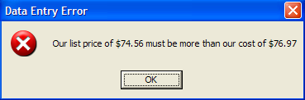

Meaningful error messages
are a beauty to behold!

Hand in:

- Title Page
- Marking schema
- upload to eConestoga
- Demo to instructor

