Assignment #5a

Master Table Maintenance - with Searching
Customer and Inventory Master tables frequently contain many records. Even small businesses can have a customer list with thousands of entries. A process that helps the user get to any specific record in the table is a desirable feature.

Design a form that contains the following information - feel free to create a professional design your own.
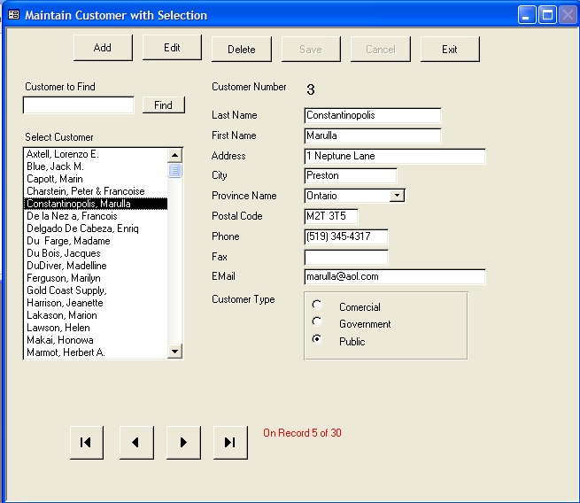

Optional Enhancement

When there are no records in the database use this area to give a user a message to that effect. See demo.

Notice the listbox on the left (Select Customer) provides a sorted list of the names in the table. The records on the form are presented in the same sorted order as the list of names in the list box. As the selection is moved in the listbox the customer data matching that customer appears in the form view on the right. The user may also type a name in the Find Last Name text box. When the find button is clicked the form view on the right displays details for the next customer that matches or is larger than the name entered, and the list box will reposition itself to that customer as well.

While the user is browsing the table, the details of the records should be protected from accidental change. Set the Locked property to True for each of the editable controls on the form. Since the listbox (and txtFindName) must be active, you must unlock these controls after locking all other controls. Use a procedure containing a For/Next loop to set the lock property of all the controls. Pass a Boolean argument to your one locking/unlocking procedure. Controls that can’t be edited (such as labels) will generate an error during this process so use the statement On Error Resume Next inside the procedure to let the process skip over such errors.

Use the same techniques as in the last assignment to control the Add, Edit, Delete, Save, and Cancel buttons.

The AS5.mdb database is stored on eConestoga. It contains only the Customer table. We are aiming to build a complete application which will include part maintenance (asn4), customer maintenance (asn5) and more yet to come!

Validate, using VBA code: LastName is not blank. FirstName is not blank.
Address more than 5 chars. City 3 or more chars.
Province was selected. Postal code is 6 chars. or empty
Phone 10 chars. or empty Fax is 10 chars. or optional
Email is optional ** CustomerType is one of 1,2,3

Note that Phone, Fax and Postal display the mask characters, but do not store them in the table.

Optional additions: for bonus marks
This is a nice way to boost your mark in case you missed some of the mandatory requirements.
BUT your assignment mark may not exceed perfect.

** Email: validate email to ensure that there is a prefix before the @ of at least 1 character, an @, a middle part of at least 1 character, followed by a ‘.’ (dot), and an ending section of at least 1 character.

** Record count message: use the recordset properties that provide the current (absolute) record number that the count of records to build a message in a label that tells the user what record they are on out of how many. (i.e. mimic the navigation bar message on a bound form).

Hand in:
- Standards Sheet
- Marking schema
- Test Plan
- Upload to eConestoga
- Demo to instructor

