Customer Order Maintenance

Assignment #6

Customer Order Inquiry – show the ‘many’ side of a one to many relationship on a form.

One customer has many orders (illustrated via a list box), and one order is for many parts (illustrated via a subform).

The data typically required for an order requires many tables: customer, orderHeader, orderDetail and parts. There may be no orders for a customer. If an order exists, it may contain 1 or more different parts ordered (orderDetail records).

The order process begins by selecting the customer. This will trigger a list indicating all the open orders that currently exist for that customer. The user must then indicate if they will be Editing an existing order, or Adding a new order. Once this is specified the user may add, edit, and delete parts on the order.

Customer Order Entry

Entering sales orders for customers is a more complex process. The data typically required for an order requires many tables: customer, orderHeader, orderDetail and parts, and several 1:M relationships. There may be 0, 1 or many orders for a customer. If an order exists, it may contain 1 to many different parts ordered (orderDetail records).

The order process begins by selecting the customer. This will trigger a list indicating all the open orders that currently exist for that customer. The user must then indicate if they will be Editing an existing order, or Adding a new order. Once this is specified the user may add, edit, and delete parts on the order.

Create a form containing the following information. The design is your choice. Auto load the form at startup.

Sample Screen shot in BrowseOrder mode:
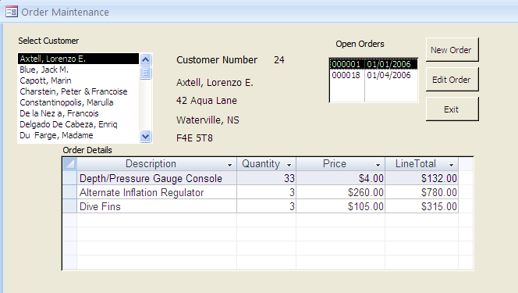

In the sample form, the upper portion is used for customer and order selection, and the lower part is used for order detail entry. The upper part of the form is where the focus is set until the user selects New Order or Edit Order.

When a customer is selected from the list box on the left, their number, name and address are displayed to the right of the list box. These fields are for display only and may not be edited.

The list box on the right displays all open orders for the selected customer. Open orders are orders that have not been printed. Populate this list box from a query that selects only open orders. To restrict the list to only those orders for the current customer, alter the query used for the listbox’s rowsource. This my be done directly in the query design grid view of the rowsource by adding a criteria limiting the selection to only those records where the CustomerNumber in orderHeader is equal to the CustomerNumber in the customer number text box/or label caption, or select customer list box, or customer recordset (all will be the same value). Be sure to reset the current selection in the open orders list box to empty (“”) whenever a new customer appears on the form.

The lower part of the form (Parts on Order) contains all the orderDetail records for the selected order. This is accomplished through the use of a subform. Subforms are connected to the mainform by parent/child links. In this way only, those orderDetail entries for the selected OrderNumber will be shown. Use the OpenOrder list box as the parent link.

Create the subform separately, or use the wizard to create it from within the mainform. The subform is datasheet view (i.e. linear – 1 record per row). The subform is bound to a query that contains a mixture of fields from the orderDetail and Parts tables, as well as a calculated value. Be sure to include the key fields (OrderNumber , LineNumber and PartID) in the query for the sub form. Even though they are not shown, they are used to link the sub form to the main form and later to select orderDetail records to delete and the selected part to appear in the combo box on an edit. The user will never be allowed to insert, delete or edit data directly on the subform so lock it up!

At the start, ensure that the form loads with the first customer in the listbox selected (highlighted), the open orders appear for that customer, and that the form is in BrowseOrder state.

New Order:
- change to ModifyOrder mode
- Use the .AddNew method add a new blank orderHeader record
- Set the OrderDate equal to the current date, Printed to false and CustomerNumber to the current customer selected
- Use the .Update method to write the changed contents to the orderHeader record
- Save the order number value generated by the autonumber for the newly added record
- Requery the open orders list box so that the added order appears
- Set the Open Orders list box to the saved order number (autonumber) of the new record

Edit Order:
- If an order has been selected… change to ModifyOrder mode

Sample screen shot in ModifyOrder mode:
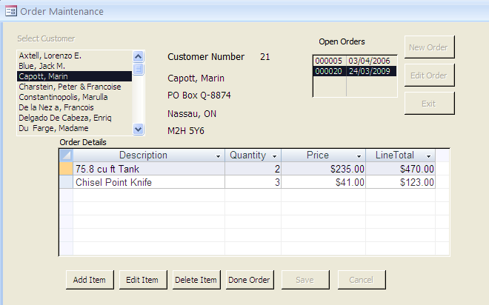
User must select an order to Edit Order

Buttons and listboxes not enabled when in BrowsePart Mode

Subform shows all OrderDetail lines for currently selected order

Buttons diaplayed for BrowsePart Mode

Changes may now be made to the orderDetail via the buttons at the bottom on the form.
Add Item:
- Change to ModifyPart mode
- Set the 3 data controls to empty (NULL) or zero (0)
- Set a variable to “A” to indicate in Adding

Edit Item::
If a line is selected on the sub form…. (check that the subformName.Form.currentRecord isn’t 0)
- Change to ModifyPart mode
- Set the 3 data controls to the values on current sub form’s line (subformName.Form!fieldname)
- Set a variable to “E” to indicate in Editing

When the user selects a part from the combo box set the SalePrice control value to the ListPrice (it will be one of the hidden columns in the Select Part combo box). The user may later override this price by entering another price (if for example the part is on sale or discounted).

Delete Item:
If a line is selected on the sub form….
- Using the orderDetail recordset object; find the record based on LineNumber in the subform and use the .Delete method on the recordset
- Requery the subform

Done Order:
- Change back to BrowseOrder mode

Save:
- check the controls to ensure that only valid data has been entered.
- If valid then
If Adding
Use the .AddNew method add a new orderDetail record
Set the order number to the value of the Open Orders list box
Else (Editing)
Using orderDetail recordset object; find the record based on LineNumber in the subform
End of If
Set the values in the current orderDetail record to the values in the 3 data controls
Write to the changes to the orderDetail recordset object using the .Update method
Requery the subform
Return to ModifyOrder mode.
Cancel:
- return to ModifyOrder mode.

Sample screen shot in ModifyPart Mode:
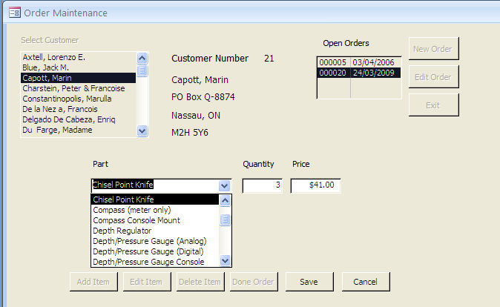

3 column combo box from sorted part query –

PartID, Description, ListPrice

The three controls are on the form underneath the sub form. To make them appear change the subform’s visible property to False… magic!



Only Save and Cancel buttons enabled.

Startup:

The AS6student is on eConestoga. It contains the orderHeader and orderDetail tables.
You will also need the part table from assignment 4 (customers order parts).

Still working towards a complete system that contains forms for part maintenance (assignment 4), customer maintenance (assignment 5), order maintenance (assignment 6) and more good stuff yet to come (switchboard and report). You may combine all the steps together in the end (import forms, tables, queries), or you may work towards a complete system now by have assignment 6 include what you did in assignment 4 as well. To accomplish this do the following:

- If your As5 contains As4 as well:
- take a copy of your As5.accdb and name it As6.accdb.
- Then, import the 2 new tables from AS6.accdb database stored on Scratch

If not:
- then begin As6 with the 2 new tables, and import the parts using the External Data
Tab as described below.

2. To import the 2 new tables from scratch into YOUR as6

Use External Data tab | Access| browse to the As5.accdb that contains the new tables, select the tables to import (customer and province) | click OK

Make sure the table field names are all changed with a three character prefix…txt..

Hand in (In the order shown below) with the standard title page/standards sheet:

- One page containing screen shots of your form in design view and form view.
- A printout of your code.
- Printout of the marking sheet
- Plus upload your compressed .accdb file to your instructor’s drop box.
- No Demo minus 5%.

