**Reporting results**

Best Run showed as below:

BestRun(run_id='2a90fb8a', objective=0.7969418960244649, hyperparameters={'learning_rate': 2.49816047538945e-05})

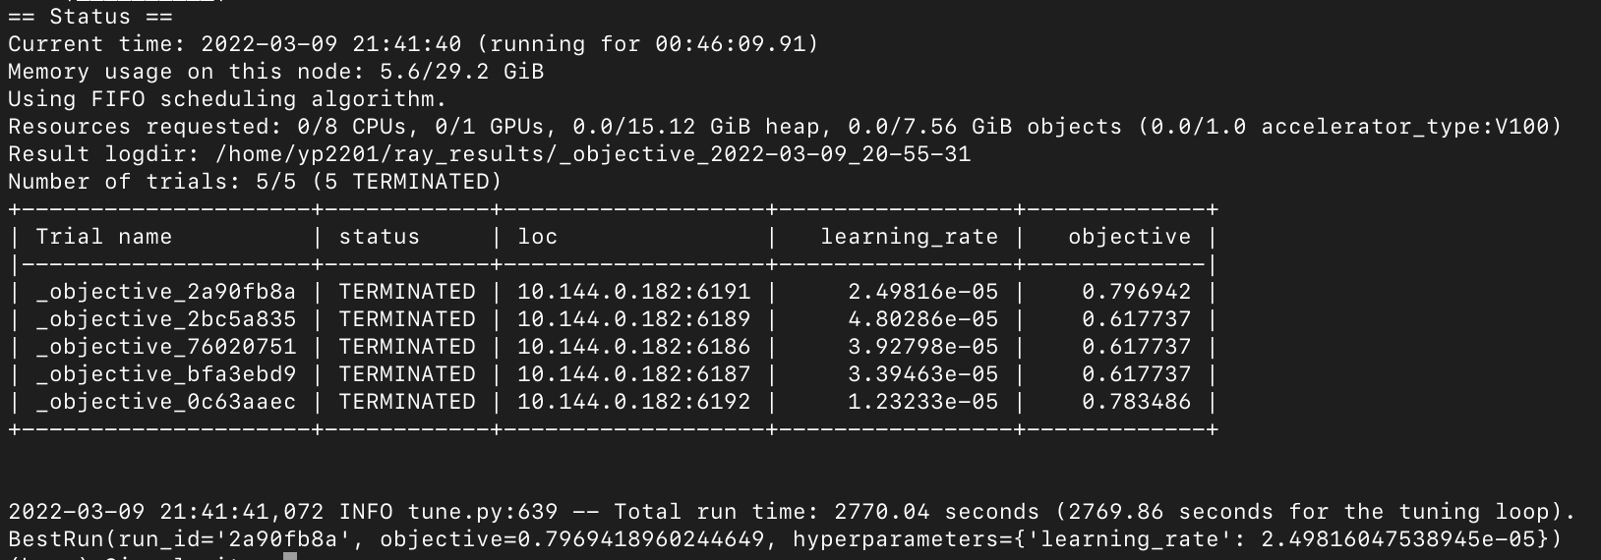

1) _objective_0c63aaec:

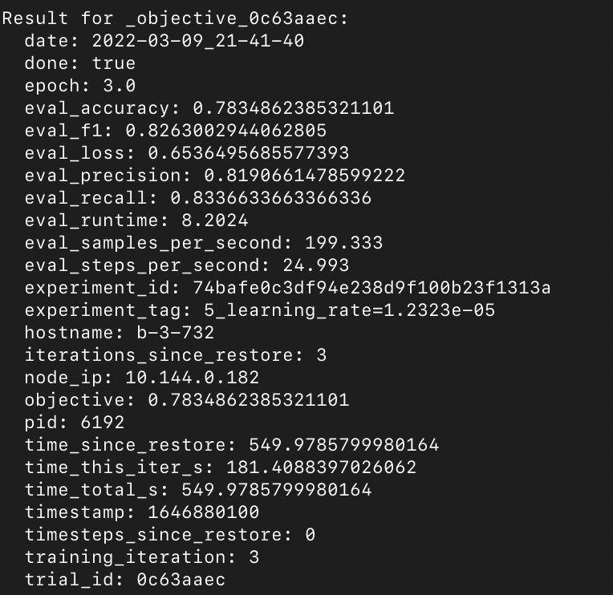

2)

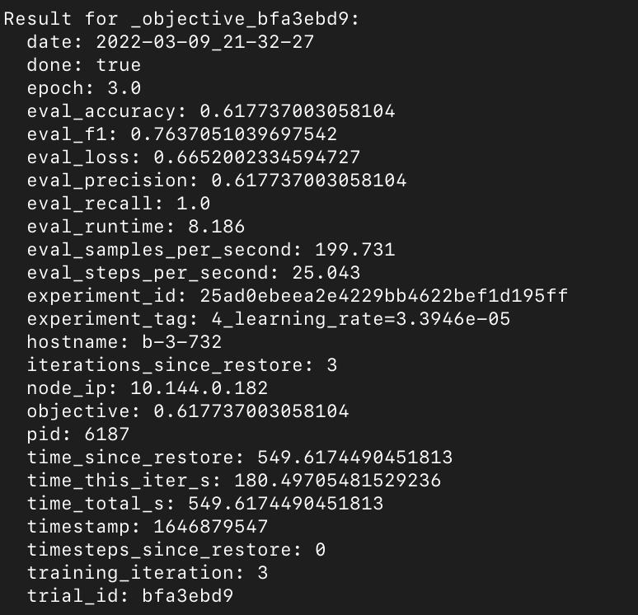

3)

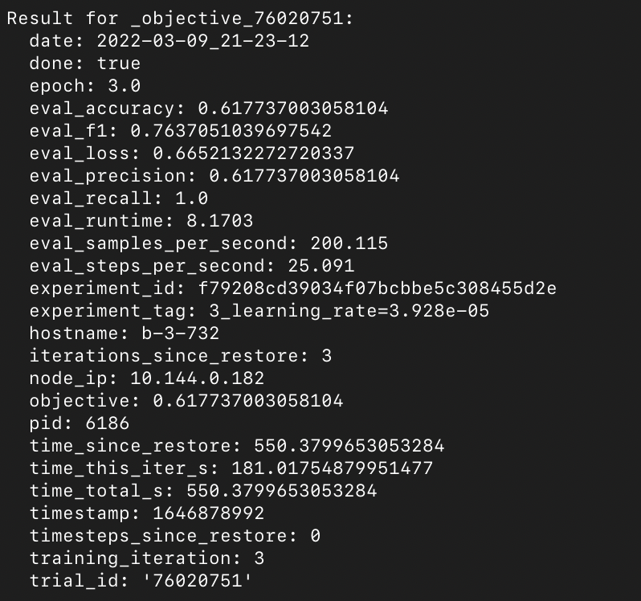

4)

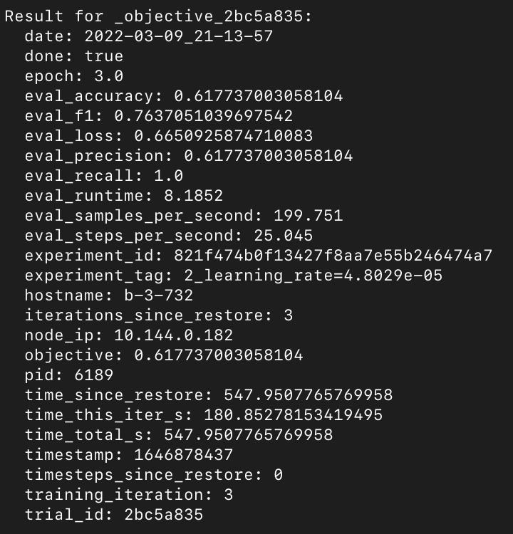

5)

