**Api design rules**

The following are api design rules that we applied in our project.

1. Use nouns for names and plural nouns for resources it has.



1. Show the created Id of the resource in the header with location attribute form which the newly created resource can be assessed easily.

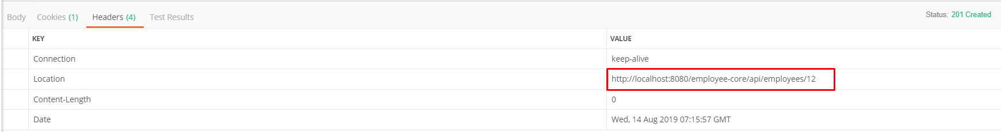

1. Return the correct status code.For example

404 BAD REQUEST- The server could not understand the request due to invalid syntax (Validation errors).

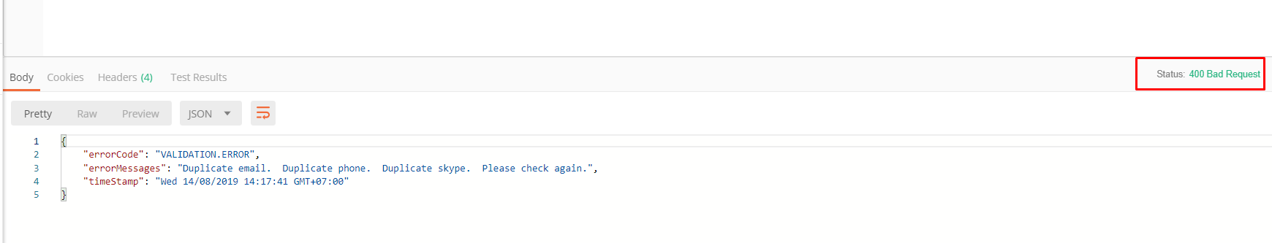

4.Name the api with giving meaningful information.



1. Use Swagger for documenting the api automatically. Here the link for Swagger for our api.

[http://](http://localhost:8080/employee-tool/dist/index.html)[192.168.70.59:8080](http://192.168.70.59:8080/)[/employee-tool/dist/index.html](http://localhost:8080/employee-tool/dist/index.html) (Swagger link for Dev Server)

[http://](http://localhost:8080/employee-tool/dist/index.html)[localhost:8080](http://192.168.70.59:8080/)[/employee-tool/dist/index.html](http://localhost:8080/employee-tool/dist/index.html) (Swagger link for localhost)