**Script design rules**

1. Creating script file for creating table that we initially had . And also script file for initializing the table.

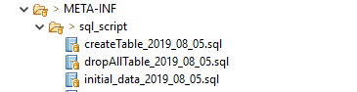

1. Needing to add new column or table, then have to write new script file for updated one and the name should be meaningful and clear with created date.

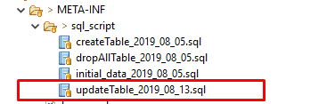

1. Don’t make so many updated script files if necessary merge with original script file.So that it will be easy to deploy the script.