AAVN UI Component

(User Guide)

Contents

**I.** **Download** 2

**II.** **Install** 3

**III.** **Convention coding UI** 4

**IV.** **How to use?** 4

1. Import css/js into your xhtml page: 4

2. Heading: 5

3. Using class “aavn-form-component” for the form to apply the CSS design for form component. 5

4. Form component: Input Text 5

5. Form component: Input Number 6

6. Form component: Input TextArea 6

7. Form component: Select Box 8

8. Form component: AutoComplete 8

9. Form component: Radio Box 9

10. Form component: Check Box 9

11. Form component: Calendar 9

12. Form component: File Upload 10

13. Form component: CommandButton 10

14. Datatable 11

15. Modal Dialog 12

16. Confirm Dialog 13

17. Dialog Framework 14

18. Spinner 16

19. Progress Bar 17

1. **Download**

You can get *aavn-ui-component-<VERSION>.zip* from Jenkin workspace:

<https://build.axonactive.vn.local/job/aavn-ui-component/ws/release/>

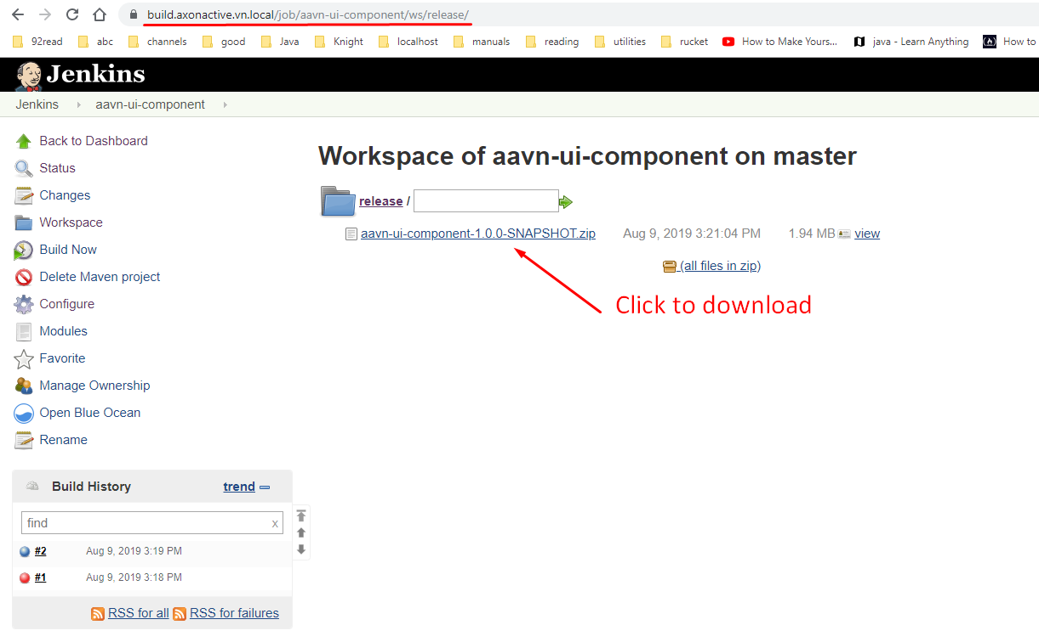

1. **Install**

Extract “src” folder of installation package, then overwrite the “src” folder in your Java EE project. The following folders and files will be added/overwritten:

\---src

\---main

\---webapp

~~| mini-example-of-using-dialog-template.xhtml~~

~~| mini-example-of-using-page-template.xhtml~~

|

+---resources

| \---library

| +---css

| | aavn-form-components.min.css

| | aavn-nova-light-theme.min.css

| |

| +---font-awesome

| |

| +---fonts

| | \---roboto-condensed

| |

| +---js

| | aavn-script.min.js

| |

| \---materialize

| \---css

|

\---WEB-INF

dialog-template.xhtml

page-template.xhtml

* If you want to uninstall the aavn-ui-component, you can remove the files and folders by yourself.

1. **Convention coding UI**

* Create a new special css/js file for your screen/feature
* About Icon: using icon of Font-Awesome (fa fa-icon)
* About Grid CSS: using of primefaces grid (ui-g)

1. **How to use?**
2. Import css/js into your xhtml page by extending our templates:

Stylesheet and Javascript of aavn-ui-component already imported to the following files:

- /src/main/webapp/WEB-INF/dialog-template.xhtml

- /src/main/webapp/WEB-INF/page-template.xhtml

When creating a new page, you can extend the page-template.xhtml as following example:

new-page.xhtml  
------------------------------------------------------------------------------------

<ui:composition xmlns="http://www.w3.org/1999/xhtml"

xmlns:h="http://java.sun.com/jsf/html"

xmlns:f="http://java.sun.com/jsf/core"

xmlns:ui="http://java.sun.com/jsf/facelets"

xmlns:p="http://primefaces.org/ui"

template="/WEB-INF/page-template.xhtml">

<ui:define name="head">

<!-- define your head section here -->

</ui:define>

<ui:define name="body">

<!-- define your body section here -->

</ui:define>

<ui:define name="script">

<!-- define your script section here -->

</ui:define>

</ui:composition>

------------------------------------------------------------------------------------

(Note: the library attribute based on you structure project)

When creating a new dialog-framework-page, you can extend the dialog-template.xhtml as following example:

new-dialog-framework-page.xhtml  
------------------------------------------------------------------------------------

<ui:composition xmlns="http://www.w3.org/1999/xhtml"

xmlns:h="http://java.sun.com/jsf/html"

xmlns:f="http://java.sun.com/jsf/core"

xmlns:ui="http://java.sun.com/jsf/facelets"

xmlns:p="http://primefaces.org/ui"

template="/WEB-INF/dialog-template.xhtml">

<ui:define name="head">

<!-- define your head section here -->

</ui:define>

<ui:define name="body">

<!-- define your body section here -->

</ui:define>

<ui:define name="script">

<!-- define your script section here -->

</ui:define>

</ui:composition>

------------------------------------------------------------------------------------

1. Heading:

* Page heading: <h2 class="aavn-page-heading">AAVN UI Component</h2>
* Heading lv1: <h4 class="aavn-heading-lv1">Form Components</h4>
* Heading lv2: <h5 class="aavn-heading-lv2">Input field</h5>

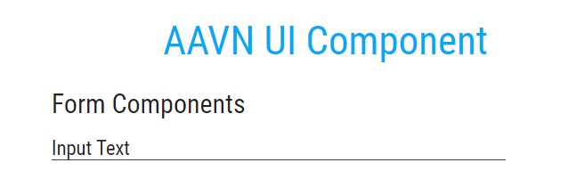

1. Using class “aavn-form-component” for the form to apply the CSS design for form component.
2. Form component: Input Text

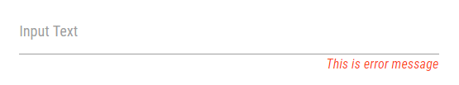

<p:outputPanel styleClass="input-field aavn-input-field">

<p:inputText id="inputText" styleClass="aavn-input-text" value=""></p:inputText>

<label class="aavn-input-text-label active" for="inputText">Input Text</label>

<h:outputText styleClass="aavn-error-msg-input-field" value="This is error message"></h:outputText>

</p:outputPanel>

(Note: in case you want to use h:message to show the error message, use the same CSS class "aavn-error-msg-input-field")

1. Form component: Input Number

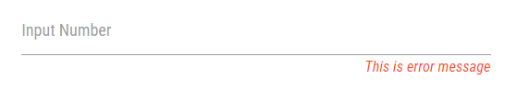

<p:outputPanel class="input-field aavn-input-field">

<p:inputNumber id="inputNumber" styleClass="aavn-input-number" value=""></p:inputNumber>

<label class="aavn-input-number-label active" for="inputNumber">Input Number</label>

<h:outputText styleClass="aavn-error-msg-input-field" value="This is error message"></h:outputText>

</p:outputPanel>

(Note: in case you want to use h:message to show the error message, use the same class "aavn-error-msg-input-field")

1. Form component: Input TextArea

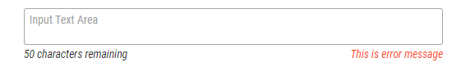

<p:outputPanel styleClass="input-field aavn-input-field">

<p:inputTextarea styleClass="aavn-text-area" counter="textArea-remaining-message" counterTemplate="{0} characters remaining" maxlength="50" placeholder="Input Text Area"></p:inputTextarea>

<h:outputText id="textArea-remaining-message" styleClass="aavn-remaining-msg-input-text-area"></h:outputText>

<h:outputText styleClass="aavn-error-msg-input-text-area" value="This is error message"></h:outputText>

</p:outputPanel>

(Note: in case you want to use h:message to show the error message, use the same CSS class "aavn-error-msg-input-field")

1. Form component: Select Box

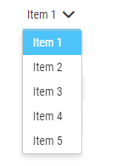

<p:selectOneMenu styleClass="aavn-select-box">

<f:selectItem itemLabel="Item 1" itemValue="1" />

<f:selectItem itemLabel="Item 2" itemValue="2" />

<f:selectItem itemLabel="Item 3" itemValue="3" />

</p:selectOneMenu>

1. Form component: AutoComplete

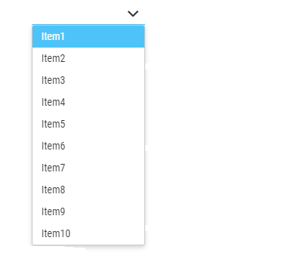

<p:autoComplete styleClass="aavn-auto-complete" dropdown="true" value="#{formComponentBean.selectedAutoComplete}" completeMethod="#{formComponentBean.completeItem}">

</p:autoComplete>

1. Form component: Radio Box



<p:selectOneRadio styleClass="aavn-radio-box">

<f:selectItem itemLabel="Item 1" itemValue="1" />

<f:selectItem itemLabel="Item 2" itemValue="2" />

<f:selectItem itemLabel="Item 3" itemValue="3" />

</p:selectOneRadio>

1. Form component: Check Box



<p:selectManyCheckbox styleClass="aavn-checkbox">

<f:selectItem itemLabel="Item 1" itemValue="1" />

<f:selectItem itemLabel="Item 2" itemValue="2" />

<f:selectItem itemLabel="Item 3" itemValue="3" />

</p:selectManyCheckbox>

1. Form component: Calendar

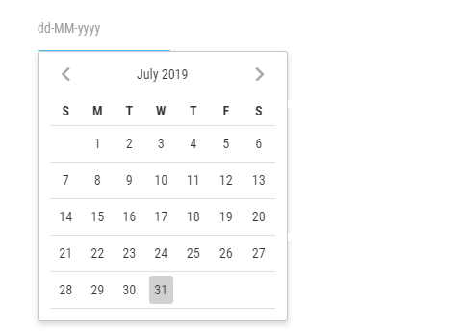

<p:calendar styleClass="aavn-calendar" pattern="dd-MM-yyyy" placeholder="dd-MM-yyyy"></p:calendar>

1. Form component: File Upload



<p:fileUpload fileUploadListener="#{formComponentBean.handleFileUpload}" mode="advanced" styleClass="aavn-file-upload" auto="true" fileLimit="1" sizeLimit="100000" allowTypes="/(\.|\/)(gif|jpe?g|png)$/"></p:fileUpload>

1. Form component: CommandButton



<p:commandButton styleClass="aavn-active-button" icon="fa fa-check" value="Active Button"></p:commandButton>

<p:commandButton styleClass="aavn-inactive-button" icon="fa fa-times" value="InActive Button"></p:commandButton>

1. Datatable

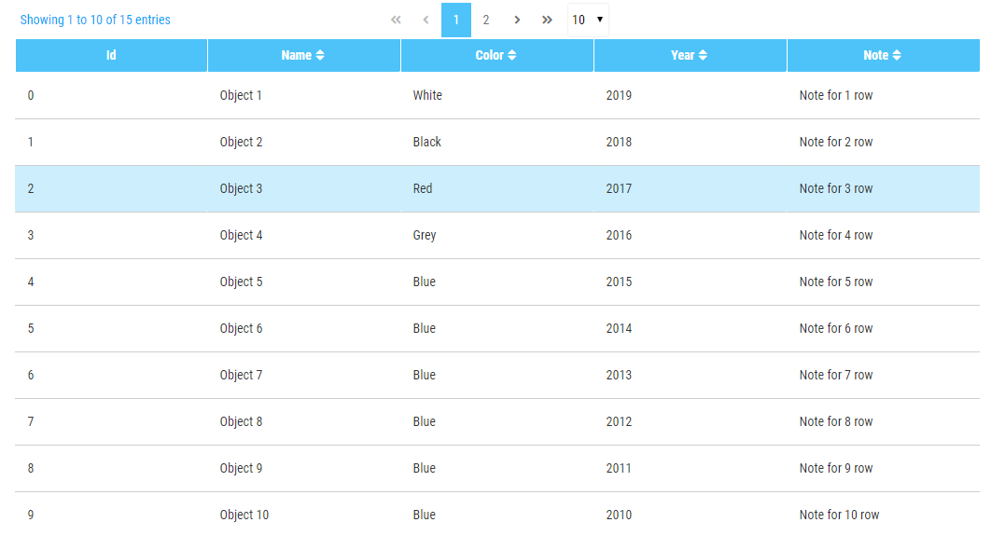

<p:dataTable styleClass="aavn-data-table"

value="#{formComponentBean.dataTableObjs}" var="dataTableRow"

rows="10" rowIndexVar="rowIndex" paginator="true" paginatorPosition="top"

paginatorTemplate="{CurrentPageReport} {FirstPageLink} {PreviousPageLink} {PageLinks} {NextPageLink} {LastPageLink} {RowsPerPageDropdown}"

rowsPerPageTemplate="10,20,50,100"

currentPageReportTemplate="Showing {startRecord} to {endRecord} of {totalRecords} entries"

emptyMessage="No records found">

<p:column headerText="Id">

<h:outputText value="#{rowIndex}"></h:outputText>

</p:column>

<p:column headerText="Name" sortBy="#{dataTableRow.name}">

<h:outputText value="#{dataTableRow.name}"></h:outputText>

</p:column>

<p:column headerText="Color" sortBy="#{dataTableRow.color}">

<h:outputText value="#{dataTableRow.color}"></h:outputText>

</p:column>

<p:column headerText="Year" sortBy="#{dataTableRow.year}">

<h:outputText value="#{dataTableRow.year}"></h:outputText>

</p:column>

<p:column headerText="Note" sortBy="#{dataTableRow.note}">

<h:outputText value="#{dataTableRow.note}"></h:outputText>

</p:column>

</p:dataTable>

1. Modal Dialog

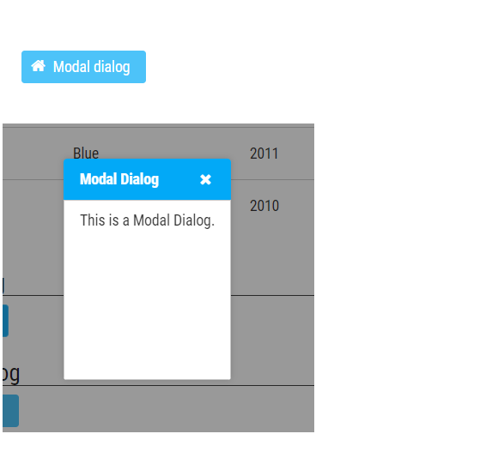

<p:commandButton styleClass="aavn-active-button" icon="fa fa-home" value="Modal dialog" onclick="PF('modal-dialog').show()"></p:commandButton>

<p:dialog styleClass="aavn-modal-dialog" header="Modal Dialog" widgetVar="modal-dialog" modal="true" height="150" closeOnEscape="true">

<h:outputText value="This is a Modal Dialog."></h:outputText>

</p:dialog>

1. Confirm Dialog

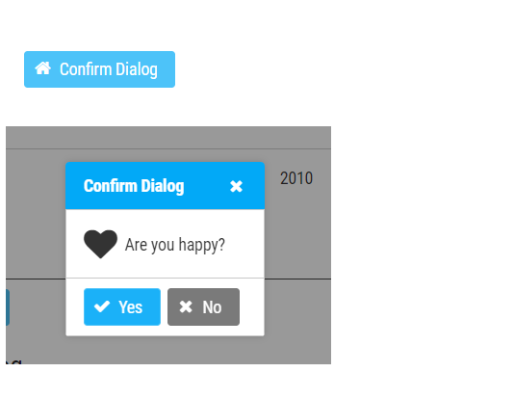

<p:commandButton styleClass="aavn-active-button" icon="fa fa-home" value="Confirm Dialog">

<p:confirm header="Confirm Dialog" message="Are you happy?" icon="fa fa-heart"></p:confirm>

</p:commandButton>

<p:confirmDialog styleClass="aavn-confirm-dialog" global="true" closeOnEscape="true">

<p:commandButton value="Yes" type="button" styleClass="aavn-active-button" icon="fa fa-check" />

<p:commandButton value="No" type="button" styleClass="aavn-inactive-button" icon="fa fa-times" />

</p:confirmDialog>

1. Dialog Framework

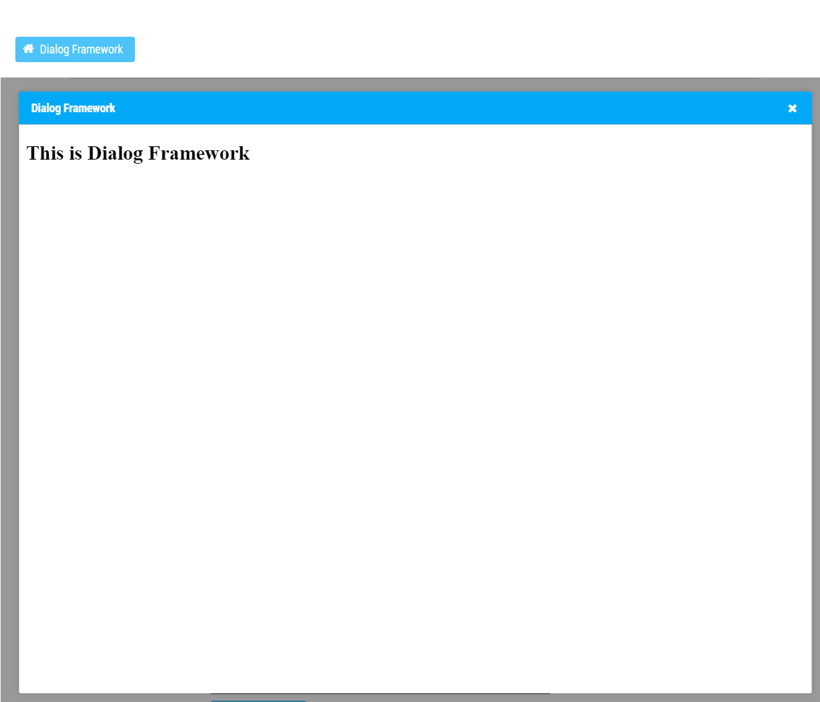

<p:commandButton styleClass="aavn-active-button" icon="fa fa-home" value="Dialog Framework" action="#{formComponentBean.showDialogFramework}" ></p:commandButton>

In Bean:

public void showDialogFramework() {

Map<String, Object> options = new HashMap<>();

options.put("modal", true);

options.put("width", "950px");

options.put("height", "70vh");

options.put("contentWidth", "100%");

options.put("contentHeight", "100%");

options.put("resizable", true);

options.put("draggable", true);

options.put("closable", true);

options.put("closeOnEscape", true);

Map<String, List<String>> params = new HashMap<>();

PrimeFaces.current().dialog().openDynamic("DialogFramework.xhtml", options, params);

}

1. Spinner

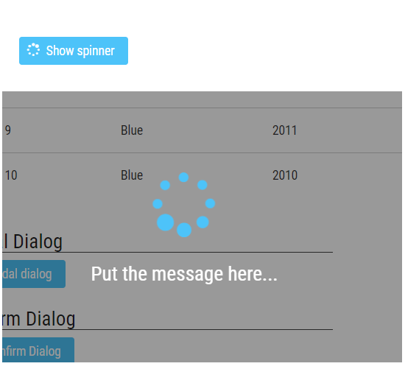

<p:commandButton styleClass="aavn-active-button" icon="fa fa-spinner fa-pulse" value="Show spinner" onstart="showBackDrop('aavn-spinner')"></p:commandButton>

<div class="aavn-spinner">

<div class="content">

<i class="fa fa-spinner fa-pulse fa-5x fa-fw"></i>

<div class="message">Put the message here...</div>

</div>

</div>

(Note: incase you want to stop the snipper, use hideBackDrop('aavn-spinner') javascript method)

1. Progress Bar

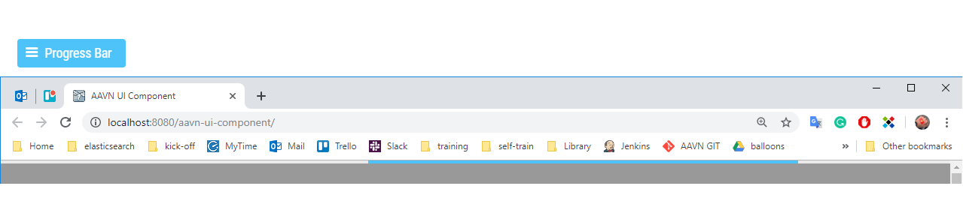

<p:commandButton styleClass="aavn-active-button" icon="fa fa-bars" value="Progress Bar" action="#{formComponentBean.toggleProgressBar()}" update="aavn-progressBar"

onstart="showBackDrop('aavn-progress-bar-container')" ></p:commandButton>

<p:outputPanel id="aavn-progressBar">

<p:progressBar styleClass="aavn-progress-bar" mode="indeterminate" rendered="#{formComponentBean.active}" ></p:progressBar>

</p:outputPanel>

<div class="aavn-progress-bar-container"></div>

In Bean:

@Getter private Boolean isActive;

public void toggleProgressBar() {

this.isActive = !this.isActive;

}

(Note:

* Incase you want to stop the progress bar, use hideBackDrop('aavn-progress-bar-container') javascript method
* The method toggleProcessBar() in formComponentBean is change the value of active variable from false -> true and reverse)

This is all of common component, for more detail, you can run the aavn-ui-component project and access to the main.xhtml page to see the showcase.