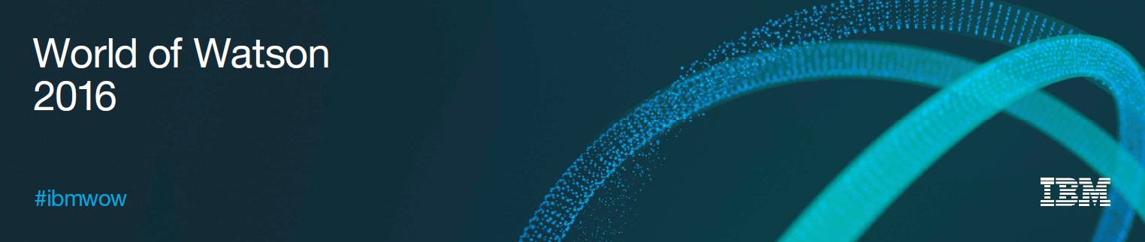

**Lab Center – Hands-on Lab**

**Session 3548**

**Session Title Building a web app that uses your model**

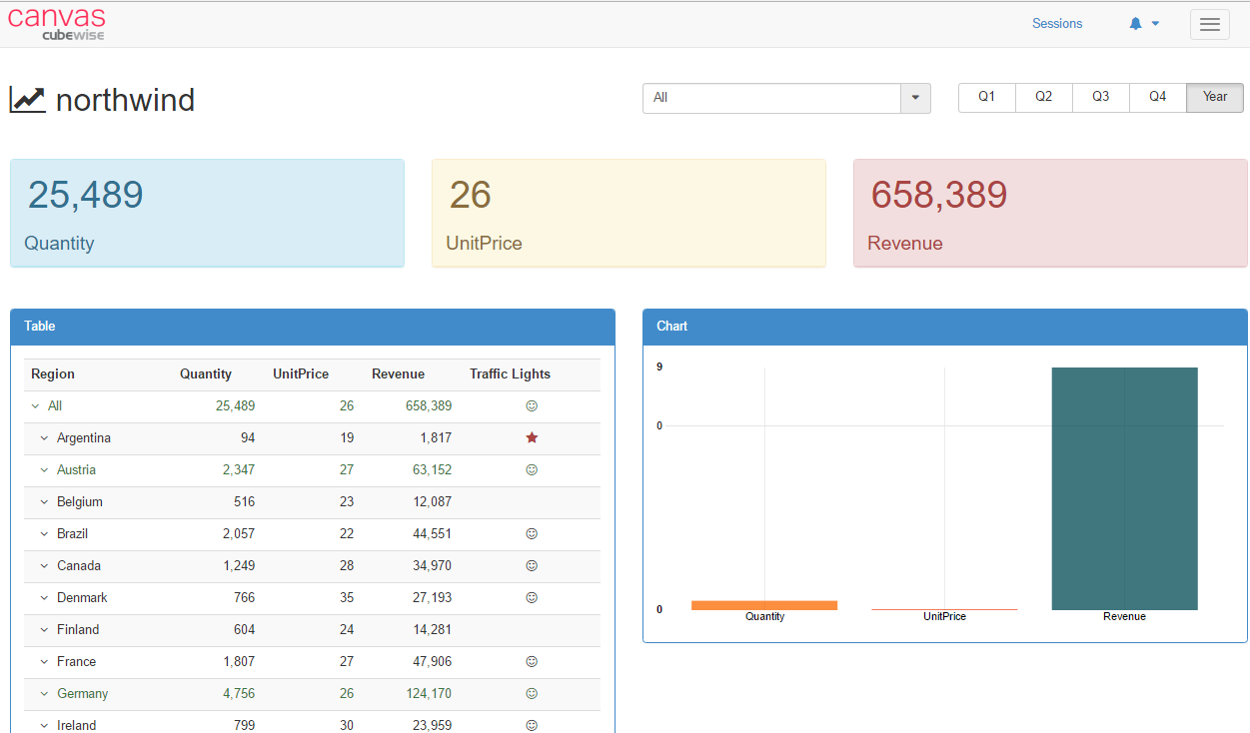

Hubert Heijkers, IBM, hubert.heijkers@nl.ibm.com

# Start-up the Canvas application server

Canvas uses a Apache Tomcat server, which is different to an Apache HTTP Server. Tomcat is a Java application server that can be used for lots of purposes including serving HTML pages, CSS, etc..

To start-up the Tomcat server, you need to double click on C:\HOL-TM1SDK\canvas\start.bat:

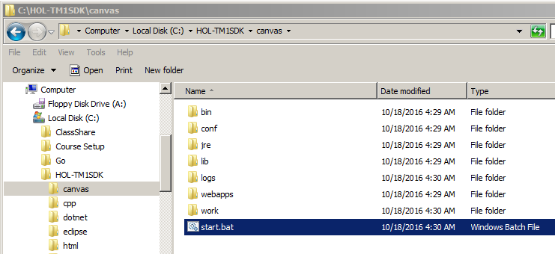

And then click Allow access:

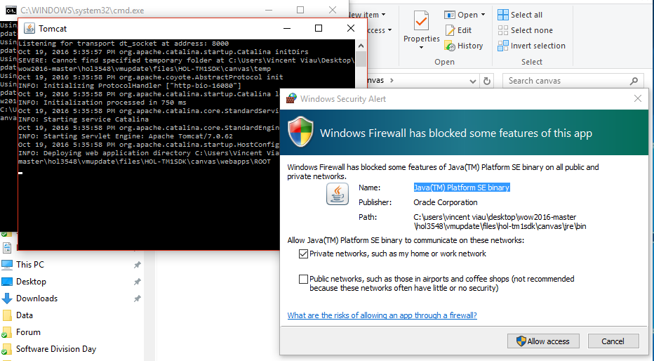

It’s going to start the Tomcat server:

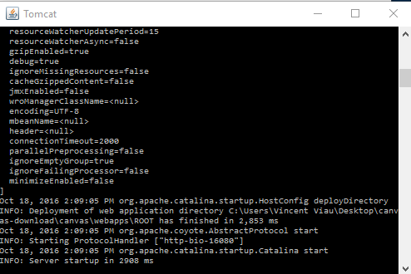

Canvas uses a combination of client side components and an application server that simplifies requests to the TM1 server:

