### Project #5 – CUDA: Monte Carlo Simulation

Young-Joon Park

[parky8@oregonstate.edu](mailto:parky8@oregonstate.edu)

1. Tell what machine you ran this on

The simulation was run locally on a desktop PC with a Ryzen 5600 and an RTX 2080.

1. What do you think this new probability is?

|  |  |  |  |
| --- | --- | --- | --- |
| Ntrials | Blocksize | MegaTrials/sec | % Probability |
| 1024 | 8 | 34.2612 | 24.41 |
| 1024 | 32 | 33.8624 | 25.98 |
| 1024 | 64 | 22.7111 | 26.46 |
| 1024 | 128 | 61.5385 | 26.27 |
| 4096 | 8 | 229.3907 | 27.2 |
| 4096 | 32 | 239.2523 | 26.93 |
| 4096 | 64 | 225.3521 | 26.05 |
| 4096 | 128 | 225.7496 | 27.05 |
| 16384 | 8 | 795.031 | 26.88 |
| 16384 | 32 | 942.9098 | 26.93 |
| 16384 | 64 | 516.6499 | 26.88 |
| 16384 | 128 | 340.4255 | 26.89 |
| 65536 | 8 | 1134.626 | 26.88 |
| 65536 | 32 | 1020.429 | 26.71 |
| 65536 | 64 | 595.0029 | 26.91 |
| 65536 | 128 | 1148.626 | 27.01 |
| 262144 | 8 | 1462.335 | 26.93 |
| 262144 | 32 | 1710.587 | 26.94 |
| 262144 | 64 | 3880.625 | 26.78 |
| 262144 | 128 | 5204.574 | 26.89 |
| 1048576 | 8 | 2602.287 | 26.88 |
| 1048576 | 32 | 4717.535 | 26.86 |
| 1048576 | 64 | 4610.017 | 26.85 |
| 1048576 | 128 | 7949.539 | 26.91 |
| 2097152 | 8 | 2980.942 | 26.86 |
| 2097152 | 32 | 6594.486 | 26.88 |
| 2097152 | 64 | 6246.879 | 26.85 |
| 2097152 | 128 | 8790.878 | 26.87 |

The probability is about 26.9 to 27%.

1. Show the table and the two graphs

Table:

|  |  |  |  |  |  |  |  |
| --- | --- | --- | --- | --- | --- | --- | --- |
|  | **1024** | **4096** | **16384** | **65536** | **262144** | **1048576** | **2097152** |
| 8 | 34.2612 | 229.3907 | 795.031 | 1134.626 | 1462.3349 | 2602.2872 | 2980.9416 |
| 32 | 33.8624 | 239.2523 | 942.9098 | 1020.4285 | 1710.5868 | 4717.5354 | 6594.486 |
| 64 | 22.7111 | 225.3521 | 516.6499 | 595.0029 | 3880.6253 | 4610.0168 | 6246.8785 |
| 128 | 61.5385 | 225.7496 | 340.4255 | 1148.6259 | 5204.5744 | 7949.5387 | 8790.8784 |

Graphs:

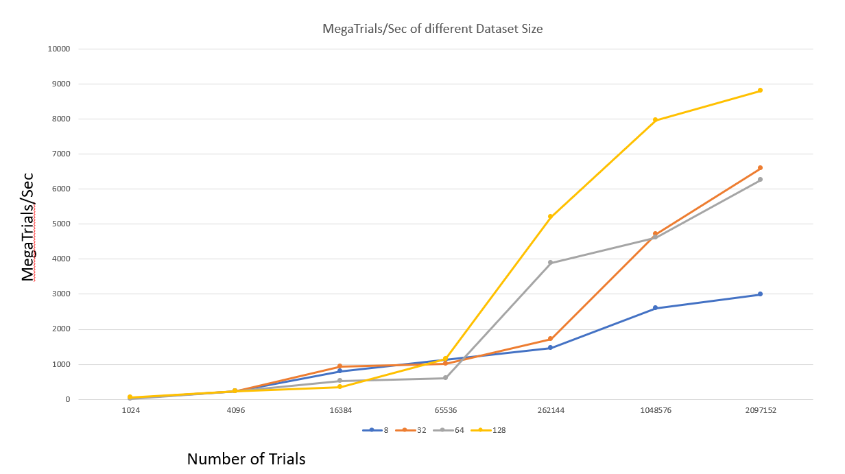

Blocksize

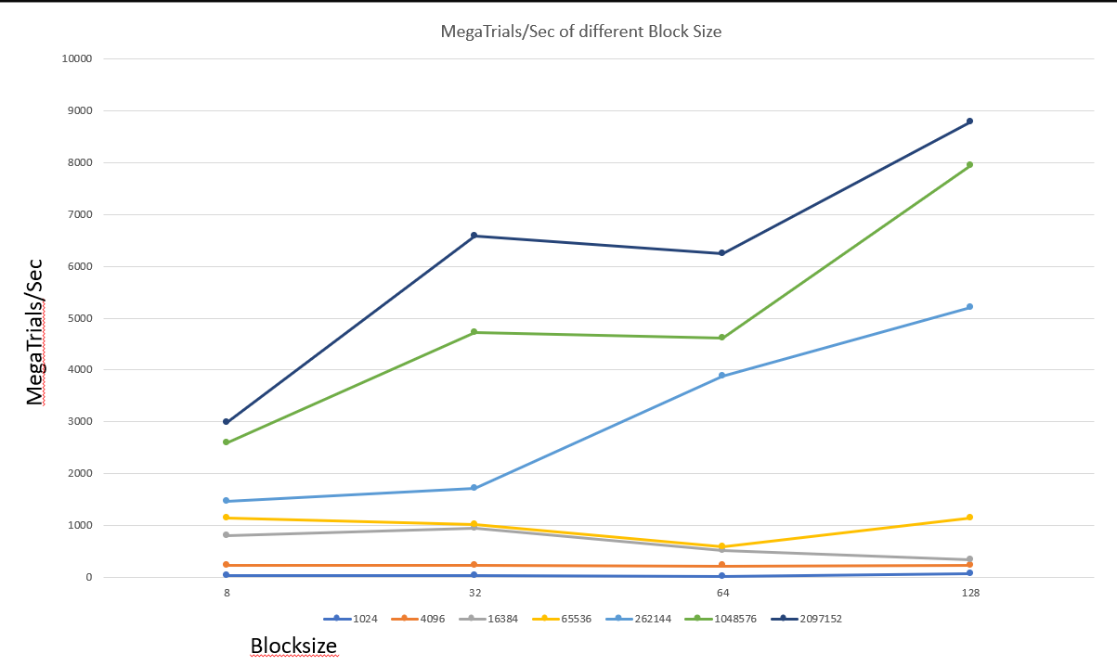

Number of Trials

1. What patterns are you seeing in the performance curves?

32 and 64 block sizes show similar performance (in relative terms, 64 is marginally better), while 128 show much better performance compared to 32 and 64. Block size 8 shows very bad performance compared to others.

1. Why do you think the patterns look this way?

CUDA works based on increments of blocks of threads called warps. Each warp consists of 32 threads. This means a block size of 8 leads to wasted threads as 24 threads in a warp are idle while only 8 are working. For 32 and 64, there is not as much as a performance difference compared to 128, most likely because the overhead required to set up CUDA (setting up and making sure the registers of the threads in each block are filled up) overshadows the performance gains from utilizing only one or two warps, leading to small performance increase as opposed to 4 warps working which leads to ample time for CUDA to set things up as part of its overhead. This results in moderate performance gains in the jump from 1 to 2 warps, as compared to the big gain from 2 to 4 warps.

1. Why is a BLOCKSIZE of 8 so much worse than the others?

As stated above, CUDA performs in increments of warps and a warp consists of 32 threads. Only utilizing 8 threads of 32 threads in a warp leads to 75% of a warp being idle, resulting in the bad performance as shown in the experiment.

1. How do these performance results compare with what you got in Project #1? Why?

For reference, here is the graph from project 1. Granted that project 1 was performed on my much worse laptop, one can see that the number of MegaTrials/sec is much higher when using CUDA. This is because it harnesses the power of the specialized threads in the GPU, as opposed to solely relying on threads on the CPU.

1. What does this mean for what you can do with GPU parallel computing?

Under certain conditions in which one’s program can utilize GPU parallel computing, using it can lead to extreme performance gains.