Domain: Data Analysis
Submitted By: Yupesh Kumar
Submitted To: Miss Manjot Kaur Sandhu
Institution: ThinkNEXT Technologies Private Limited

Hospital Analysis Report

Acknowledgement
I would like to express my gratitude to my mentor Miss Manjot Kaur for their valuable guidance throughout this project. I also extend my thanks to ThinkNEXT Technologies Private Limited for providing the necessary resources and support to complete this work successfully.

Table of Contents
1. Executive Summary 3
2. Objective 3
3. Data Sources & Methodology 3
3.1 Data Sources 3
3.2 Tools & Process 4
4. Data Overview 4
5. Key Findings 5
5.1 Admissions by Disease 5
5.2 Admissions by Disease Category 5
5.3 Admission Type: Elective vs. Emergency 6
5.4 Disease Distribution by Gender 6
5.5 Admissions by Blood Group 7
5.6 Repeat Admissions 7
5.7 Monthly Admission Trend (Seasonality) 8
5.8 Patient Geography 8
6. Conclusions & Recommendations 9
6.1 Conclusions 9
6.2 Recommendations 9
7. Appendix: SQL Queries Used 9

1. Executive Summary
This report analyzes 45,000 hospital admission records spanning six years (January 2020 to December 2025), covering 30,000 registered patients, 20 disease categories, 6 departments, and 27 wards. The dataset was cleaned and validated with pandas, cross-checked against a relational MySQL schema (patients, diseases, admissions), and contains no missing values across any of the 17 combined fields.
The analysis finds that admissions are almost evenly spread across all 20 diseases (each accounting for roughly 4.9%-5.1% of total cases), that Elective admissions (59.8%) considerably outnumber Emergency admissions (40.2%), and that just over half of all patients admitted (56.9%) returned for more than one admission. No meaningful seasonal pattern was found in monthly admission volume across the six-year period.

2. Objective
The goal of this project is to explore hospital admission patterns to surface operational insights that could support hospital planning, including which diseases drive the most admissions, how admission types differ by condition, patient return/readmission behavior, and whether admission volume fluctuates by season.

3. Data Sources & Methodology

3.1 Data Sources
- patient.csv — 30,000 records (patient_id, gender, date_of_birth, blood_group, city, contact_number)
- admission.csv — 45,000 records (admission_id, admission_date, discharge_date, admission_type, admission_status, patient_id, department_id, ward_id, bed_id, disease_id)
- disease.csv — 20 records (disease_id, disease_name, disease_category)

3.2 Tools & Process
- Python (pandas) — data cleaning, merging, and exploratory analysis
- MySQL — relational schema design and validation queries (joins, grouping, aggregation)
- Matplotlib / Seaborn — visualizations
The three tables were merged into a single working dataset (patient_id and disease_id as join keys) to allow combined analysis across patient demographics, disease information, and admission details.

4. Data Overview
Metric | Value
Total admission records | 45,000
Total registered patients | 30,000
Unique patients admitted | 23,275
Disease types | 20
Disease categories | 10
Departments | 6
Wards | 27
Date range | Jan 2020 - Dec 2025
Missing values | 0 (across all fields)
Average length of stay | 5.2 days (range: 1-15 days)

Not all registered patients have an admission record on file — of 30,000 patients, 23,275 (77.6%) have at least one admission, while the remainder are registered but have no admission history in this dataset.

5. Key Findings

5.1 Admissions by Disease
Admission volume is nearly uniform across all 20 diseases, indicating the dataset does not show a dominant condition driving hospital load. Stroke (2,300 admissions) and Sepsis (2,297) are the highest, while COVID-19 (2,184) and Diabetes Mellitus (2,189) are the lowest — a spread of only about 5% between the busiest and quietest disease.
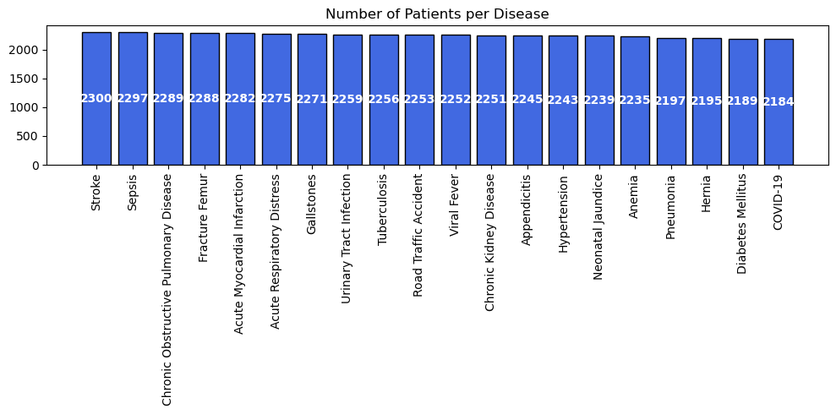
Figure 1: Number of admissions per disease (20 disease types)

5.2 Admissions by Disease Category
Grouping the 20 diseases into their 10 broader categories shows a similarly even spread, with no single category overwhelmingly dominating patient load.
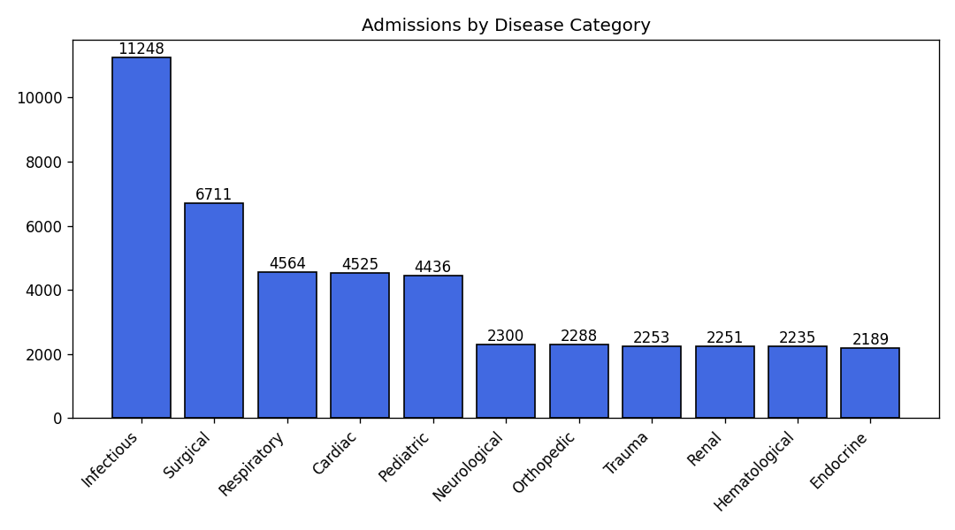
Figure 2: Admissions grouped by disease category

5.3 Admission Type: Elective vs. Emergency
Of the 45,000 admissions, 26,923 (59.8%) were Elective and 18,077 (40.2%) were Emergency. This roughly 60/40 split held consistently across nearly every disease in the cross-tabulation, meaning no single condition is disproportionately responsible for emergency-driven admissions.
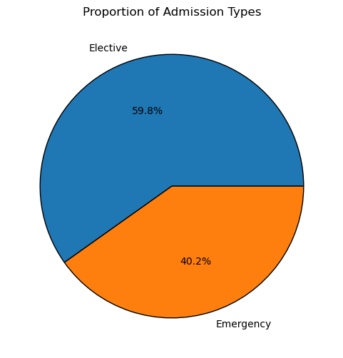
Figure 3: Proportion of admission types across all admissions

5.4 Disease Distribution by Gender
Male patients account for the largest share of admissions (24,031), followed by Female (20,058) and Other (911). This ratio holds broadly consistent across disease types, without any single disease showing a sharply skewed gender split.
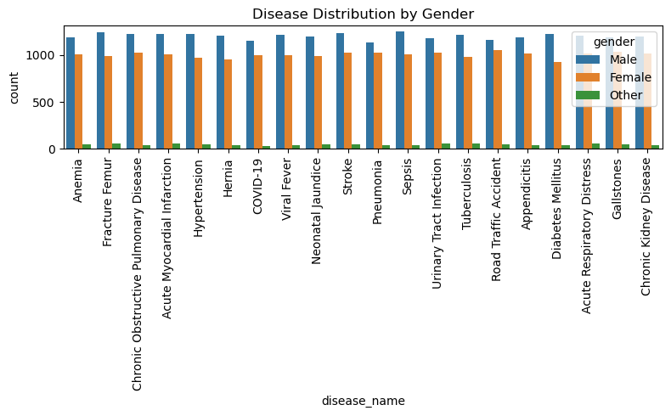
Figure 4: Admissions by disease, split by gender

5.5 Admissions by Blood Group
Blood group distribution is fairly even, with O+ the most common (5,886 admissions) and B- the least common (5,397) — a difference of under 10% between the highest and lowest groups.
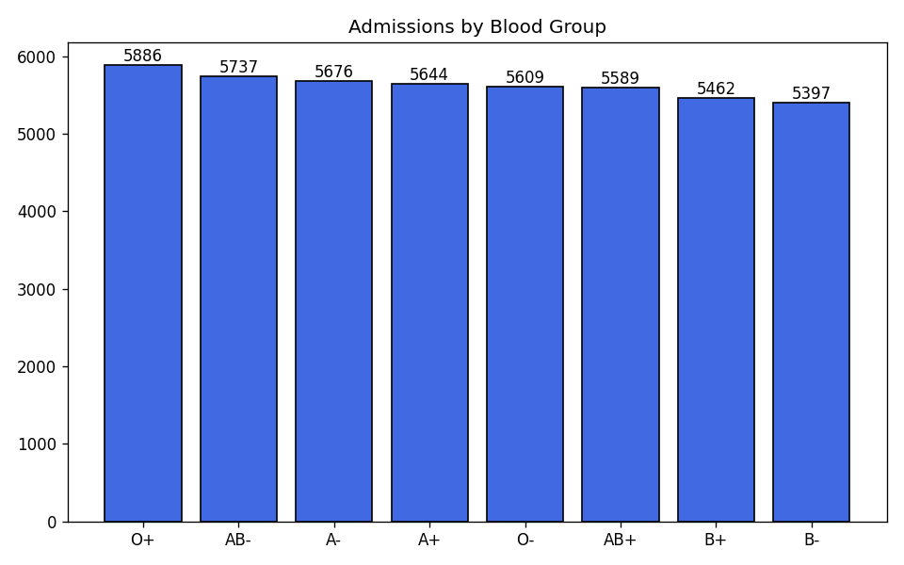
Figure 5: Admissions by patient blood group

5.6 Repeat Admissions
Of the 23,275 unique patients admitted, 13,248 (56.9%) were admitted more than once, while 10,027 (43.1%) had exactly one admission. The most frequently readmitted patients were admitted 8 times over the six-year period. This is a notable operational signal: more than half of the patient base represents recurring hospital utilization rather than one-off visits, which has implications for continuity-of-care planning and readmission-reduction programs.
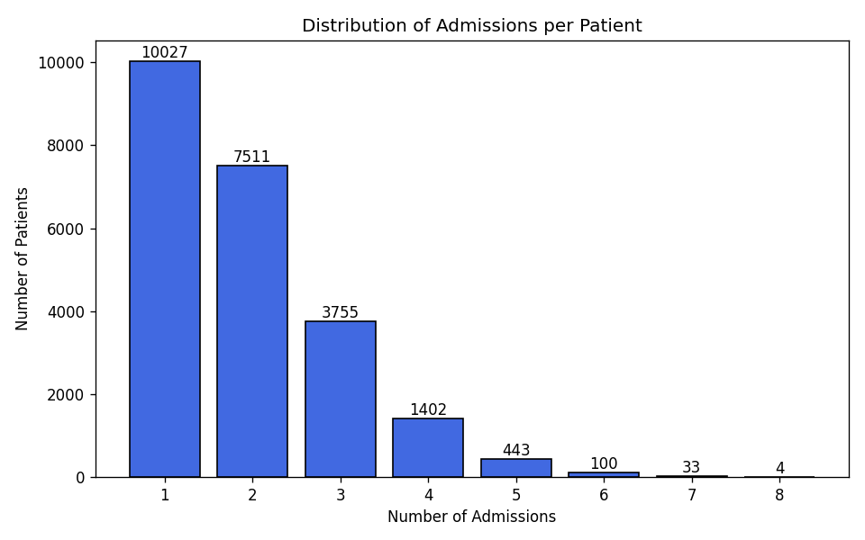
Figure 6: Distribution of admission counts per patient
Admissions per patient | Number of patients
2 | 7,511
3 | 3,755
4 | 1,402
5 | 443
6 | 100
7 | 33
8 | 4

5.7 Monthly Admission Trend (Seasonality)
Monthly admission volume was analyzed across the full six-year period (72 months) to check for seasonal peaks. Volume fluctuates narrowly between roughly 540 and 705 admissions per month, with no sustained upward or downward trend and no clearly recurring seasonal peak (e.g., no consistent winter or monsoon spike). Aggregating by calendar month across all years confirms this: every month falls within a similarly narrow band (3,499 to 3,874 total admissions), suggesting admission demand in this dataset is effectively stable year-round rather than seasonal.
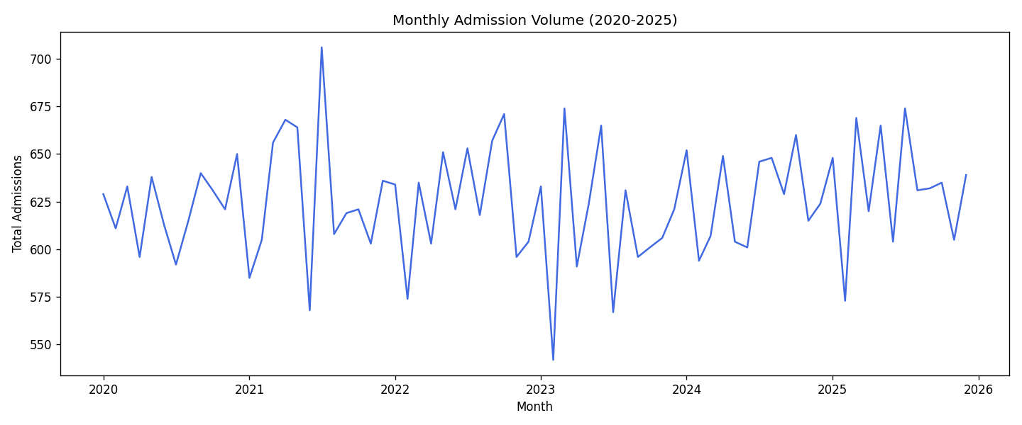
Figure 7: Total admissions per month, January 2020 - December 2025

5.8 Patient Geography
Patients are drawn from 14,868 distinct cities, and the overwhelming majority of cities contribute only a single patient each. The most-represented city (South Michael) accounts for just 57 patients out of 45,000 admissions. This extreme fragmentation suggests the patient base is geographically dispersed and not concentrated around a handful of catchment areas — or the underlying data was synthetically generated with a very large city name pool.

6. Conclusions & Recommendations

6.1 Conclusions
- Admission load is evenly distributed across diseases and categories — no single condition dominates capacity planning needs.
- Elective admissions substantially outweigh Emergency admissions (roughly 3:2), suggesting scheduled care is the primary driver of hospital throughput.
- More than half of admitted patients (56.9%) return for repeat admissions, pointing to a chronic-care or recurring-utilization population worth deeper segmentation.
- No strong seasonal pattern exists in admission volume across six years, so staffing and resource planning do not need to anchor heavily around calendar seasonality in this dataset.
- Demographic factors (gender, blood group) show admissions spread fairly evenly, without a specific at-risk segment standing out from this data alone.

6.2 Recommendations
- Investigate the 13,248 repeat-admission patients further (e.g., time between admissions, whether repeat visits cluster by disease) to identify candidates for readmission-reduction programs.
- Break down Elective vs. Emergency admissions by department and ward to identify where scheduled-care capacity could be optimized.
- Extend the analysis with length-of-stay by disease category to identify which conditions place the greatest load on bed capacity over time.
- Validate the city field against a real geographic reference if this dataset is used for location-based planning, given the unusually high fragmentation observed.

7. Appendix: SQL Queries Used
Key validation and exploration queries run against the MySQL schema (patients, diseases, admissions):
SELECT p.patient_id, p.city, COUNT(a.admission_id) AS total_admissions FROM admissions a JOIN patients p ON a.patient_id = p.patient_id GROUP BY p.patient_id, p.city HAVING total_admissions > 1 ORDER BY total_admissions DESC;
SELECT DATE_FORMAT(admission_date, '%Y-%m') AS admission_month, COUNT(admission_id) AS total_admissions FROM admissions GROUP BY admission_month ORDER BY admission_month ASC;

