#42255 - MICRO MWC Flight control board V1.1

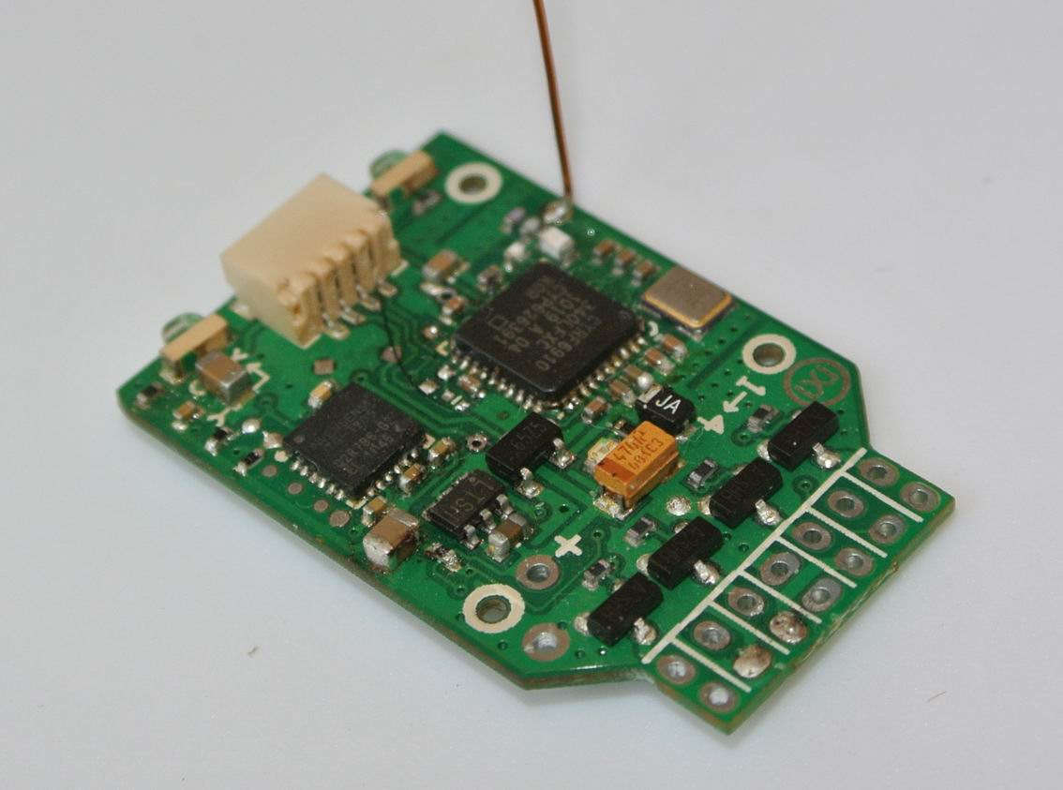
MICRO MWC Flight control board is specially designed for micro 4-Axis(QUADX，QUADP，Y4), it comes with a 6CH DSM2 compatible receiver and 4CH brushed ESC, so it can support 4-Axis of super light and supper small flight.
The physical parameter of MICRO MWC flight control board:
- Size：32.0 *20.0 *4.8 mm；
- Weight：1.8g（not including power wires）；
- Size of the mounting hole：Φ1.0mm
MICRO MWC flight control board diagram（：mm）：
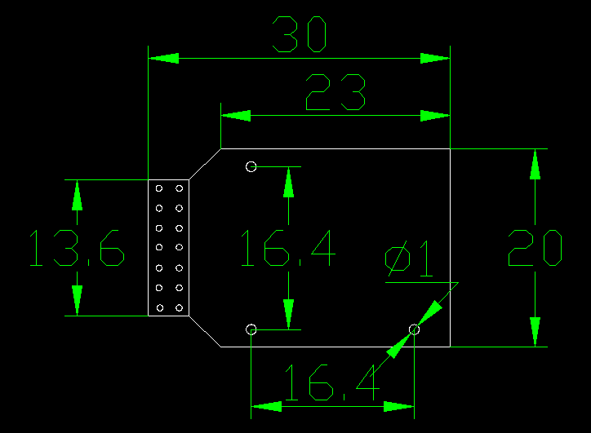

MICRO MWC ports for connection：

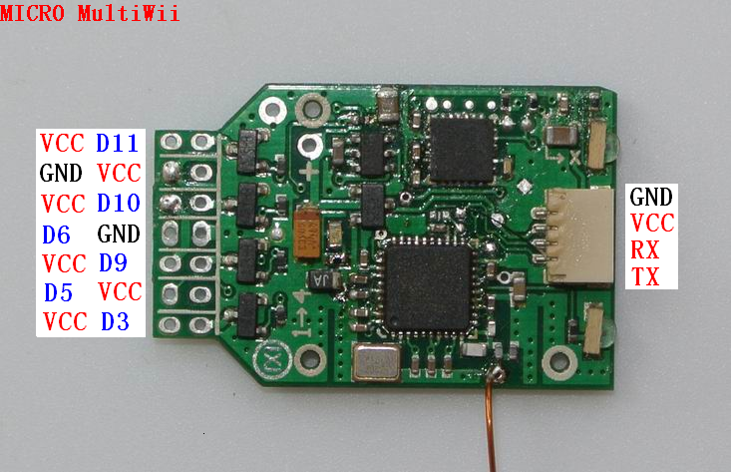
ATTN：D3，D9，D10，D11 can drive brushed motor directly;

Major components of MINI MWC flight control board
- ATMEGA328P；
- MPU6050；
- CYRF69103；

MINI MWC flight control board working voltage：3.6~4.2V（1S lipoly battery is recommended）；

Recommended transmitter： supports DSM2 compatible transmitter of 4CH or above (6CH transmitter is recommended);

MINI MWC flight control board support the following modes：
1）4 Axis（QUADX，QUADP，Y4）；
2）6 Axis（Y6，HEX6，HEX6X）；

