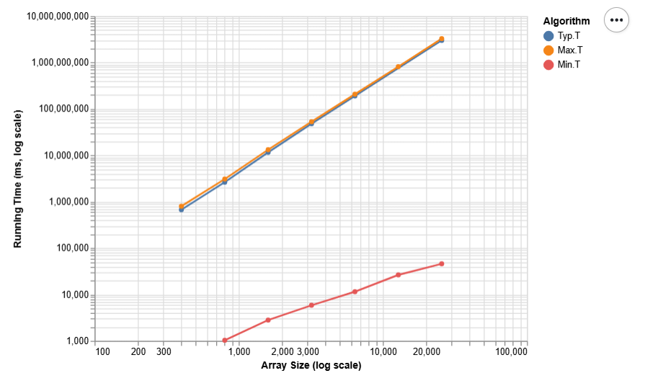
Min(T) : O(n)
best case, only iterate through the array once.
Typ(T) : O(n^2)
typical case, requires multiple passes through the array.
Max(T) : O(n^2)
worst case, maximum number of swaps, has to pass through the array as many times as the size dictates.

