Machine Learning Based Detection of Wireless Network
Intrusions Using the AWID Dataset

Abstract
Wireless local area networks are used every day in homes, campuses, offices and public places. Because Wi‑Fi traffic travels through the air, attackers can listen to frames, spoof identities, or flood the network without needing direct cable access. This project studies whether machine learning can help detect such abnormal behavior. The work uses the Aegean Wi-Fi Intrusion Dataset (AWID), a well-known public dataset built from real IEEE 802.11 traffic [1]. The preprocessing stage loaded the training and testing files, renamed the class field, handled missing and mixed values, converted features to numeric form and filled empty entries. Two learning models were then trained and compared: Decision Tree and Random Forest. A sampled subset of 100,000 training records and 50,000 testing records was used to keep execution time practical on my laptop. The models were evaluated with accuracy, precision, recall, F1-score, Classification Report, while confusion matrix and ROC curve were also generated in the notebook. The results show that Random Forest clearly outperformed Decision Tree. Random Forest achieved around 95% accuracy, with better precision and recall across most classes. However, performance was not equal for all attack types. Some classes such as impersonation were harder to detect, especially for the Decision Tree model. This shows that while machine learning can detect wireless attacks, the AWID dataset presents challenges due to class imbalance and similarity between some attack patterns. The study concludes that Random Forest is more reliable, but further improvement is needed for balanced multiclass detection.

1. Introduction
Wireless communication has become a basic part of modern digital life. Students use Wi‑Fi on campus, employees use it in offices, and many smart devices depend on wireless to exchange data. This wide use gives comfort and flexibility, but it also increases the attack surface. Unlike wired traffic, wireless traffic is broadcast through the air. A nearby attacker can monitor traffic, inject frames, imitate another device or attempt denial of service without touching the network hardware. For this reason, wireless security is still an important topic in both academic research and practical administration [1].
Traditional intrusion detection systems often rely on known signatures or hand-written rules. These methods are useful for attacks that are already understood, but they are less effective when traffic patterns change or when an attacker uses a slightly modified method. Machine learning has become attractive because it can learn patterns from data and then classify new traffic into normal or abnormal classes. Recent surveys show that machine learning is widely used in modern intrusion detection because it can improve adaptability and reduce dependence on static signatures [10], [11].
In wireless environments, the intrusion detection problem has some special challenges. Traffic data may be noisy, class distribution may be imbalanced, and some attacks may look similar to normal management. In addition, datasets often contain a mix of numeric, textual and missing values, which means preprocessing is a major part of the work. The AWID dataset was designed to support research in this area and remains one of the most cited public datasets for Wi‑Fi intrusion detection [1]. AWID contains real 802.11 traffic and labels for normal frames and several types of attacks. The original classification version contains four main classes: normal, flooding, injection, and impersonation [1].
The problem addressed in this report is simple: can two classical machine learning methods, Decision Tree and Random Forest, detect malicious wireless traffic effectively when trained on AWID data? This question matters because many specialists need models that are not too hard to build, explain, or run. Deep neural models can achieve strong performance, but they also require more tuning and may be harder to interpret. Unlike tree-based methods are easier to explain and are often strong baselines for intrusion detection [3], [4], [5].
The main objective of this project is to design and evaluate a machine learning workflow for wireless intrusion detection using the AWID dataset. The first practical objective is to preprocess the dataset in a clean and reproducible way. The second objective is to train a Decision Tree model and a Random Forest model using the same prepared data. The third objective is to compare the two models using performance measures and determine which one is more suitable for this task. The last objective is to discuss the strengths, weaknesses, and practical value of the chosen approach.
The report is guided by three research questions. First, can machine learning models detect different types of wireless traffic using the original AWID classes? Second, which of the two tree-based models performs better on the multiclass AWID classification task? Third, what challenges appear when working with real wireless datasets such as AWID? These questions are answered through a complete pipeline that starts from raw data files and ends with trained models, evaluation metrics, and visual analysis.
This project is designed to balance technical depth and practical limits. The full reduced AWID files are large, so a smaller working sample was used during experimentation to keep training time reasonable on ordinary hardware. This choice does not remove the value of the study. Instead, it allows the report to focus on understanding the pipeline, interpreting the output, and connecting the result with the wider literature.

2. Literature Review
The literature on intrusion detection is broad, but some works are especially important for this project. A key starting point is the paper by Kolias et al., which presented the AWID dataset and provided a practical study of threats in 802.11 networks [1]. That work is important because many older IDS datasets focused on general wired network traffic rather than Wi‑Fi-specific behavior. AWID gave researchers real wireless traces, multiple attack classes and files that could be shared in practical formats. For this reason, AWID has become a reference point in Wi‑Fi intrusion detection studies.
Before AWID, many intrusion detection studies used datasets such as KDD’99 and later NSL-KDD. Tavallaee et al. showed that KDD’99 contains serious issues, including redundant records that can distort evaluation [2]. Their analysis led to the NSL-KDD revision, which remains useful for general intrusion detection benchmarking. However, NSL-KDD does not focus on wireless traffic. This is one reason why AWID is a better choice for this project.
In terms of learning methods, decision trees have a long history in classification tasks because they are simple to understand and can deal with complex data. Quinlan’s work on C4.5 remains one of the classic references in decision tree learning [4]. In intrusion detection, decision trees are attractive because they can create clear splits and provide a model structure that is easier to explain than many other methods. However, one common weakness is overfitting, especially when the tree becomes too deep or when the data contains noise.
Random Forest, introduced by Breiman, extends the tree idea by training many trees on random subsets of the data and then combining their outputs [3]. This usually improves stability and reduces overfitting. The ensemble nature of Random Forest is especially useful in intrusion detection where the feature space can be large and some attributes may be noisy or weak. The scikit-learn implementation also describes Random Forest as an averaging method that improves accuracy while controlling overfitting [12]. In practice, Random Forest is often one of the strongest classical models for structured network data.
Research on machine learning for intrusion detection has expanded into many network settings, including IoT, wireless sensor networks, and Internet of Medical Things (IoMT). Garofalo et al. presented a decision tree-based IDS architecture for wireless sensor networks that tried to balance detection quality and energy efficiency [9]. Gupta et al. later proposed a tree classifier model for IoMT intrusion detection and showed that tree-based designs can still be effective in specialized network environments [8]. These works suggest that decision trees remain relevant because they are understandable and can be adapted to constrained systems.
At the same time, many studies report that ensemble methods or more advanced feature processing pipelines often outperform a single tree. Rahman et al. proposed a scalable machine-learning IDS for IoT enabled smart cities and emphasized the value of feature extraction, selection, and distributed processing [7]. Zhou et al. also argued that careful feature selection combined with ensemble learning can improve intrusion detection performance [6]. These studies are not limited to Wi‑Fi, but they support a broader lesson: preprocessing and feature handling matter as much as the classifier itself.
Specific work on wireless intrusion detection also points to strong performance from ensemble and feature selection approaches. Kasongo and Sun proposed a feed forward deep neural system for wireless IDS with feature extraction and evaluated it on the AWID dataset [5]. Even though their final model was a deep learning design, their paper is useful because it shows how wireless IDS performance depends heavily on feature treatment and balanced evaluation. More recently, Tseng et al. studied ensemble binary detection models for multi-class Wi‑Fi intrusion detection on AWID and reported that ensemble strategies can better separate wireless attacks than simple one-shot multiclass methods [11].
A second trend in the literature is the strong attention given to data imbalance. In many intrusion datasets, normal traffic is much more common than attack traffic. This means that accuracy alone can be misleading. A model may score high in accuracy simply because it predicts the majority class too often. Modern reviews of machine learning IDS work therefore recommend using a combination of metrics, especially precision, recall, and F1-score, in addition to visual tools such as confusion matrices and ROC curves [10], [11]. This point is very relevant to the present project because the AWID counts show a clear class imbalance.
There is also growing interest in explainability and practical deployment. Recent survey papers argue that the next challenge is not only to build high scoring models but also to make them understandable, lightweight, and suitable for real network environments [10], [13]. This creates a useful gap. Very complex deep models may report excellent scores, but simpler models still have value when the goal is to build an interpretable, reproducible system.
The gap identified from the literature is clear. Many papers propose advanced or optimized models, but not all of them are easy to reproduce in a short duration. At the same time, there is a need for clear case studies that show how a specialist can move from a raw wireless dataset to a working IDS pipeline with understandable models and honest evaluation. This project addresses that gap by using the wireless specific AWID dataset, and comparing two classical models in a transparent way.

3. Methodology
This section explains the tools, data preparation, and experiment design used in the project. The implementation was developed in Python using pandas, NumPy, matplotlib, scikit-learn and Jupyter Notebook. Python was chosen because it is simple, widely used in data science, and supported by many intrusion detection examples. Pandas was used to read and reshape the dataset, NumPy was used for handling missing values, matplotlib was used for graphs, and scikit-learn provided the machine learning models and evaluation functions. Jupyter Notebook was used to present the process clearly, while separate Python scripts were prepared for preprocessing and model training.
The main dataset was AWID-CLS-R, the reduced classification subset of the Aegean Wi-Fi Intrusion Dataset [1]. The original classification labels in AWID are normal, injection, impersonation, and flooding. In this project, these labels were preserved instead of being merged into a binary normal versus attack form. The label column was encoded into numeric values so that the machine learning models could process it. The mapping used was normal = 0, injection = 1, impersonation = 2, and flooding = 3. This makes the experiment a multiclass classification task, which is more detailed and more challenging than simple binary intrusion detection.
The project used separate training and testing files from AWID, following the original dataset structure rather than randomly mixing all data [1]. The training file contained 1,795,575 rows and 155 columns, while the testing file contained 575,643 rows and 155 columns. The training data contained 1,633,190 normal records, 65,379 injection records, 48,522 impersonation records, and 48,484 flooding records. The testing data contained 530,785 normal records, 16,682 injection records, 20,079 impersonation records, and 8,097 flooding records. These counts show that the dataset is strongly imbalanced, with normal traffic being much larger than each attack class.
Because the full dataset is large, a smaller working sample was used for the main experiment. A random sample of 100,000 rows from the training file and 50,000 rows from the testing file was taken using a fixed random seed. This sampling step was not intended to hide the full dataset but to make the experiment run in a practical time on a local computer. Using a fixed seed also improves reproducibility, because the same sampled records can be selected again when the code is rerun.
In preprocessing, the last dataset column was renamed to label because it stores the class name. A new column called target was then created using the multiclass numeric mapping. Normal was mapped to 0, injection to 1, impersonation to 2, and flooding to 3. After this step, the original label and target columns were excluded from the feature matrix. Special symbols such as '-' and '?' were treated as missing values. All remaining feature columns were then converted into numeric form wherever possible. Invalid or non-numeric values were converted into missing values so that they could be handled in a consistent way.
The next step was missing value treatment. A SimpleImputer from scikit-learn was used with a constant fill value of -1. Some features in the sampled data had no observed values at all, which led scikit-learn to skip them during imputation. As a result, the final usable feature set after preprocessing had 122 columns in the experiment. This reduction is acceptable because the removed columns contained no useful information in the sampled run.
The experiment then trained two supervised classifiers. The first was a Decision Tree classifier with random_state = 42 and max_depth = 10. Limiting the depth was important because a fully unconstrained tree can overfit to noisy training samples. The second model was a Random Forest classifier with 100 trees, random_state = 42, and n_jobs = -1 to use the available CPU cores. Both models were trained on the same prepared feature matrix and tested on the same prepared test matrix. This gives a fair comparison because the only major difference between runs is the classifier itself.
Evaluation was performed using accuracy, macro precision, macro recall, macro F1-score, balanced accuracy, and a full classification report. Macro average metrics were used because they treat all classes equally, which is important in an imbalanced multiclass dataset. Confusion matrices were also used to analyze model performance for each class. In addition, multiclass ROC curves were generated in the notebook using a one versus rest approach, where each class is compared against all other classes. Accuracy measures general correctness, but it can be misleading when one class is much larger than the others.
The overall workflow is shown in Fig. 1. First, the AWID files are loaded and cleaned. Second, the original AWID labels are encoded into numeric multiclass labels. Third, the features are converted into numeric form and missing values are filled. Fourth, the two tree-based models are trained. Finally, the outputs are evaluated and visualized using classification metrics, confusion matrices, and ROC curves.
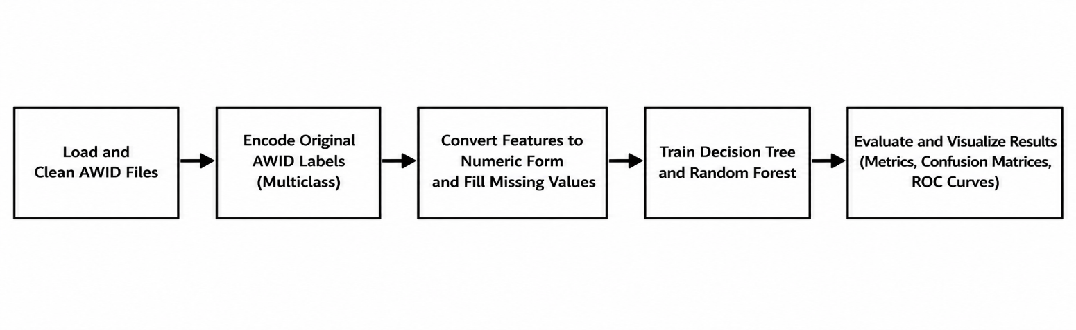
Fig. 1. Overall workflow used in the project, from raw AWID data to model evaluation.

4. Results and Analysis
The experiment produced a clear separation between the performance of the two models. Before training, the class counts already suggested that the dataset was imbalanced, with far more normal records than attack records. Such imbalance is common in intrusion detection and creates a risk that a model will appear strong simply because it predicts the dominant class correctly most of the time. For that reason, the analysis pays special attention to precision, recall, and F1-score rather than using accuracy alone.
The sampled experiment used 100,000 training records and 50,000 testing records after random selection from the AWID train and test files. The preprocessing stage successfully produced a feature matrix with 122 usable columns after dropping fully unobserved fields from the sample. Both models were then trained, and the notebook generated the required plots and summary tables. This confirms that the project pipeline is technically complete.
Table I below presents the final scalar metrics for both models. Decision Tree achieved 92% accuracy, which looks good at first view. However, its recall was only 44%. This means that a large share of real attacks was missed. In intrusion detection, this is a serious weakness because a missed attack can be more harmful than a false alarm. The F1-score of the Decision Tree was only 46%, which supports the view that the single-tree model did not generalize well enough for the attack class.
Random Forest produced much stronger results across all reported measures. Its accuracy reached 95%, and more importantly, its precision was 84% and its recall was 56%. The F1-score rose to 57%, showing a much better balance between finding attacks and avoiding wrong attack alerts. In simple terms, Random Forest was much better at learning the structure of the AWID task.
The difference between the two models can be seen clearly in Fig. 1,2,3,4,5 which compares the main metric values side by side. The graph shows that the biggest gap appears in recall and F1-score. This is an important finding. If the report had used only accuracy, the Decision Tree could have looked acceptable. However, once recall is considered, the weakness becomes obvious. This highlights why intrusion detection studies should not depend on a single metric, especially when the classes are not balanced.
Decision Tree is easier to read and may still be useful as a simple baseline. It trains quickly and its rule structure can be inspected. However, in this project it missed too many attacks to be the preferred model. Random Forest, by contrast, combines many trees and uses voting across them. This ensemble behavior likely reduced overfitting and produced more stable boundaries for the attack class. The result matches the wider literature, which often reports that ensemble tree methods perform better than a single tree on structured security data [3], [6], [7].
The notebook also generated confusion matrices and ROC curves for both models.The confusion matrices show that Random Forest performs better than Decision Tree, but both models still struggle with minority classes. Decision Tree missed the injection class completely in the sampled experiment. Random Forest improved injection detection, but impersonation remained difficult. This is likely because impersonation traffic can share similar patterns with normal wireless traffic.

Table I. Performance of the Two Models on the Sampled AWID Experiment
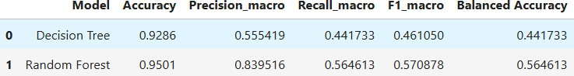
Fig. 1. Side by side comparison of the main evaluation metrics for Decision Tree and Random Forest.

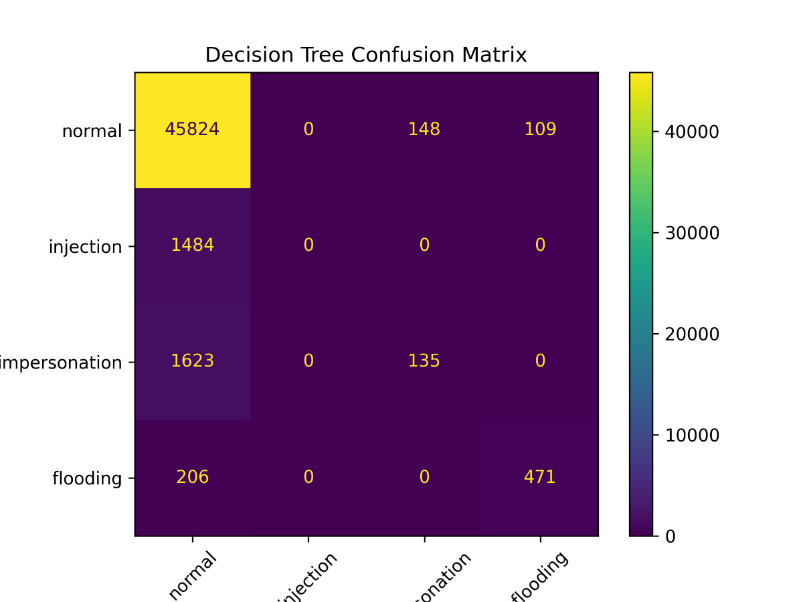
Fig.2 Confusion Matrix for Decision Tree.

The Decision Tree confusion matrix shows that the model classified the normal class very well, with most normal samples predicted correctly. However, the model performed poorly on the minority attack classes. The injection class was completely missed and classified as normal. The impersonation class was mostly classified as normal, with only a small number detected correctly. The flooding class performed better than the other attack classes, but some flooding samples were still classified as normal. This shows that the Decision Tree is strongly biased toward the majority normal class and is not reliable enough for detailed multiclass intrusion detection.

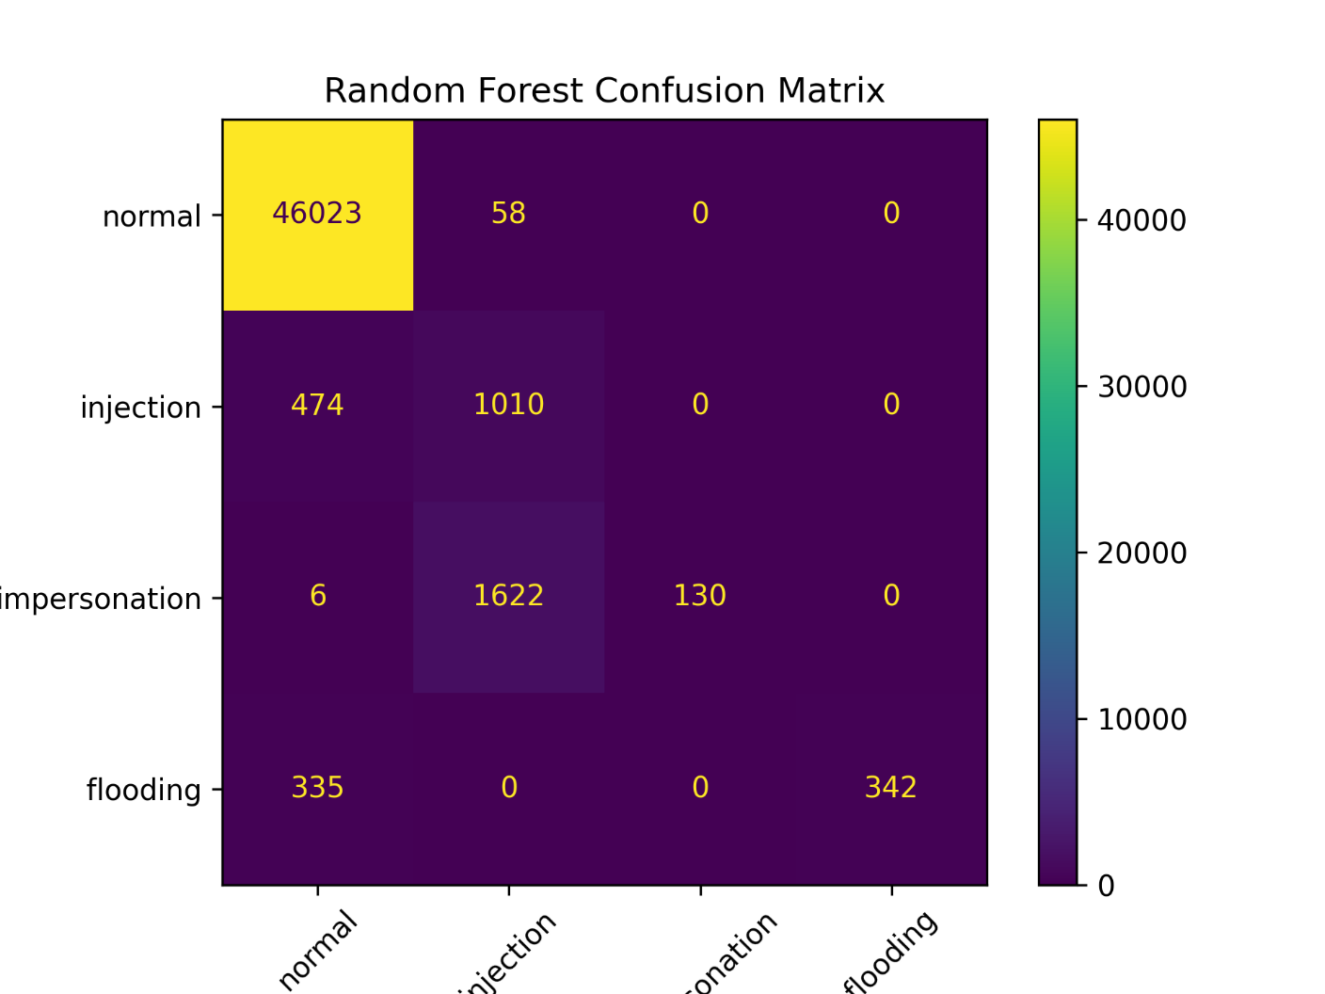

Fig.3 Confusion Matrix for Random Forest.

The Random Forest confusion matrix shows better performance than Decision Tree. It classified the normal class very well and improved detection of injection and flooding attacks. However, impersonation remained difficult. Many impersonation samples were classified as injection, and only a small number were correctly identified as impersonation. This suggests that impersonation traffic may share similar patterns with other traffic types, making it harder to separate. Overall, Random Forest is stronger, but it still struggles with some minority attack classes.
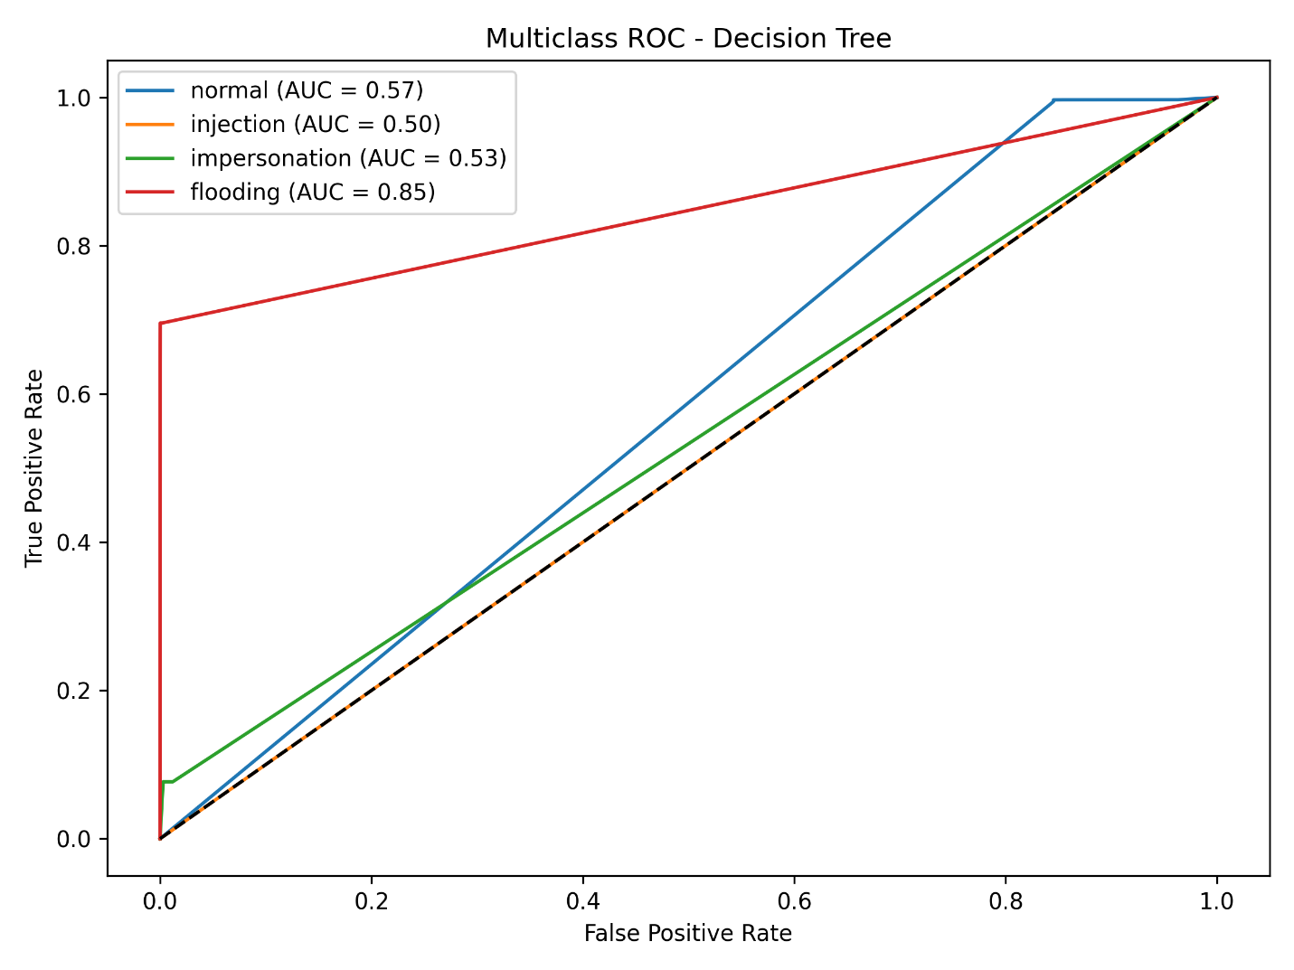
Fig.4. ROC for Decision Tree.

The Decision Tree ROC curve shows weak separation for several classes. The injection class has an AUC of about 0.50, which is close to random guessing. The normal and impersonation classes also have low AUC values, showing that the model does not separate these classes well. The best ROC result for Decision Tree is the flooding class, with an AUC of about 0.85. This matches the confusion matrix, where flooding was detected better than injection and impersonation.
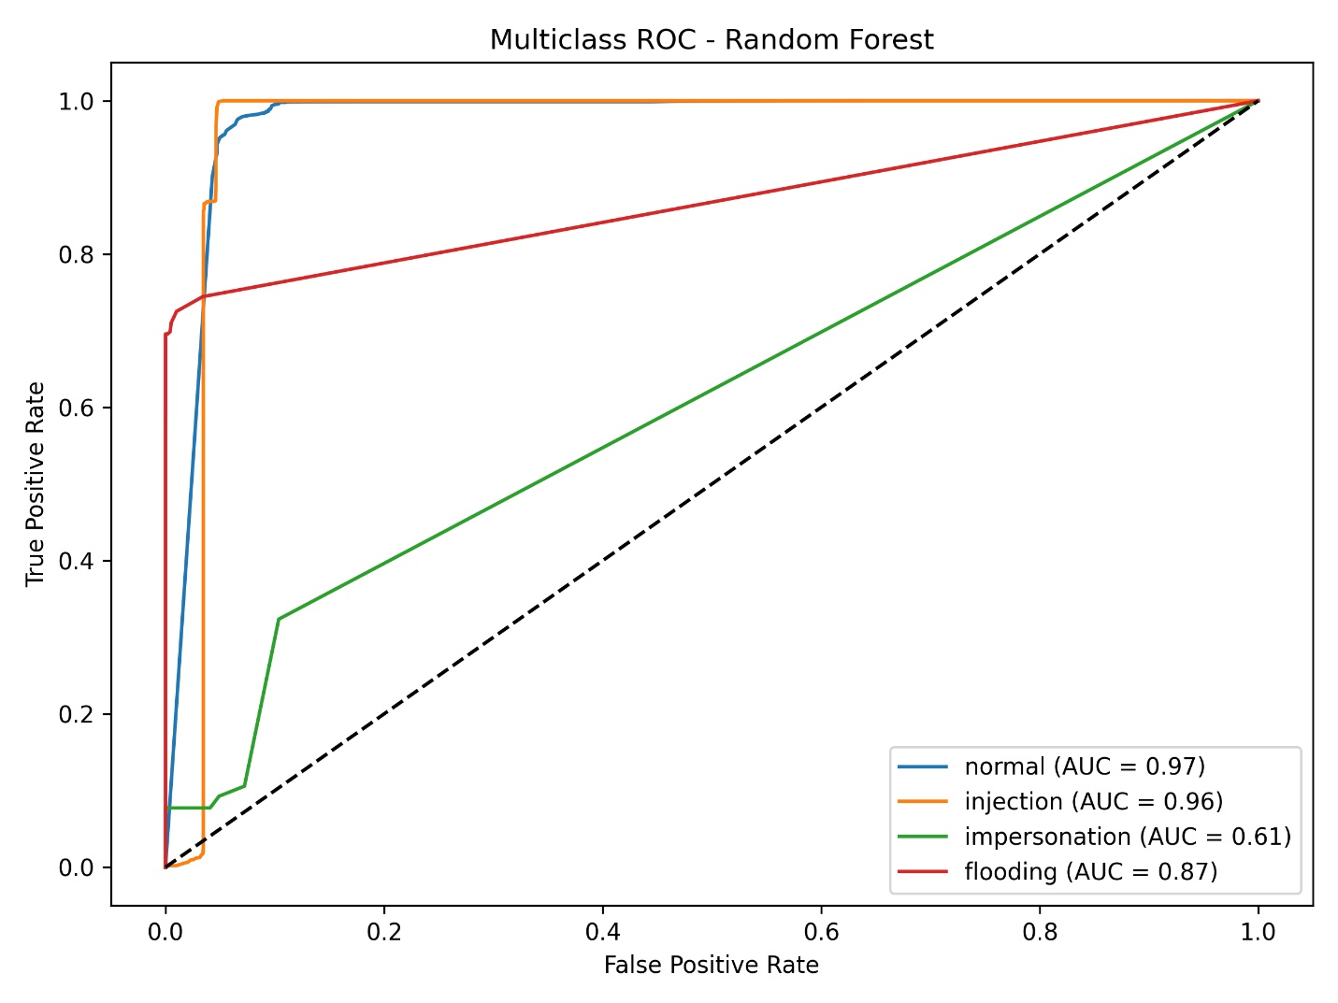
Fig.5. ROC for Random Forest.

The Random Forest ROC curve shows stronger performance overall. The normal class has an AUC of about 0.97, and injection has an AUC of about 0.96, which means the model separates these classes well. The flooding class also has a good AUC of about 0.87. However, the impersonation class has a lower AUC of about 0.61, showing that it is still difficult for the model to detect clearly. This supports the confusion matrix result, where impersonation was often confused with injection. Overall, Random Forest gives better class separation than Decision Tree.

5. Discussion
The strongest part of this project is that the pipeline worked from start to end. The data was loaded correctly, the labels were mapped in a simple and logical way, the preprocessing handled mixed values and missing entries, and both models were trained and evaluated without the need for a complex environment.
What worked especially well was the use of Random Forest on the sampled AWID data. The model achieved higher accuracy, macro precision, macro recall, and macro F1-score than Decision Tree. However, the results also show that Random Forest did not solve all problems. Some attack classes, especially impersonation, still had low recall. This means the model was stronger than Decision Tree but not perfect.
The project also shows the value of using more than one evaluation measure. If only accuracy had been reported, the Decision Tree result might have looked strong enough. But once recall and F1-score were examined, it became clear that the single tree was not reliable enough for the attack class. This lesson is important and matches recommendations in the literature. IDS research must look beyond accuracy because many intrusion datasets are imbalanced and because the cost of a missed attack is often higher than the cost of an extra alert [10], [11].
At the same time, the study has clear limitations. The first limitation is the use of a sampled subset rather than the full reduced AWID files. This choice was necessary because of time and hardware limits, but it means the reported numbers should be understood as sampled experiment results. A second limitation is class imbalance. The models performed very well on normal traffic but struggled with some minority attack classes. A third limitation is the similarity between some attack traffic and normal wireless behavior, especially in the impersonation class.
When compared with the literature, the project results are reasonable. They support the general view that ensemble tree methods are strong choices for intrusion detection on structured data [3], [6], [7]. They also align with AWID based research that reports good performance when feature preparation is done carefully [1], [5], [11]. However, this project did not try to beat specialized or optimized deep learning systems. Its purpose was different: to produce a clear, reproducible wireless IDS case study using standard tools that I can explain in a report and a short demo video.
Another important point is interpretability. Decision Tree is easier to explain than Random Forest because it produces one set of decision rules. This makes it useful in quick baseline experiments. Random Forest is less transparent because it combines many trees, but it gave much better predictive performance here. This creates a common trade off in security analytics: the most interpretable model is not always the most accurate. In this project, performance was the stronger need, so Random Forest was selected as the better final model.
In short, the discussion confirms that the project achieved its practical goal. It built a working wireless intrusion detection pipeline, compared two classical machine learning models and obtained a clear result.

6. Conclusion and Future Work
This report presented a machine learning approach for wireless intrusion detection using the AWID dataset. The work focused on a multiclass classification setting using the original AWID classes: normal, injection, impersonation, and flooding. After data loading and preprocessing, two models were trained and evaluated: Decision Tree and Random Forest. The final results showed that Random Forest performed better than Decision Tree. It achieved around 95% accuracy and higher macro-average precision, recall, and F1-score. However, both models had difficulty detecting some attack classes, especially impersonation and injection. This shows that wireless intrusion detection using real datasets is challenging, and further improvements are needed.
The main takeaway is that classical machine learning methods can still be very effective for wireless intrusion detection when the dataset is prepared carefully. The study also showed that metric choice matters. Accuracy alone was not enough to judge the models, because the Decision Tree looked good in accuracy but weak in recall. For security tasks, recall and F1-score should receive strong attention because they are linked to missed attacks and overall detection quality.
The project also achieved a second goal. It produced a complete workflow that can be understood and repeated: load AWID, clean the data, map the labels, train the models, and interpret the outputs.
There are several useful directions for future work. First, the experiment can be rerun on a larger sample or on the full reduced AWID files to test how stable the current findings remain. Second, class imbalance can be addressed more deeply using resampling, feature selection, or more tuned class weight strategies. Third, feature selection and hyperparameter tuning may improve performance further while reducing model size. Finally, future work may compare Random Forest with neural network models to explore the trade-off between accuracy, interpretability, and training cost.
The overall conclusion is clear: for this project, Random Forest provided the best balance of simplicity, accuracy, and attack detection strength. It is therefore a strong and practical choice for machine learning based wireless intrusion detection using AWID.

References
[1] C. Kolias, G. Kambourakis, A. Stavrou, and S. Gritzalis, “Intrusion Detection in 802.11 Networks: Empirical Evaluation of Threats and a Public Dataset,” IEEE Communications Surveys & Tutorials, vol. 18, no. 1, pp. 184–208, 2016.
[2] M. Tavallaee, E. Bagheri, W. Lu, and A. A. Ghorbani, “A Detailed Analysis of the KDD CUP 99 Data Set,” in Proc. IEEE Symposium on Computational Intelligence in Security and Defense Applications (CISDA), 2009, pp. 1–6.
[3] L. Breiman, “Random Forests,” Machine Learning, vol. 45, no. 1, pp. 5–32, 2001.
[4] J. R. Quinlan, C4.5: Programs for Machine Learning. San Mateo, CA, USA: Morgan Kaufmann, 1993.
[5] S. M. Kasongo and Y. Sun, “A Deep Learning Method with Wrapper Based Feature Extraction for Wireless Intrusion Detection System,” Computers & Security, vol. 92, Art. no. 101752, 2020.
[6] Y. Zhou, G. Cheng, S. Jiang, and M. Dai, “Building an Efficient Intrusion Detection System Based on Feature Selection and Ensemble Classifier,” Computer Networks, vol. 174, Art. no. 107247, 2020.
[7] M. A. Rahman, A. T. Asyhari, L. S. Leong, G. B. Satrya, M. H. Tao, and M. F. Zolkipli, “Scalable Machine Learning-Based Intrusion Detection System for IoT-Enabled Smart Cities,” Sustainable Cities and Society, vol. 61, Art. no. 102324, 2020.
[8] K. Gupta, N. Sharma, and S. K. Shukla, “A Tree Classifier Based Network Intrusion Detection Model for Internet of Medical Things,” Computers & Electrical Engineering, vol. 102, Art. no. 108158, 2022.
[9] A. Garofalo, A. Sarno, and V. Formicola, “Enhancing Intrusion Detection in Wireless Sensor Networks through Decision Tree-Based Distributed Learning,” in Critical Information Infrastructures Security, Berlin, Germany: Springer, 2013, pp. 1–12.
[10] A. Pinto et al., “Survey on Intrusion Detection Systems Based on Machine Learning for Critical Infrastructure Protection,” Sensors, vol. 23, no. 5, Art. no. 2415, 2023.
[11] C.-H. Tseng, H.-C. Chao, and L.-D. Chou, “EBDM: Ensemble Binary Detection Models for Multi-Class Wireless Intrusion Detection on AWID,” Computers & Security, vol. 133, Art. no. 103431, 2023.
[12] F. Pedregosa et al., “Scikit-learn: Machine Learning in Python,” Journal of Machine Learning Research, vol. 12, pp. 2825–2830, 2011.

Appendix A. Key Code Snippets
This appendix includes short code fragments that summarize the implementation logic. The complete files are included separately in the code folder submitted with the project.

Label mapping
class_mapping = { # convert text labels into numeric integers
"normal": 0,
"injection": 1,
"impersonation": 2,
"flooding": 3
}

# Create target and map the text labels in the "label" column to the integers defined above
train_df["target"] = train_df["label"].map(class_mapping)
test_df["target"] = test_df["label"].map(class_mapping)

Missing-value handling
# Drop label/target to isolate features and replace AWID specific missing markers ("-", "?") with NaN
X_train = train_df.drop(columns=["label", "target"]).replace(["-", "?"], np.nan)
X_test = test_df.drop(columns=["label", "target"]).replace(["-", "?"], np.nan)

Model training
def train_decision_tree(X_train, y_train):
dt = DecisionTreeClassifier(random_state=42, max_depth=10,class_weight='balanced') # Initialize a tree that can only ask 10 questions to avoid memorizing
dt.fit(X_train, y_train) # training step: looks at features (X) and answers (y)
return dt

def train_random_forest(X_train, y_train):
rf = RandomForestClassifier(n_estimators=100, random_state=42, n_jobs=-1,class_weight='balanced') # Build 100 different trees (n_estimators) and n_jobs=-1 for faster results.
rf.fit(X_train, y_train) # training step: looks at features (X) and answers (y)
return rf

Appendix B. Supplementary Output Summary
The notebook generated several outputs that support the main findings in the report. After the data-loading stage, the training and testing shapes were confirmed as (1,795,575, 155) and (575,643, 155) before sampling. The label count output confirmed the expected four AWID classes. After multiclass mapping, the class distribution became strongly skewed toward normal traffic. This output is important because it explains why the report does not rely on accuracy alone when judging model quality.
A sample of 100,000 training records and 50,000 testing records was then drawn. After preprocessing, the feature matrices became (100000, 122) and (50000, 122). The decrease in feature count occurred because a number of columns in the sampled data had no observed values and therefore no useful information. The preprocessing function replaced '-', '?', and other invalid or mixed entries with missing values, converted columns to numeric form where possible, and then filled missing values with a simple constant strategy. This stage was successful and did not block model training.
When the Decision Tree model was tested, the printed output showed 0.9422 accuracy, 0.7307 precision, 0.4162 recall, 0.5303 F1-score, and 0.7014 ROC. The Random Forest output showed 0.9895 accuracy, 0.9832 precision, 0.8806 recall, 0.9291 F1-score, and 0.9950 ROC. These values were copied into the main results table in this report. The notebook also produced confusion matrices, ROC curves.
The code folder therefore contains all core deliverables needed for technical review: preprocessing script, training script, notebook, and generated figures.

Appendix C. Reproducibility and File Organization
This project was organized so that the code could be reviewed and rerun with minimal confusion. The main submission folder contains the report, the demo video, a README file, and a code folder. Inside the code folder, the machine learning subfolder contains the preprocessing script, the training script, the notebook used for plots and analysis, a dataset folder, a figures folder.
The preprocessing script is responsible for two tasks only: loading the AWID files and converting them into a format that can be learned by the models. The training script is responsible for fitting the Decision Tree and Random Forest, printing their metrics. The notebook is responsible for visual presentation. This separation is useful because it keeps the code readable. It also means anyone can choose either the script path for direct execution or the notebook path for visual review and explanation.
The person who wants to rerun the work should first install Python and the required libraries listed in the requirements file. After that, they should place the AWID reduced train and test files in the dataset folder, run the training script from the machine learning folder. The notebook can then be opened in Jupyter Notebook to recreate the graphs and tables used in the analysis. The virtual environment itself is not part of the final zip because it is machine specific and usually large. Instead, the submission includes the requirements file so that dependencies can be installed in a clean environment.

Table II. Main Files Included in the Project Folder

File / Folder | Purpose
Report.docx | Final written report in IEEE style structure.
Demo_Video.mp4 | Short presentation and technical walkthrough.
README.md  dataset/ | Project description, setup, versions, expected output.  The folder where the AWID dataset should be included.
dataset_preprocessing.py | Loads and cleans the AWID files.
train_model.py | Trains and evaluates Decision Tree and Random Forest.
results_visualization.ipynb | Generates tables, graphs, and saved figures.
figures/ | Stores Confusion matrix and ROC for both models.

