SEO & Metadata Audit
Ignis Leadership, www.ignisleadership.com
Prepared for: Yorik Tisseau
Date: 2 September 2026
Scope: Whole site: homepage, newsletter hub, blog posts, privacy and terms pages

1. Executive summary
This audit reviewed the metadata, social preview and technical SEO foundations of ignisleadership.com, and researched keyword positioning for a boutique bid management consultancy targeting complex tenders in energy, infrastructure and industrial markets (including data centres and biotech capital projects).
The most important finding is not the LinkedIn preview itself. It is that Google's current search listing for the site still describes an earlier, unrelated business (an identity and hypnotherapy-based coaching programme) rather than the bid management consultancy the site now presents. This is very likely why the LinkedIn card also looked wrong: both are symptoms of stale cached data following the site's repositioning, not a live design fault.
Fixes implemented directly in the site files during this session:
- A new, on-brand LinkedIn/social preview card on a pure white background, saved to the “Ignis logo (Logo)-3” folder.
- Open Graph and Twitter Card tags completed and made consistent across every page (several pages had none at all).
- Keyword-strengthened title tags and meta descriptions for the homepage and newsletter hub.
- Structured data (schema.org JSON-LD) added: ProfessionalService on the homepage, BlogPosting on both articles.
- robots.txt and sitemap.xml created (neither existed before this audit).
- noindex applied to Privacy and Terms so they stop competing with real content in search results.
Action still needed from you (cannot be done from the site files alone): force Google and LinkedIn to re-scrape the site now that it is fixed. Instructions are in Section 5.

2. Critical finding: stale search listing
A live search for the site returned this description, currently shown to anyone searching for “Ignis Leadership” or similar terms:
“Ignis Leadership: The Clear Identity Method for Senior Leaders, an integrated programme combining coaching with advanced techniques that work at the unconscious level... solution-focused hypnotherapy... helping leaders distinguish between inherited ambition and authentic desire.”
This is not the current site. It has nothing to do with bid management, and it is actively working against the positioning you want (boutique bid consultancy for complex energy, infrastructure and industrial tenders). It confirms the site was previously positioned around executive identity coaching, and Google has not yet re-crawled the rebrand.
This matters more than any single keyword change: anyone searching your name or brand right now sees the wrong business. Section 5 sets out exactly how to fix this. It takes a few minutes but does need to be done from your Google Search Console account, which I cannot access on your behalf.

3. Social preview (LinkedIn) card

What was actually wrong
Every image file currently referenced by the site was inspected pixel-by-pixel. None contain any pink. The live og:image (og-social-card-v5.png) is already an off-white card with the / ignis wordmark. The pink LinkedIn preview you saw is almost certainly a cached scrape from an earlier version of the site or image, which LinkedIn does not automatically refresh: it only rescrapes when the URL changes or when someone forces it via the Post Inspector tool.

What was changed
- Designed a new card on a pure white (#FFFFFF) background, no cream/off-white tint, exactly as requested.
- Used the full “/ ignis” wordmark, not the favicon mark (rationale below), plus the “Bid Management Consultancy & Advisory” line and a sector line (Energy · Infrastructure · Industrial & Data Centres).
- Built at the correct 1200×630 social card size, using the site's real brand typeface (Inter) and colours.
- Saved the master file to: assets/Ignis logo (Logo)-3/og-social-card-white.png
- Placed a working copy at assets/img/og-social-card-v6.png: this is the one actually referenced in the page code, because file paths with spaces (like the “Logo)-3” folder name) are unreliable once deployed. Keep using the Logo)-3 folder as your master asset library; the clean-named copy is what the live site should point to.
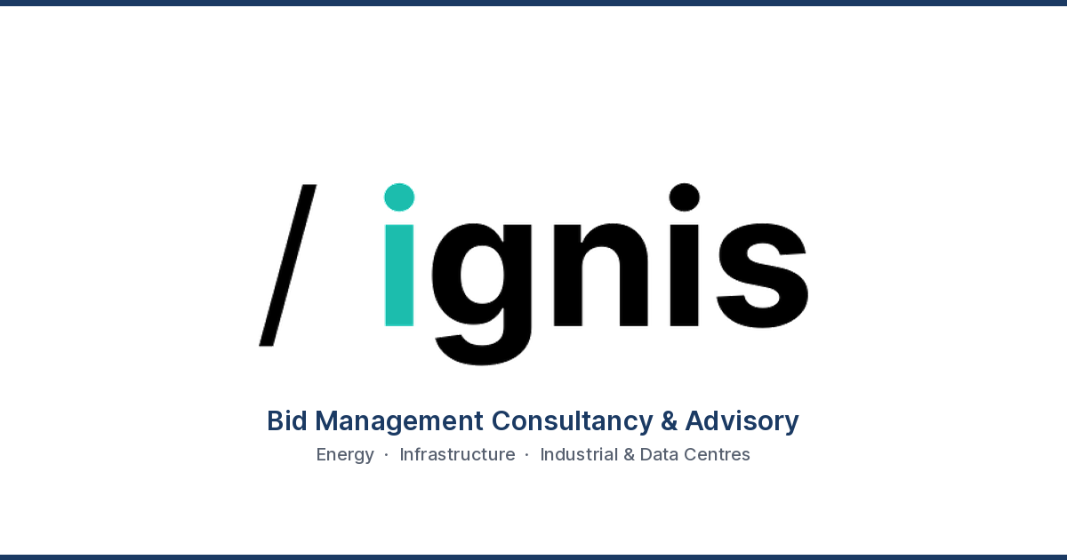

Full logo vs favicon mark: recommendation
Use the full wordmark for social/OG cards (as implemented). The favicon mark alone (just the “/” or the dot) is designed to be legible at 16–32px in a browser tab or app icon; blown up across a 1200×630 landscape card it reads as an abstract shape, not a brand. The full wordmark is what makes the card recognisable in a crowded LinkedIn feed. Keep the favicon mark for its intended jobs: browser tab icon, app icon, and the small square avatar contexts (e.g. WhatsApp link previews, Slack unfurls) where a wordmark would be squeezed illegible. The existing files in “Ignis logo (Logo)-3” (Black favicon.png, white favicon.png) are correctly scoped for that.

4. Metadata fixes implemented, page by page
Page | Issue found | Fix applied
Homepage (/) | Title/description didn’t mention target sectors; og:image pointed at old asset; no structured data; no og:image:alt/locale | Rewrote title & description with sector keywords; pointed to new white card; added ProfessionalService JSON-LD; added image alt/locale
Newsletter hub (/newsletter) | No Twitter title/description/image alt; generic description | Completed Twitter Card fields; strengthened description with sector terms; new image
Archive (/archive) | No Open Graph or Twitter tags at all | Added full OG + Twitter block, canonical confirmed, new image
Privacy (/privacy) | No canonical, no OG tags, indexable by default | Added canonical, minimal OG/Twitter, set to noindex,follow
Terms (/terms) | No canonical, no OG tags, indexable by default | Added canonical, minimal OG/Twitter, set to noindex,follow
Blog: “Bids are lost before the writing starts” | No Twitter title/description; no article structured data | Added Twitter title/description; added BlogPosting JSON-LD
Blog: “Why does every bid feel like starting again?” | No og:image:alt; no Twitter title/description; no article structured data | Added image alt, Twitter title/description, BlogPosting JSON-LD
Site-wide | No robots.txt, no sitemap.xml: search engines had no explicit crawl map | Created both; sitemap lists the five indexable pages

5. Actions only you can take (5–10 minutes)

Force LinkedIn to refresh the preview
- Go to the LinkedIn Post Inspector: linkedin.com/post-inspector
- Enter https://www.ignisleadership.com/ and click Inspect: this forces LinkedIn to re-scrape and should immediately show the new white card.
- Repeat for any specific page you plan to share (e.g. a newsletter post URL) if you link it directly.

Get Google to drop the old “identity coaching” listing
- If you don’t already have one, set up Google Search Console (search.google.com/search-console) and verify www.ignisleadership.com.
- Submit the new sitemap: https://www.ignisleadership.com/sitemap.xml
- Use the URL Inspection tool on the homepage and click “Request indexing” to push Google to re-crawl now rather than waiting.
- This won’t update instantly (typically a few days to a couple of weeks), but requesting it directly is much faster than waiting for an organic re-crawl.
I'm not able to complete either of these from here as they require your Google/LinkedIn account access, but both are quick once you're logged in, and I'm happy to talk you through either step by step.

6. Keyword positioning: energy, infrastructure & industrial bid management
Search volumes in this space are inherently low (it's a specialist B2B service, not a consumer category) but intent is high: the people searching these terms are usually already trying to solve a bid resourcing problem. The realistic strategy for a boutique practice is to own specific, sector-modified long-tail terms rather than compete head-on with larger names (Teneo, Ramboll, Thornton & Lowe, EiB Group, The BidBase) for generic “bid management consultancy” searches.

Core / brand-adjacent terms
Keyword theme | Example terms | Where to target
Core service | bid management consultancy, bid management consultant, complex tender consultancy | Homepage title/description (done); footer; About
Fractional positioning | fractional bid director, fractional bid leadership, interim bid manager | Homepage H1/subhead (already present); LinkedIn headline
Practice transformation | bid practice transformation, AI-augmented bid management, agentic bid workflows | Practice Transformation section (already strong); blog

Sector long-tail terms (highest-value opportunity)
Sector | Example long-tail terms
Energy (generation, renewables) | renewable energy bid consultant, offshore wind bid support, EPC tender management consultant, energy from waste bid management
Infrastructure / IPPs | IPP tender support consultant, independent power producer bid management, infrastructure tender consultancy
Industrial & data centres | data centre tender consultant, data center RFP bid management, hyperscaler colocation tender support, industrial capital projects bid consultant
Biotech / life sciences capital projects | biotech facility tender consultant, life sciences capital project bid management (currently no proof point on-site, see note below)
Assurance / governance | Red Team review bid, bid readiness review, go/no-go decision consultant

Note on biotech: the site currently evidences energy, offshore wind, industrial, data centre and hospital MEP experience (via the About section and client logos) but not biotech specifically. If you have a biotech-relevant bid or client reference, adding one specific proof point would let you credibly target those terms; otherwise I’d hold off using “biotech” in metadata until there is something on the page to back it up.

On naming specific target companies
EDF, bp, Ørsted, Engie and E.ON are useful for briefing me on positioning and for outreach, but I’d avoid stating on the public site that you work “for” or “with” a company unless that’s already true and they’re comfortable being named. The current bp/RWE/Bouygues logo strip works because that experience is real and already published. The better SEO move for reaching similar buyers (large utilities/IPPs and their tier-1 contractors) is owning the sector and role-based terms above, which is what the people at those companies actually search.

7. Content recommendations (blog)
Six topic ideas mapped to the keyword themes above, in the site's existing “field notes” voice:
- Data centre tenders: why hyperscaler and colocation RFPs need dedicated bid leadership, not a shared resource
- What a Red Team review actually catches before an offshore wind or EPC submission goes out
- Bid management for IPPs: scaling pursuit capacity without adding permanent headcount
- Fractional vs. full-time: when a critical energy tender needs a bid director for 8 weeks, not 8 months
- Agentic AI in bid management: separating genuinely useful workflows from hype, for complex infrastructure tenders
- The hidden cost of go/no-go decisions made too late in industrial and energy pursuits
Each post should keep the existing pattern (JSON-LD BlogPosting, per-post OG image, canonical URL) that the audit found already working well on your two published posts.

8. Ongoing monitoring
As agreed, a monthly scheduled task has been set up to review metadata health, technical SEO and content/keyword opportunities against this positioning. It will flag issues (broken tags, new stale-cache risk, missing metadata on new pages) and suggest the next 1–2 keyword or content opportunities rather than repeating this full audit each time.

End of report.

