Scalable Architecture Design Overview
<robertb@cyberworldgroup.com> Sept. 4 2001

- Introduction

One of the major problems with the current state of the poker code is that the architecture is not very scalable. This document describes our current procedures, the problems that plague it, and a proposed method for implementing a more scalable solution. In order to become market leader in our space, we need to be able to offer multi-player games to a large audience. The techniques documented in this paper should show how this design maximizes availability through fault-tolerance and high scalability through distributed processing. Implementing the principles presented in this paper should enable us to provide services to tens or hundreds of thousands of players.

- Current Architecture

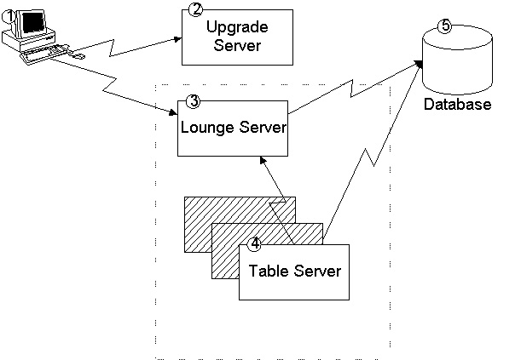

(Figure 2-1)

In our initial (and current) state, our architecture is fairly simple. A diagram is presented as
Figure 2-1. What follows is a brief description of the contents of this diagram (by number).

- A client process runs on a player’s machine which accepts input from the player, and passes this input along to a server process for handling. This process initially connects to the Upgrade Server (see 2). The client then connects to the Lounge Server (and later the Table Server) where the bulk of the player’s time will be spent. All messages between the client process and any server process (excepting the Upgrade Server) are encrypted using the SSL (secure socket layer) libraries.
- The Upgrade Server is responsible for ensuring that all players are running with the newest version of the client software package. When a new feature or enhancement is added to the software, the client will be automatically upgraded upon connecting to the Upgrade Server.
- The Lounge Server is responsible for managing lists of currently connected players, and active games running on the system. The Lounge Server is capable of spawning Table Servers (see 4) on-demand. The Lounge Server is also responsible for authenticating players upon their initial connection.
- The Table Server is responsible for conducting the game. This includes seating the players, dealing cards, evaluating hands, declaring a winner, and storing game logs in the database.
- The database contains customer-related information, and logs of all actions that occur in games.

- Limitations Identified With The Current Architecture

In our initial design, several factors contribute to poor scalability. The client application is required to have a persistent connection to the Lounge Server, as well as an additional connection to each Table Server in which the player is either participating or observing. Currently, a Lounge Server is responsible for spawning a Table Server process, and there is no mechanism for spawning a Table Server process on a remote (non-local) server machine. This implies that there can be at most one physical server, with at most one Lounge Server process in the current architecture. If we were to simply “throw hardware at the problem” without changing our design at a fundamental level, we could most likely only hope to serve a maximum player count in the low thousands.

- Proposed Design

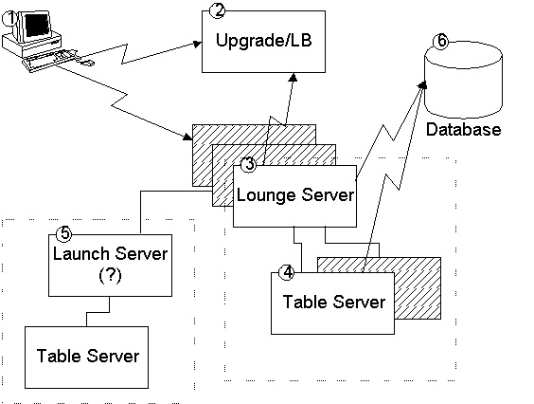
(Figure 4-1)

In our proposed design, several changes are made. A diagram is presented as Figure 4-1. What follows is a brief description of the contents of this diagram (by number).

- As in the existing architecture, a client application is resident on a player’s workstation. In the new design however, the chain of events that occur differs from the old model. In the new model, the client first connects to the upgrade server. As a design decision to be considered, it could be possible to make the server-side SSL components a run-time option (reverting to unencrypted communication when toggled off). This would allow the computationally-intensive operations envolved in the encryption process to be off-loaded to a SSL termination device such as the Cisco Content Services Switch or products from Alteon Websystems. These devices have specific hardware acceleration capabilities for those operations.
- At the Upgrade Server, no authentication is done, and a player receives an update to the client software if one is available. After the upgrade procedure, the new function of “Load Balancer” of the Upgrade/LB server process is realized. The Upgrade/LB server now redirects the client to one of potentially many Lounge Server processes. The Lounge Server gives a cookie to both the client, and the anticipating Lounge Server. The connection between the client application and the upgrade server is closed, and the client application now initiates a connection to the lounge server directly.
- The Lounge Server checks the client’s credentials for connection (the cookie), then conducts username/password authentication on the client. At this point, all changes to the existing architecture are transparent to the player.
- When a player wishes to observe or take a seat at a table, the player does not initiate a new connection directly to the Table Server. Instead, all communication between a table server and a player is proxied through at least one Lounge Server.
- A new server process dubbed the “Launch Server” extends the capabilities of the Lounge Server by permitting it to launch Table Server processes on remote machines as well as the local machine. Quite simply, this allows Table Servers to run on a machine without requiring another Lounge Server to participate in the Lounge Server web.

- Realized Improvements

In the case when the Table Server is not “hosted” at the player’s home Lounge Server, the communication path will transit at least two Lounge Servers. In times of network failure, the possibility for reliable communication among all server processes may be possible via a message routing algorithm implemented by the Lounge Servers. In this case, the communicating path may encompass three or more Lounge Servers.

When a Table Server has a broadcast message (a message which should be public to all parties at the table), it marks this message as public, and sends it to the host Lounge Server. The Lounge Server is responsible for tracking which other Lounge Servers, as well as which player connections have an active interest in this table instance. The Lounge Server is responsible for replicating and sending the message to the target Lounge Server/player connection. Message replication should always occur as close to the player connection as possible. As an example, consider have an interest in this table, and also which player connections are interested in this table instance.

