Python Amazing Game Engine (Pythonage) user guide

Introduction

Pythonage provides a basic game engine that allows you to write games in python which can then be run with a suitable web browser. One that provides HTML5 canvas, websockets and also if your developing your game locally on your own computer, allows you access your local files.

All games must contain a game-loop which gets triggered at a regular interval or on a cycle. The game-loop is responsible for monitoring the users input, moving players in the game, and updating the screen (usually referred to as rendering) at a regular interval.

In Pythonage these game loops get run on a pythonage server, which is a long running program that you must start which listens and responds to browsers connecting. I say game loops (plural) because every time a browser open a new game web-page then new game-loop gets spawned on the server and it keeps running until they close the web-page.

To create your own game you will need to create you own game-loop. In-fact most likely you will need several, one to wait for all the images and sounds you game needs to get loaded in the web-page then another to actually play the game, and possibly one more to display and animate your game-over page. This may sound a little daunting to some, but don't worry, much of the complexity gets hidden away, you simply have to create your own sub-class of PPlayingGame then use the methods you inherit from it to get the job done. PPlayingGame is a representation of a particular web-page playing a particular game.

Now your probably keen to get started and wondering how these instances of your sub-class of PPlayingGame get created. Well actually I'm afraid to say that is the other bit you have to do. You create your own class that is a sub-class of PGame. As a minimum this sub-class needs to provide the gamename property (so the pythonage server can match calls from the web-page to the right PGame subclass) and an implementation of get_playinggame method.

Your PGame sub-class could also do many other amazing things, such as pass a reference to itself into each playinggame it creates then provide methods that coordinate the sharing of information between separate playinggame instances... Wow, you can do online co-op or PvP games too! Yes, but be warned this is not for newbies... these methods can get called by any player at any time, concurrency is hard.

The web-page for your game does not need to contain much, just copy the example (index.html) then alter the pythonage_game_name variable in it to match the one in your PGame sub-class. Alter the bottom of pythonage1.js to point at where-ever your pythonage server is. You could possibly fire it up on a small Google cloud compute-engine, along with a python http.server.

Wow, that is amazing how does it work?

When the web-page opens it creates a thing called a web-socket. The web-socket allows two way communication between the web-page and the pythonage server. The first thing the web-page sends is a requestinggame message to the server along with the pythonage_game_name variable. The pythonage server wraps its end of the new web-socket in a PUser class and keeps a list of these PUser instances which it polls to see if they have messages that need receiving or sending.

The pythonage server needs a PGameFactory instance when it starts, and you need to have registered all your PGame sub-classes in this beforehand. The PUser is given a reference to this PGameFactory and it uses it to create the playinggame instance the web-page requested. Next the PUser gets linked to this playinggame instance so that when methods get called on it they affect the canvas in the browser, and when the user presses keys or clicks with the mouse the playinggame is made aware of them.

Figure 1
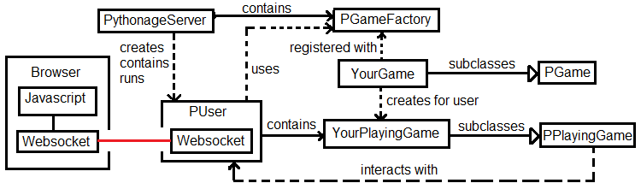
Does it have built-in classes?

If that is all there is to pythonage... does your playinggame have to draw everything, work out where everything is, detect collisions, work out when sounds are loaded and is ready to play, what about all that messaging... seems like lots of work... I'm going to need to write lots of classes for that right?... No, there built in too... let me explain how that works.

The PPlayingGame has several create methods you can use to create instances of classes such as PRectangle, PCircle, PImage . When you call one of these the websocket sends a message creating a reflection of that object in the browsers javascript. When you alter properties on these objects it also alters the properties on the objects in the browser... they are entangled. One slight difference you need to remember though is when you no longer need an object, you should call its remove_from_browser() method first to ensure it gets forgotten about on the browser as well.

How are things positioned and moved on the screen?

Say you have player that you want to wave his arms around, there are several articulated bits how does pythonage achieve that? In pythonage it is rare to call render() on the individual objects themselves, what you usually do is compose a scene-graph then call render() on the root of that scene-graph.
Figure 2

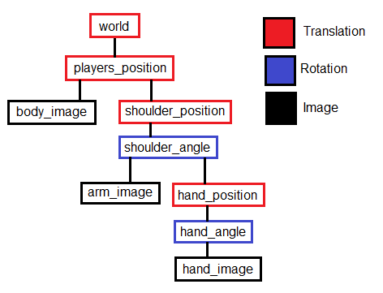
translation represents a move around and rotation represents a turn. Each is after the translation or rotation above it has been applied, so the hand turns on the end of the arm.

Figure 3
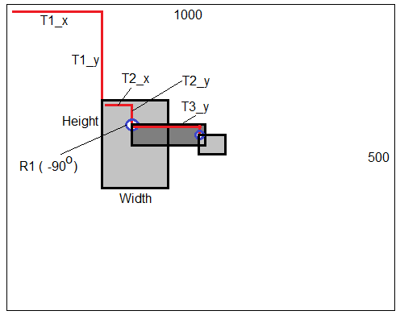
This shows how the co-ordinates work, the x-axis goes across the screen starting from the top-left and the y-axis goes down the screen. Because R1 (shoulder_angle) has turned everything after it anti-clockwise by 90 degrees, consequently T3_y now goes off to the right.

So is all I have to do if I want my player to move is alter the x property on player_position then call render() on the world translation object I created?... Nope, before rendering you need to call the update() method on your world object first, this causes all those little changes you made to things in your world scene-graph to be combined together before being sent off to the browser.

Also the PPlayingGame class has a store_messages property which when set True stops most messages being sent to the browser and queues them instead, this feature allows your code to make changes its scene-graph while the browser is rendering, without those changes your making interfering with what the browser is currently rendering. Once you know the rendering is complete and you want to send your changes ahead of the next render simply set the property False.

If you want to know if the browser is rendering set the render_complete_notification property on PPlayingGame True, this informs the browser to send notification when the rendering is complete. The rendering property on PPlayingGame then tells you when rendering is still in progress.

How are things layered on the screen?

You can determine what gets drawn over what else on the screen when render is called by the order you attach things to the translation and rotation objects. This is sufficient for simple games but becomes tricky on games with complex foregrounds and backgrounds for example. Fortunately you can set a layer property on your objects (to a value from 0 => 4) then call render_layers() on your world instead of render() and the ordering gets sorted for you.
So how do you create game loops?

The pythonage server runs async making it efficient, but also means that games must co-operate so its power gets shared out across all the browsers that are connected to it... your game needs to share. If it did not share then only one playing game would be allowed at a time.

To create a game loop that shares you first write a method (or methods) in your PPlayingGame sub-class that does your key-press handling, physics, rendering and stuff like that, each of these methods must only take a very short time to run... microseconds.... Then you use the PPlayingGame's create_timer() method which ensures these methods are called at regular intervals. Sometimes you may require something to be called once some time in the future, in which case use the create_timeout() method instead.

How do you detect key-presses?

In order to detect if a key is pressed your game needs to periodically call PPlayingGame's update_keys() method and pass it a list (or tuple) of all the keys it is interested in knowing the state of, this sends a query to the browser. Shortly after you can use the this_key_is_pressed() method to find if a key is currently pressed. You might want to update direction keys fast, but then check other keys (say for landing gear) less frequently to reduce network traffic.

How do you detect mouse clicks?

Check the clicked property on PPlayingGame if this returns True it means a click happened since last time you called reset_clicked() and the properties click_x and click_y hold the clicks position.

How do you show images?

First you need to make sure the the image you want is available on host (or as a file on your computer) that the browser is able to access. The code-sample keeps its images in the img directory. Next you need to call create_imagedata() passing it the URL to the image or a relative path from your web-page, which gives you back a PImageData instance. Unfortunately you cannot use that straight way, you need to keep periodically checking its loaded (or not_loaded) property to check the browser has finished loading it. Once it has loaded you can use it in create_image() calls to create an image that you can attach to your scene-graph. If you need transparency use tools such as photoshop to create .png files with transparency.

There is also a create_pixelmap_from_imagedata() method you can use to create an object that behaves much like an image, but allows you to set the colour pure blue to be transparent. In addition there is a create_pixelmap_from_string() method that allows you to create 1980's style pixel-art in your games by passing it an array of strings, without having to mess with images at all.

How do you make noises?

Use the create_sound() method to create an instance of PSound passing it the URL or relative path to the file. It is a good idea to use .mp3 files as they are able to load on most computer and tablet browsers. Like imagedata instances you need check its loaded property before calling play() on it.

What is an PAlbum and how do I get one?

Call create_album() to get an album instance, you can then append PImageData and PSound instances to it. Its length is the number of instances it contains, its pending and loaded properties allow you to track how many are still loading and if they have all loaded respectively.

How can I tell where something is on the screen?

Since the scene-graph can make it a bit complicated to track where something is, fortunately there is built-in help for you. In order to use it you must first call calculate_position() on the same scene-graph object that you usually called render() on, like this.

from pythonage.matrix import Pmatrix
...
world.calculate_position(PMatrix.unity())

Once you have done this the objects in the scene-graph have screen_x, screen_y properties and rectangular objects have p1_x, p1_y …. p4_x, p4_y properties as well as centre_x, centre_y. Lines have p1_x, p1_y, p2_x, p2_y as well as centre_x, centre_y.

How can I tell when things have collided?

Once you have called calculate_position() the PSuperCollider class contains several functions that can be used to work out if two things have collided (and how deep the collision is). These are fairly basic and only look to see if one rectangle has a corner point inside another. This has a few weaknesses especially when things in your world travel fast.

Figure 4

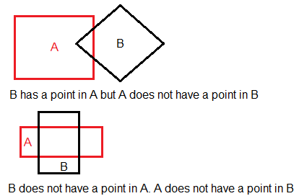

Getting started

1) Ensure you have Python3 is installed on you computer.

2) If you do not already have pip3 installed your going to need that. In windows this installs along with python3 . In linux you may need to use:

sudo apt-get install python3-pip

3) Then from the command prompt (under Windows System on the start menu)

pip3 install websockets

4) Next fire up the pythonage server up with startpythonageserver.py which you can either do with IDLE Python 3.7 or with the windows command prompt with something like...

C:\Users\BLAH\AppData\Local\Programs\Python\Python37-32\python.exe startpythonageserver.py

5) If you need to change the port edit the numbers in startpythonageserver.py and the bottom of pythonage1.js

6) Right-click the index.html file and choose open with Firefox.

7) This is now running car_playinggame.py that car_game.py provided. Feel free to experiment with these and see what you can do.

8) If you need more sounds add them to the img and sound directories.

9) If you want to make a completely new game, take a copy the index.html file and change the pythonage_game_name variable in it. Copy car_playinggame.py and change it to do what you want. Next copy car_game.py and alter the gamename property to match your pythonage_game_name variable, also change its get_playinggame() method to return an instance of your new playinggame class. That is it.

What is the next step?

Look at the pythonage reference guide to see what classes are available, what they do and the methods and properties they possess.

