REST API with authentication using Spring Security + OAuth2 + JPA

1. No private resource:

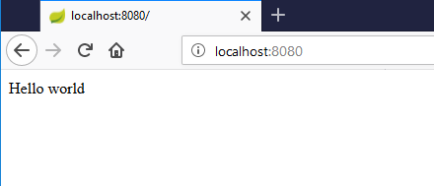

2. Access private resource:

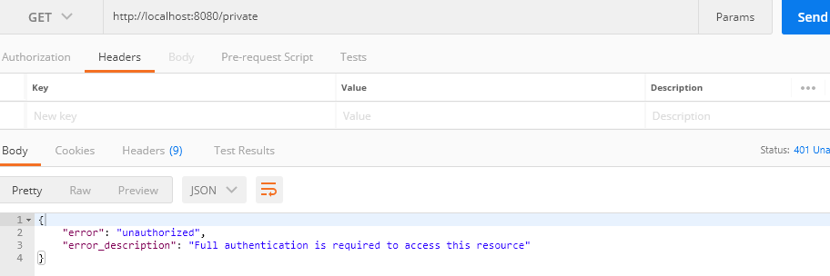

3. Request for Access Token:

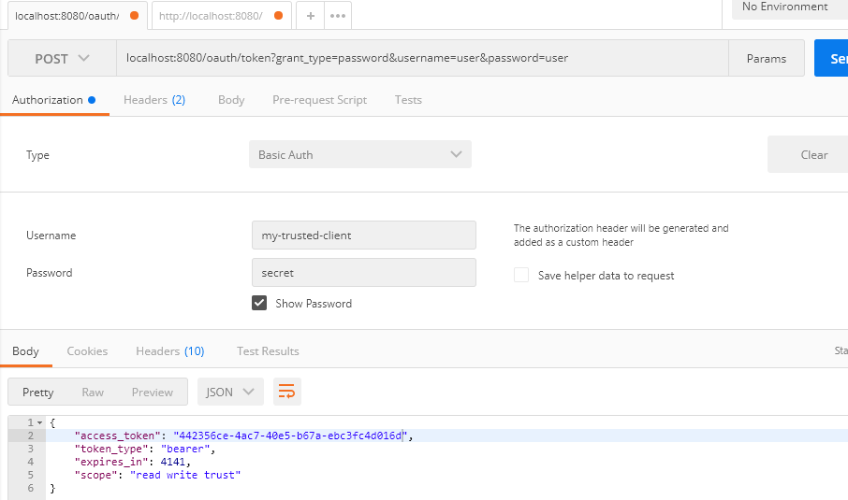

4. Access private resource with access-token:

