Quiz Four for Software Engineering Course June 14, 2020

Name: Student ID: Group ID Score:

- Please fill in the following blanks: (15 pts., 1pt. for each)

1. Usually there are generic software engineering framework activities for a software project, such as communication, …, and deployment.

2. During Quality Function Deployment, it should identify three types of requirements: requirements, expected requirements and requirements.

3. There are four kinds of Requirements Models: Models, Class-Based Models, Flow-oriented and Behaviors Models.

4. There are four Interface Analysis and Design Models: User model, Design model, Mental model, Implementation model. Among them, model depicts the image of a system that an end user creates in his/her head.

5. There are two testing ways for any engineered product: Testing and Black-Box Testing. For the latter, testing techniques include: Partitioning and Analysis

6. Software Configuration Items (SCI) include programs, and .

7. There are two Metrics for the requirement model: Metrics (LOC) and Metrics (FP)

8. There are four Organizational Paradigms: closed paradigm, paradigm, paradigm, and synchronous paradigm

9. There are two kinds of Risk Strategies: risk strategies and Proactive risk strategies.

- Please give brief answers to the following questions: (25 pts.)

- Agility development is regarded as an efficient and effective method for software development. It can response to change and communicate among all stakeholders efficiently. Meanwhile, it will draw the customers onto the team. So, it can deliver software rapidly and incrementally. To accomplish this goal, a series of principles are put forward. Please list at least 6 pieces of agility principles (6 pts.).

- Please draw schematic diagrams for any three of following four architectures: the data-centered architecture, data flow architecture, call and return architecture, and layered architecture respectively (6 pts.)

- Technical review is very important for uncovering software errors before the software is released to the end users since errors can be amplified in the latter steps if they cannot be found in the former phase, as shown in the following defect amplification models:
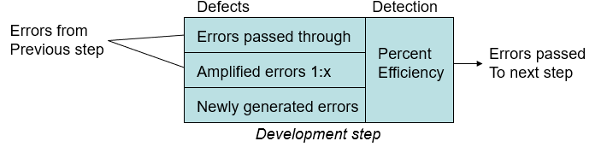
Suppose: (1) the newly generated errors are 20, 60, 60 for the preliminary design, detail design and code/unit test respectively; (2) the errors passed through and the amplified errors are the same between preliminary and detail design and between detail design and code/unit test; (3) the values of x are also the same for detail design and code/unit test and are 3.

If the values of percent efficiency for the whole process without FTR (Formal Technical Review) and with TR are 0 and 50% respectively, please illustrate the defect amplification process for preliminary design, detail design and code/unit test, and calculate the final errors after code/unit test respectively (8 pts.).

- The Personal Software Process (PSP) is a structured software development process that is intended (planned) to help software engineers better understand and improve their performance by tracking their predicted and actual development of code. Please give at least three framework activities for PSP (5 pts.).

III. Paper Processing System (PPS) (60 pts.)
Software scope: A lease company wants to develop a Phone Renting System (PRS) to share the phone by renting the devices.
After inputting the name, sex, age, address and ID, customer can register a new account online. When he/she login in the system, he/she can search the phone by the price, model, manufacturer, screen size, etc. Then he/she can browse the detailed information of the phone. After finding the favorites, customers can select the payment and make the order. The business manager of platform will evaluate his/her credit by calculating the log of user, or getting his/her credit scores of Alipay. If the customers can pass the evaluation, the order will be approved, then the manager will execute the order, conduct the following the actions, package the phone, mail the phone, notify the customer, track the package, and finally finish the order. Meanwhile, the manger will contact the customers and withdraw the phone before the renting expiration. The administrator of platform will maintain the system, such as phone repository, customers list, and security policies.
- Please draw the data flow diagram for processing the order. (12 pts.)
- Please give the two CRC cards for classes “customer” and “business manager”. (10 pts.)
- Please give the state diagram for the “order” class. (8 pts.)
- Please draw the software architecture of PRS. (10 pts.)
- Please describe the testing strategy for PRS platform. (10 pts.)
- During the project development, if some of key software engineers in the project team leave, what will happen and how would you deal with this situation? (10 pts.)

Answer:

