Département de Génie Informatique et Communication

Department of Information and Communication Engineering

Topic : TP14

Subject : Internet Programming

Teacher : Mr. Hok Tin

Name : YORNG TONGHY

ID : e20191313

Group : I4-GIC-C

Year : 2022-2023

Table of Contents

GitHub Link: 3

Constants 4

String Concatenation 5

Arithmetic 6

Assignment 7

If else statement 8

Elseif statement 9

Switch statement 10

While loop 11

Do while loop 12

For loop 13

Foreach loop 14

Array 15

Multi-dimensional 16

PHP forms (Post from handling) 17

PHP forms (Get from handling) 17

Sample HTML forms 17

Registration check 18

Registration form 18

Registration get 18

Registration post 19

PHP file Upload 19

PHP file upload handle 19

PHP composer 20

GitHub Link: <https://github.com/yorng-tonghy/TP14_Internet_Programming>

# Constants

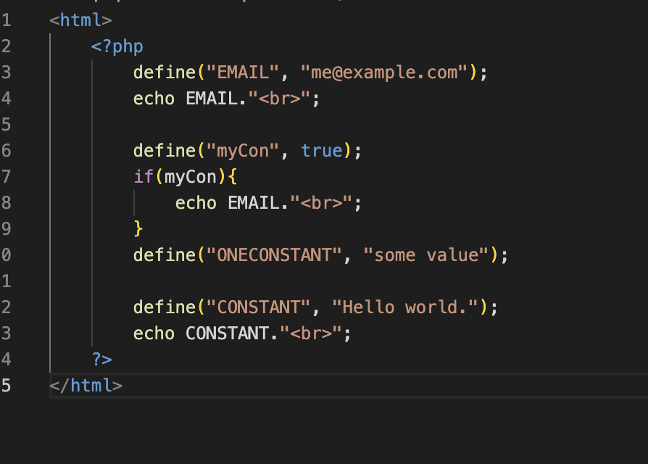

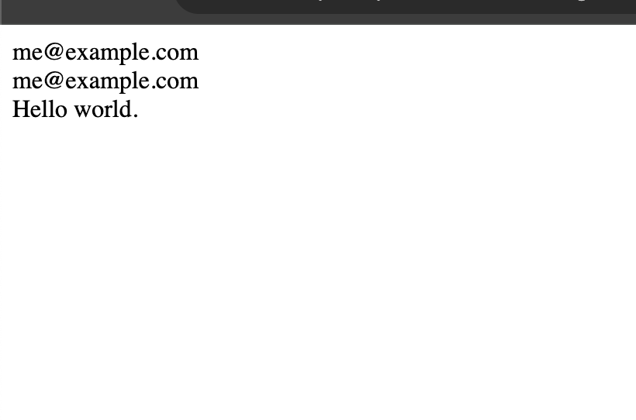

# String Concatenation

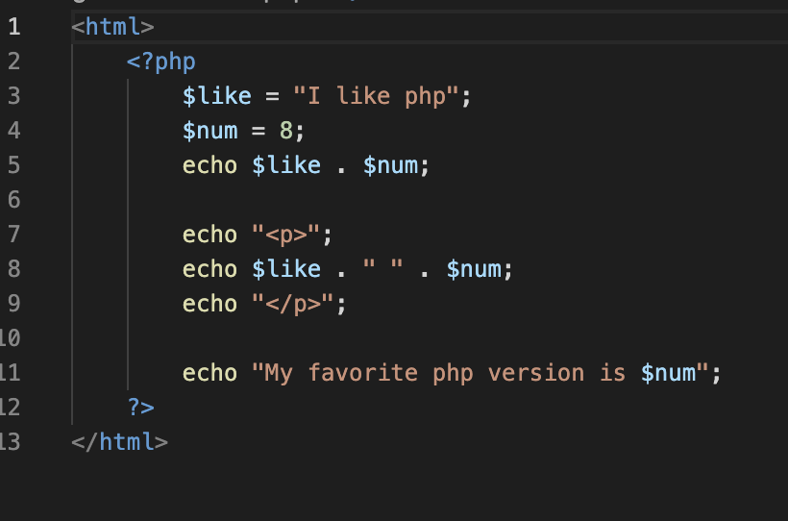

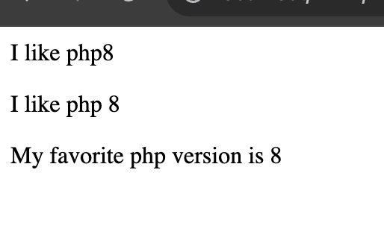

# Arithmetic

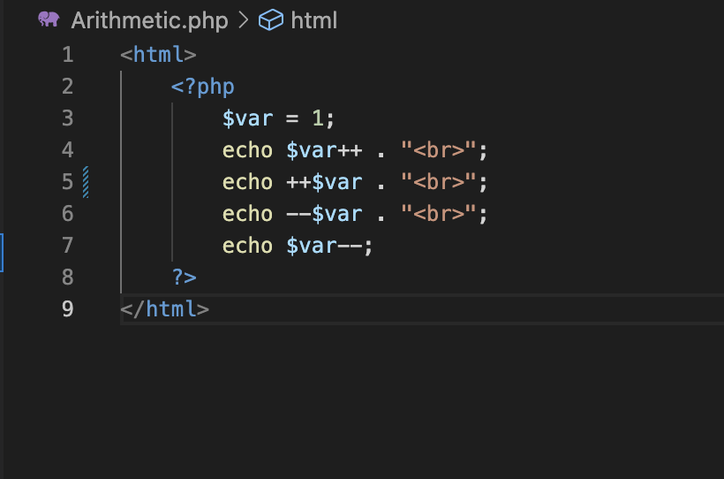

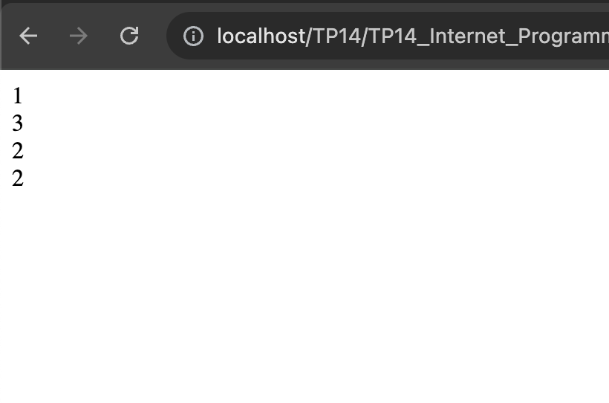

# Assignment

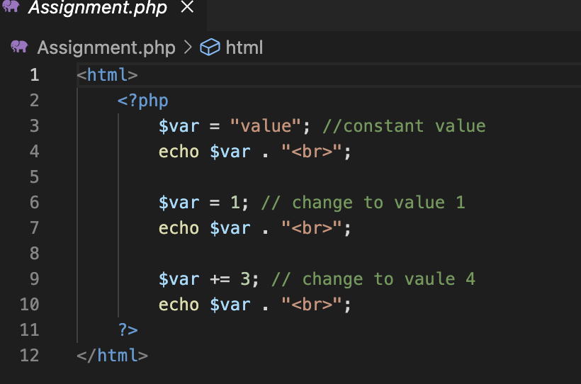

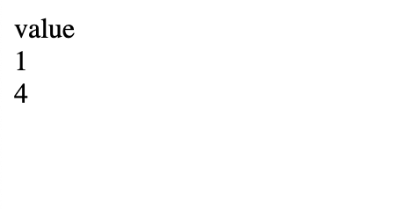

# If else statement

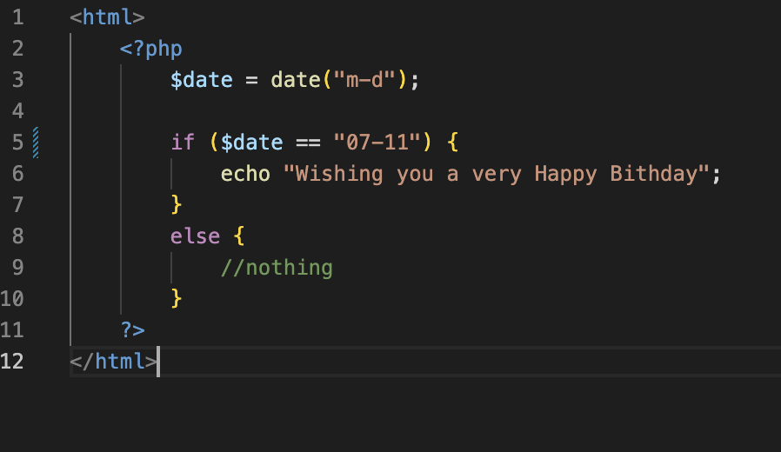

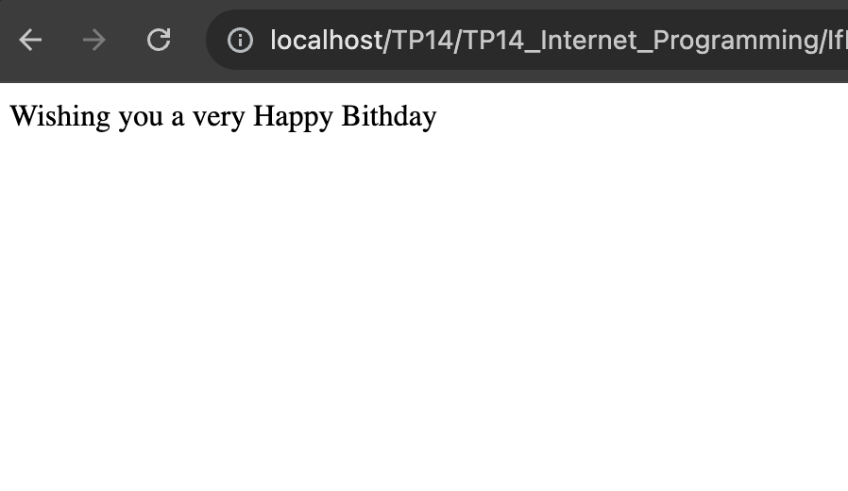

# Elseif statement

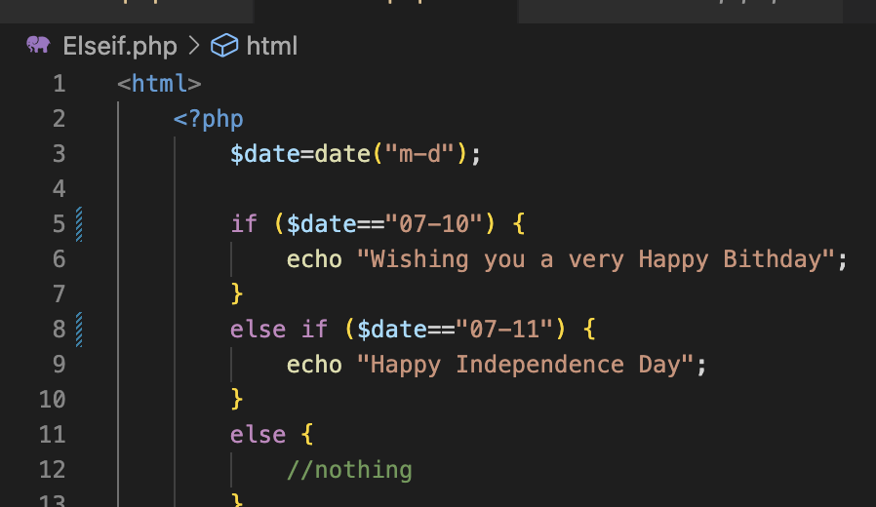

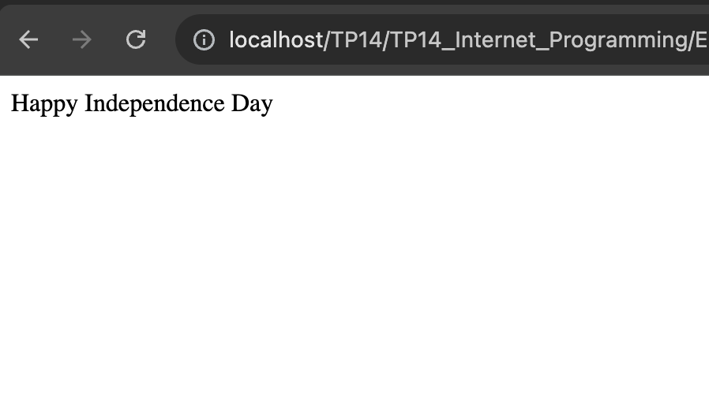

# Switch statement

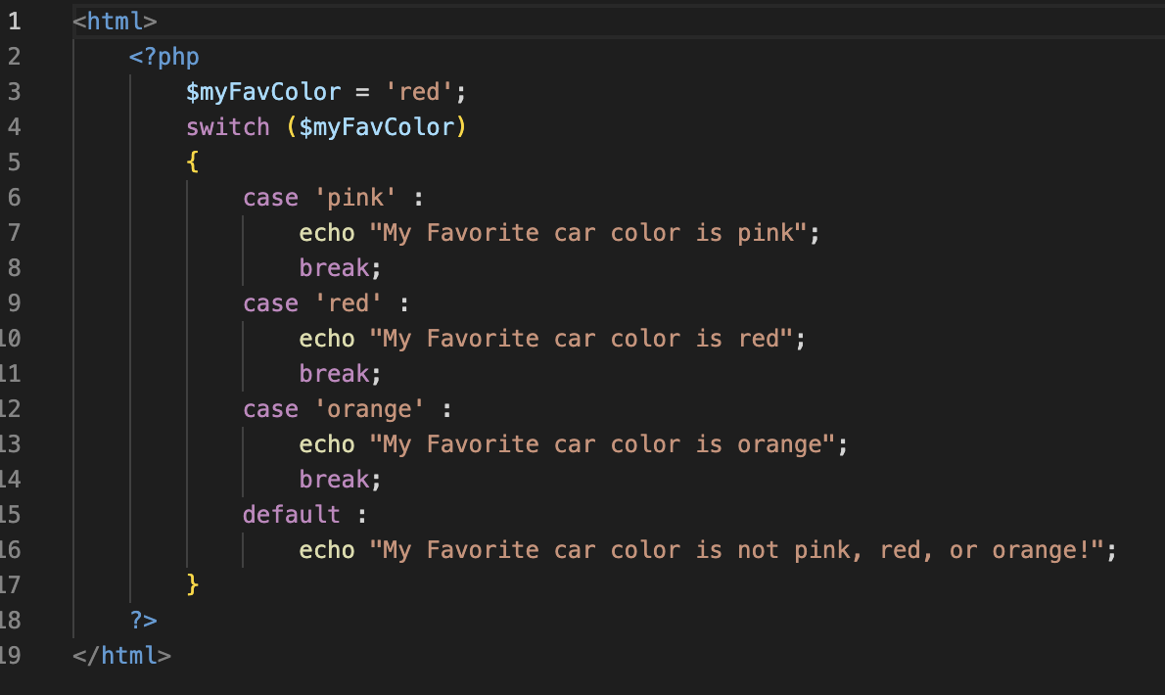

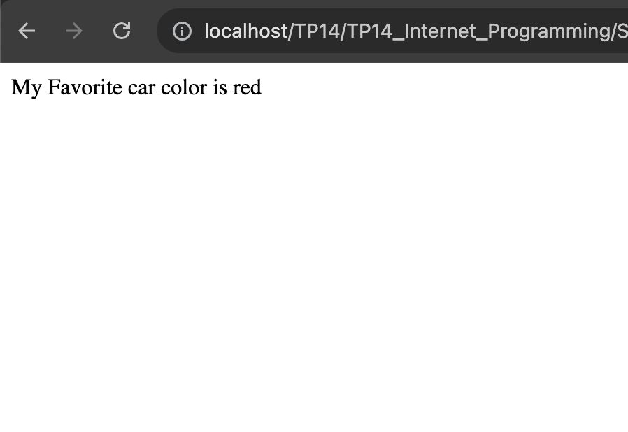

# While loop

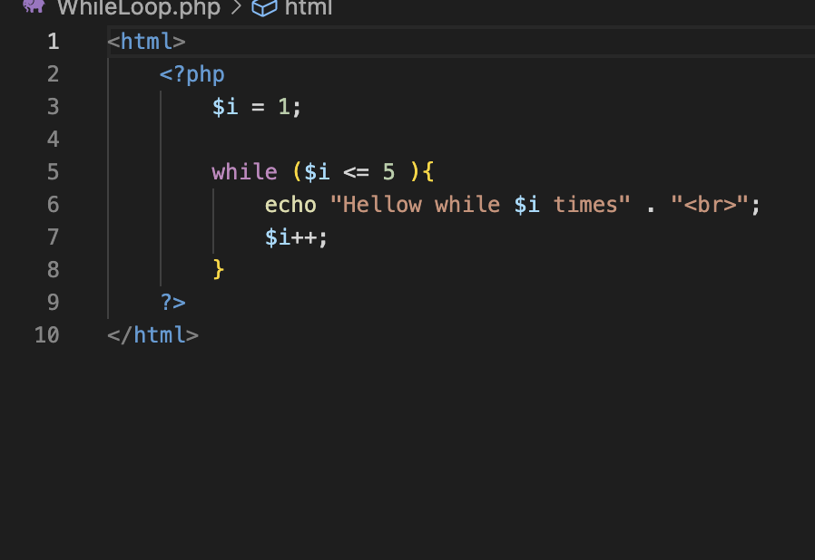

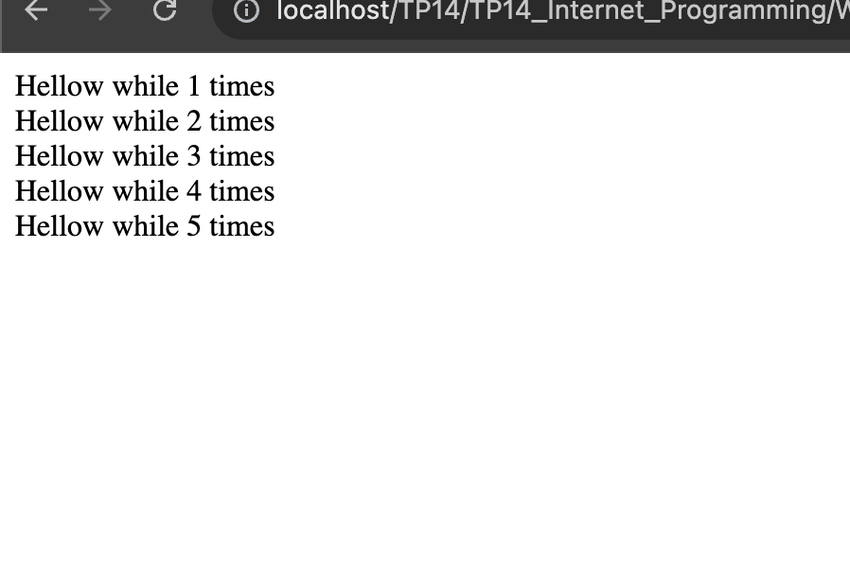

# Do while loop

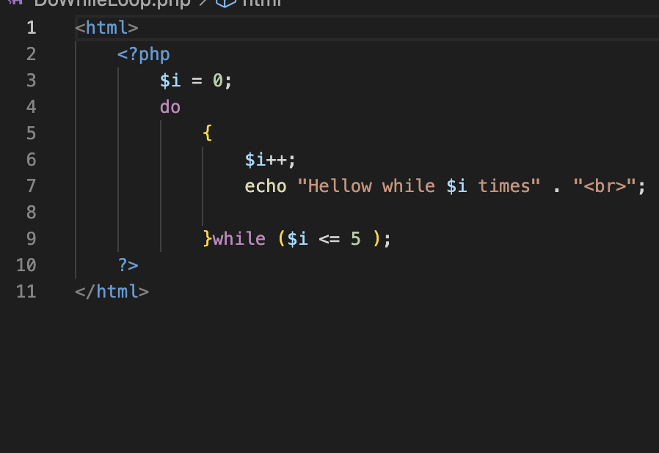

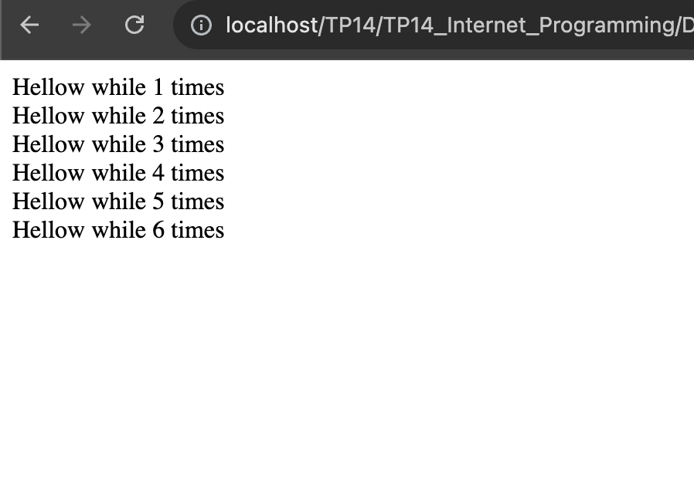

# For loop

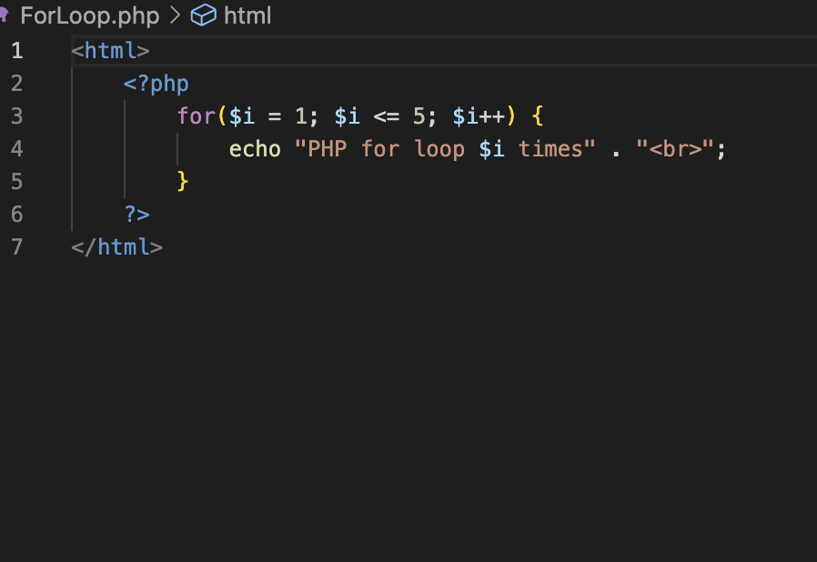

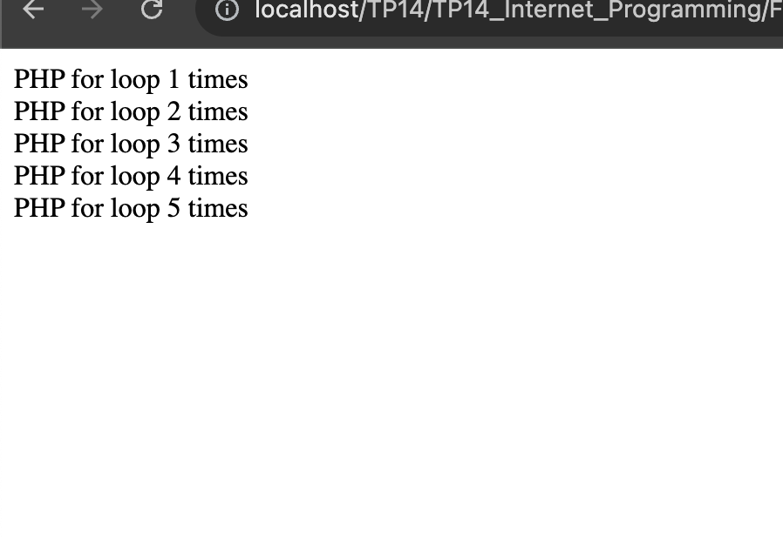

# Foreach loop

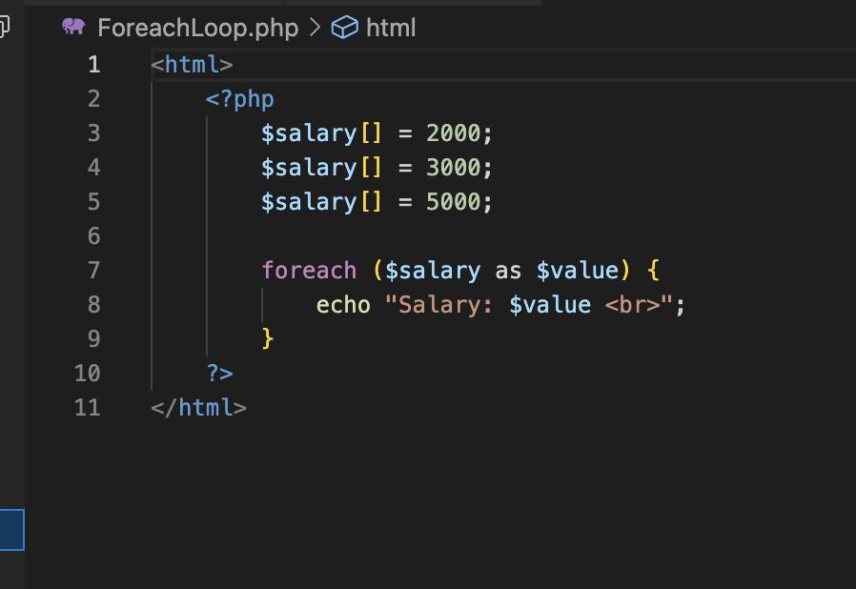

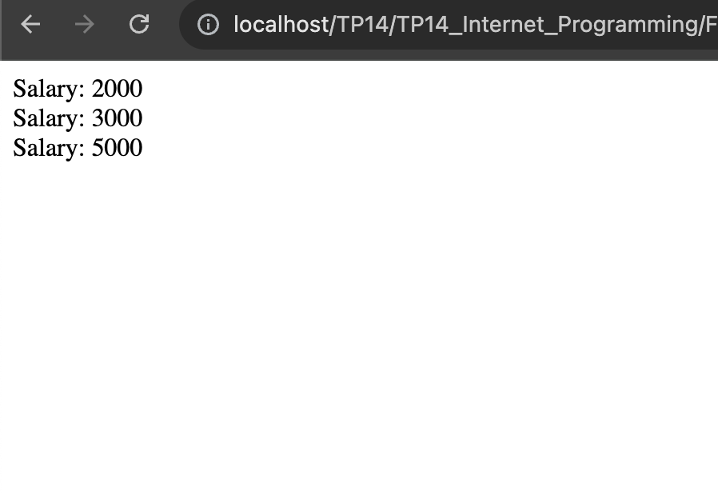

# Array

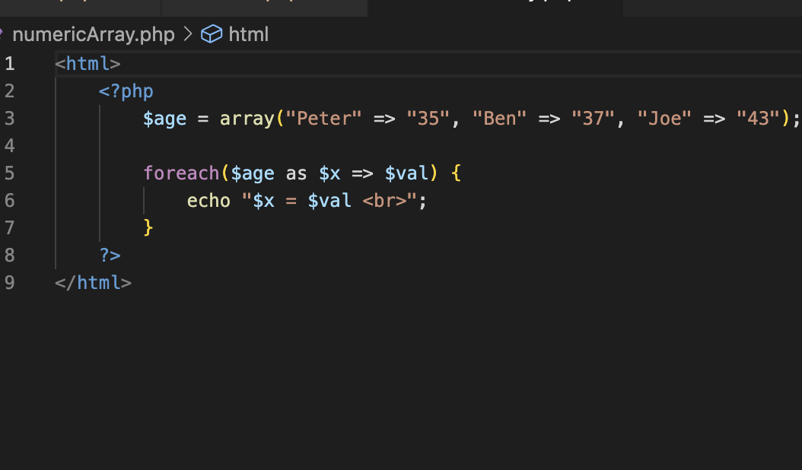

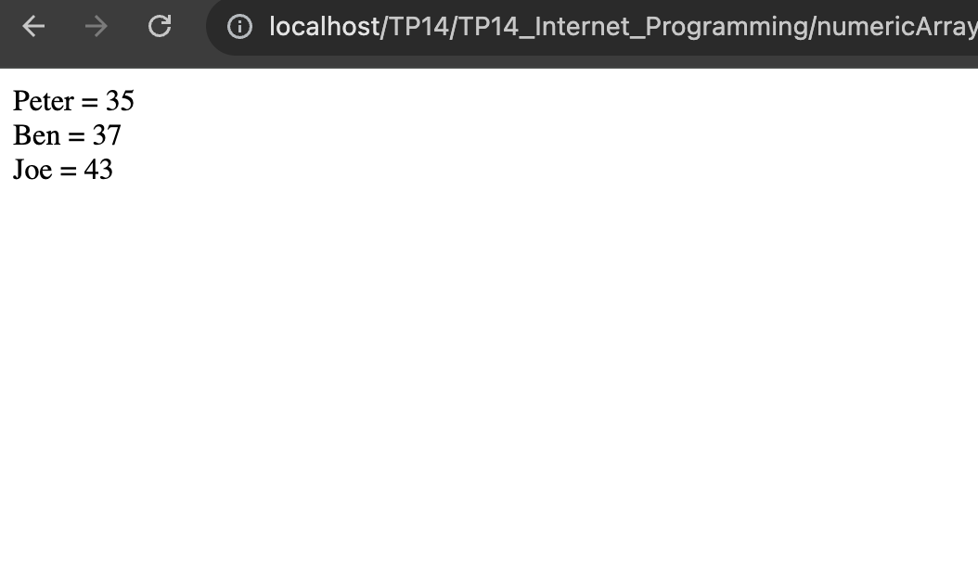

# Multi-dimensional

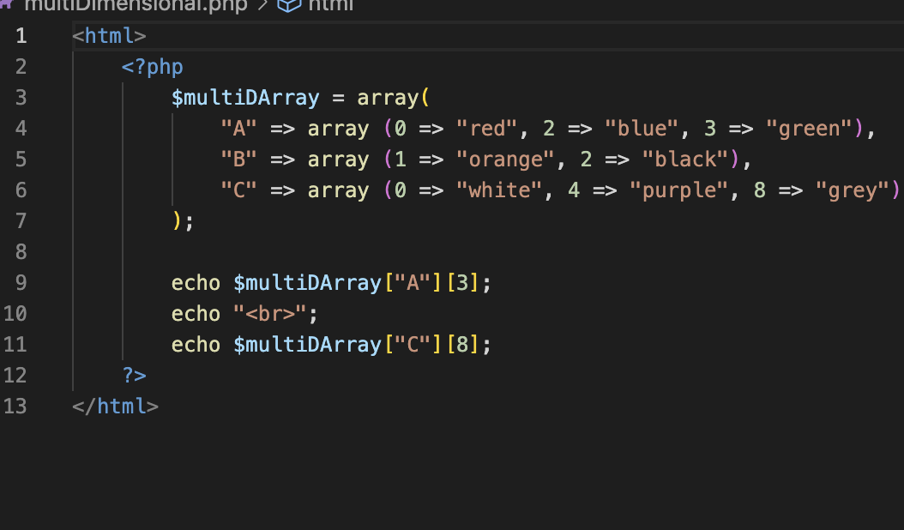

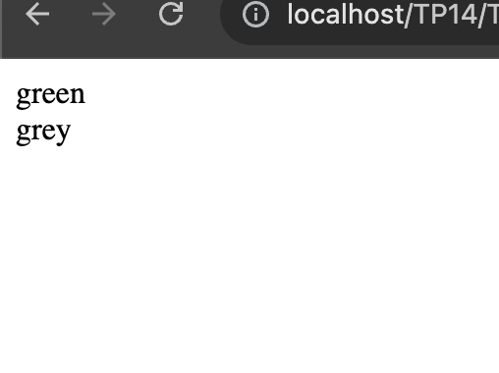

# PHP forms (Post from handling)

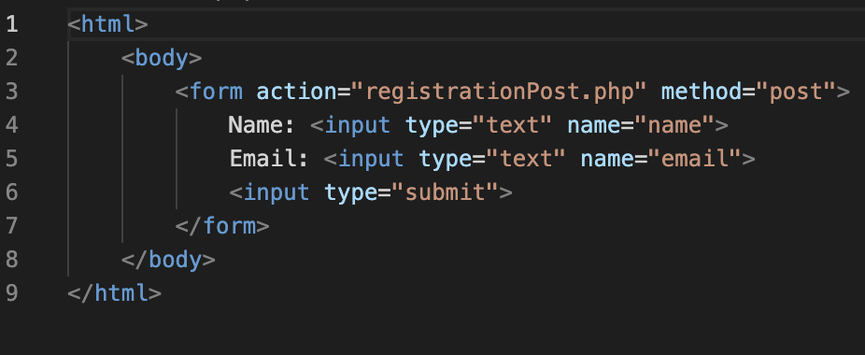

# PHP forms (Get from handling)

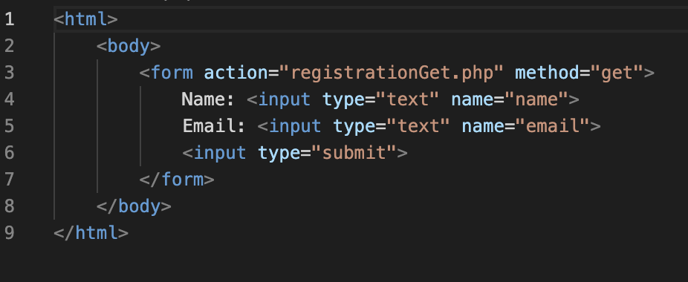

# Sample HTML forms

## Registration check

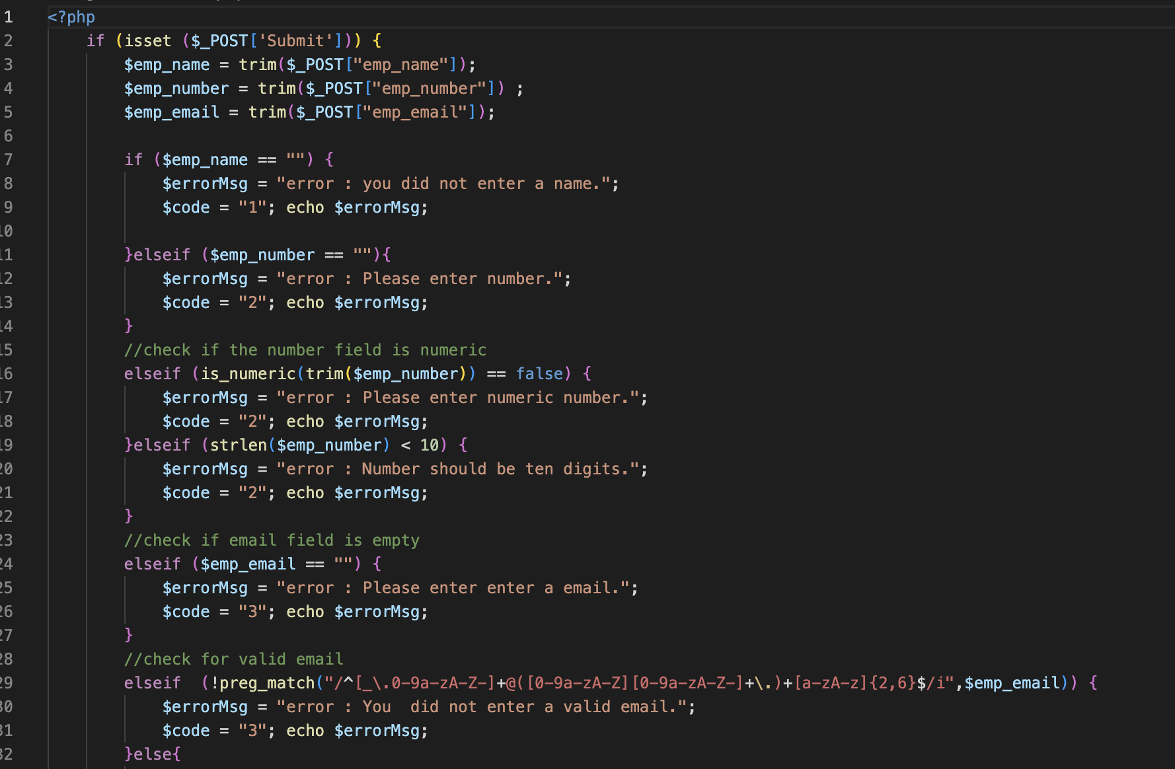

## Registration form

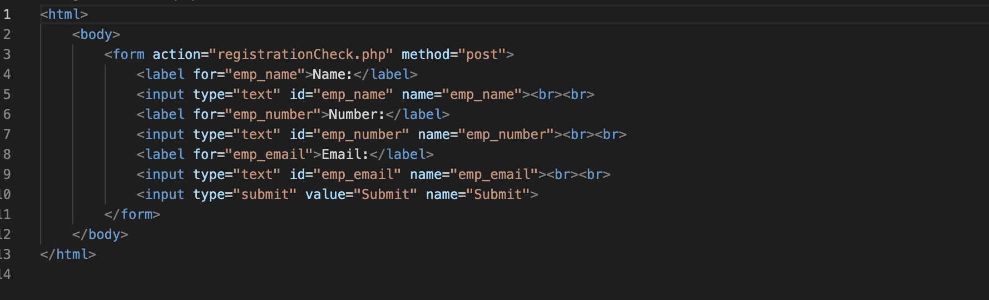

## Registration get

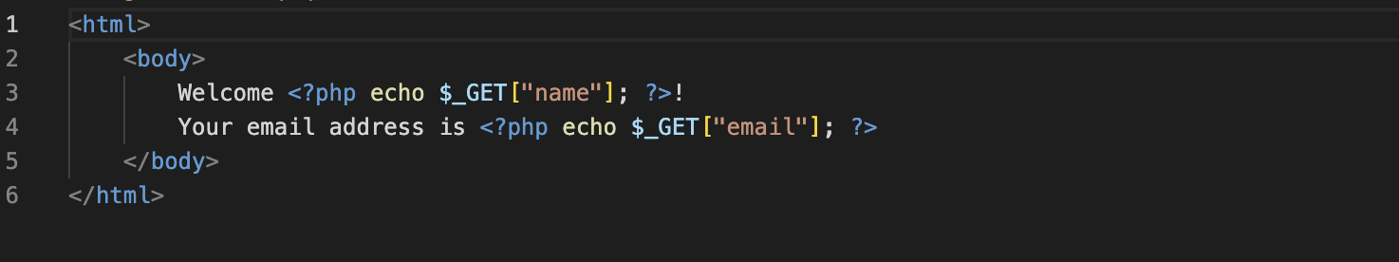

## Registration post

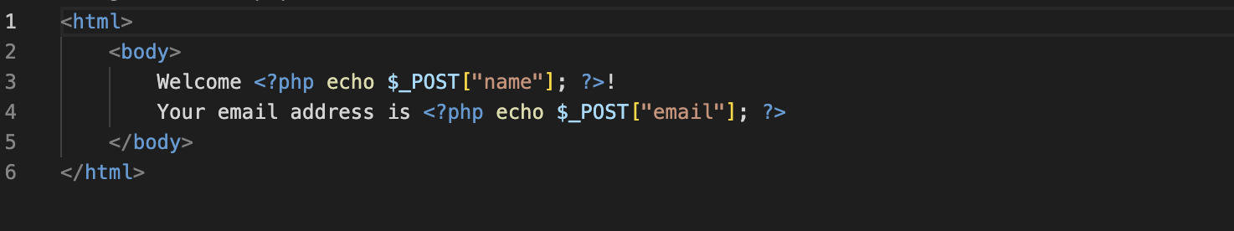

# PHP file Upload

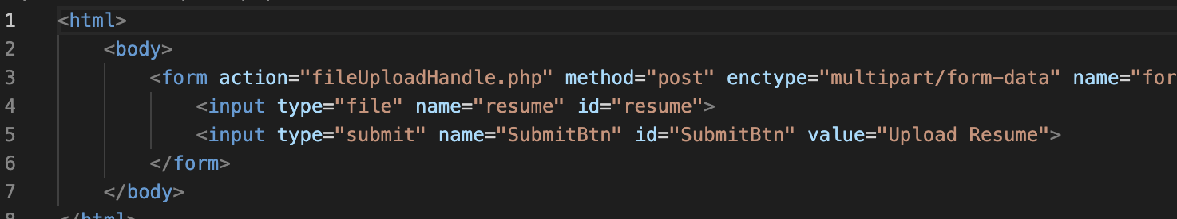

## PHP file upload handle

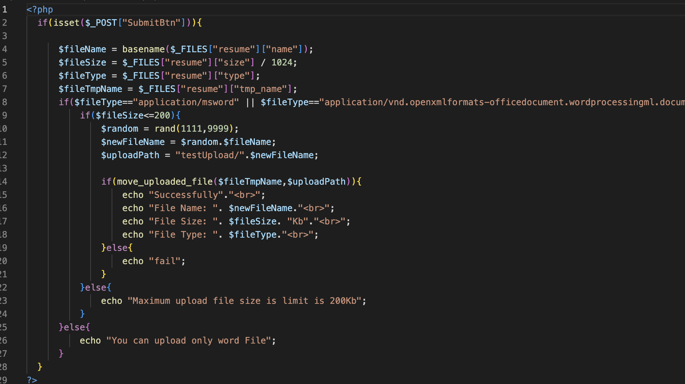

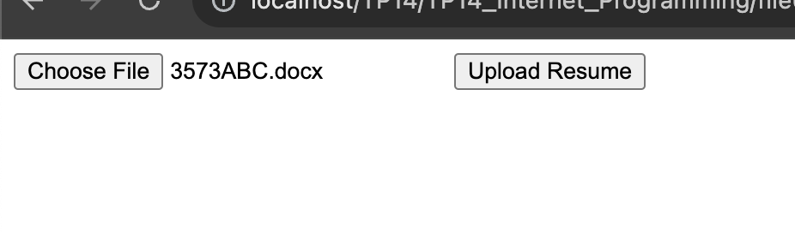

# PHP composer

