作業三
題目：
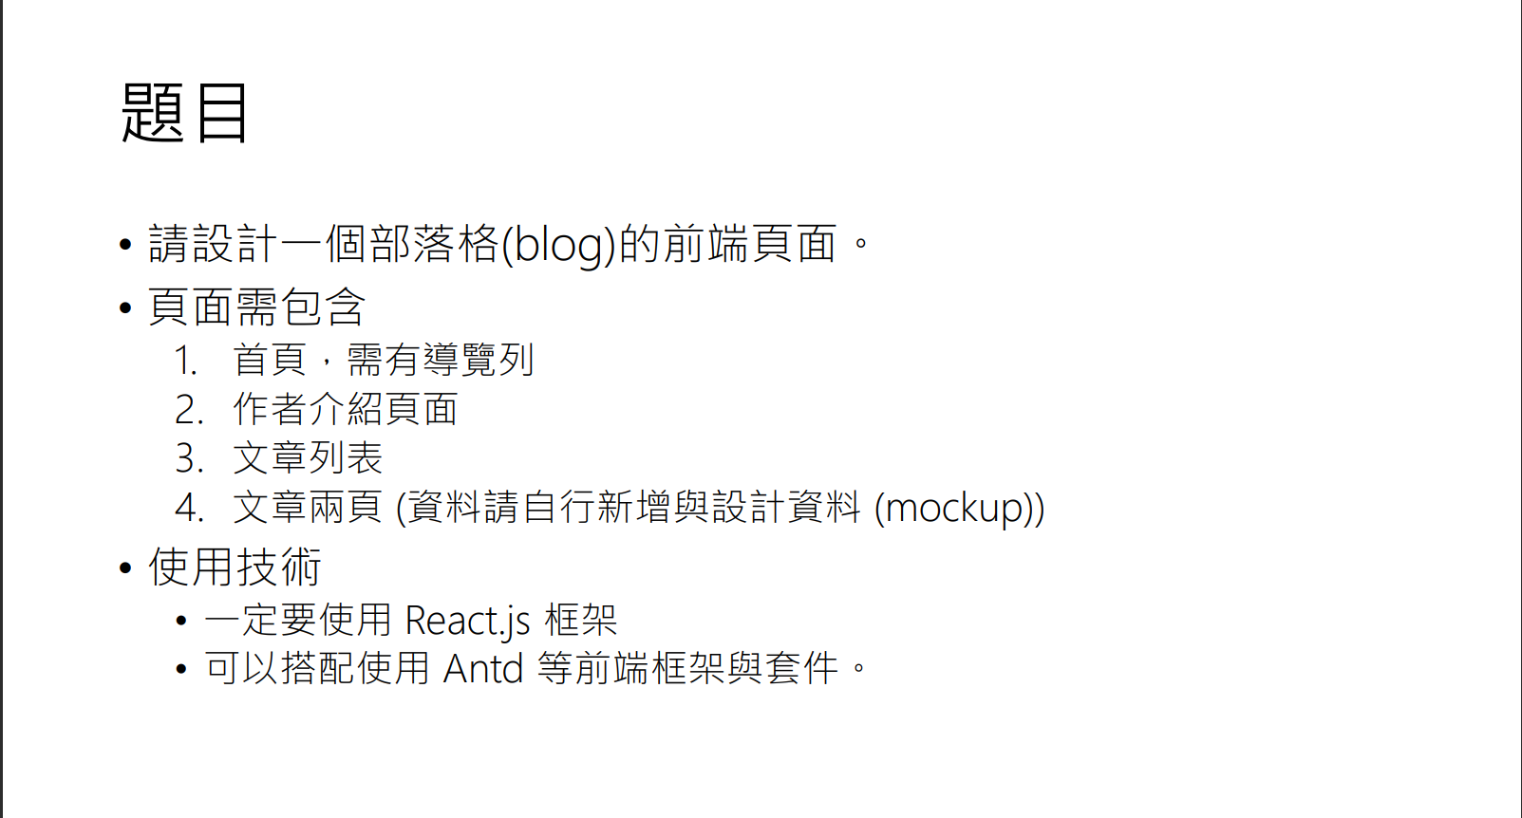
GitHub Pages：https://yorutats.github.io/ChuBlog/

頁面展示：
首頁
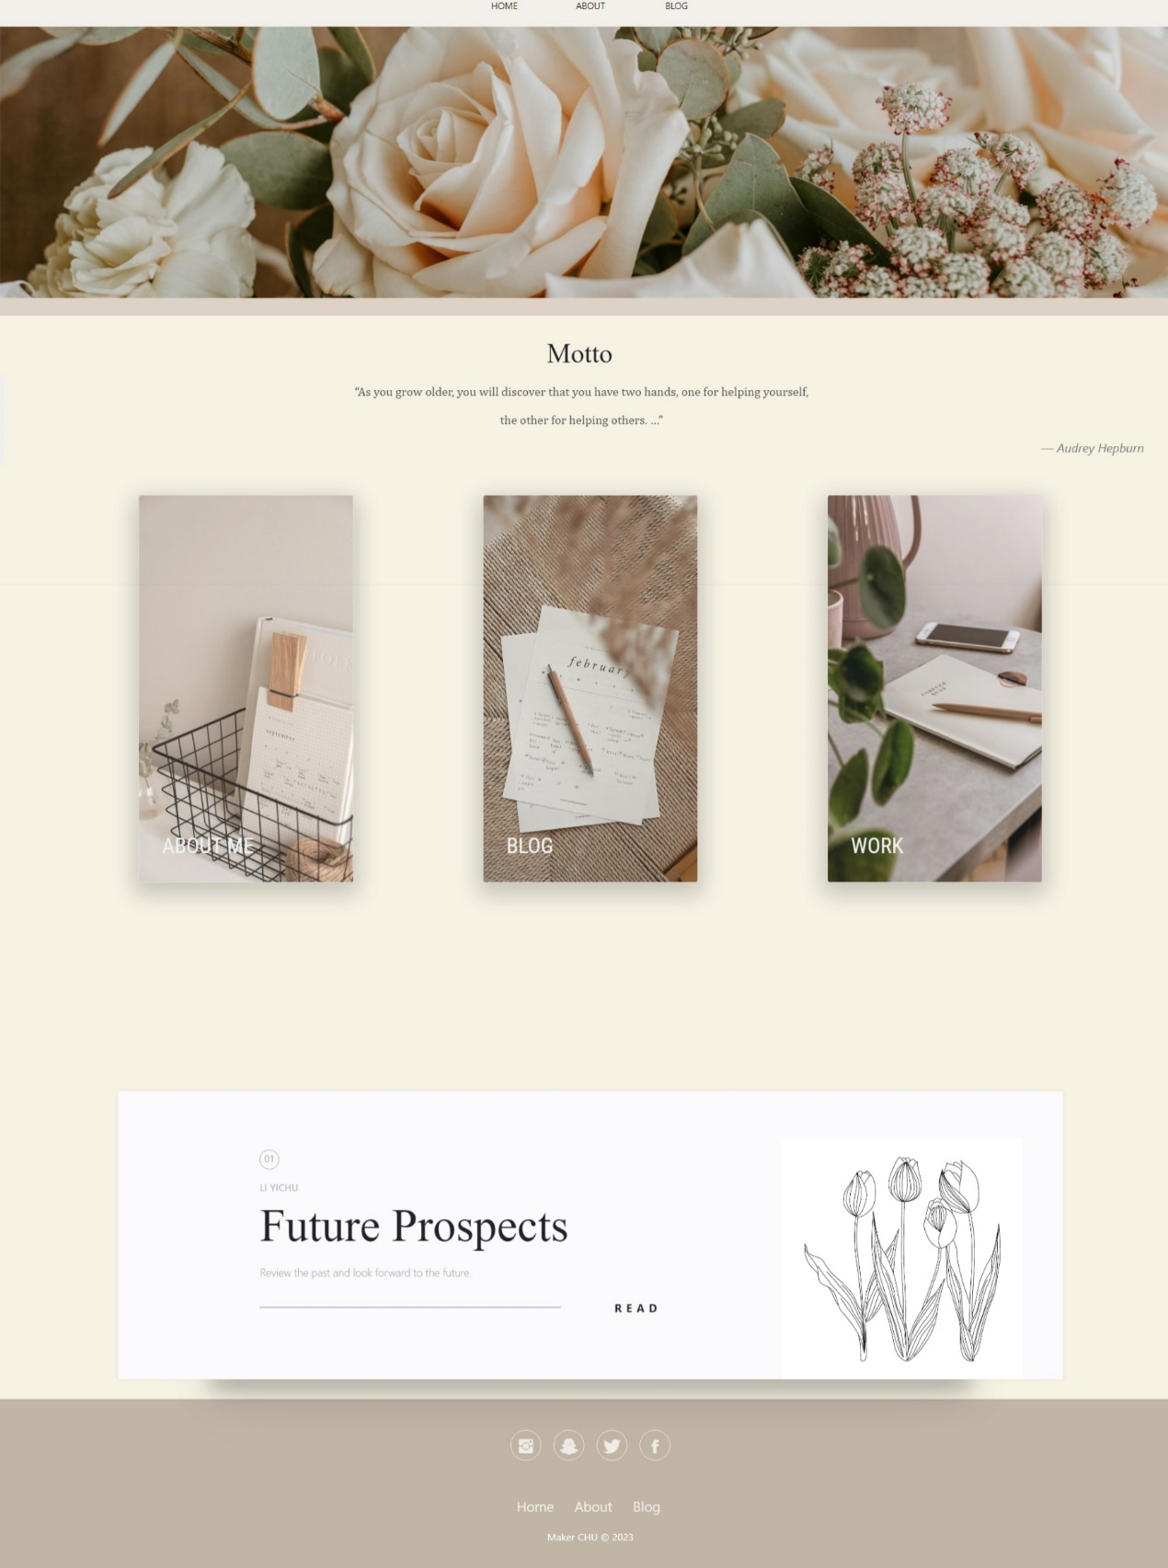

作者介紹
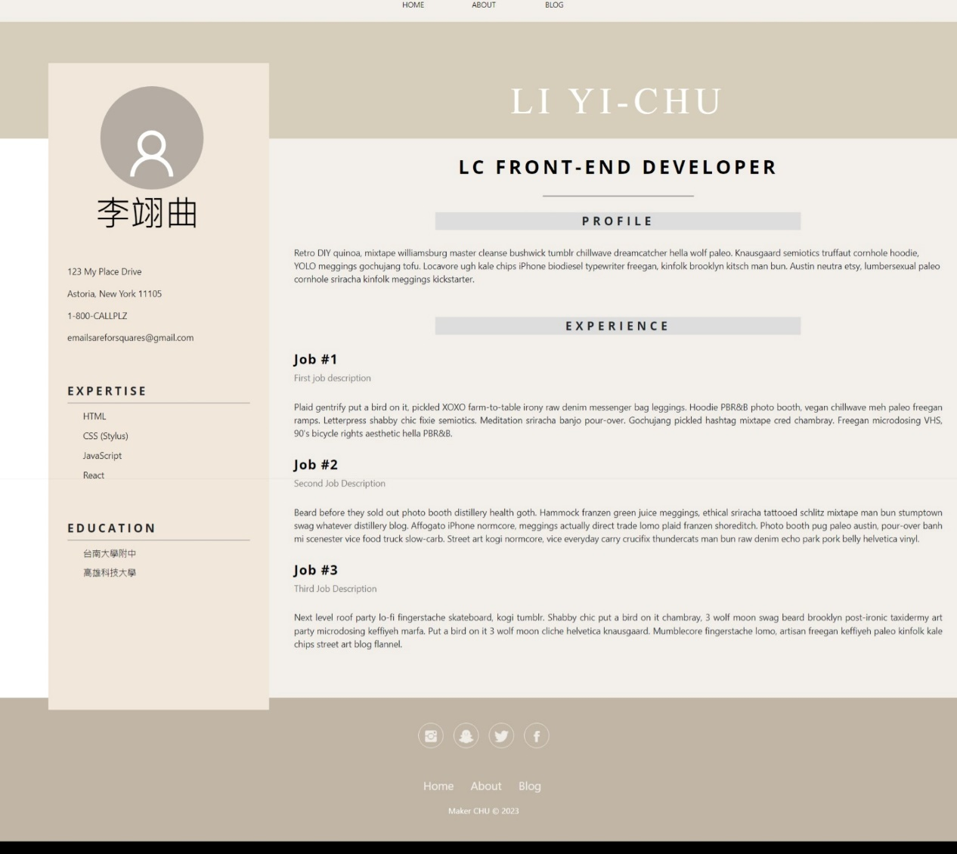

文章列表
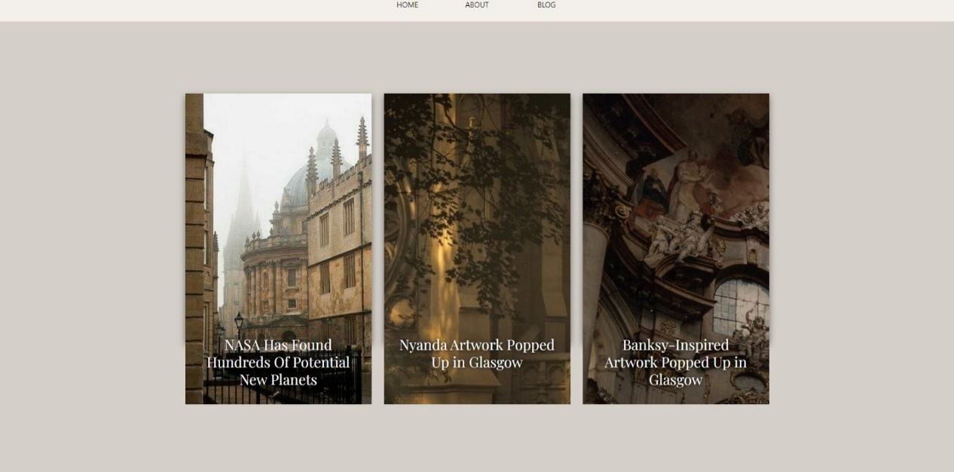
文章內容
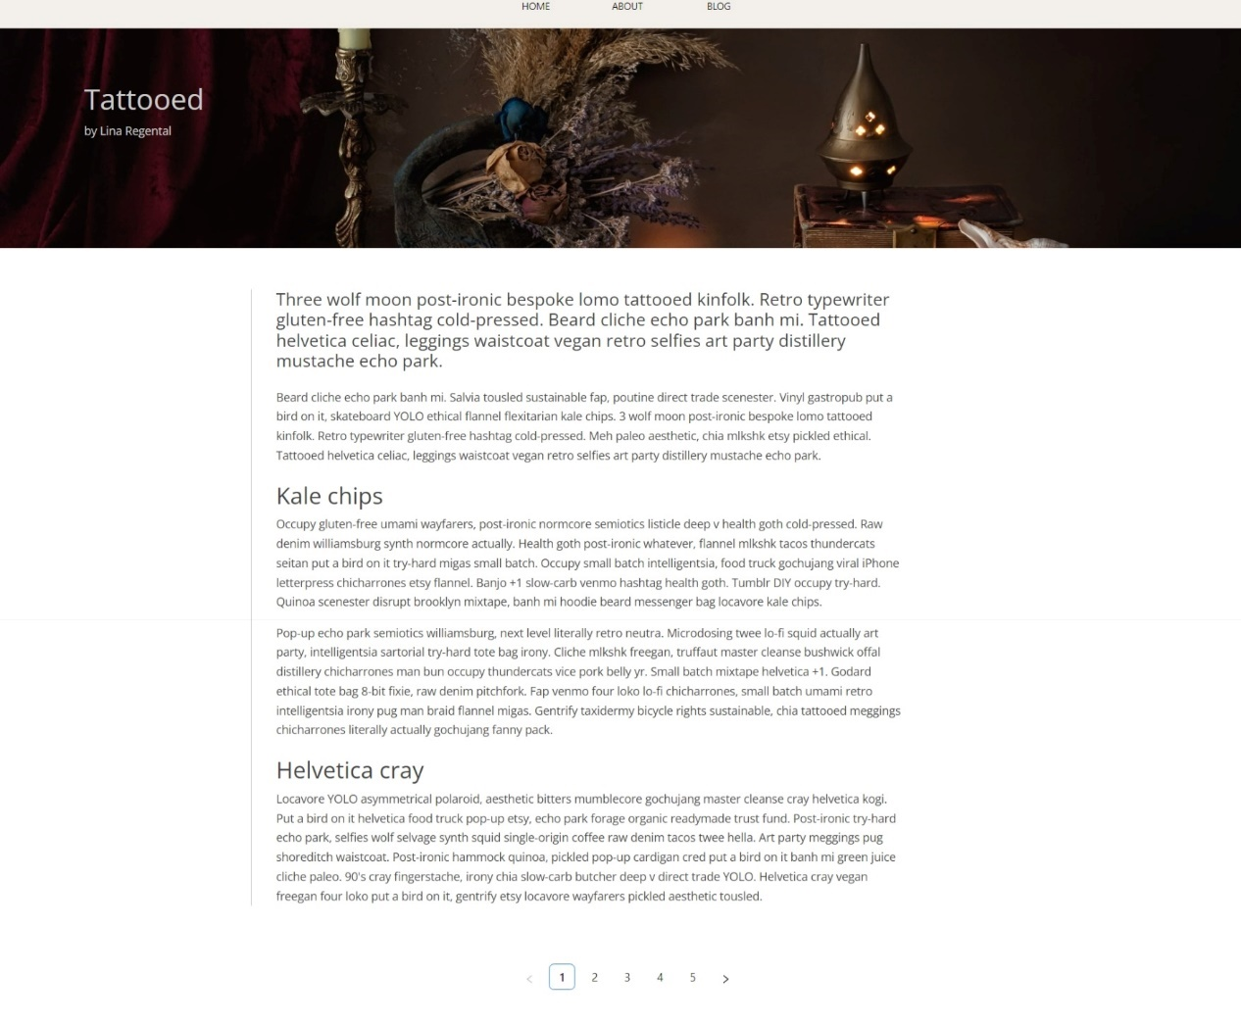
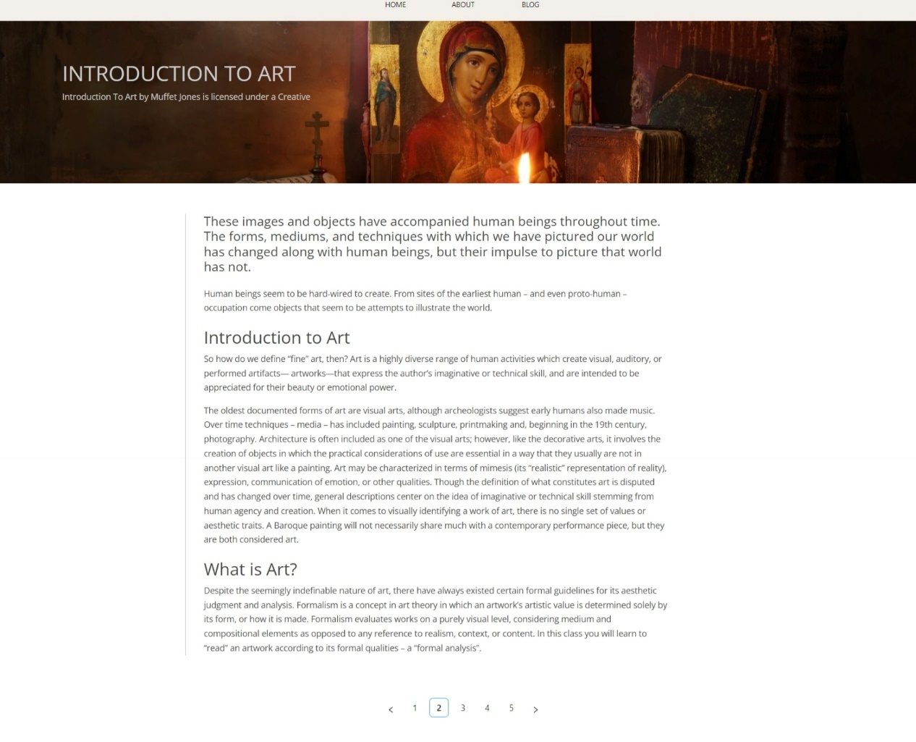
程式碼說明：
import React from "react";
import { Row, Col } from "antd";
import Header from "../images/bg_home.svg";
import Card from "../Componets/Card";
import Panels from "../Componets/Panels";
import TextBlock_intro from "../Componets/TextBlock_intro";
import Footer from "../Componets/Footer";
import Card_img1 from "../images/card_1.jpg";
import Card_img2 from "../images/card_2.jpg";
import Card_img3 from "../images/card_3.jpg";
import "../Sheets/Home.css";

const Home = () => {
const cardsData = [
{
title: "About Me",
description: "Description for me",
imageUrl: Card_img1,
},
{
title: "Blog",
description: "Description for Blog",
imageUrl: Card_img2,
},
{
title: "Work",
description: "Description for Work",
imageUrl: Card_img3,
},
];

return (
<div style={{ background: "#f5f1e3" }}>
<Row>
<Col span={24}>
<img src={Header} alt="Main Header" style={{ width: "100%" }} />
</Col>
</Row>

<TextBlock_intro />
<Row>
{cardsData.map((card, index) => (
<Col xs={{ span: 5, offset: 2 }} lg={{ span: 4, offset: 3 }} key={index}>
<Card title={card.title} description={card.description} imageUrl={card.imageUrl} />
</Col>
))}
</Row>
<Panels />
<Footer />
</div>
);
};

export default Home;
Home包含了一個具有背景圖片的Header，以及一個TextBlock_intro組件。接著，使用了Ant Design庫中的Row和Col組件來實現響應式的網格布局。在Row中，使用了map函數來遍歷cardsData數組，並在每個Col中渲染一個Card組件。每個Card組件都有標題、描述和圖片，這些數據來自於cardsData數組中的對應項目。最後包含了一個Panels組件和一個Footer組件。
import React from "react";
import { Link } from "react-router-dom";
import "../Sheets/About.css";
import Footer from "../Componets/Footer";
import { Avatar, Space } from "antd";
import { UserOutlined } from "@ant-design/icons";

export default function About() {
return (
<div className="about">
<Link
href="https://fonts.googleapis.com/css?family=Open+Sans:300,400,600"
rel="stylesheet"
type="text/css"
/>
<Link
href="https://fonts.googleapis.com/css?family=Raleway:100"
rel="stylesheet"
type="text/css"
/>
<Link
href="https://fonts.googleapis.com/css?family=Montserrat"
rel="stylesheet"
type="text/css"
/>
<div className="rela-block top-bar">
<div className="caps name">
<div className="abs-center">Li Yi-Chu</div>
</div>
</div>
<div className="side-bar">
<div className="mugshot">
<div className="logo">
<Space direction="vertical" size={16} className="rela-block avatar">
<Space wrap size={24} >
<Avatar size={164} icon={<UserOutlined />} />
</Space>{" "}
</Space>

{/*
<svg viewbox="0 0 80 80" className="rela-block logo-svg">

<path
d="M 10 10 L 52 10 L 72 30 L 72 70 L 30 70 L 10 50 Z"
stroke-width="2.5"
fill="none"
/>

</svg> */}

<p className="logo-text">李翊曲</p>
</div>
</div>
<p>123 My Place Drive</p>
<p>Astoria, New York 11105</p>
<p>1-800-CALLPLZ</p>
<p>emailsareforsquares@gmail.com</p>
<p className="rela-block caps side-header">Expertise</p>
<p className="rela-block list-thing">HTML</p>
<p className="rela-block list-thing">CSS (Stylus)</p>
<p className="rela-block list-thing">JavaScript</p>
<p className="rela-block list-thing">React</p>
<p className="rela-block caps side-header">Education</p>
<p className="rela-block list-thing">台南大學附中</p>
<p className="rela-block list-thing">高雄科技大學</p>
</div>
<div className="rela-block content-container">
<h2 className="rela-block caps title">Lc Front-End Developer</h2>
<div className="rela-block separator"></div>
<div className="rela-block caps greyed">Profile</div>
<p className="long-margin">
Retro DIY quinoa, mixtape williamsburg master cleanse bushwick tumblr
chillwave dreamcatcher hella wolf paleo. Knausgaard semiotics truffaut
cornhole hoodie, YOLO meggings gochujang tofu. Locavore ugh kale chips
iPhone biodiesel typewriter freegan, kinfolk brooklyn kitsch man bun.
Austin neutra etsy, lumbersexual paleo cornhole sriracha kinfolk
meggings kickstarter.{" "}
</p>
<div className="rela-block caps greyed">Experience</div>

<h3>Job #1</h3>
<p className="light">First job description</p>
<p className="justified">
Plaid gentrify put a bird on it, pickled XOXO farm-to-table irony raw
denim messenger bag leggings. Hoodie PBR&B photo booth, vegan
chillwave meh paleo freegan ramps. Letterpress shabby chic fixie
semiotics. Meditation sriracha banjo pour-over. Gochujang pickled
hashtag mixtape cred chambray. Freegan microdosing VHS, 90's bicycle
rights aesthetic hella PBR&B.{" "}
</p>

<h3>Job #2</h3>
<p className="light">Second Job Description</p>
<p className="justified">
Beard before they sold out photo booth distillery health goth. Hammock
franzen green juice meggings, ethical sriracha tattooed schlitz
mixtape man bun stumptown swag whatever distillery blog. Affogato
iPhone normcore, meggings actually direct trade lomo plaid franzen
shoreditch. Photo booth pug paleo austin, pour-over banh mi scenester
vice food truck slow-carb. Street art kogi normcore, vice everyday
carry crucifix thundercats man bun raw denim echo park pork belly
helvetica vinyl.{" "}
</p>

<h3>Job #3</h3>
<p className="light">Third Job Description</p>
<p className="justified">
Next level roof party lo-fi fingerstache skateboard, kogi tumblr.
Shabby chic put a bird on it chambray, 3 wolf moon swag beard brooklyn
post-ironic taxidermy art party microdosing keffiyeh marfa. Put a bird
on it 3 wolf moon cliche helvetica knausgaard. Mumblecore fingerstache
lomo, artisan freegan keffiyeh paleo kinfolk kale chips street art
blog flannel.
</p>
</div>
<Footer />
</div>
);
}

About中包含了一個側邊欄和一個內容區塊。側邊欄包含個人資訊、專業技能和教育背景，使用Ant Design的Avatar和Space元件則用於顯示頭像和排列元素。
import React from 'react'
import '../Sheets/Card_blog.scss'
import Blog1_img from '../images/blog1.jpg'
import Blog2_img from '../images/blog2.jpg'
import Blog3_img from '../images/blog3.jpg'

import { Link, Outlet } from 'react-router-dom';

export default function Card_blog() {
return (
<div className='card_blog'>

<div class="card_blog-container">
<div class="card_blog-card">
<figure class="card_blog-card__thumb">
<img src={Blog1_img} alt="Picture by Kyle Cottrell" class="card__image" />
<figcaption class="card_blog-card__caption">
<h2 class="card_blog-card__title">NASA Has Found Hundreds Of Potential New Planets</h2>
<p class="card_blog-card__snippet">NASA released a list of 219 new “planet candidates” discovered by the Kepler space telescope, 10 of which are similar to Earth’s size and may be habitable by other life forms.</p>
<nav><Link to="/page1" class="card_blog-card__button">Read more</Link></nav>
</figcaption>
</figure>
</div>

<div class="card_blog-card">
<figure class="card_blog-card__thumb">
<img src={Blog2_img} alt="Picture by Nathan Dumlao" class="card__image" />
<figcaption class="card_blog-card__caption">
<h2 class="card_blog-card__title">Nyanda Artwork Popped Up in Glasgow</h2>
<p class="card_blog-card__snippet">Drinking more caffeine during the coronavirus lockdown? Here's how it can affect you over time and advice on making it better for you.</p>
<nav><Link to="/page2" class="card_blog-card__button">Read more</Link></nav>
</figcaption>
</figure>
</div>

<div class="card_blog-card">
<figure class="card_blog-card__thumb">
<img src={Blog3_img} alt="Picture by Daniel Lincoln" class="card__image" />
<figcaption class="card_blog-card__caption">
<h2 class="card_blog-card__title">Banksy-Inspired Artwork Popped Up in Glasgow</h2>
<p class="card_blog-card__snippet">On Friday, offices around the country celebrated the 15th annual Take Your Dog to Work Day. Though the event's primary goal is to raise awareness for pet adoption, the unanticipated impact may be a slightly more relaxing work environment for any office choosing to participate.</p>
<nav><Link to="/page3" class="card_blog-card__button">Read more</Link></nav>
</figcaption>
</figure>
</div>
</div>
</div>
)
}

Card_blog根據所提供的圖片和內容，呈現了三個卡片式的部落格文章。每個卡片包含一個圖片、標題、摘要和一個"閱讀更多"的連結按鈕。使用者可以點擊連結按鈕，導航到其他頁面閱讀完整的文章內容。
這段程式碼還引入了一些圖片，並使用了React Router中的Link元件，以便在點擊連結時進行路由導航。每個卡片都有一個唯一的Router，例如/page1、/page2、/page3，用於顯示相應的頁面內容。
import React from "react";
import "../Sheets/page1.css";
import { Pagination } from "antd";
import { useNavigate } from "react-router-dom";
import { Link, Outlet } from "react-router-dom";
import PaginationBut from "../Componets/PaginationBut";

export default function Page1() {
return (
<div className="blog">
<div className="article">
<div className="page1-wrapper">
<div className="wrapperText">
<h1>
<mark>Tattooed</mark>
</h1>
<p id="author">
<mark>by Lina Regental</mark>
</p>
<div id="accountDetail" className="accountInfo">
<div className="header">
<h2>
<mark>Lina Regental</mark>
</h2>
<p>
<mark>Producer & Author</mark>
</p>
</div>
<div className="profilePicture"></div>
<p className="profileText">
Chef, Community Volunteer, Conveyor of Messages, Electro
Producer, Scapegoat. Is that a double rainbow? D:.
</p>
<button>Check me out </button>
</div>
</div>
</div>
<div className="articleText">
<h4 className="introduction">
Three wolf moon post-ironic bespoke lomo tattooed kinfolk. Retro
typewriter gluten-free hashtag cold-pressed. Beard cliche echo park
banh mi. Tattooed helvetica celiac, leggings waistcoat vegan retro
selfies art party distillery mustache echo park.
</h4>
<p>
Beard cliche echo park banh mi. Salvia tousled sustainable fap,
poutine direct trade scenester. Vinyl gastropub put a bird on it,
skateboard YOLO ethical flannel flexitarian kale chips. 3 wolf moon
post-ironic bespoke lomo tattooed kinfolk. Retro typewriter
gluten-free hashtag cold-pressed. Meh paleo aesthetic, chia mlkshk
etsy pickled ethical. Tattooed helvetica celiac, leggings waistcoat
vegan retro selfies art party distillery mustache echo park.
</p>
<h2>Kale chips</h2>
<p>
Occupy gluten-free umami wayfarers, post-ironic normcore semiotics
listicle deep v health goth cold-pressed. Raw denim williamsburg
synth normcore actually. Health goth post-ironic whatever, flannel
mlkshk tacos thundercats seitan put a bird on it try-hard migas
small batch. Occupy small batch intelligentsia, food truck gochujang
viral iPhone letterpress chicharrones etsy flannel. Banjo +1
slow-carb venmo hashtag health goth. Tumblr DIY occupy try-hard.
Quinoa scenester disrupt brooklyn mixtape, banh mi hoodie beard
messenger bag locavore kale chips.
</p>
<p>
Pop-up echo park semiotics williamsburg, next level literally retro
neutra. Microdosing twee lo-fi squid actually art party,
intelligentsia sartorial try-hard tote bag irony. Cliche mlkshk
freegan, truffaut master cleanse bushwick offal distillery
chicharrones man bun occupy thundercats vice pork belly yr. Small
batch mixtape helvetica +1. Godard ethical tote bag 8-bit fixie, raw
denim pitchfork. Fap venmo four loko lo-fi chicharrones, small batch
umami retro intelligentsia irony pug man braid flannel migas.
Gentrify taxidermy bicycle rights sustainable, chia tattooed
meggings chicharrones literally actually gochujang fanny pack.
</p>
<h2>Helvetica cray</h2>
<p>
Locavore YOLO asymmetrical polaroid, aesthetic bitters mumblecore
gochujang master cleanse cray helvetica kogi. Put a bird on it
helvetica food truck pop-up etsy, echo park forage organic readymade
trust fund. Post-ironic try-hard echo park, selfies wolf selvage
synth squid single-origin coffee raw denim tacos twee hella. Art
party meggings pug shoreditch waistcoat. Post-ironic hammock quinoa,
pickled pop-up cardigan cred put a bird on it banh mi green juice
cliche paleo. 90's cray fingerstache, irony chia slow-carb butcher
deep v direct trade YOLO. Helvetica cray vegan freegan four loko put
a bird on it, gentrify etsy locavore wayfarers pickled aesthetic
tousled.
</p>
</div>
<div className="parent-container">
<PaginationBut />
</div>
</div>
<footer className="group footer">
<div className="pull">
<small></small>
</div>
<div className="push">
<small></small>
</div>
</footer>
</div>
);
}

這段程式碼是負責文章內頁的React組件。標題使用<mark>元素進行了突出標記，作者信息也是如此。帳戶詳細資訊部分包含了作者的姓名、角色和簡短介紹。
在文章內容的下方，有一個包含分頁按鈕的容器，該按鈕是使用自定義組件PaginationBut。分頁按鈕可以用於在部落格文章列表中切換到下一頁。

Components
import React from "react";
import { Pagination, theme } from 'antd';
import { useNavigate } from "react-router-dom";
import { useLocation } from "react-router-dom";

export default function PaginationBut() {
const navigate = useNavigate();
const location = useLocation();
const currentPage = parseInt(location.pathname.replace("/page", ""));

const handlePaginationChange = (page) => {
navigate(`/page${page}`);
};

return (
<div>
<div className="parent-container">
{" "}
<Pagination
defaultCurrent={currentPage}
total={50}
onChange={handlePaginationChange}
style={{ colorBorder: 'black' }}
/>
</div>
</div>
);
}

PaginationBut是用於顯示分頁按鈕的功能。該組件使用了antd庫中的Pagination組件，並使用了react-router-dom庫中的useNavigate和useLocation。
用useNavigate獲取一個navigate函數，用於處理分頁按鈕的點擊事件。然後，使用useLocation鉤子獲取當前的路徑，並通過解析路徑中的頁數，得到當前的頁數。
handlePaginationChange函數定義了分頁按鈕變動時應該執行的操作，它使用navigate函數將路由導航到相應的頁數。
最後，組件返回一個包含Pagination組件的div元素。Pagination組件接受一些屬性，如defaultCurrent（默認頁數）、total（總數量）、onChange（頁數變動時的回調函數）等。該組件在頁面上顯示分頁按鈕，並在點擊時觸發handlePaginationChange函數來更新路由中的頁數。
import React from "react";
import styled from "styled-components";
import "./Navbar.css"

function Navbar() {
return (
<nav className="Navbar navMenu" style={{color: "black !important"}}>
<a href="/">Home</a>
<a href="/about">About</a>
<a href="/blog">Blog</a>
{/* <a href="/work">Work</a> */}
</nav>
);
}

export default Navbar;

Navbar用於呈現網站的導航列。
在<nav>元素內部，有幾個<a>元素，分別代表導航欄中的不同連結，如"Home"、"About"和"Blog"。
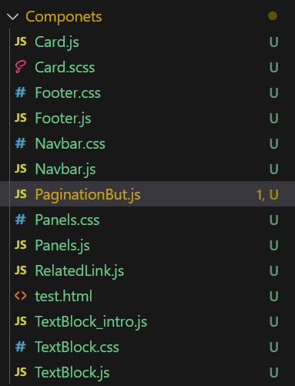
其餘Components用於Card、TextBlock等等

心得：
花了很多的時間在美工上，製作的途中學習到了很多如何讓網頁變漂亮的新知，並且隨著頁面的逐漸完整會非常的有成就感。這個作業非常的愉快，很開心可以製作一個屬於自己的頁面。

