

**American College of Technology (ACT)**

**Department of Computer Science**

**Undergraduate Project Proposal**

**Title: Techsync Ethiopian Developer Platform**

**Group Members**

**Name ID**

1. **Samuel Yohannes RCDS-178-21A**
2. **Yeabsra Awgchew RDCS-194-21A**

**Advisor Name: ___________________________ Signature:____________**

**22/03/24**

Table of Contents

1. Introduction: 1

1.1. Background: 1

1.2. Statement of the Problem: 2

1.3. Objectives: 2

1.3.1. General Objective: 2

1.3.2. Specific Objectives: 3

1.4. Methodology: 3

1.4.1. Investigation (Fact-Finding) Methods 3

1.4.2. System Development Tools: 4

**1.4.3 Software Development Process:** 5

1.5. Scope and Limitation: 6

Scope: 6

Limitations: 7

1.6. Significance of the Project: 7

1.7. Beneficiaries of the System: 8

1.8. Project Schedule: 9

# 1. **Introduction:**

## 1.1. Background:

The Ethiopian developer community, unfortunately, is faced with a range of problems which hamper the acknowledgment and influence of its innovative projects.  In this context, we’ll be using Django, JavaScript, and SQLite to develop the system. Although Ethiopia has a storehouse of talents and some localized solutions, this group still seems to be unheard and underappreciated. This is amplified by the lack of centralized platforms for exposing projects, communication platforms that are disintegrated, and language barrier within the community. That being said, many of the valuable local solutions stay in place, restricting their chances to handle the social issues as well as they could.

In addition, they slow down tech industry's ability to grow. In order to tap the full potential of Ethiopian developers, we must handle these issues and create an environment that encourages such things as collaboration and innovation. This would lead to the sustainable development of the tech ecosystem.

Moreover, the establishment of effective platforms for project visibility and collaboration, alongside mechanisms for career advancement and job matching, is crucial for leveraging local talent to drive innovation and progress within the tech industry.

The system's core functionality includes facilitating project visibility, enabling collaboration among developers, supporting career advancement opportunities, and facilitating job matching within the tech industry and more on specific objectives.

Thus, the accumulated knowledge and thesis statement fixes the stage of which the coming proposal is to solve the problems faced by Ethiopian developers and the need for the solutions to drive their growth in the tech world.

# 1.2. Statement of the Problem:

The community of Ethiopian developers have multiple obstacles; these are hindrances to showcasing their innovative projects and making an impact. Plenty of talent and local solutions can be found but local developers still do not get adequate exposure that they deserve. On one hand, it makes things worse given the lack of centralized platforms for exposing projects, the fragmented communication channels, and language barriers existing in the community. Instead, a lot of valuable local solutions get trapped and cannot proceed, leading to the unfulfilled potential to deal with the wide-scale issues and depriving the tech industry from meaningful impact. Tackling these issues is pivotal for enabling the best possible developers and creating collaboration as well as innovations which in turn will build upon sustainable development in the sphere of technology. This combined background and problem statement sets the stage for a comprehensive proposal addressing the challenges faced by Ethiopian developers and the critical need for solutions to propel their growth and impact within the tech industry.

# 1.3. Objectives:

## 1.3.1. General Objective:

To establish the "TechSync Ethiopian Developers Platform" as a robust, inclusive hub fostering collaboration, visibility, and career growth for Ethiopian developers. This platform empowers individuals to contribute to the community's knowledge, offer mentorship, and benefit from collective support. By promoting innovation, collaboration, and continuous learning, it aims to elevate the standard of tech excellence in Ethiopia and drive sustainable growth within the local tech ecosystem.

## 1.3.2. Specific Objectives:

1. Facilitate Project Visibility: Develop a feature that allows developers to create comprehensive profiles and upload their projects, showcasing their work to a broader audience and enhancing their visibility within the community.
2. Enable Peer-to-Peer Messaging: Implement a direct messaging system that facilitates one-on-one communication among developers, enabling them to connect, share insights, and collaborate privately.
3. Establish Group Messaging Based On Interest-Based: Create a Dynamic functionality for developers to form/Create group or join interest-based groups where they can engage in discussions, share resources, and collaborate on projects, fostering a sense of community and collective problem-solving.
4. Event Centralization: Introduce a feature for developers to easily discover and engage with tech events in Ethiopia, overcoming current visibility challenges and fostering a vibrant tech community.
5. Develop intuitive user interfaces: that facilitate easy navigation and interaction with the application, ensuring a seamless user experience for Ethiopian developers.
6. Implement Language Localization Feature: Enable the platform to switch between multiple languages, ensuring that developers from Ethiopia's diverse linguistic backgrounds can access the website content in their preferred language.

# 1.4. Methodology:

## 1.4.1. Investigation (Fact-Finding) Methods

* Online Surveys: Deploy online surveys targeted at Ethiopian developers to assess their needs, preferences, and challenges. Surveys will include questions about desired platform functionalities, communication preferences, and barriers to project visibility and collaboration.
* Interviews: Conduct structured interviews with a representative sample of developers, including both seasoned professionals and newcomers to the industry. These interviews will delve deeper into the specific needs and expectations of developers regarding community support, job matching, and project collaboration.
* Observational Studies: Engage in observational studies by directly observing Ethiopian developers in their work environments or during community events. This method can provide valuable insights into their behaviors, workflows, and interactions, offering a more nuanced understanding of their needs and challenges.

## 1.4.2. System Development Tools:

1. Backend Development:
   * Django: Django is primarily used for backend development. It provides a framework for server-side logic, database management, authentication, and routing. With Django, developers can create robust web applications with clean, maintainable code.
2. User Interface (UI) Development:
   * HTML (HyperText Markup Language): Essential for UI development, HTML defines the structure and content of web pages, including headings, paragraphs, lists, links, and more, laying the foundation for the visual layout of websites or web applications.
   * CSS (Cascading Style Sheets): CSS controls the presentation aspects of web pages defined in HTML, including layout, colors, fonts, and spacing, enhancing the visual appeal and user experience of web applications by customizing the appearance of UI elements.
   * JavaScript: Crucial for UI development, JavaScript adds interactivity and dynamic behaviour to web pages. It enables developers to handle user events, manipulate HTML and CSS dynamically, make asynchronous requests to servers, and update content without reloading the entire page, creatingmodern,responsiveUIs.
3. Version Control:
   * Git: For tracking changes to the codebase and facilitating collaboration.
   * GitHub: For repositories and collaboration tools like issue tracking and pull requests.

## 1.4.3 Software Development Process:

Agile Software Development:

We've opted for Agile methodology, ideal for small teams like ours, for its flexibility, iterative approach, and emphasis on collaboration, transparency, and continuous improvement. Agile enables us to adapt quickly to changes, deliver working increments regularly, collaborate effectively, maintain transparency, and continuously enhance our processes and outcomes.

Testing

Testing is a crucial aspect of software development, ensuring the quality and reliability of your application. In my project, we'll be employing various testing techniques and frameworks to verify functionality, performance, and security. This includes unit testing, integration testing, and end-to-end testing. Specifically, I plan to utilize Django's built-in testing framework for backend testing, and for frontend JavaScript testing, libraries like Jest or Mocha are on my radar. These tools will help ensure that my project meets the highest standards of quality and user satisfaction.

# 1.5. Scope and Limitation:

## Scope:

1. Facilitate Project Visibility: Develop a feature that allows developers to create comprehensive profiles and upload their projects, showcasing their work to a broader audience and enhancing their visibility within the community.
2. Enable Peer-to-Peer Messaging: Implement a direct messaging system that facilitates one-on-one communication among developers, enabling them to connect, share insights, and collaborate privately.
3. Establish Group Messaging and Interest-Based Forums: Create functionality for developers to form or join interest-based groups where they can engage in discussions, share resources, and collaborate on projects, fostering a sense of community and collective problem-solving.
4. Event Centralization: Introduce a feature for developers to easily discover and engage with tech events in Ethiopia, overcoming current visibility challenges and fostering a vibrant tech community.
5. Develop Intuitive User Interfaces: Create user interfaces that facilitate easy navigation and interaction with the application, ensuring a seamless user experience for Ethiopian developers.
6. Implement Language Localization Feature: Enable the platform to switch between multiple languages, ensuring that developers from Ethiopia's diverse linguistic backgrounds can access the website content in their preferred language.
7. Development of the platform will primarily utilize Django for backend development, HTML/CSS/JavaScript for user interface development, and Git/GitHub for version control.

## Limitations:

1. Language Support: While efforts will be made to implement a language localization feature, the platform's effectiveness in addressing language barriers may be limited by the availability of translated content and the complexity of maintaining multiple language versions.
2. Internet Accessibility: The platform's accessibility may be constrained by the availability and reliability of internet connectivity in certain regions of Ethiopia, potentially limiting the reach of the platform to developers in remote areas.
3. Technical Constraints: The functionality and performance of the platform may be impacted by technical constraints such as compatibility issues with users' devices and browsers.
4. Adoption Challenges: The success of the platform may depend on the willingness of Ethiopian developers to adopt and actively engage with it, which could be influenced by factors such as awareness, trust, and perceived value.
5. Complex Workflows: The platform may not fully accommodate complex workflows related to portal jobs and events. While efforts will be made to support diverse functionalities, certain intricate processes may require additional customization or may not be fully integrated.
6. Security Vulnerabilities: The platform's security measures may encounter vulnerabilities that could pose risks to user data and system integrity. Continuous monitoring, updates, and adherence to security best practices will be essential to mitigate these risks and ensure user trust and confidentiality.

# 1.6. Significance of the Project:

The "TechSync Ethiopian Developers Platform" project holds significant potential to transform Ethiopia's tech landscape by enhancing the visibility of local developers and their projects, thereby facilitating better collaboration within a fragmented community. By providing a centralized hub for showcasing innovations, sharing knowledge, and accessing job opportunities, the platform will strengthen community ties, promote economic empowerment, and foster the development of solutions tailored to local needs. Additionally, with multilingual support, it will ensure inclusivity and inspire future generations of tech talent, propelling long-term technological growth and innovation across the region.

# 1.7. Beneficiaries of the System:

1. Ethiopian Developers:

Seasoned professionals: Experienced developers can benefit from increased visibility for their projects, networking opportunities, and access to career advancement.resources.

Newcomers to the industry: Novice developers can leverage the platform to connect with mentors, seek guidance, find inspiration and collaborate on projects, accelerating their learning curve and integration into the tech community.

1. Tech Industry Employers:

Discover talent, post openings, and engage with developers, fostering a skilled workforce.

1. Educational Institutions:

Educational institutions can utilize the platform to showcase student projects, connect with professionals, and offer internships.

1. Tech Community Organizers:

Promote events, engage wider audiences, and enrich knowledge-sharing culture.

1. Government and Policy Makers:

Utilize insights to inform policies and investments, fostering digital innovation.

1. Open-Source Community:

Contribute, share resources, and foster collaboration and innovation.

# 1.8. Project Schedule:

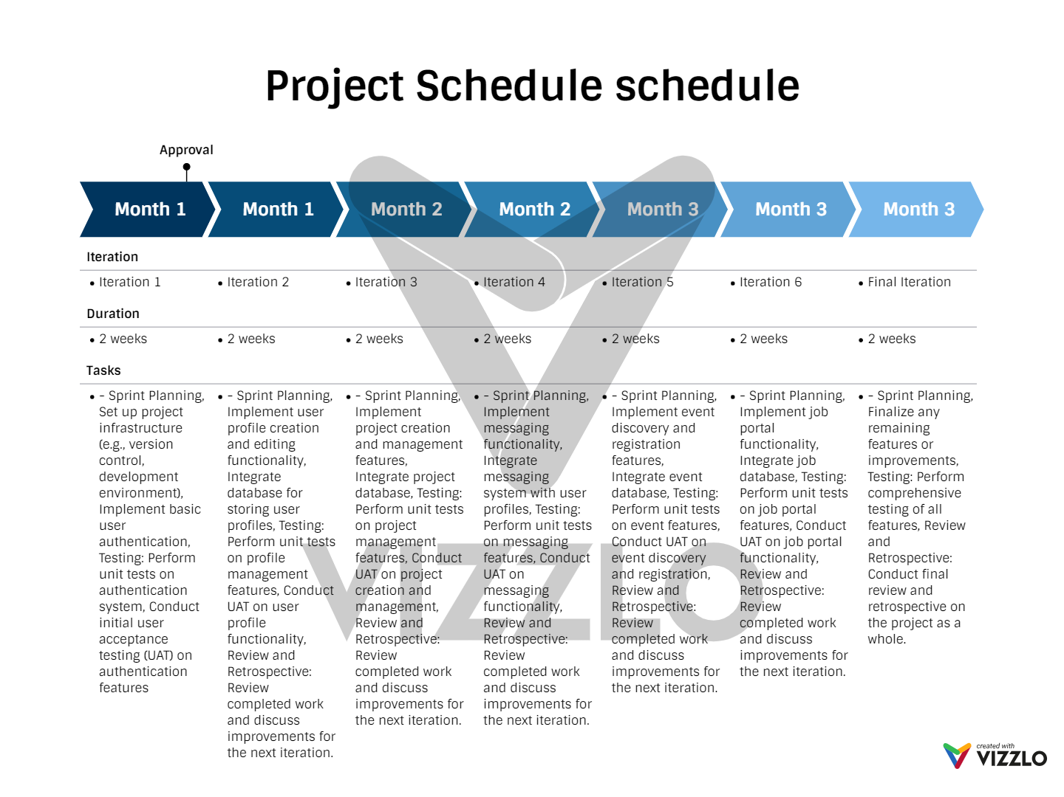

Disclaimer: The project timeline and priorities may change based on project requirements, resource availability, and stakeholder feedback. Adjustments may be made to accommodate unforeseen challenges or opportunities. Please note that ongoing classes and academic commitments may also impact the project schedule. Your understanding and flexibility are appreciated.