class04.R

Mo Tzu

2024-10-11

# My first Rscript  
x <- 1:50  
plot(x)

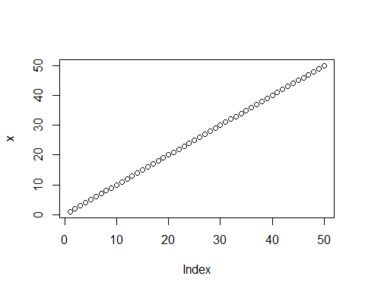

plot(x, sin(x), type="l", col="blue", lwd=3)

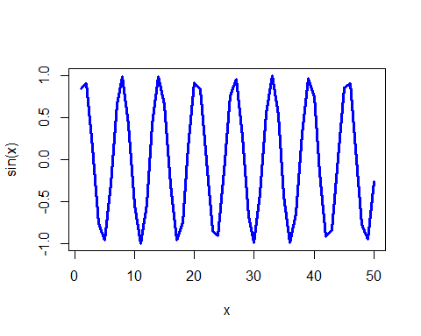

plot(x=x, y=sin(x), col="red", typ="l", lwd=3)

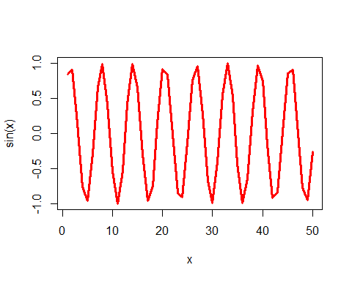

log(10, 10)

## [1] 1