Embedded C lesson2

Assignment Lab 1: you have to create a BareMetal Software to send a “learn-in-depth:<Your Name>” using UART.

1-Create App.c UART.c UART.h files and write the code.

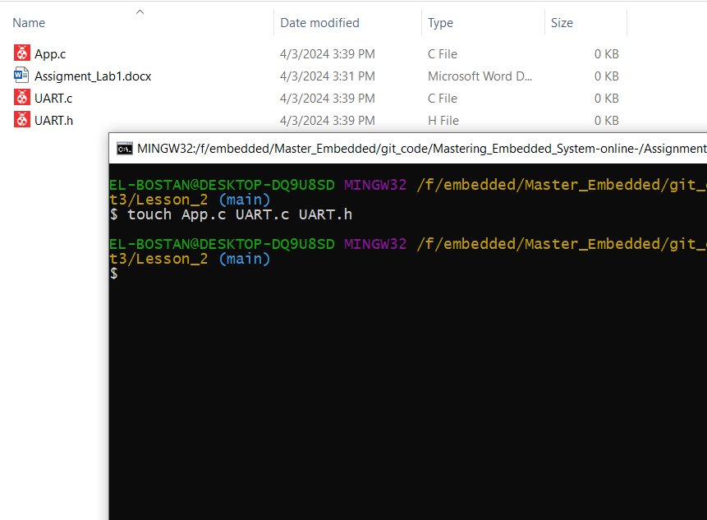

UART.c

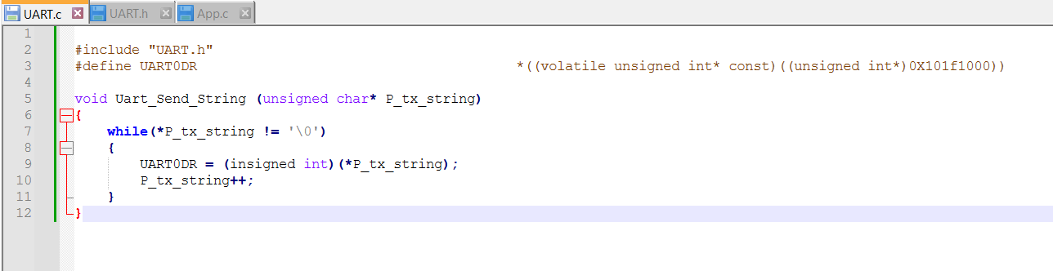

UART.h

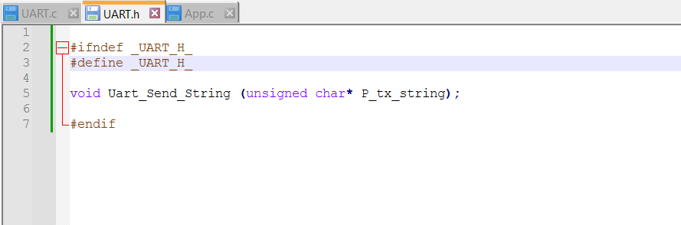

App.c

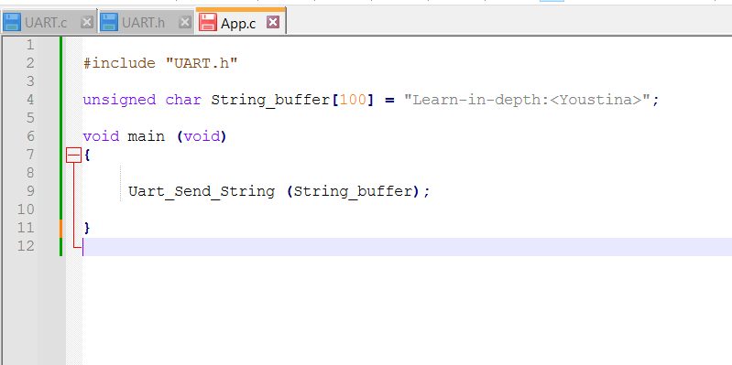

Startup.s

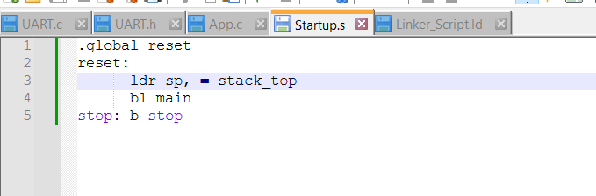

Linker_Script.ld

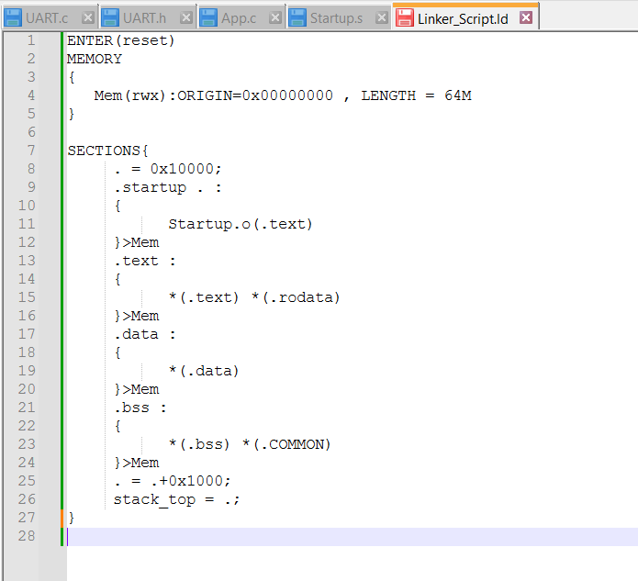

2-Object Files

-App.o



Sections

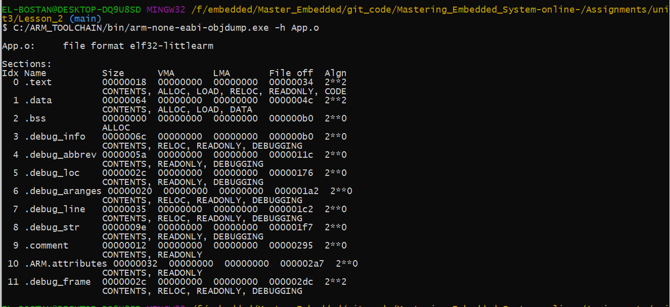

-UART.o



Sections

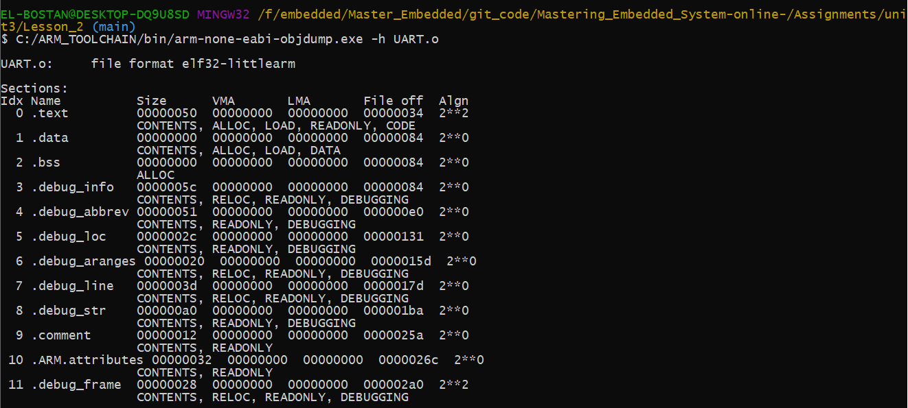

-Startup.o



Sections

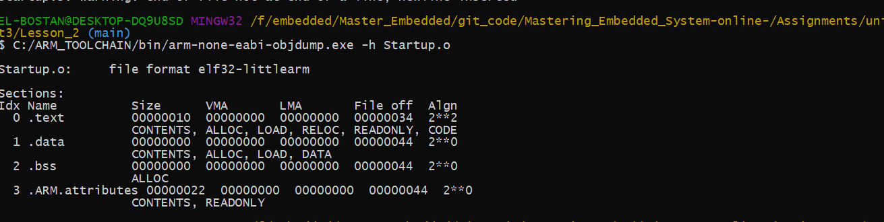

-Symbol Table

App.o



UART.o



Startup.o

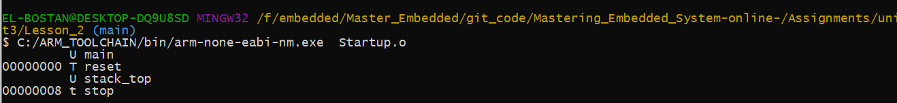

3-Excutable file APP.elf



Sections

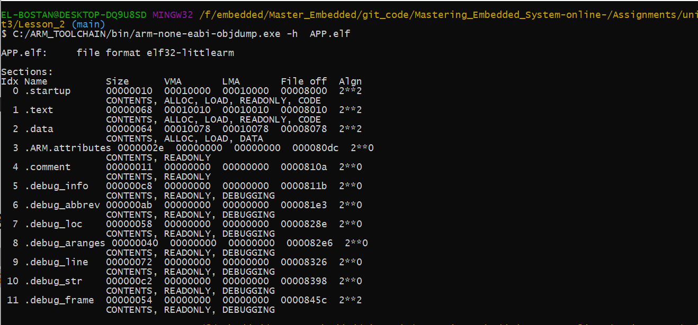

Symbol table

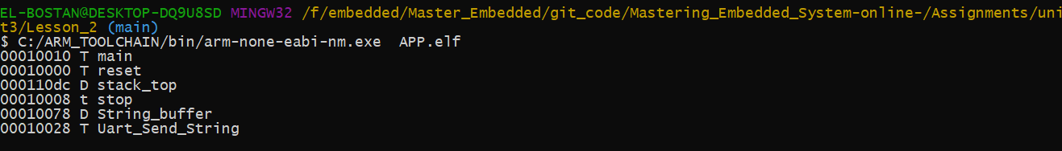

4-Binary file



5-burn the binary file on board using qemu

