Game Design Document

Fill up the Following document

1. Write the title of your project.

Emma’s Ghostly Escape

1. What is the goal of the game?

The main character, Emma must go across the map to collect a key and unlock the box to get the gem.

1. Write a brief story of your game?

Emma gets stuck in an abandoned hospital with monsteres and ghosts everywhere, she mush get past the ghosts and get the key to retrieve the gem and escape.

1. Which are the playing characters of this game?

* Playing characters are the ones which respond to the user based on the input from the user
* Cars, monkeys, dinos, wizards etc, are the playing characters in the game.

|  |  |  |
| --- | --- | --- |
| Number | Character Name | What can this character do? |
| 1 | Emma | Dodge monsters and ghosts, collect key, get gem. |

1. Which are the Non Playing Characters of this game?

* Non Playing characters are the ones which don't have an action or a behaviour when the user interacts with the game.
* Hurdles, stones, bananas, coins, etc are non playing characters in the game.

|  |  |  |
| --- | --- | --- |
| Number | Character Name | What can this character do? |
| 1 | Ghost 1 | Catch Emma |
| 2 | Ghost 2 | Catch Emma |
| 3 | Ghost 3 | Catch Emma |
| 4 | Ghost 4 | Catch Emma |
| 5 | Monsters | Catch Emma |

Draw your imagination of this game. What does this game look like?

* Draw the game either on your computer or on paper,
* Add images of scenes of the game to show each of the playing and non-playing characters at least once.

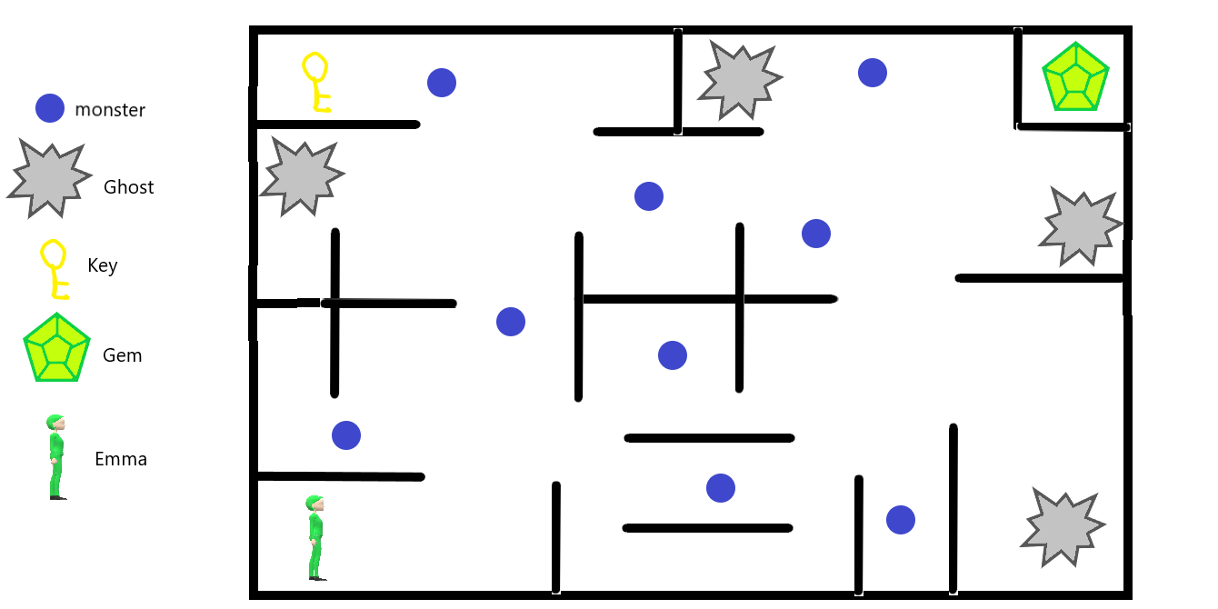

How do you plan to make your game engaging?

The non-player characters are moving on random trying to catch Emma.