**User guide**

User requerments.

Os : windows 10 operation system.

Prosessor 32\64 bit intel architected

Python packets:

Built-in modules:

os: Operating system interfaces for file handling and directory operations.

shutil: High-level file operations such as copying and removing files and directories.

hashlib: Provides hash functions, like SHA-256, used for cryptographic operations.

hmac: Implements keyed-hashing for message authentication.

sys: Provides access to system-specific parameters and functions.

External libraries:

pefile: A library for parsing and analyzing PE (Portable Executable) files on Windows.

lief: A library for parsing and modifying executable formats like PE and ELF.

angr: A binary analysis framework that helps analyze binaries, disassemble code, explore execution paths, etc.

Cryptography modules:

default_backend: Part of the cryptography library, it provides a default backend for cryptographic operations.

Cipher, algorithms, modes: Classes and functions for symmetric encryption using AES (Advanced Encryption Standard).

First, the user should generate his own pc id using Generate_PC_Id.exe file. the file will generate hex stream in fixed size. The user should send his pc id.



Then the server will generate the user license using the file License-Generator.exe given him the user id pc id as command parameter.

Requirements, server private key in the same directory as the License-Genrator.exe. if not, the file will create new RSA pair key and will use than to generate the license.





The License has created.

Now we will run time python code to generate to protected version of the software. 

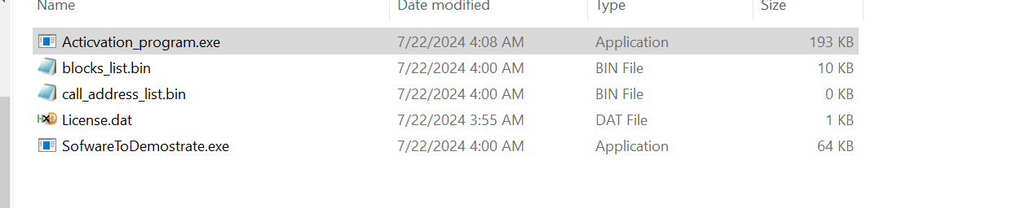

This is the output of the server. It contains all we need. Now we will send to the user everything. The last thing we need now is the activation program. for each software we want to protect the server should compile the activation with the right name and mode as he wants. After that all he needs to do is to sending the same activation software for everyone.

The all context of the folder is being send to the client. For the user to use the SofwareToDemostare.exe he will need to activate the Actiavtion_progarm.exe