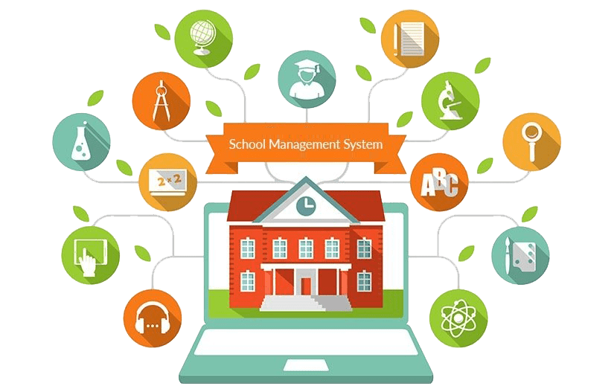

**Software Engineers / Anas Abu Zarour/ Yousef Ghanem**

Contents

Use Cases 2

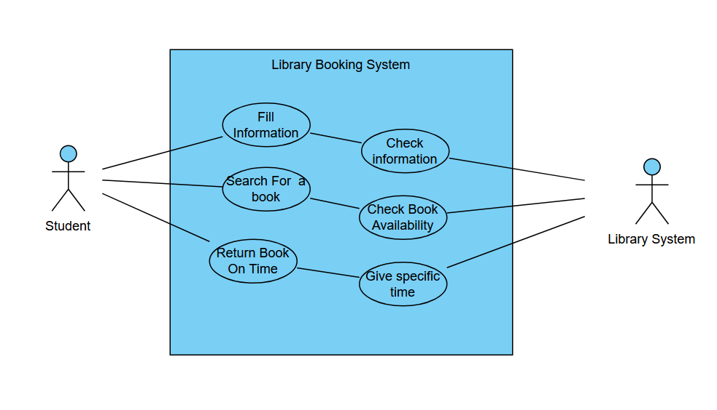Quality Attributes 2

Constraints 3

Conclusion 3

# Use Cases

# Quality Attributes

**Scalability** :

* More than one student will be using the system in future.
* Checking information frequently as system gets bigger.

**Usability :**

* The system should be user-friendly, ensuring that students can easily fill in their information and search for books without confusion.
* The user interface should be intuitive and accessible.

**Security** :

* Protect student information, such as personal details and borrowing history, from unauthorized access.
* Ensure that sensitive data is encrypted when transmitted.

## **Constraints**

* Fill information incorrectly
* Some books need pre-requests subjects for them
* Send warning fees if not returning book on time

# **Conclusion**

* This use case was designed lovely by Yousef Ghanem and Anas Abu Zarour.☺