Software engineer : Yousef

ASU university

SDD ASU

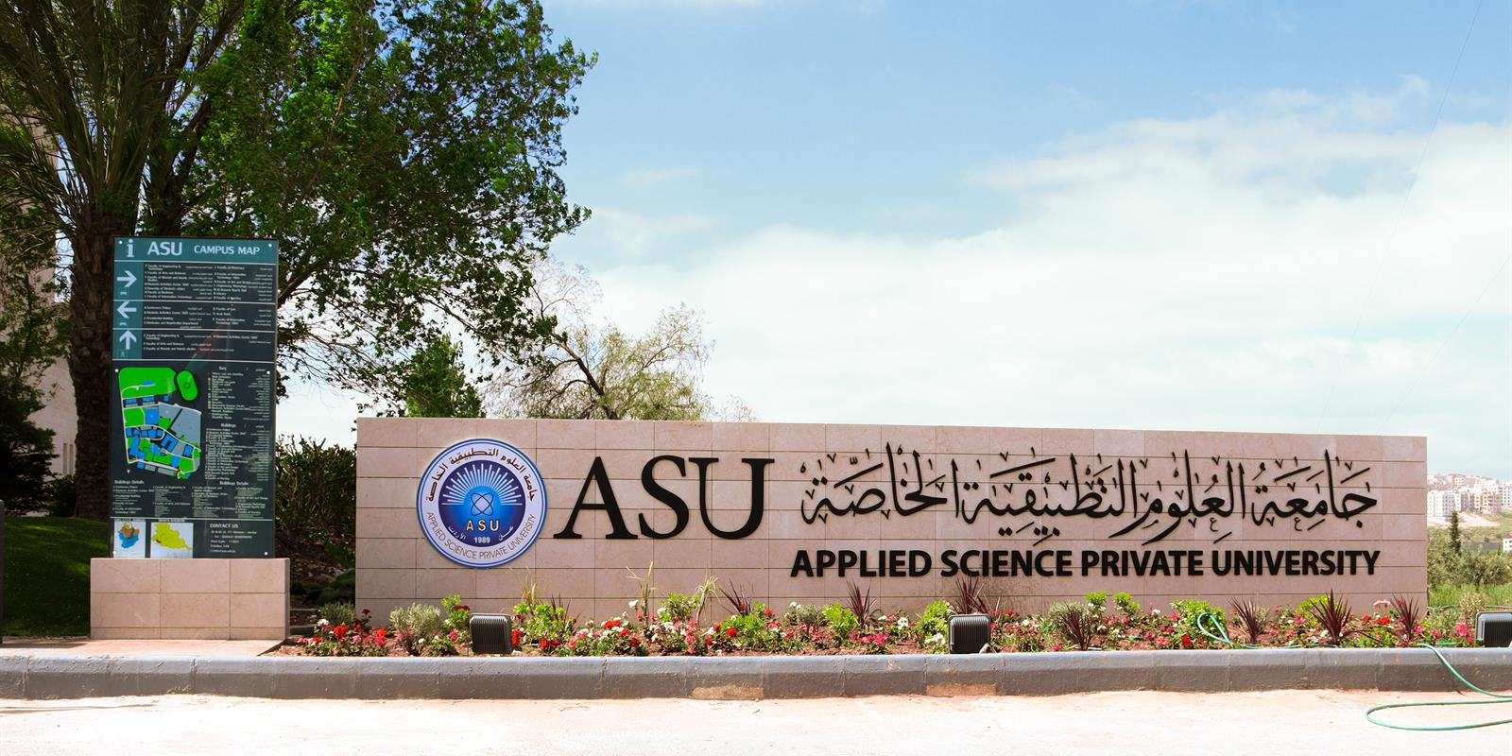

Contents

System Description 2

System Components 2

Component1 2

Component2 2

Component3 2

User Details 2

System Components2 2

Component1 2

Component2 2

Component3 2

Conclusion 2

# System Description

Simple Text

# System Components

## Component1

## Component2

## Component3

# User Details

# System Components2

## Component1

## Component2

## Component3

# Conclusion