**Nama : Yosef Andrian Kristiadi**

**NIM : 2019114019**

**Prodi : SI Enterprise 1/4**

**TUGAS PERTEMUAN KE 8**

**PI 2**

**INDEX(HOME)**

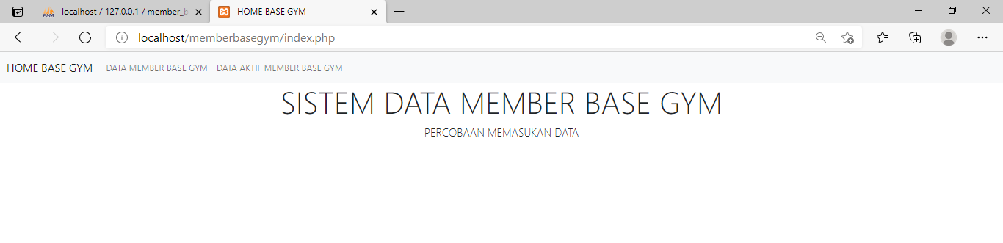

**MENU DATA MEMBER**

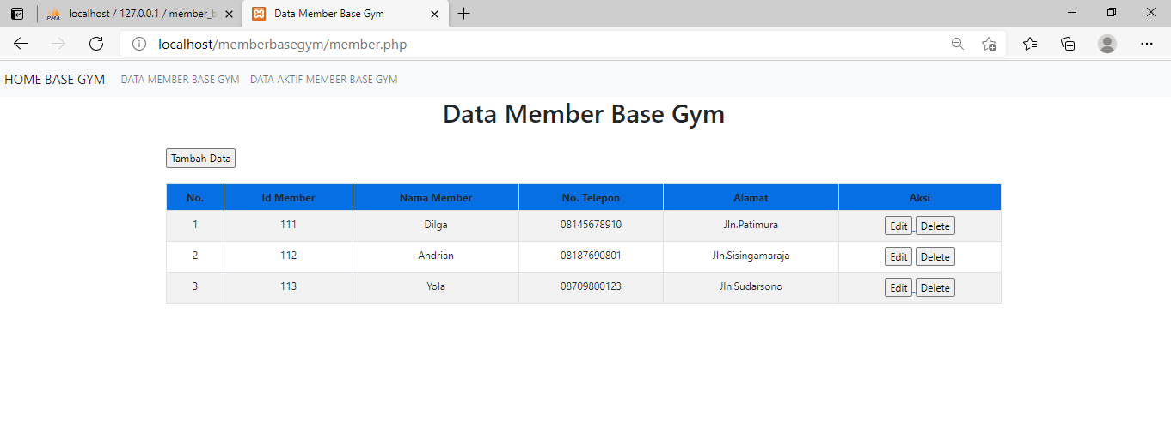

**MENU DATA MASA AKTIF**

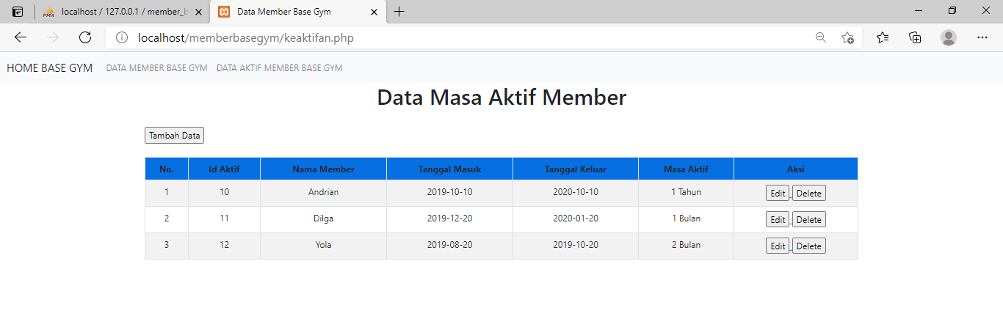

**TAMBAH DATA**

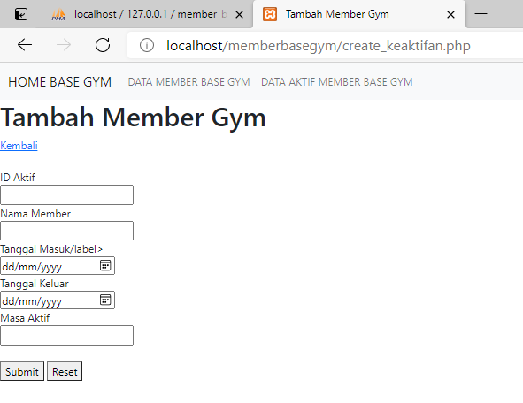

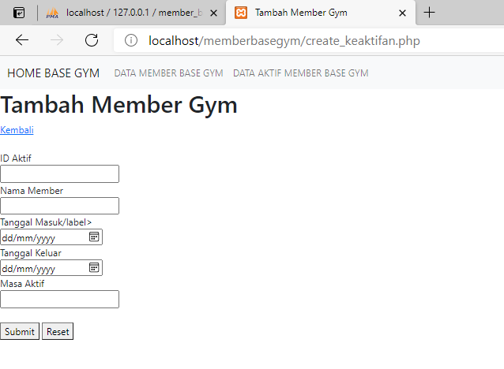

**DATA BASE**

