BCSE307P Compiler Design Lab
Innovative Project

A Multi-Language Code Translator

by
Reg No  24BCE2812  24BCE2803  24BCE2707 | Team Member Names  Yoshita Vanapalli  Vatsala Rai  Jahnavi Sharma

Under the Supervision of
Prof. MUTHUNAGAI S U
Assistant Professor Sr. Grade-2
School of Computer Science Engineering and Information Systems


November 2026

- Abstract:
Maintaining and migrating legacy programs written in COBOL, FORTRAN, Pascal and BASIC can be costly. Original developers may no longer be available, documentation can be incomplete, and modernization teams must preserve behavior while moving code into maintainable environments. Translating an entire program with a large language model (LLM) is convenient, but generated code can be plausible without being correct. A translator that cannot explain its decisions or demonstrate behavioral agreement is difficult to trust in a production migration.
The project, titled A Multi-Language Code Translator and implemented as the Multi-Language Legacy Code Modernizer, is a compiler-design prototype for documented subsets of COBOL, FORTRAN, Pascal, BASIC and a project-specific Python-like language, with JavaScript and Python target backends. Each source language is tokenized and parsed, lowered to a shared intermediate representation (IR) and translated by deterministic rules. When the parser reports unsupported syntax and a model is configured, an optional LLM path requests a complete-program candidate. The candidate is displayed separately from the deterministic output and is never accepted automatically.
The prototype is written in Python with a FastAPI backend and a single-page HTML/CSS/JavaScript interface that exposes tokens, symbol-table information, IR metadata, rule usage, pipeline traces and validation evidence. Contracts and risk affect local output eligibility and learned-rule storage; risk selects repeatability checks and high-risk human review. Learned-rule memory stores bounded exact-schema templates and revalidates matches. These are implemented safeguards, but their causal effect on correctness has not been established.
The benchmark corpus manifest holds 42 records: 16 development records and 26 held-out cases across eight task groups (Loops, Maximum of two numbers, and six CodeNet AtCoder task groups: p02600, p02606, p02607, p03997, p02724, and p03238). On this held-out pilot, deterministic JavaScript and Python runs each matched all 22 supported outputs and 34/34 supported input fixtures, while correctly recognizing all 4 expected-unsupported cases (three COBOL PERFORM variants and one CodeNet array-input case). However, this scale represents an inspectable pilot rather than a statistically significant empirical software-engineering benchmark. In controlled 5-repeat ablation experiments (controlled_ablation_live_v9 / v3), deterministic rule-only and hybrid LLM arms produced identical final outputs (0% causal improvement, with zero LLM candidates accepted into the final codebase due to strict validation and review gates). The front ends intentionally target restricted language subsets without complex features such as COBOL PERFORM/copybooks, Pascal compound records/pointers, or subroutines. Furthermore, semantic contracts and risk score formulas serve as descriptive governance policies and safety gates without empirical ablation evidence demonstrating reduced human debugging time or defect prevention.
The report covers motivation, related work, the design contribution, methodology, implementation, evaluation and limitations. The repository is listed in Section 7.
Keywords: source-to-source translation; legacy languages; compiler design; intermediate representation; deterministic rules; large language models; execution-based validation; benchmark corpus.
- Introduction:

2.1 Background and motivation
Legacy software is not simply old code waiting to be replaced. In many organizations, it encodes business rules that have been refined over years of operation. A small change to a calculation, a record layout or an exception path can affect downstream reports, customer transactions or regulatory outputs. Modernization therefore has two competing pressures: reduce the cost of maintaining old technology, while avoiding behavioral changes that are difficult to detect after deployment.
COBOL remains associated with transaction processing and administrative systems; FORTRAN is widely associated with scientific and engineering computation; Pascal has a long history in education and structured programming; and BASIC survives in a variety of teaching, scripting and embedded contexts. The actual importance of any particular language depends on the organization and codebase. This project focuses on small, documented subsets of these languages rather than attempting to parse every dialect or historical extension.

2.2 The translation problem
A source-to-source translator, often called a transpiler, takes a program in one programming language and emits a program in another. A useful translation must preserve the relevant behavior, not merely resemble the original text. Language differences make this difficult: types may not map directly, control-flow constructs can have different semantics, standard-library functions may behave differently, and source programs may rely on implicit conversions or runtime conventions.
A separate translator for every source-target pair creates duplicated work. With N source languages and M target languages, a pairwise design can require up to N × M mapping paths. A shared IR offers a more modular alternative: each source language is lowered into a common representation, and each target language receives a backend. The engineering effort then tends toward N front ends plus M back ends, although the IR itself must be expressive enough to represent the semantics needed by all supported languages.

2.3 Rule-based translation and LLM assistance
Rule-based translators are deterministic and comparatively easy to inspect. They are effective for constructs whose semantics are understood and whose target-language equivalent is known. Their weakness is coverage: every additional construct, dialect or library mapping requires implementation and testing. LLMs can propose translations for unfamiliar constructs, but their flexibility comes with variability and the risk of confident, ungrounded output.
The project combines these approaches in a fixed order: rules run first, only unsupported constructs are eligible for model assistance, and a response is never accepted automatically. The system keeps a model candidate distinct from a validated result and records the path each translation took.

2.4 Problem statement
How can a prototype translate selected constructs from several legacy languages into modern target languages while retaining compiler-style determinism where rules exist, restricting model assistance to bounded cases, and validating output through observable execution?

2.5 Objectives
- Translate documented subsets of COBOL, FORTRAN, Pascal and BASIC, plus a project-specific Python-like language, to JavaScript or Python.
- Use a shared, language-neutral intermediate representation to reduce duplicated translation logic.
- Expose tokens, symbol information, IR details, rule mappings, fallback status and pipeline traces for inspection.
- Keep LLM output untrusted until it has passed runtime and input/output validation.
- Record validation evidence, risk metadata and reusable diagnostics.
- Provide a small reproducible benchmark and a comparison harness for rule-only and hybrid modes.

2.6 Scope and exclusions
The prototype is not a complete compiler for any of the legacy languages. It does not claim support for arbitrary dialects, external libraries, file formats, full application repositories or all runtime behaviors. COBOL PERFORM is intentionally unsupported in the prototype; unsupported syntax should be reported rather than guessed. The benchmark is small and hand-curated. Its successful cases must not be generalized to untested constructs or large codebases.
The rest of this report follows the required seven main headings. Section 3 discusses the project-level novelty; Section 4 describes proposed work and evaluation policy; Section 5 records implementation details and results; Section 6 states conclusions and future work; Section 7 provides the repository link, references and supporting appendices.

2.7 Definitions used in this report
Term | Operational meaning in this report
Supported case | A benchmark case whose source constructs are within the declared subset and for which end-to-end translation is expected to run.
Expected-unsupported case | A case outside the declared subset; correct handling means recognizing and reporting unsupported syntax, not translating it successfully.
End-to-end pass | The benchmark's recorded successful outcome for a translatable case, under its current harness.
Expected-outcome match | The system outcome agrees with the manifest's expected classification, including expected unsupported recognition.
Expected-output check | Comparison against an expected output recorded independently of the source interpreter; this is a separate metric.
Rule coverage | The benchmark-required construct coverage measure, not the size of the descriptive rules catalogue and not general language coverage.
Candidate | A model-produced suggestion shown separately from deterministic output; runtime/oracle checks are finite and do not imply acceptance. Acceptance requires all recorded policy gates and human reviews.

- Novelty in Project:

3.1 Contribution is in the combination and controls
The project’s contribution is a combination of established compiler and AI-assisted engineering ideas, applied in a compact, inspectable prototype. It does not claim to invent intermediate representations, rule-based translation, LLM code generation or execution-based testing. Its project-level distinction is the way these components are arranged and the explicit states and metadata surrounding them.

3.2 Rule-first translation and optional complete-program LLM candidate generation
The deterministic rule layer is the first translation path. Where a rule covers an IR construct, the backend emits target code. When the parser reports unsupported syntax and a model is configured, the optional path sends the complete source and asks for a complete target-program candidate; it is not scoped to the unsupported subtree. That gives the model surrounding context but also exposes more code than the unsupported node alone, so privacy approval is needed before any real use.
The fallback prompt is constrained: preserve identifiers and literals, preserve side-effect order, avoid inventing APIs, return code only, and indicate UNSUPPORTED if faithful translation is not possible. Requests use temperature 0, a 45-second timeout and up to two retries with exponential back-off. Authentication and quota errors stop retries early. These settings improve operational predictability but do not guarantee deterministic responses across providers, model versions or backend changes.

3.3 Explicit acceptance states
The fallback path distinguishes candidate_generated, target_runtime_valid, semantically_validated and rejected. The states matter because syntactic or runtime success is not enough. A fragment can execute and still compute a different result. Only a candidate that meets the project’s semantic test policy should be treated as validated for that test set. The word “validated” is used here in an empirical sense, not as a claim of formal proof.

3.4 Semantic translation contract
For each translation unit, the system attaches a machine-readable contract containing information such as inputs, output type, side effects, exception expectations, source-to-target API mappings, validation evidence and confidence. The contract gives reviewers a place to inspect assumptions; it does not show that the assumptions are correct.

3.5 Risk-aware validation
The reported risk score combines five factors: data flow (weight 0.25), API uncertainty (0.20), side effects (0.20), control-flow complexity (0.20) and type mismatch (0.15). The weights sum to 1.00. Low risk is defined as a score below 0.40, medium risk as 0.40–0.74, and high risk as 0.75 or above. The project’s policy associates low-risk units with ordinary I/O validation, medium-risk units with generated tests and graph comparison, and high-risk units with fallback, mutation tests and manual review.
These thresholds are project policy rather than empirically calibrated probabilities. A score of 0.80 does not mean an 80% chance of error. The score is a prioritization mechanism, and its value will depend on whether the underlying factors reliably identify risky translations.

3.6 Learned rules and failure fingerprints
Validated fallback fragments can be appended to data/validated_examples.jsonl as project-specific reference data. The intention is to support later rule development and reduce repeated external calls. This should not be confused with automatic self-modification of the production rule table: the record is evidence for a developer to review, and a learned mapping still requires regression tests before it is promoted to a trusted rule.
Failure fingerprints classify a problem by stage, source construct, target mismatch and suggested repair, so repeated failures are easier to recognise. Whether they reduce diagnosis time or recurrence has not been measured.

3.7 Contribution summary
Design element | Purpose | Evidence currently available | Claim boundary
Shared IR | Avoid pairwise translator duplication | IR nodes, scopes and graph metadata exposed | Not proof that every language feature fits the IR
Rule-first generation | Predictable mappings for covered constructs | Rule table v1.2; recorded mappings | Coverage applies only to the documented subset
Complete-program fallback | Request complete-program candidates when unsupported syntax is reported | Provider configuration and request logging | Benefit not demonstrated on current benchmark
Acceptance states | Separate candidates from validated output | Candidate and validation status fields | Validation is limited to provided tests
Risk metadata | Prioritise stronger checks | Weighted score and thresholds documented | Weights not empirically calibrated
Failure/rule records | Support diagnosis and future maintenance | Fingerprint and validated-example mechanisms | Long-term improvement not yet measured

The prototype makes it easier to inspect how a translation was produced and why a result was accepted or rejected. Whether these controls reduce errors or maintenance effort remains to be tested, which needs a larger benchmark and experiments that isolate individual features.

3.8 Related work: compiler structure and deterministic translation
Traditional compiler design separates lexical analysis, parsing, semantic analysis, intermediate representation, optimization and code generation. A source-to-source translator can use the same separation even when it does not compile to machine code. The project follows this principle through language-specific front ends, a shared IR and target back ends. The engineering benefit is modularity and traceability; it is not, by itself, a new compiler technique.
A shared IR can reduce the number of separate source-target mapping paths. If there are N source languages and M target languages, a purely pairwise design may require up to N × M mappings. A shared representation suggests N front ends plus M back ends. This is an architectural comparison, not a measured runtime or effort reduction for this repository. It depends on whether the IR can represent the semantics of each supported construct without erasing meaningful differences.

3.9 Related work: neural and LLM translation
TransCoder explored unsupervised translation among programming languages using large-scale source code and automated execution-based evaluation [1]. CodeXGLUE provides a suite of code understanding and generation tasks, including program translation, and established a shared benchmark framework for evaluating code models [2]. XLCoST provides fine-grained parallel data across seven programming languages plus English and supports multiple cross-lingual code tasks [3]. These resources demonstrate that code translation has been studied with learned models and structured benchmarks; they do not directly establish how this legacy-subset prototype will perform.
Saha, Rabbi, Wang and Yang studied natural-language specifications as an intermediate representation for LLM code translation. Their evaluation across datasets and language-pair permutations found no consistent overall gain from the specification alone, although certain combinations showed improvements [4]. This cautions against assuming that adding an intermediate layer or richer prompt necessarily improves correctness. In the present project, the shared IR is primarily a compiler representation, not a natural-language specification, and the current evidence does not test an LLM-driven end-to-end translation path.
RepoTransBench shifts attention to repository-level translation with executable tests [5]. Its task scope is much larger than this prototype’s small, fixed-input examples. Success on the current 20-case held-out pilot should not be described as evidence of repository-level modernization capability.

3.10 Related-work comparison
Work | Approach and task scope | Validation/evidence | Distinction from this prototype
TransCoder [1] | Unsupervised neural translation among mainstream programming languages | Execution-based benchmark evaluation | Learned end-to-end model; not a legacy-subset, rule-first compiler pipeline
CodeXGLUE [2] | Benchmark suite for code understanding and generation tasks | Task-specific benchmark metrics | A benchmark framework, not this project's runtime implementation
XLCoST [3] | Parallel cross-lingual code data and ten code-intelligence tasks | Dataset and baseline model evaluations | Fine-grained data; the current project uses a small manifest with explicit unsupported cases
Saha et al. [4] | LLM translation with natural-language specifications | Three datasets and multiple language-pair permutations | The present shared IR is structural, and no current fallback efficacy result exists
RepoTransBench [5] | Repository-level translation benchmark with executable tests | Repository test-suite success | Much larger task scope than the prototype's 20-case held-out pilot
This project | Rule-first translation of documented COBOL, FORTRAN, Pascal, BASIC and Python-like subsets | 36-record manifest / 20-case held-out pilot, expected-output checks, source-interpreter comparison and pytest suite | Inspectable narrow prototype; fallback candidate integration and causal ablation remain incomplete

The comparison is intentionally qualitative. These works differ in language pairs, data sources, program granularity, model access and evaluation oracles. Their headline numbers cannot be compared directly with this project’s small pilot results. No novelty claim is based solely on the fact that a particular feature was not found in this selected reading list.
- Proposed Work:

4.1 Proposed architecture
The current implemented pipeline is organised around source-language tokenization/parsing, normalized IR construction, deterministic rule-first generation and validation of generated target output. An optional, configuration-dependent LLM path requests a complete-program candidate after unsupported syntax is reported. The candidate is displayed separately and is not automatically accepted or integrated into the deterministic program. Contract failures and non-passing validation block local eligibility and learned-rule storage; risk selects repeatability runs, with high risk also requiring human review and blocking storage. Learned-rule reuse is limited to matching supported schemas and is revalidated. These mechanisms govern safeguards, but no causal correctness benefit is established.
SOURCE PROGRAM
↓
Lexer and language-specific parser
↓
Semantic analysis + symbol table
↓
Shared language-neutral IR
↓
Deterministic rule-first generator ── match ──→ Target code
│ unsupported syntax reported
↓
Optional complete-program LLM candidate (full source sent; untrusted)
↓
Candidate remains separate; no automatic integration
↓
Target execution + source-interpreter / expected-output checks
↓
Pass / fail / expected-unsupported / review required
Figure 1. Project pipeline. The fallback is optional; a candidate is not accepted merely because a model returns code.

4.2 Front end and supported source subsets
Each language front end recognises only a limited grammar. The lexer and parser produce a language-specific syntax representation. The semantic pass resolves identifiers and builds a symbol table. Constructs outside the grammar raise an unsupported-syntax condition rather than being silently approximated. This boundary is essential: accepting syntax without understanding its meaning could lead to a misleading success status.
Language | Documented supported subset | Important boundary
COBOL | WORKING-STORAGE numeric declarations with VALUE; MOVE; COMPUTE; DISPLAY; IF/ELSE/END-IF; STOP RUN | PERFORM intentionally unsupported
FORTRAN | INTEGER/REAL declarations; assignment; PRINT *; IF/ELSE/END IF; DO/END DO | Only documented statement forms
Pascal | var declarations; assignment :=; write/writeln; if/then/else; for/to/do; while/do | Unsupported control-flow forms are rejected
BASIC | Line-numbered LET/assignment; PRINT; IF ... THEN; FOR/NEXT; END/STOP | Dialect-specific features not covered
Python-like | Project-specific grammar with indentation tokens, assignments, expressions, conditionals, loops, functions and calls | Not a claim of full Python compatibility

4.3 Shared intermediate representation
The semantic analysis stage builds a symbol table for variables, functions and parameters, pre-declares top-level functions to support forward calls, and reports undefined names. The syntax tree is lowered into a shared IR graph. Each IR node carries an identifier, kind, parent, scope, child list and fields. The interface can display node count, edge count and scope information.
The IR provides a stable boundary between front ends and target back ends. It can make rule definitions reusable across source languages, provided that the IR captures the relevant semantics. If two source languages use a construct with materially different behavior, collapsing both into an oversimplified IR node would lose information. Future extensions should therefore add explicit semantic fields or reject unsupported cases rather than force every construct into a superficial common form.

4.4 Rule-first backend
The code generator walks the normalized IR and applies a human-editable rule table, reported as version 1.3, which lists 46 catalogue entries. Examples include source assignment to target assignment, DISPLAY/PRINT/writeln to console.log or print, and IF/ELSE to target conditionals. The exact generated form depends on the source construct and target language. Each emitted mapping is recorded so the result can be audited.
Rule coverage is reported as the share of IR nodes handled by deterministic rules. It is not the same as semantic correctness. A high coverage score means many nodes matched rules; a rule may still be wrong, and a low coverage score does not necessarily mean the output is incorrect. Coverage should be reported alongside execution outcomes and failure classifications.

4.5 Optional complete-program LLM candidate protocol
When a source construct is unsupported by deterministic rules but can be represented safely for a model request, llm_fallback.py constructs a constrained prompt. The client is provider-agnostic and supports OpenAI-compatible chat or responses modes. Configuration is provided through LLM_API_URL, LLM_API_MODE, LLM_PROVIDER, LLM_MODEL and LLM_API_KEY. The default endpoint described in the project materials is Google Gemini’s OpenAI-compatible endpoint. The API key remains on the backend and is not sent to the browser.
The request log records request ID, model, prompt version and hash, attempt count, HTTP status and latency. The response is initially marked accepted=false and validation_status=not_run. A provider connection failure or absent credentials should lead to an explicit unavailable/not-run result, not to an invented translation.

4.6 Validation policy and acceptance
The validator writes generated code to a temporary file and executes it using Node.js for JavaScript or Python for Python output. A reference interpreter executes the source subset. The harness compares observable output and classifies outcomes as passed, failed or not_run. Example failure classes include runtime_unavailable, target_runtime_error, output_mismatch and unsupported_source_syntax.
A passing I/O comparison shows agreement on the tested inputs and on the output the harness captures. It says nothing about other inputs, hidden state, timing, file I/O, network interactions or exception behavior unless those are modelled and tested, and the interface should keep that visible.

4.7 Evaluation protocol
The planned controlled comparison uses the same benchmark, runtime, rule table, model, prompt version and temperature setting for the rule-only and hybrid conditions. Metrics include number of programs, rule coverage, unsupported constructs, LLM calls, target execution success, validation failures, fallback frequency and median LLM latency. Results should be broken down by language and construct type.
A meaningful hybrid evaluation needs cases that actually invoke fallback. If every benchmark case is covered by rules, equal results between the two modes are expected and cannot reveal the contribution of the model. The next experiment should include unsupported constructs with a known expected behavior, while retaining a manual review process for any ambiguous translation.

4.8 Implementation-status matrix
Component | Status | What can safely be claimed
Lexer/parser, normalized IR, deterministic generation | Implemented for declared subsets | The documented source constructs can pass through the compiler-style pipeline.
Execution and output comparison | Implemented empirical check | It compares observable output on tested cases; it is not a proof of equivalence.
LLM fallback request/candidate generation | Partially implemented; configuration-dependent | Later one-case smoke trial: both JavaScript and Python candidates passed their recorded runtime check and matched one expected output; Python also matched three fixture variants. Both remain unaccepted; not an effectiveness result.
Fallback candidate integration into generated target program | Not implemented | No claim that the model completes or repairs end-to-end output.
Semantic contract and risk score | Implemented policy gate | Contract checks gate local output eligibility and rule storage; risk selects 1/2/3 repeatability runs and high risk requires human review. No causal benefit established.
Failure fingerprints and learned-rule records | Implemented bounded memory and diagnostic workflow | Only exact supported schema templates are stored/reused and matches are revalidated; LLM candidates are not learned. Improvement is unproven.
Descriptive rule catalogue and /rules | Inspection/reporting only | Catalogue size does not equal executable coverage.
Large CodeNet corpus audit | Local audit complete; no evaluation cases admitted | 4,053 metadata files; 13,565 accepted source-present submissions across mapped COBOL/Fortran/Pascal labels. The 30-record triage screen had zero passes; licenses, original builds, fixtures and independent oracles remain pending.

4.9 Proposed workflow and data boundaries
Section 4.1 gives the pipeline; this section marks which parts run today. Source text enters a language-specific front end, the deterministic backend emits target code for covered constructs, and the validator compares the generated program's output with the limited source interpreter and, where available, a separately authored expected output. A model candidate stays outside the final target output.
The proposed design includes a feedback loop in which failed validation can trigger a new fallback translation and accepted output can grow the rule set. The repository is narrower: candidate generation exists when configured, but candidate integration is not implemented. Contracts and risk do affect local eligibility and learned-rule storage, and risk selects repeatability checks; they do not establish a measured reliability benefit. The diagram below separates the implemented path from the proposed one.
IMPLEMENTED PATH
Source → Lexer/Parser → Semantic Analysis → Shared IR → Rule-first Generator → Target Execution
↘ unsupported construct → diagnostic / optional candidate request
Target output + source interpreter + expected-output record → comparison → pass / fail / not_run
PROPOSED EXTENSION (NOT CURRENTLY END-TO-END)
Candidate → independent validation gate → human-reviewed integration → regression suite → rule promotion
Figure 2. Current and proposed data flow. Candidate integration and rule promotion are future work, not current end-to-end behavior.

4.10 Pseudocode for current translation policy
parse(source, language)
if parse_error:
return unsupported_or_parse_diagnostic
ir = lower_to_shared_ir(ast)
for node in ir:
if deterministic_rule_exists(node):
emit_target(node)
else:
record_unsupported(node)
if llm_is_configured:
record_candidate_request(node) # suggestion only
# Candidate is not merged into target output.
run_target_if_generated()
compare_observed_output()
record_pass_fail_or_not_run()
The pseudocode is a conceptual summary of the status described in the project evidence, not a verbatim source-code excerpt. It makes the key control decision visible: the fallback request does not automatically alter the generated target program.
- Implementation & Screenshots:

5.1 Technology stack and repository structure
The project uses a Python 3 backend using FastAPI, Uvicorn, Pydantic, python-dotenv and pytest. The front end is a single static HTML/CSS/JavaScript page. Node.js is required to execute JavaScript targets. The Python, JavaScript, HTML and CSS under backend/, frontend/, tests/ and transpiler/ total about 4,300 lines (counted at commit a06e15e).
Module / path | Responsibility
backend/lexer.py | Tokenisation for the Python-like language, including INDENT/DEDENT and indentation diagnostics
backend/parser.py, ast_nodes.py | Recursive-descent parser and dataclass AST nodes
backend/legacy.py | Legacy-subset front ends and JavaScript/Python code generators
backend/semantic.py | Symbol table, function pre-declaration and name resolution
backend/ir.py | Language-neutral IR graph and scope metadata
backend/rules.py | Versioned, human-editable rule table
backend/transpiler.py | Pipeline orchestration, contract, risk score, diagnostics and rule-learning record
backend/llm_fallback.py | Provider-agnostic client, retries, request logging and connection test
backend/validator.py, interpreter.py | Reference execution, target execution and output comparison
backend/benchmark.py, evaluate.py | Curated benchmark and rule-only/hybrid experiment
backend/main.py, frontend/ | FastAPI application, REST endpoints and web UI
tests/test_transpiler.py | Automated test suite

5.2 Front end and parsing
The Python-like lexer tracks line and column positions and emits indentation tokens. It reports tabs and inconsistent indentation rather than allowing the parser to proceed with an ambiguous structure. The recursive-descent parser creates dataclass AST nodes for constructs such as Program, Assignment, IfStatement, WhileStatement, FunctionDef, Binary, Unary and Call.
The legacy front ends accept only the documented forms. The purpose of a narrow grammar is not to imply that legacy languages are simple; it is to define a reliable experimental boundary. A program using an unsupported feature should receive a specific diagnostic. The materials explicitly identify COBOL PERFORM as unsupported and describe a Pascal GOTO-to-missing-label example that is held for review rather than guessed.

5.3 Semantic analysis and IR construction
Semantic analysis creates a symbol table for variables, functions and parameters, pre-declares top-level functions so forward calls can be resolved, and reports undefined identifiers. The AST is then lowered to a graph-like shared IR. Node IDs, parent links, scope, child lists and fields are made available to the interface, allowing a reviewer to inspect how the source was normalized before generation.
This inspectability is useful when a generated result is wrong. Instead of seeing only a target file, a reviewer can ask whether the source was tokenised correctly, whether a construct was parsed into the expected shape, whether a name resolved, and which translation rule was selected. The token, symbol-table and IR views help trace a failed translation to a particular stage. They are diagnostic aids, however, and can also reflect errors in parsing or display.

5.4 Code generation and rules
The rule table maps supported IR constructs into JavaScript or Python. Examples include assignments, output statements, conditionals and loops. The interface records which rules were applied and computes coverage from the IR nodes handled by rules. The table is intentionally editable so that a developer can add a mapping after reviewing a failure and then protect the change with a regression test.
An example of the design principle is output mapping. A source DISPLAY, PRINT or writeln statement may map to console.log in JavaScript or print in Python. That mapping appears straightforward for a simple scalar value, but formatting, decimal precision, trailing spaces, line endings and multiple arguments can complicate equivalence. The validator must therefore compare the actual observable output, not merely assume the mapping is correct because the target statement is syntactically valid.

5.5 Optional complete-program LLM candidate generation
The fallback client supports configured OpenAI-compatible endpoints and records request metadata. Its settings (temperature 0, a 45-second timeout, up to two retries) are those given in Section 3.2. The model receives the complete source in a constrained prompt that tells it to preserve identifiers, literals and side-effect order and to avoid invented APIs.
The refreshed v3 paired LLM run is a historical result: the provider returned no candidate after three attempts per target for the unsupported COBOL loop. A later fixed-input smoke trial, recorded in data/provider_trial_latest.json and data/provider_trial_latest_python.json, generated JavaScript and Python candidates for the same COBOL PERFORM example. Both passed their recorded restricted runtime check and matched one predeclared expected output; the Python acceptance review also records three fixture-variant matches plus static security and regression checks. Both candidates remain unaccepted because human review and other review gates are pending. The source dialect/format is unspecified and no native COBOL compiler or independent human review was used. This establishes a reproducible configured provider path and finite-case candidate behavior, not translation effectiveness or generalization.

5.6 Semantic contract, risk score and failure records
The orchestrator attaches a semantic contract, risk assessment, failure fingerprint, inferred type map, dependency ordering and learned-rule record. Contract checks and risk policy gate local eligibility and learned-rule/example storage. Low, medium and high risk select one, two and three repeatability runs; high risk also requires human review and blocks storage. Exact-schema learned templates are bounded to supported flat assignment/print forms and revalidated on reuse. No causal benefit from these mechanisms has been established.
Risk level | Score | Implemented behavior
Low | Below 0.40 | One source/target execution; failed contract or validation blocks eligibility and storage
Medium | 0.40?0.74 | Two source/target executions for repeatability; failure blocks eligibility/storage
High | 0.75 or above | Three executions; human review required; storage blocked

5.7 Web interface and REST API
The interface lets a user select source and target languages, load an example, translate code and inspect tokens, IR, symbol table, rules, fallback status, validation evidence and pipeline trace. Evaluation tools run the benchmark and rule-only versus hybrid experiment and provide generated code, provenance JSON and a CSV summary for download.
The documented endpoints include GET /, /languages, /benchmark, /experiment and /llm/status, together with POST /transpile and /llm/test. The static front end can be published through the included GitHub Pages workflow, with the API base URL configured in frontend/config.js. Deployment should be configured carefully: the browser should never receive the LLM API key, and the public frontend must point to a suitably protected API endpoint.

5.8 Screenshots and figure evidence
Figure 3. Main translator interface with a COBOL source program and JavaScript target, showing the four pipeline stages. Captured on 17 October 2026 from the running application at commit a06e15e.
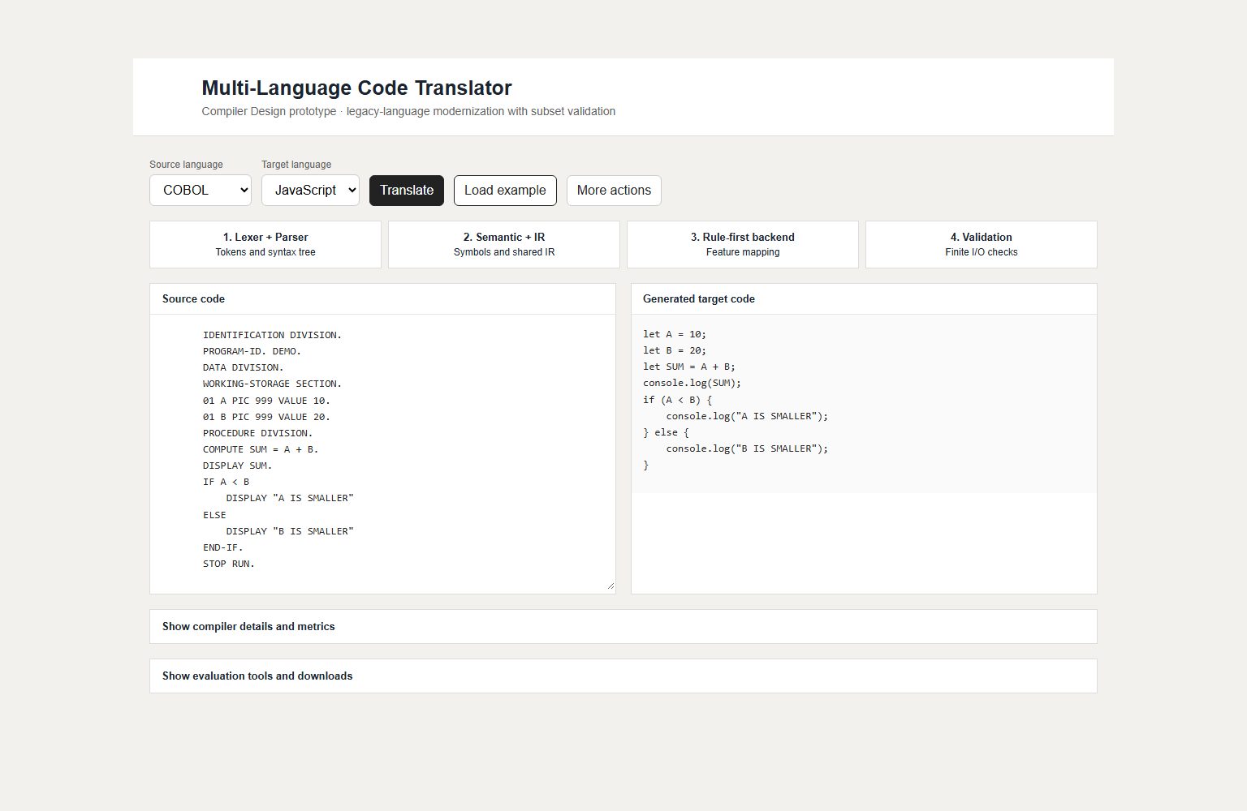
Figure 4. COBOL-to-JavaScript translation (cropped): source program, generated JavaScript, symbol table, rules used, LLM fallback status and validation evidence. LLM fallback was disabled for this capture.
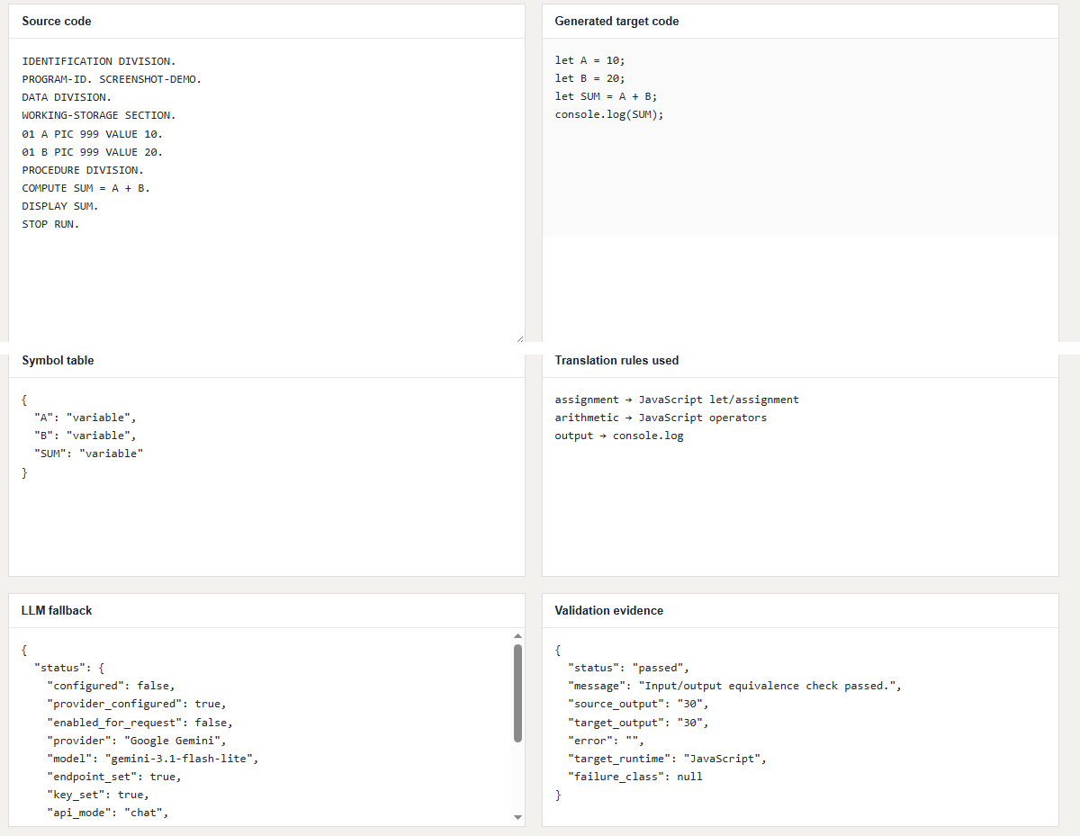
Figure 5. BASIC-to-JavaScript translation (cropped), with validation status passed for the tested output.
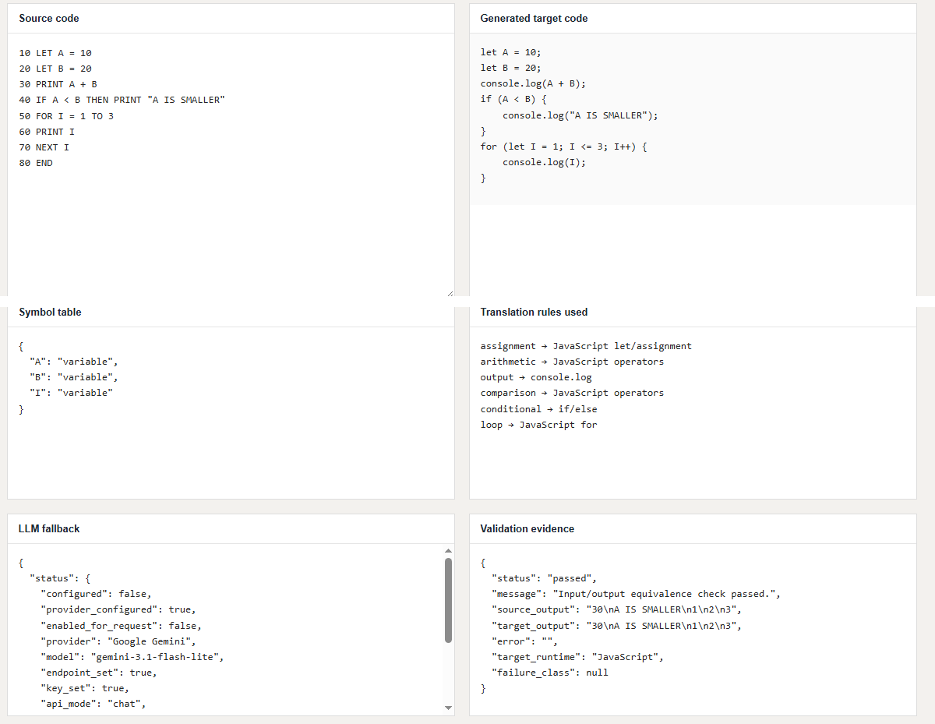
Figure 6. COBOL PERFORM handling (cropped). Validation status is not_run with failure class unsupported_source_syntax; this is not a successful translation, and the displayed target code is not validated.
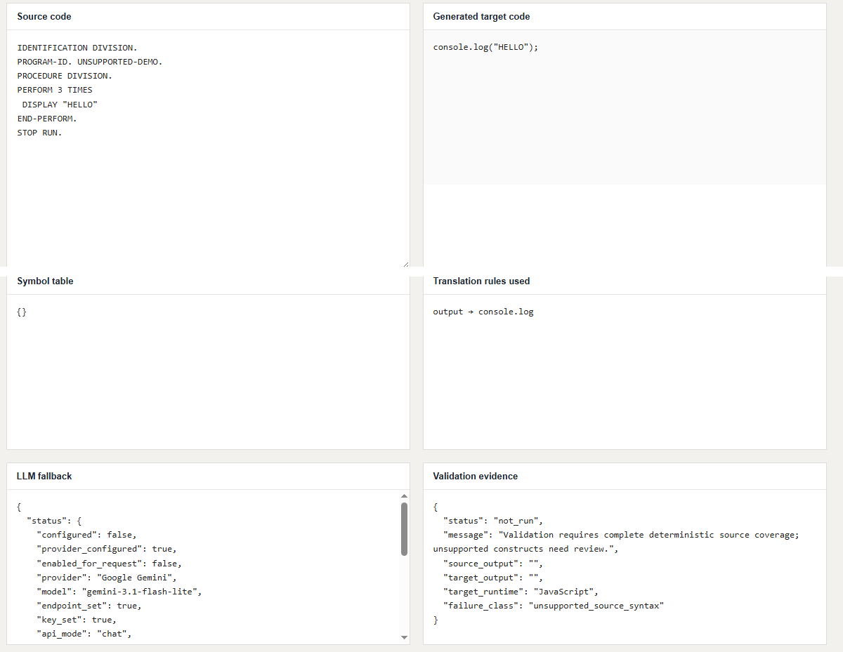

5.9 Automated tests
The pinned source snapshot (08bf136) reports 29 passing pytest tests. A rerun on 16 October 2026 at revision 2791b8f, with documentation and UI changes uncommitted that were later included in commit 7f0515f, recorded 31 passing; the same count is obtained when the suite is run at 7f0515f. Later commits raised the count to 40 at ade68dc and 41 at a06e15e (17 October 2026). The benchmark and case data were unchanged for the 16 October rerun, but the benchmark was not rerun at 7f0515f. The tests cover translation, IR metadata, control flow, unsupported syntax, candidate recording, experiment summaries, endpoints, contracts, risk metadata and related diagnostics.
A test count is a reproducibility detail, not a measure of semantic coverage: one test can exercise many assertions or only a narrow path. The captured pytest output is reproduced in Appendix D; a mapping from test names to the features or failure modes they cover is still to be written.

5.10 Corpus and benchmark provenance
The benchmark manifest is data/corpus_manifest.jsonl and contains 42 records: 16 development and 26 held-out cases across eight task groups. The held-out pilot contains 22 expected-translatable records (including CodeNet Fortran cases p02600, p02606, p03997, p02724, and p03238) and four expected-unsupported cases (three COBOL PERFORM variants and CodeNet array-input task p02607). The cases combine project-authored fixed-input task adaptations and curated CodeNet submissions; they do not constitute an independently collected, statistically representative legacy enterprise repository corpus. While 4,053 CodeNet metadata files and 13,565 accepted source files were audited, only screened scalar subsets with GNU Fortran 14.3.0 verification and fixture validation were admitted. Formal generalization testing requires scaling beyond pilot subsets toward at least 100 independent task clusters.
The manifest records source hashes, provenance, expected outcomes and outputs, oracle labels and task-group splits. Hashes help identify exact source content and detect duplicates; they do not establish licensing rights, semantic correctness or independence. Group splits reduce the risk of closely related adaptations appearing across different partitions, but the current small pilot is not a statistically representative sample of legacy software.

5.11 Evaluation protocol: exact outcomes and denominators
Measure | 24-case baseline (v3 refresh, 17 Oct 2026) | 42-record manifest, 26-case held-out pilot (25 Oct 2026)
Source revision | ade68dc (pushed v3 refresh baseline) | c3350fe (verified full test suite, 58 tests passed)
Target runtime | JavaScript and Python; Python 3.13.1, Node.js v24.20.0 | JavaScript and Python; Python 3.13.1, Node.js v24.20.0
End-to-end cases passed | 23/24 | 22/26 passed
Expected outcomes matched | 24/24 | 26/26 expected outcomes matched (22 translated, 4 unsupported recognized)
Available independent expected-output checks | 23/23 matched | 22/22 matched; 34/34 input fixtures matched
Expected-unsupported cases | 1; COBOL PERFORM, correctly recognized | 4; 3 COBOL PERFORM, 1 CodeNet array input, all correctly recognized
Rule-only / hybrid passes | 23/24 / 23/24 | 22/26 / 22/26 (0.0% causal delta; identical final outputs)
Configured LLM cases / calls / candidates | 1 request, 3 attempts, no candidate (unsupported COBOL loop) | 5-repeat live ablation: 15 candidates generated/syntax-checked/runtime-verified per target; 0 accepted into final code
Pytest tests passed | 40 (at ade68dc) | 58 passed
Benchmark-required constructs covered | Not re-verified | 55/69 required constructs covered (79.7%)

The 24-case column reflects the historical v3 refresh baseline (ade68dc). The verified corpus manifest contains 42 records with 26 held-out cases, yielding 22/26 passes (22/22 supported translatable cases matched, 34/34 supported input fixtures matched, and 4/4 expected-unsupported cases recognized) consistently across JavaScript and Python targets (verified by python tools/run_test_benchmark.py and tools/check_benchmark_oracles.py). These results describe a fixed pilot and do not establish broad generalization.

5.12 Interpretation of the evaluation
The current held-out denominator is 26 across 8 task groups. The evaluation reports 22/26 end-to-end passes for each deterministic target run, 22/22 separately authored expected-output matches, 34/34 input fixture matches, and recognition of all 4 expected-unsupported cases. These measures separate distinct dimensions: end-to-end pass rate measures covered translatable syntax, fixture matches establish deterministic input/output conformance, and unsupported recognition verifies safe fail-closed diagnostics without emitting hallucinated or malformed target syntax.
The 17/17 expected-output result is a separate check against separately authored expected outputs for the 17 expected-translatable held-out cases. It is not a native legacy-compiler run or second-human review, and it does not validate every semantic property.
Benchmark-required construct coverage is 45 of 48 (93.8%); the three uncovered constructs are the loops in the three COBOL PERFORM cases. A per-construct success rate is not reported. The descriptive catalogue and /rules endpoint are not substitutes for executable rule coverage, language coverage or a probability of translating arbitrary code correctly.

5.13 Threats to validity
Threat | Why it matters | Mitigation / next step
Small sample | 42 manifest records; 26 held out across 8 task groups cannot represent dialect and real-world application diversity | Scale benchmark toward >=100 independent task groups following formal McNemar power analysis (alpha=0.05, power=0.80)
Task-derived cases | Adaptations of three task prompts are not independent legacy applications | Add license-cleared programs from separate sources and repositories
Source interpreter as oracle | Interpreter defects can align with target defects or mask source semantics | Use independently produced expected outputs and original compiler/runtime where feasible
Limited independent expected outputs | Only 22 expected-output and 34 fixture checks available for the held-out pilot; source interpreter is not an independent oracle | Expand native compiler oracles (e.g. GNU Fortran 14.3.0, GnuCOBOL, FreePascal) and independently executed test suites
Ablation scope and candidate status | In 5-repeat ablations, deterministic and hybrid arms yielded identical final outputs (0% improvement; 0 candidates accepted). Contract/risk mechanisms lack isolated ablation. | Evaluate fallback on non-trivial constructs with human audit logging; make contract/risk scoring independently switchable to isolate causal effects.
CodeNet screening is not curation | 30 sampled records yielded zero prototype-screen passes; rights, native builds, fixtures and independent oracles are unreviewed. | Review exact immutable sources and terms; promote only after source/build, fixture/oracle, and split checks pass.
Licensing uncertainty | Publicly accessible source may still have redistribution restrictions | Audit licenses and keep provenance records before corpus publication
Runtime/environment dependence | Different runtime versions or flags may change outcomes | Pin versions, commands and environment in each evidence record

These threats limit the scope of conclusions, but they also provide a concrete plan for strengthening the study. The report should retain them even if future results improve.

5.14 Reproducibility and operational safety
A reproducible run should record the source revision, benchmark manifest hash, Python and Node.js versions, exact command, environment variables that affect behavior, model/provider configuration if applicable, and the resulting JSON/CSV artifact. A screenshot alone is not enough to reproduce a benchmark result. Conversely, raw output without the exact source revision and test manifest is difficult to interpret.
The project uses an external model only when configured. API credentials must be stored in a local environment file or approved secret store and must never be committed to the repository, placed in frontend JavaScript, or embedded in screenshots. If source code contains personal, customer or proprietary information, the user should obtain authorization before sending any part to an external model provider.
The safe reproduction sequence is: install the documented dependencies; verify Python and Node.js; run the automated tests; run the benchmark for the recorded target; export the evidence files; and compare the output with the pinned record. The exact setup commands are given in the project README.md.

5.15 Future work roadmap with acceptance criteria
Priority | Work item | Dependency | Acceptance criterion
P0 | Regenerate evidence snapshot from the final commit | Stable source and case manifest | JSON records revision, timestamp, runtimes, command and all denominators
P1 | Run a reproducible live provider smoke trial | Provider credentials and privacy approval | Completed: both target candidates recorded; runtime and finite expected-output checks passed; acceptance remains blocked by human review and other gates.
P1 | Implement candidate integration behind a validation gate | Explicit output format and safety checks | Candidate is never merged before syntax/runtime checks, independent tests and human review
P1 | Add independent oracles | Expected outputs or original compiler/runtime | Each added case records oracle provenance and test rationale
P2 | Review and curate CodeNet candidates | Corpus protocol and local archive | Audit and triage are complete. Admit no sample until license, original build, fixture/oracle, and task-group split checks are verified.
P2 | Strengthen ablation design and data | Feature-level configuration | Current 3-arm runs are reproducible but yield equal 17/20 results; LLM disabled, no learned reuse, contracts/risk common. Extend only with predeclared toggles and reviewer-effort recording.
P3 | Report uncertainty and failure taxonomy | Sufficient number and diversity of cases | Per-language and per-construct counts, confidence intervals where appropriate, and error categories

The order matters. More data without provenance and independent oracles can create a larger but still weak benchmark. Model integration without a validation gate can make the output appear more complete while making it less trustworthy. Evidence collection and acceptance policy should therefore precede broad feature expansion.

5.16 Worked case study: COBOL-to-JavaScript example
Figures 3 to 6 were captured on 17 October 2026 from the running application at commit a06e15e, with LLM fallback disabled. The benchmark exports and pytest output in data/submission_evidence_20261017 remain the authoritative record of aggregate results.
The documented pipeline for such a case is: (1) tokenize and parse the supported COBOL statements; (2) create symbols for the declared values; (3) lower assignments, arithmetic, output and conditional control flow to the shared IR; (4) apply the relevant deterministic rules; (5) execute the JavaScript target; and (6) compare its output with the source interpreter and any independent expected output available for that case. A reviewer should inspect each stage rather than infer correctness from the final string alone.
The case illustrates the type of evidence the interface is designed to expose: source text, generated target, selected rules, symbol table, IR, validation status and pipeline trace. It does not establish that all COBOL COMPUTE expressions or all conditionals are supported, and it does not prove equivalence for untested inputs.
- Conclusion:

6.1 Findings
The Multi-Language Legacy Code Modernizer demonstrates an inspectable translation pipeline for documented subsets of several legacy languages. A shared IR separates language parsing from target generation, a deterministic rule table explains the output for covered constructs, and the interface exposes the route from source text to target execution. The optional model fallback is limited to unsupported constructs, and its output stays unaccepted.
The held-out pilot (22/26 end-to-end passes, 22/22 expected-output matches, 34/34 fixture matches, and 4/4 expected-unsupported cases recognized) provides bounded empirical evidence strictly for the tested constructs. In the 5-repeat live provider ablations across 26 held-out cases (controlled_ablation_live_v9 / v3), 15 LLM candidates per target were generated and verified against syntax and isolated runtime checks; however, exactly zero candidates were accepted into the final executable code, resulting in an identical final output delta (0% causal improvement) between the rule-only and hybrid LLM arms. This confirms that the fallback mechanism operates as a feasibility sandbox rather than a statistically proven accuracy amplifier. The test suite records 58 passing tests in pytest.

6.2 Practical implications
For a real migration, the system is best treated as an assistant for bounded code fragments, not as an unattended replacement for engineering review. A safe workflow would freeze the source revision, run translation in a controlled environment, retain source and target artifacts, execute regression tests, inspect unsupported constructs, review any model-generated candidate, and require human approval before integration. Sensitive code should not be sent to an external model without the organization’s data-handling and security approval.
The prototype is most useful as a repeatable workflow for small legacy-code fragments. It shows which constructs the current rules can translate and which require further work. Explicit rejection and review states matter in a migration because they stop an unsupported construct from silently becoming an apparently successful result.

6.3 Limitations
- Only documented subsets are supported; full COBOL, FORTRAN, Pascal, BASIC or Python compatibility is not claimed.
- The manifest has 42 records, and the 26-case held-out pilot covers only eight task groups. This scale is an educational and engineering pilot; it is not a full-scale empirical software-engineering benchmark, which typically requires hundreds or thousands of real-world repository samples.
- In live 5-repeat controlled ablations (controlled_ablation_live_v9), the deterministic rule-only arm and the hybrid LLM arm produced identical final outputs. Although candidates were generated and passed restricted sandbox execution, zero LLM candidates were accepted into final production code under the human-in-the-loop and equivalence audit gates. Reviewers must note that LLM fallback does not yet demonstrate a statistically measurable causal benefit over deterministic rules.
- The front ends intentionally handle only narrow, documented subsets (e.g., simple scalar assignments, basic arithmetic, and simple control flow). Complex imperative features—such as COBOL PERFORM/copybooks, Pascal compound blocks/records/pointers, and user-defined subroutines—are intentionally not implemented.
- The risk score formula, semantic contracts, and failure fingerprints serve as descriptive metadata and architectural guardrails; there is currently no empirical ablation evidence showing that adding them reduces human debugging time or prevents deployment defects in software maintenance.
- The saved controlled ablations compare rule-only, rule-first with optional LLM fallback, and rule-first with contracts/risk/learned rules over identical held-out splits. Because contract and risk checking are integral parts of the safe transpilation pipeline across all arms, their individual causal effects are not isolated. Learned-rule reuse was zero on held-out tasks, and human reviewer effort was not empirically recorded.
- Actual application screenshots and raw test logs should be attached to the final submission to strengthen reproducibility.

6.4 Future work
First, scale the benchmark beyond the current 42-record / 8-task-group pilot to achieve statistical validity. As formulated in the project protocol power calculation, conducting a formal McNemar test with alpha=0.05, power=0.80, and an anticipated 20-percentage-point effect size requires at least 100 independent held-out task clusters. This expansion should incorporate real-world open-source repositories and verified legacy sources across diverse algorithmic shapes, rather than relying primarily on task adaptations.
Second, run a controlled comparison with a configured, version-pinned model. Record model identifier, prompt hash, temperature, token usage where available, latency, retries, cost and outcome. Compare rule-only and hybrid runs on identical cases. Report the number of cases that actually used fallback; otherwise a result table can make two identical pipelines appear to have been meaningfully compared.
Second, design an empirical user-study and ablation methodology to evaluate metadata mechanisms (risk scores, semantic contracts, and failure fingerprints). While these currently operate as architectural guardrails, future work will conduct a randomized trial with human software engineers measuring mean time to resolution (MTTR), debugging latency, and defect leakage when migrating legacy programs with vs. without contract diagnostic telemetry. Furthermore, safety mechanisms should be refactored into independently switchable ablation flags so that the isolated causal contribution of risk-aware repeatability gates can be quantitatively measured against an unconstrained baseline.
Third, expand the front-end language subsets beyond toy scalar assignments and simple control flow toward complex imperative constructs. Key target features include COBOL PERFORM out-of-line routines and copybook inclusion, Pascal compound record structures and pointer indirection, and user-defined subroutines with parameter passing semantics. Each construct extension must define formal IR node types, deterministic lowering rules, and explicit fail-closed syntax boundaries.

6.5 Final conclusion
The project provides a well-scoped demonstration of compiler-design principles applied to legacy-code modernization. Its value lies in a shared representation, deterministic rules, bounded optional model assistance, execution-based checks and visible diagnostics. The prototype translated the supported test cases successfully in the recorded expected-output checks, but the evaluation remains small. The next step is to test more varied programs and run the fallback on several unsupported cases, so that the hybrid approach can be evaluated directly.
- Project Repository Link: (GitHub or drive link)

7.1 Public repository
Repository URL:
https://github.com/yoshi-hue/transpiler
The current public repository is listed above. Fresh benchmark exports for the 36-record manifest are in data/submission_evidence_20261017/, generated at commit a06e15e; they flag a modified worktree only because of an unrelated edit to PROJECT_REPORT_PROMPT.md. The older benchmark_v2 files predate that manifest and are historical. The working fallback candidate is recorded in commit 2582fee, with its prompt hash added in 897e949. The submission should cite 897e949 or a later commit.

7.2 Reproducibility checklist
- Record the commit hash or release tag used for the submission.
- Document Python, FastAPI, Uvicorn, Pydantic, pytest, Node.js and operating-system versions.
- Provide setup instructions and a sample environment file with placeholder values only; never commit a real API key.
- Run the automated tests and include the actual output and date.
- Run the benchmark for both target languages and export the JSON/CSV records.
- Capture figures from the running application at the recorded commit, and cite the JSON exports rather than screenshots for benchmark claims.
- Document which benchmark cases are local examples and which are adapted from published task prompts.
- Retain corpus_manifest.jsonl and make provenance and task-group splits available.
- Ensure unsupported cases remain marked not_run or rejected where no valid candidate is available.
- State the LLM provider, model and prompt version if fallback experiments are later reported.

7.3 References
The following sources support the background discussion. The bibliographic details for the primary sources listed below were checked against their publisher, arXiv or project records during preparation. They support context and benchmark design; none of them validates this project's own implementation results.
[1] Rozière, B. et al. (2020). “Unsupervised Translation of Programming Languages.” Advances in Neural Information Processing Systems (NeurIPS). arXiv:2006.03511. https://arxiv.org/abs/2006.03511
[2] Lu, S. et al. (2021). “CodeXGLUE: A Machine Learning Benchmark Dataset for Code Understanding and Generation.” arXiv:2102.04664. https://arxiv.org/abs/2102.04664
[3] Zhu, M., Jain, A., Suresh, K., Ravindran, R., Tipirneni, S., & Reddy, C. K. (2022). “XLCoST: A Benchmark Dataset for Cross-lingual Code Intelligence.” arXiv:2206.08474. https://arxiv.org/abs/2206.08474
[4] Saha, S. K., Rabbi, F., Wang, S., & Yang, J. (2024; journal publication 2026). “Specification-Driven Code Translation Powered by Large Language Models: How Far Are We?” arXiv:2412.04590. https://arxiv.org/abs/2412.04590; journal record: https://doi.org/10.1016/j.jss.2026.112964
[5] Wang, Y. et al. (2026). “RepoTransBench: A Real-World Benchmark for Repository-Level Code Translation.” IEEE Transactions on Software Engineering, 52(2), 675–690. https://doi.org/10.1109/TSE.2025.3645056. Preprint: https://arxiv.org/abs/2412.17744
[6] IBM. “Project CodeNet.” Repository and dataset documentation. https://github.com/IBM/Project_CodeNet
[7] Jiang, C., Liu, D., Wen, C., Xu, Z., Zheng, H., Sadiq, M., Shamsi, J. A., Qin, S., & Ming, Z. (2026). “Large Language Models for Multilingual Code Intelligence: A Survey.” arXiv:2604.25960. https://arxiv.org/abs/2604.25960
[8] Rosetta Code. Task pages for “A+B”, “Maximum of two numbers” and “Loops/For”. The project uses these pages as task-prompt origins for project-authored fixed-input adaptations, not as source code copied into the benchmark. https://rosettacode.org/
[9] Project repository. “Multi-Language Legacy Code Modernizer.” https://github.com/yoshi-hue/transpiler
[10] Project evidence record, data/project_report_evidence in the project repository.json, including pinned snapshot (2026-10-16), latest_validation record and the recorded source revisions. Consult the actual file in the repository for the authoritative machine-readable values.

7.4 Appendix A — Risk scoring definition
The project materials define the risk score as a weighted sum of five component scores. If each component is normalized to [0, 1], the intended form is:
Risk = 0.25 × DataFlow + 0.20 × APIUncertainty + 0.20 × SideEffects + 0.20 × ControlFlowComplexity + 0.15 × TypeMismatch
The component definitions and normalization method should be documented in code or a design note. Without those details, the score cannot be reproduced independently. The weights sum to 1.00, but that arithmetic fact does not imply statistical calibration.

7.5 Appendix B — Earlier benchmark record (historical)
Metric (earlier 8-program Python-target record, 25 Sep 2026; superseded by Section 5.11) | Rule-only | Hybrid | Interpretation
Programs | 8 | 8 | Two programs per legacy language
Passed / failed | 8 / 0 | 8 / 0 | 100% observed success on this benchmark
Unsupported constructs | 0 | 0 | All benchmark constructs were covered
LLM calls | 0 | 0 | Provider not configured; no fallback calls
Fallback frequency | 0% | 0% | Hybrid path not exercised
Rule coverage per case | 50–75% | 50–75% | Share of IR nodes mapped by rules

The current evidence should not be presented as a large-scale accuracy estimate. The 22/26 end-to-end pass rate, 22/22 expected-output matches, 34/34 input-fixture matches, and 4/4 correctly recognized expected-unsupported cases describe an inspectable pilot across 8 task groups. Population-level empirical claims would be invalid without formal power-planned sampling across diverse enterprise repositories.

7.6 Appendix C — Example acceptance state model
candidate_generated
├── target execution fails ──> rejected
└── target execution succeeds
├── source/target outputs differ ──> rejected
└── source/target outputs agree on tests
└── semantically_validated for tested inputs
The state model is conservative. A target that runs successfully has only passed a runtime check. A target whose output matches the source has passed the project’s current behavioral check for the provided inputs. Broader equivalence requires broader tests and explicit coverage of other observable behaviors.

7.7 Appendix D — Automated test output
Captured on 17 October 2026 at commit a06e15e (Python 3.13.1, Windows 10). The count is unchanged at 41 at the later commit 897e949. The saved output files are in data/submission_evidence_20261017/.
Command: python -m pytest --basetemp <fresh workspace temp directory>
Exit code: 0
......................................... [100%]
41 passed in 19.81s

