HTML5:

HTML 5 is the fifth and current version of HTML. It has improved the markup available for documents and has introduced application programming interfaces (API) and Document Object Model (DOM).

**Why HTML5?**

A hypertext markup language (HTML) is the primary language for developing web pages. HTML5 is a new version of HTML with new functionalities with markup language with Internet technologies. Language in HTML does not have support for video and audio. HTML5 supports both video and audio.

**Features:**

* It has introduced new multimedia features which supports both audio and video controls by using <audio> and <video> tags.
* There are new graphics elements including vector graphics and tags.
* Enrich semantic content by including <header> <footer>, <article>, <section> and <figure> are added.
* Drag and Drop- The user can grab an object and drag it further dropping it to a new location.
* Geo-location services- It helps to locate the geographical location of a client.
* Uses SQL database to store data offline.
* Allows drawing various shapes like triangle, rectangle, circle, etc.
* Capable of handling incorrect syntax.
* Easy DOCTYPE declaration i.e., <!doctype html>
* Easy character encoding i.e., <meta charset=”UTF-8″>

**<article> and <section>:**

**Define an article**

**Defines a section of a document, such as header, footer etc.**

The <article> tag is used to represent an article. More specifically, the content within the <article> tag is independent from the other content of the site (even though it can be related).

The **<article>** element represents a section of content that forms an independent part of a document or site; for example, a magazine or newspaper article, or a blog entry.

The **<section>** element represents a section of a document, typically with a title or heading.

According to the W3C, **<section>** is a much broader element, while the **<article>** element is to be used for blocks of content that could potentially be read or consumed independently of the other content on the page.

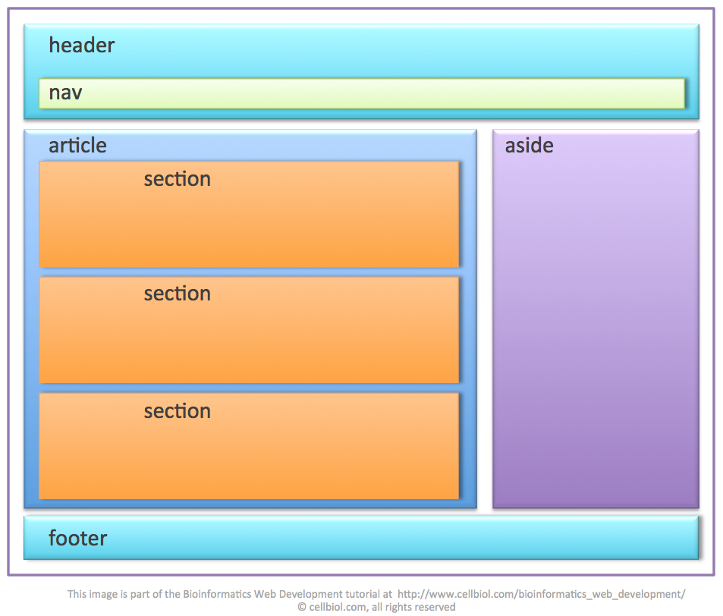

<!-- Example code -->

<body>

<article>

<h2>Mozilla Firefox</h2>

<p>Mozilla Firefox is an open-source web browser developed by Mozilla. Firefox has been the second most popular web browser since January, 2018.</p>

</article>

<section>

<h1>Welcome to Our Website</h1>

<p>Welcome and thank you for taking the time to visit our website.</p>

</section>

</body>

**<aside>:**

**Defines some content loosely related to the page content**

The <aside> tag is used to describe the main object of the web page in a shorter way like a highlighter. It basically identifies the content that is related to the primary content of the web page but does not constitute the main intent of the primary page. The <aside> tag contains mainly author information, links, related content and so on.

<!-- Example code -->

<body>

<h1>Apollo 13 Mission</h1>

<p>The Apollo 13 craft was launched on April 11, 1970 from the Kennedy Space Center, Florida, but the lunar landing was aborted after an oxygen tank exploded two days later.</p>

<aside>

<h1>Apollo 13 Facts</h1>

<p>Apollo 13 was the seventh manned mission in the American Apollo space program and the third intended to land on the Moon.</p>

</aside>

</body>

**<audio> and <video>:**

Embeds a sound, or an audio and video stream in an HTML document

<html>

<head>

<style>

p

{

color : green;

}

#new

{

color : red;

}

</style>

<title>Audio into the web page</title>

</head>

<body style="background-color: yellow">

<p id="new"> u can listen this audio

</p>

<audio controls>

<source src="C:\Users\Admin\Pictures\music.mp3"

<!--type="audio/mpeg">--></audio><br>

<p> u can watch this video </p>

<video width="450" height="250" controls>

<source src="C:\Users\Admin\Pictures\v.mp4"

type="video/mp4">

<source src="movie.ogg" type="video/ogg">

Your browser does not support the video tag.

</video>

</body>

</html>

**<bdi>:**

BDI stands for Bi-Directional Isolation.

Represents text that is isolated from its surrounding for the purposes of bidirectional text formatting

The <bdi> tag refers to the Bi-Directional Isolation. It differentiates a text from other text that may be formatted in different direction. This tag is used when a user generated text with an unknown direction.

This element is useful when embedding user-generated content with an unknown text direction.

<html>

<body>

<h1>The bdi element</h1>

<p>In the example below, usernames are shown along with the number of points in a contest. If the bdi element is not supported in the browser, the username of the Arabic user would confuse the text (the bidirectional algorithm would put the colon and the number "90" next to the word "User" rather than next to the word "points").</p>

<ul>

<li>User <bdi>hrefs</bdi>: 60 points</li>

<li>User <bdi>jdoe</bdi>: 80 points</li>

<li>User <bdi>إيان</bdi>: 90 points</li>

</ul>

</body>

</html>

**<canvas>:**

The <canvas> tag in HTML is used to draw graphics on a web page using JavaScript. It can be used to draw paths, boxes, texts, gradients, and adding images. By default, it does not contain borders and text.

The graphic to the left is created with <canvas>. It shows four elements: a red rectangle, a gradient rectangle, a multicolor rectangle, and a multicolor text.

**Note:** The <canvas> tag is new in HTML5.

**Syntax:**

<canvas id = "script"> Contents... </canvas>

**Attributes:** The tag accepts two attributes as mentioned above and described below.

* [**height**](https://www.geeksforgeeks.org/html-dom-style-height-property/)**:** This attribute is used to set the height of the canvas.
* [**width**](https://www.geeksforgeeks.org/html-object-width-attribute/)**:** This attribute is used to set the width of the canvas.

Example 1:

<html>

    <body>

         <!-- canvas Tag starts here -->

        <canvas id = "Presidency univesity" width = "200"

            height = "100" style = "border:1px solid black">

        </canvas>

        <!-- canvas Tag ends here -->

    </body>

</html>

Example 2:

<html>

    <body>

        <!-- HTML code to illustrate canvas tag -->

        <canvas id = "CSE" height = "200" width = "200"

            style = "border:1px solid black">

        </canvas>

        <script>

            var c = document.getElementById("CSE");

var cx = c.getContext("2d");

            cx.beginPath();

            cx.arc(100, 100, 90, 0, 2 * Math.PI);

            cx.stroke();

        </script>

    </body>

</html>

**Output:**



All drawing on the HTML canvas must be done with JavaScript:

Example 3:

<html><body><canvas id="myCanvas" height="300" width="300" style="border:1px solid #c3c3c3;">

</canvas>

<script>

var canvas = document.getElementById("myCanvas");

var ctx = canvas.getContext("2d");

ctx.fillStyle = "#FF0000";

ctx.fillRect(0, 0, 250, 275);

</script>

<body>

</html>

In the above code, The getContext() is a built-in HTML object, The fillStyle property can be a CSS color, a gradient, or a pattern. The default fillStyle is black.

The fillRect(*x,y,width,height*) method draws a rectangle, filled with the fill style, on the canvas:

Example 4: How to draw Line using Canvas:

<html>

<body>

<canvas id="myCanvas" width="200" height="100"

style="border:1px solid #d3d3d3;">

Your browser does not support the canvas element.

</canvas>

<script>

var canvas = document.getElementById("myCanvas");

var ctx = canvas.getContext("2d");

ctx.moveTo(0,0);

ctx.lineTo(200,100);

ctx.stroke();

</script>

</body>

</html>

To draw a straight line on a canvas, use the following methods:

* moveTo(*x,y*) - defines the starting point of the line
* lineTo(*x,y*) - defines the ending point of the line

To actually draw the line, you must use one of the "ink" methods, like stroke().

Define a starting point in position (0,0), and an ending point in position (200,100). Then use the stroke() method to actually draw the line:

Output:

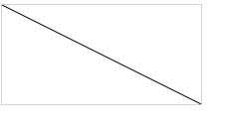

**Header and Footer:**

Most web site pages have a recognizable header and footer section.

Typically the **header** contains

* the site logo
* title (and perhaps additional subtitles or taglines)
* horizontal navigation links, and
* perhaps one or two horizontal banners.

The typical **footer** contains less important material, such as

* smaller text versions of the navigation,
* copyright notices,
* information about the site’s privacy policy, and
* perhaps twitter feeds or links to other social sites.

Both the HTML5 <header> and <footer> element can be used not only for *page* headers and footers, they can also be used for header and footer elements within other HTML5 containers, such as <article> or <section>.

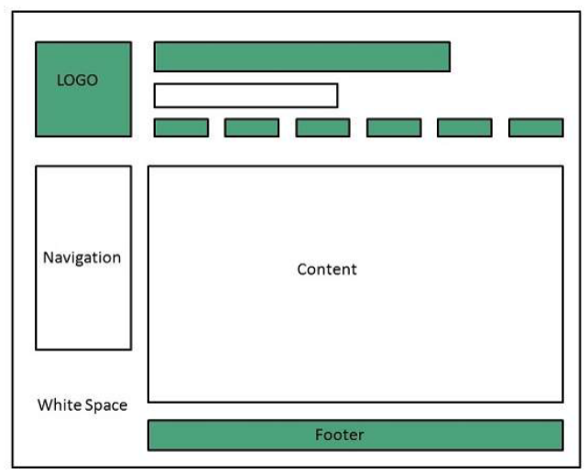

Example:

<html>

<body>

<header>

<img src="logo.gif" alt="logo" />

<h1>Fundamentals of Web Development</h1>

...

</header>

<article>

<header>

<h2>HTML5 Semantic Structure Elements </h2>

<p>By <em>Randy Connolly</em></p>

<p><time>September 30, 2012</time></p>

</header>

... <br>

</article>

<footer>

<p>Author: Hege Refsnes</p>

<p><a href="mailto:hege@example.com">hege@example.com</a></p>

</footer>

</body>

</html>

**<hgroup>:**

Defines a group of headings.

The <hgroup> element can be used to group related headings together within one container.

Example:

<html>

<header>

<hgroup>

<h1>Chapter Two: HTML 1</h1>

<h2>An Introduction</h2>

</hgroup>

</header>

<article>

<hgroup>

<h2>HTML5 Semantic Structure Elements </h2>

<h3>Overview</h3>

</hgroup>

</article>

</html>

**<nav>:**

Defines a section of navigation links.

The **<nav>** element represents a section of a page that contains links to other pages or to other parts within the same page.

Like the other new HTML5 semantic elements, the browser does not apply any special presentation to the <nav> element.

The <nav> element was intended to be used for major navigation blocks, presumably the global and secondary navigation systems.

Example:

<body>

<nav>

<ul>

<li><a href="#">Home</a></li>

<li><a href="#">About</a></li>

<li><a href="#">Contact</a></li>

</ul>

</nav>

</body>