Constructing a platform promoting indirect reciprocity based on dual-layer gamification

252002283 Yoshikawa Junki

Humans are cooperative creatures. Humans sometimes behave altruistically toward others at the expense of themselves. This behavior can be explained by reciprocity. Reciprocity is the act of doing altruistic for another person because a return is expected later. In addition, there is a method called gamification, in which game elements are introduced into non-game situations to motivate behavior and solve problems. In our laboratory, we propose DERC (Dual layer gamification Encouraging Reciprocity-based Cooperation), a system to promote altruistic behavior based on reciprocity, using two-layered gamification. DERC aims to promote altruism in level 1 (first layer) and to encourage others to act altruistically in level 2 (second layer). In this study, we introduced DERC for discussion, altruistic behavior, and health care (special case) respectively, developed a prototype DERC platform with an integrated point system, and conducted two evaluation experiments.

The results of the evaluation experiment showed that each user earned points by the actions he or she was good at and that the motivation to earn points for each level of action was also distributed among the users. The user's point transition is shown in Figure 1. In discussions (video discussions/text discussions), an increase in the quality and quantity of messages and an increase in the enjoyment of discussions were confirmed (Figure 2). In altruistic acts, it was confirmed that daily altruistic acts increased (Fig. 3) and that awareness of the altruistic acts of others increased. In addition, the motivation to walk increased, and it was confirmed that the average number of steps increased by about 10% compared to before and after the evaluation experiment (Figure 5).

Figure 4: Direction of altruistic

(Second experiment)

action

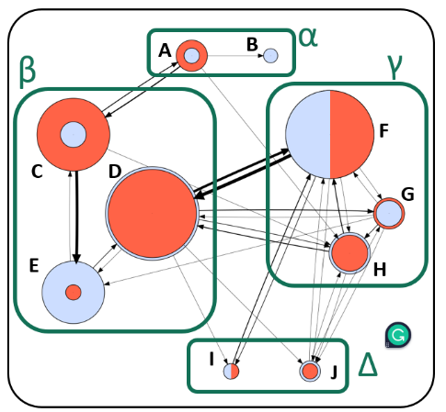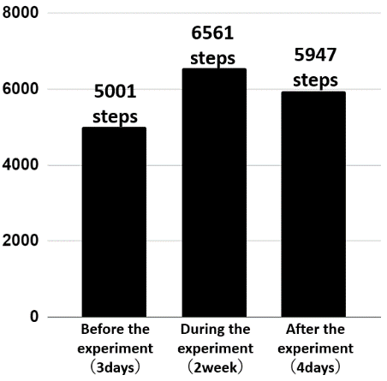

Figure 5: Average daily steps

(Second experiment)

Figure 2: Discussion Questionnaire Results 1

(Second experiment)

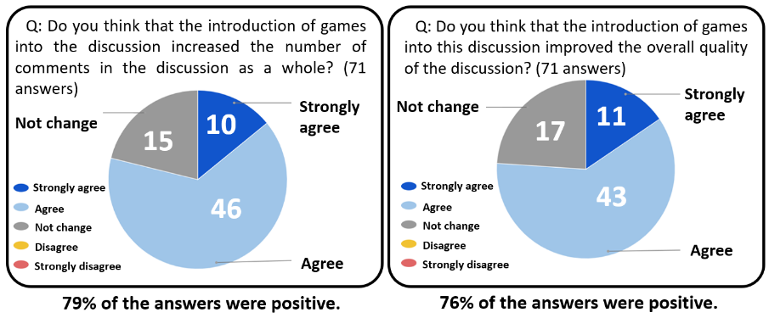

Figure 3: Discussion Questionnaire Results 2

(Second experiment)

Figure 1: User's point transition

(Second experiment)

