Practical Test - Lines

Game description

This is an endless casual game. In this mini game, user has to control the balls in order to earn points and avoid being stuck.

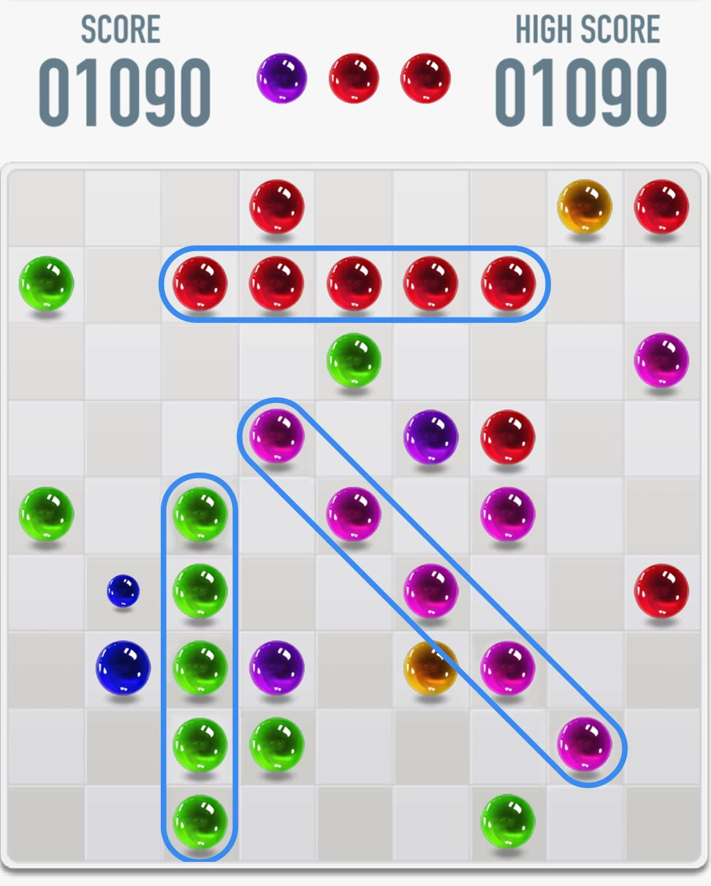
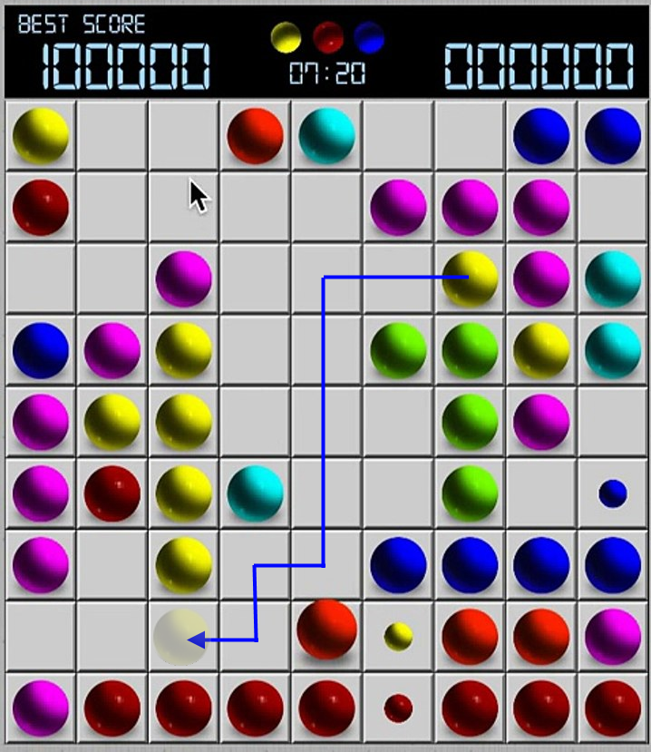

Game Rules
- Using mouse to select the ball, and then select new position for that ball.

- After a ball moves, if there are 5 or more balls with same color in a line (continuously in horizontal/vertical/diagonal), those balls will be explosive.

- End turns, 3 new balls will be added to the board randomly (random both color and positon). Before adding to the board, these balls stand in a queue in menu bar.

- Movable rules for ball: Ball can only move 4-directions and cannot overlap with the others.

- If the ball cannot move to your selected position, cancel selected.

- Each explosive ball: add one score.

- Game only ends when player cannot make the ball move.

Extra Features
- Ghost ball: Can move through another ball.
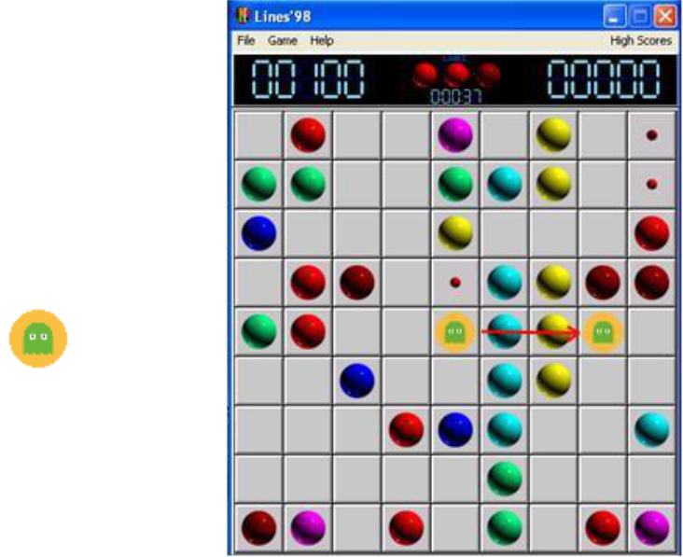

- Add 1- 3 more Special Balls.

Requirements

Section |  | Features |  | Points
 |  | Graphic: board, balls, timer, score… | 3
 |  | The ball stages: ball waiting queue, randomly added ball | 3
Gameplay |  | position, move the ball by mouse selection, move on board.
Gameplay |  | Ball Idle, ball movement, explosive and loose condition (animation, particles ) | 2
 |  | Editor to create Level Packs. (Custom Inspector) | 1
 |  | Save current situation and highest score | 0.5
 |  | Optimization(Pool Objects, resources management …) | 1->3
Bonus |  | Extra features | 1->5
Bonus |  | More effect or game features | 1->5
 |  | More effect or game features |  | points

Platform:

Unity Windows

Submit format:

Link to GitHub project

