Assignment 1
MSS301 – Cinema Ticket Booking System using API Gateway
Created by: Lê Hoàng
Link github: yoshimura178

Mục lục

F0 – Hạ tầng và khởi tạo project 5
TODO 0.1: Add docker compose for sql server, mongodb and mysql 5
TODO 0.2: Add init scripts for sql server and mysql databases 5
TODO 0.3: Bootstrap booking-service with mysql and flyway 6
TODO 0.4: Bootstrap api-gateway with gateway webmvc and resource server 6
TODO 0.5: Configure port, datasource and movie service url 7
TODO 0.6: Add global exception handler with unified error body 7
F1 – Authentication (customer-service + Gateway) 8
TODO 1.1: Configure admin account and jwt properties 8
TODO 1.2: Add bcrypt password encoder bean 8
TODO 1.3: Add jwtservice to sign hs256 access tokens 9
TODO 1.4: Implement login for admin and customers 10
TODO 1.5: Expose post /api/auth/login 10
F2 – Customer Profile & Validation 11
TODO 2.1: Add t-sql migrations with nvarchar and unicode seed data 11
TODO 2.2: Add customer entity and repository 11
TODO 2.3: Add register, profile and password dtos with validation 12
TODO 2.4: Implement customer registration with unique email 12
TODO 2.5: Implement view, update profile and change password 13
TODO 2.6: Expose register and /me endpoints 14
F3 – Admin Customers 14
TODO 3: Add admincustomerrequest dto 14
TODO 3.1: Add admincustomerrequest dto 15
TODO 3.2: Implement admin customer search and crud with soft delete 15
TODO 3.3: Expose admin customer crud endpoints 16
F4 – Genre & Room 17
TODO 4.1: Add dataseeder for genres, rooms, movies and showtimes 17
TODO 4.2: Add genre and cinemaroom documents with unique indexes 17
TODO 4.3: Implement genre and room services with delete guards 18
TODO 4.4: Expose genre and room endpoints 19
F5 – Movie CRUD & Search 19
TODO 5.1: Add movie document referencing genre id 19
TODO 5.2: Search movies with mongotemplate criteria 20
TODO 5.3: Implement movie crud with genre existence check 21
TODO 5.4: Expose movie endpoints 21
F6 – Showtime & Validation 22
TODO 6.1: Add showtime document with decimal128 price 22
TODO 6.2: Add derived query counting overlapping showtimes 23
TODO 6.3: Validate and schedule showtimes with computed end time 23
TODO 6.4: Implement showtime cancel and search by movie and date 24
TODO 6.5: Expose showtime endpoints 25
F7 – Booking (OpenFeign & Transaction) 25
TODO 7: Add openfeign and spring cloud bom 25
TODO 7.1: Add openfeign and spring cloud bom 26
TODO 7.2: Add mysql migration with varchar object id columns 27
TODO 7.3: Add booking and bookingdetail entities 28
TODO 7.4: Add movieclient feign client with string showtime id 29
TODO 7.5: Implement booking creation with seat validation 29
TODO 7.6: Add seat map for a showtime 30
TODO 7.7: Expose create booking and seat map endpoints 31
F8 – Booking History & Cancel 31
TODO 8.1: Add customer booking history sorted by date 31
TODO 8.2: Restrict booking detail to owner or admin 32
TODO 8.4: Expose history, detail, cancel and admin list endpoints 33
F9 – Booking Report 33
TODO 9.1: Add report query by booking date range 33
TODO 9.2: Implement revenue report sorted descending 34
TODO 9.3: Expose get /api/bookings/report 35
F10 – API Gateway & Security 35
TODO 10.1: Configure service urls and jwt secret 35
TODO 10.2: Forward user context headers from jwt 36
TODO 10.3: Add routes for customer, movie and booking services 37
TODO 10.4: Secure endpoints with jwt and role-based rules 37
F11 – Postman Test Runner 38
TODO 11: Add local environment 38

F0 – Hạ tầng và khởi tạo project

TODO 0.1: Add docker compose for sql server, mongodb and mysql
Chụp hình kết quả:
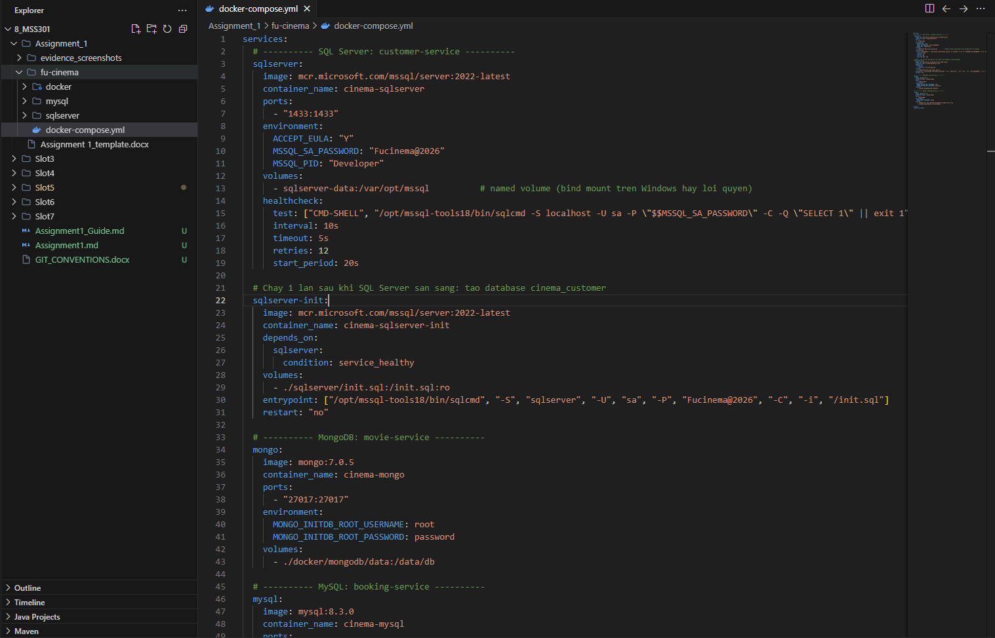
Commit: chore(infra): add docker compose for sql server, mongodb and mysql

TODO 0.2: Add init scripts for sql server and mysql databases
Chụp hình kết quả:
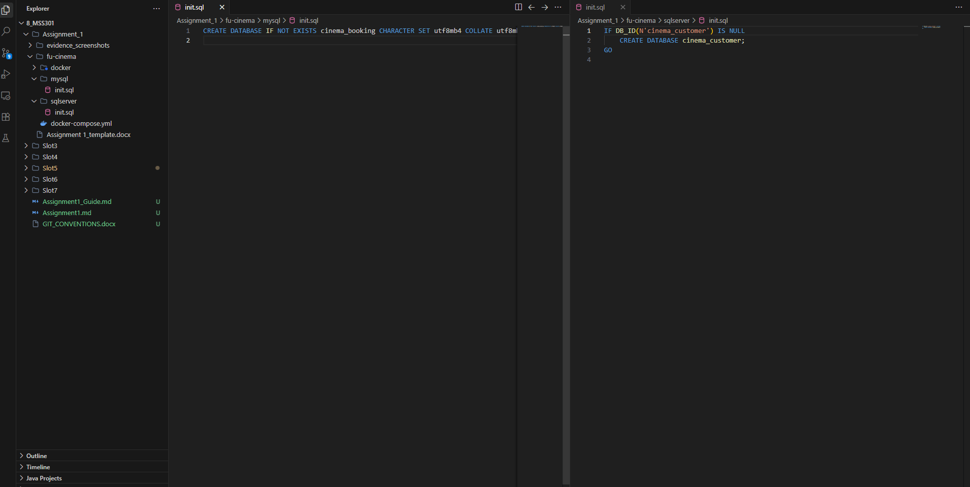
Commit: chore(infra): add init scripts for sql server and mysql databases

TODO 0.3: Bootstrap booking-service with mysql and flyway
Chụp hình kết quả:
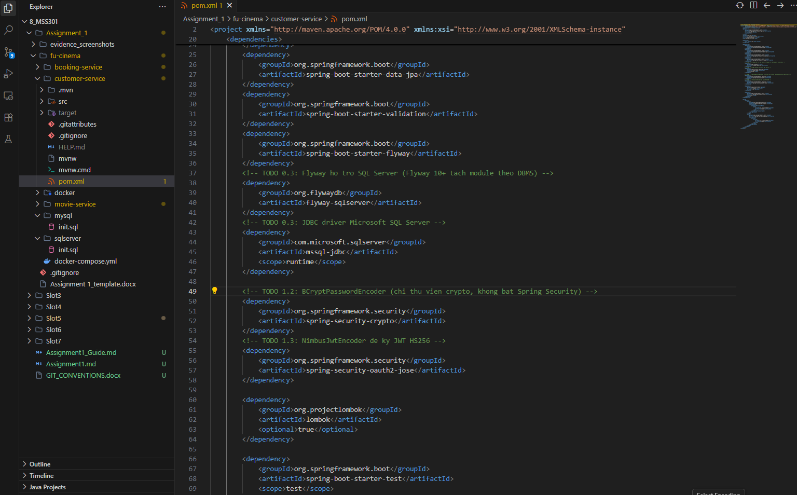
Commit: build(booking): bootstrap booking-service with mysql and flyway

TODO 0.4: Bootstrap api-gateway with gateway webmvc and resource server
Chụp hình kết quả:
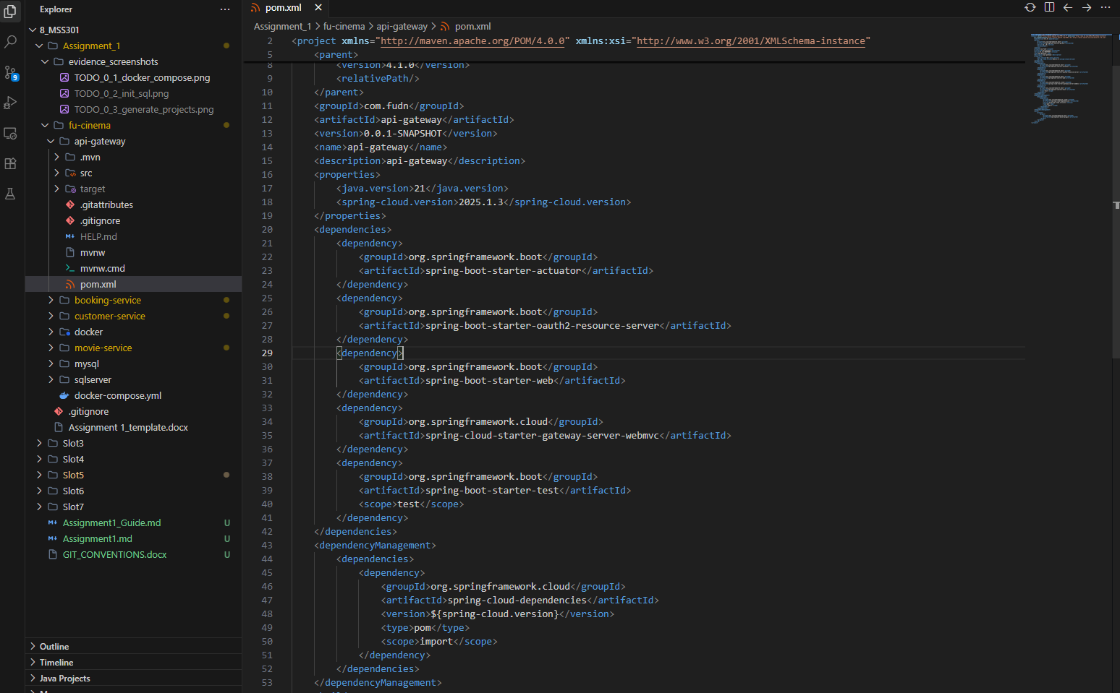
Commit: build(gateway): bootstrap api-gateway with gateway webmvc and resource server

TODO 0.5: Configure port, datasource and movie service url
Chụp hình kết quả:
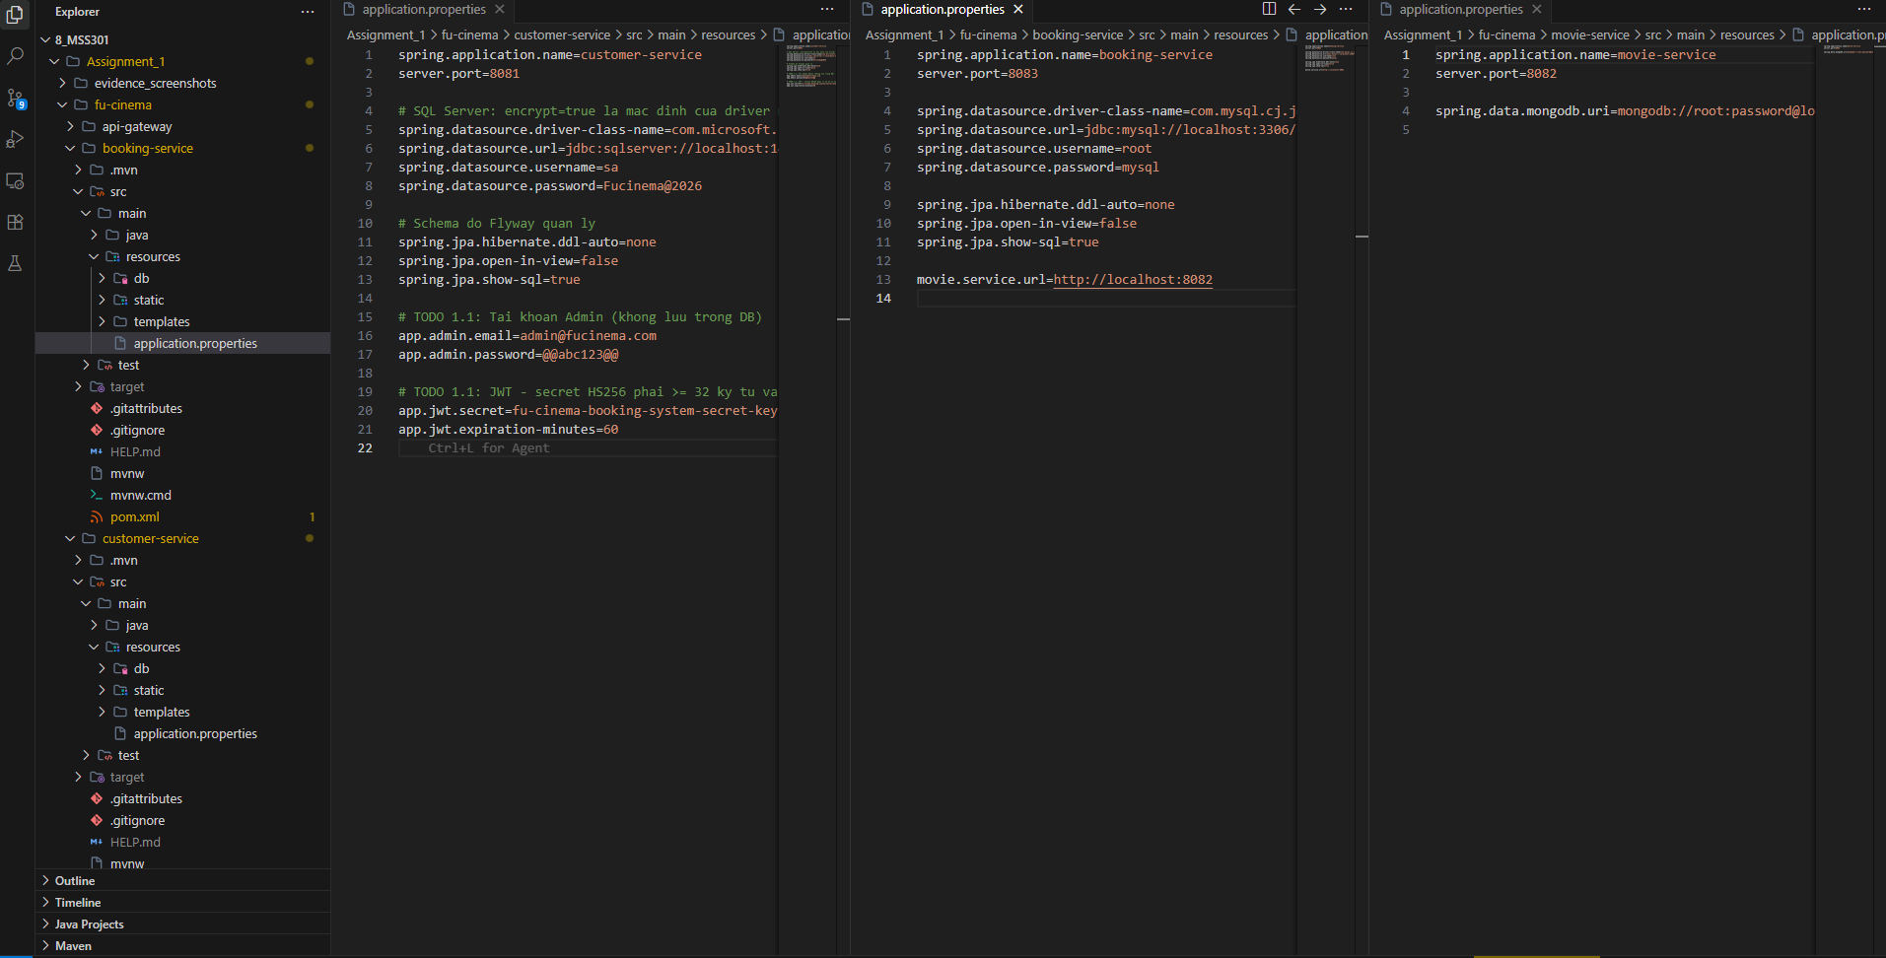
Commit: chore(booking): configure port, datasource and movie service url

TODO 0.6: Add global exception handler with unified error body
Chụp hình kết quả:
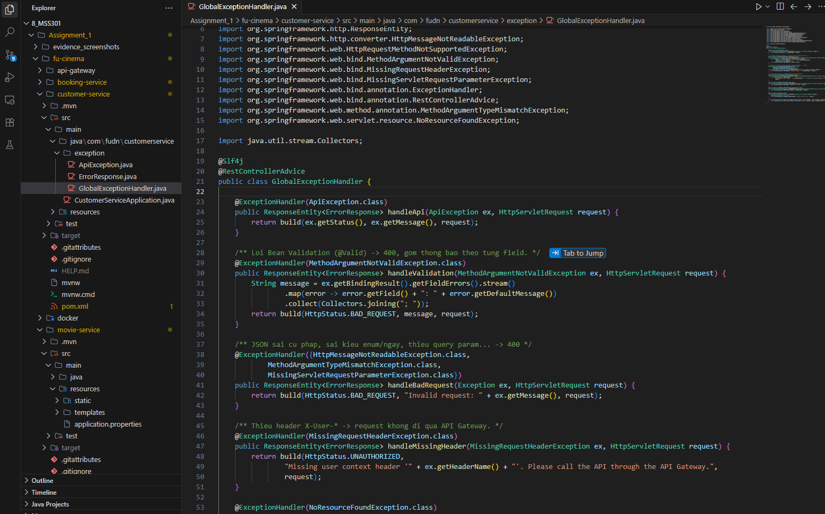
Commit: feat(booking): add global exception handler with unified error body

F1 – Authentication (customer-service + Gateway)

TODO 1.1: Configure admin account and jwt properties
Chụp hình kết quả:
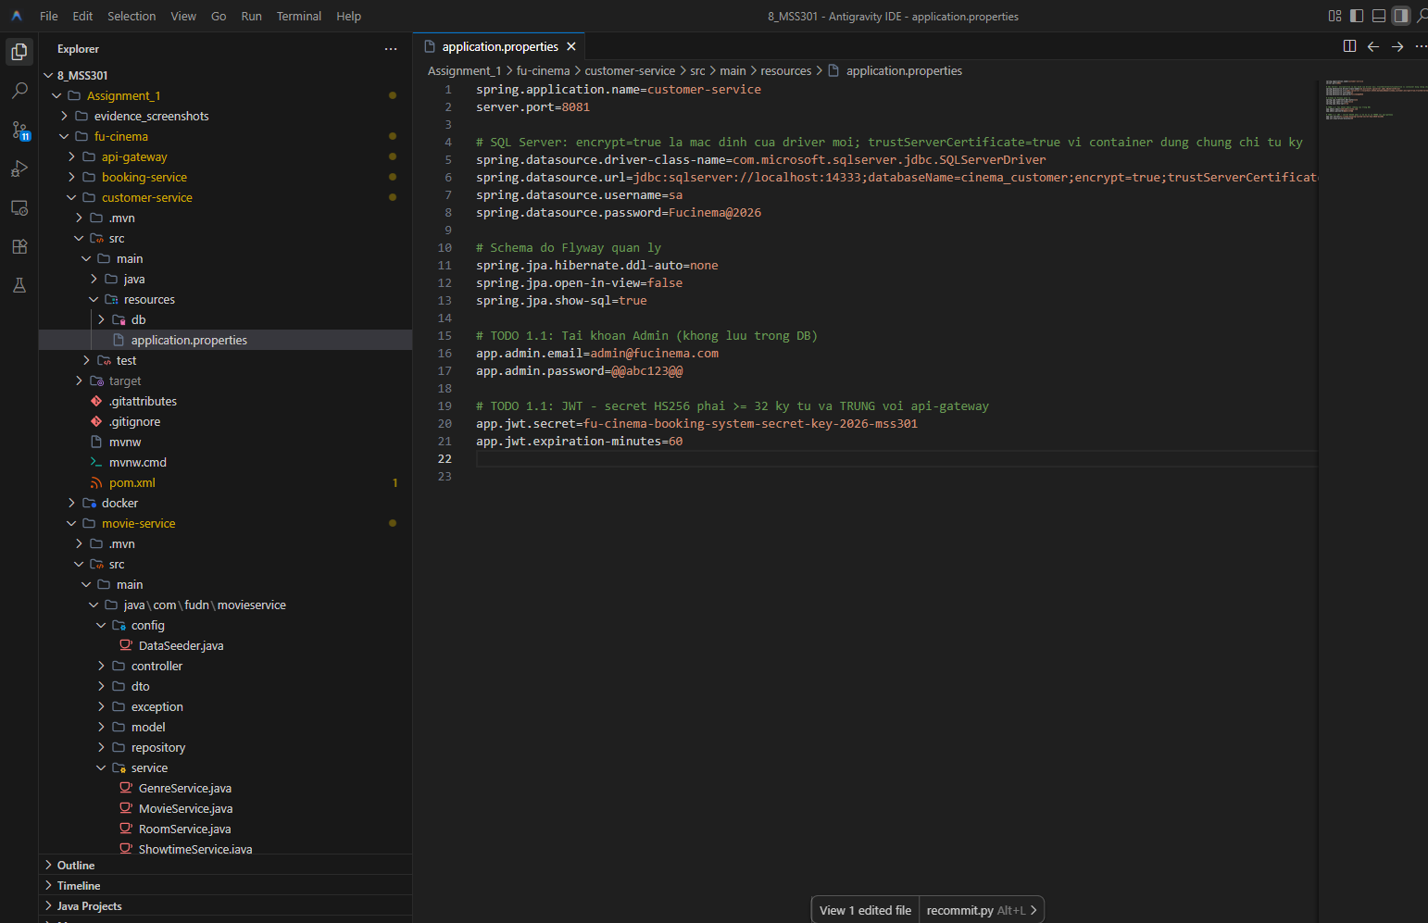
Commit: chore(customer): configure admin account and jwt properties

TODO 1.2: Add bcrypt password encoder bean
Chụp hình kết quả:
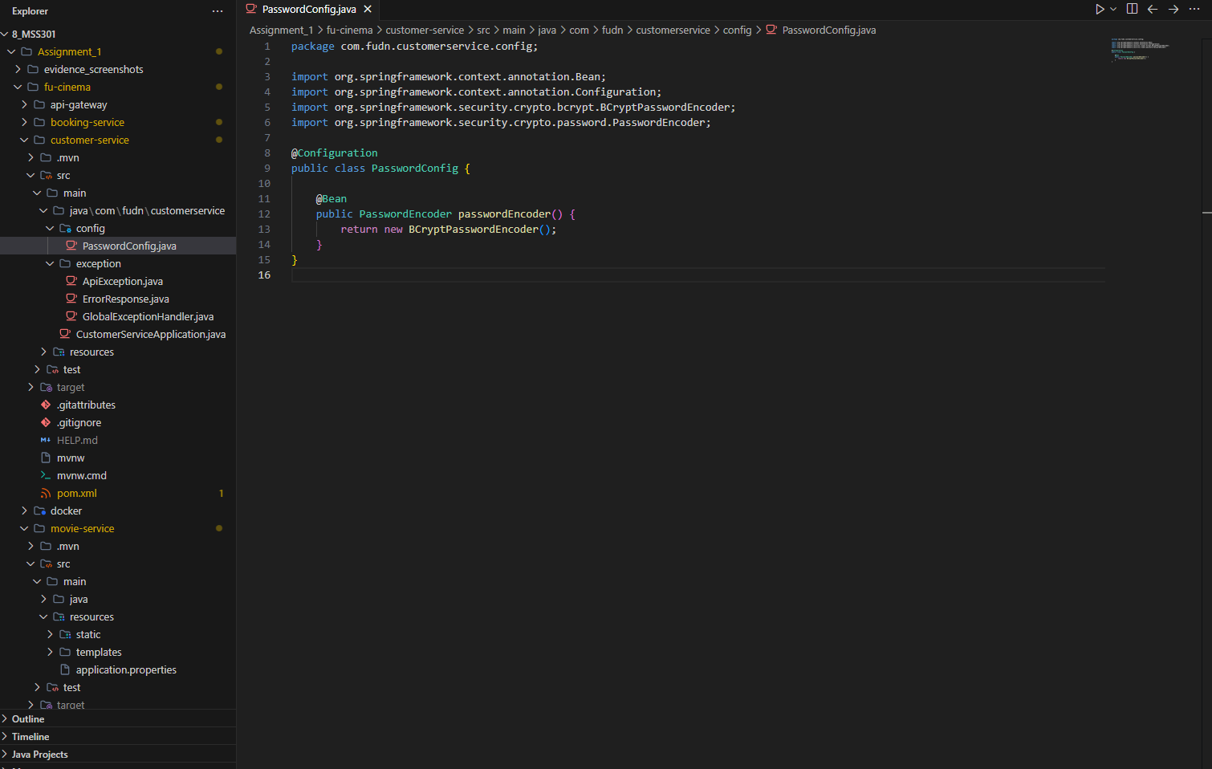
Commit: feat(customer): add bcrypt password encoder bean

TODO 1.3: Add jwtservice to sign hs256 access tokens
Chụp hình kết quả:
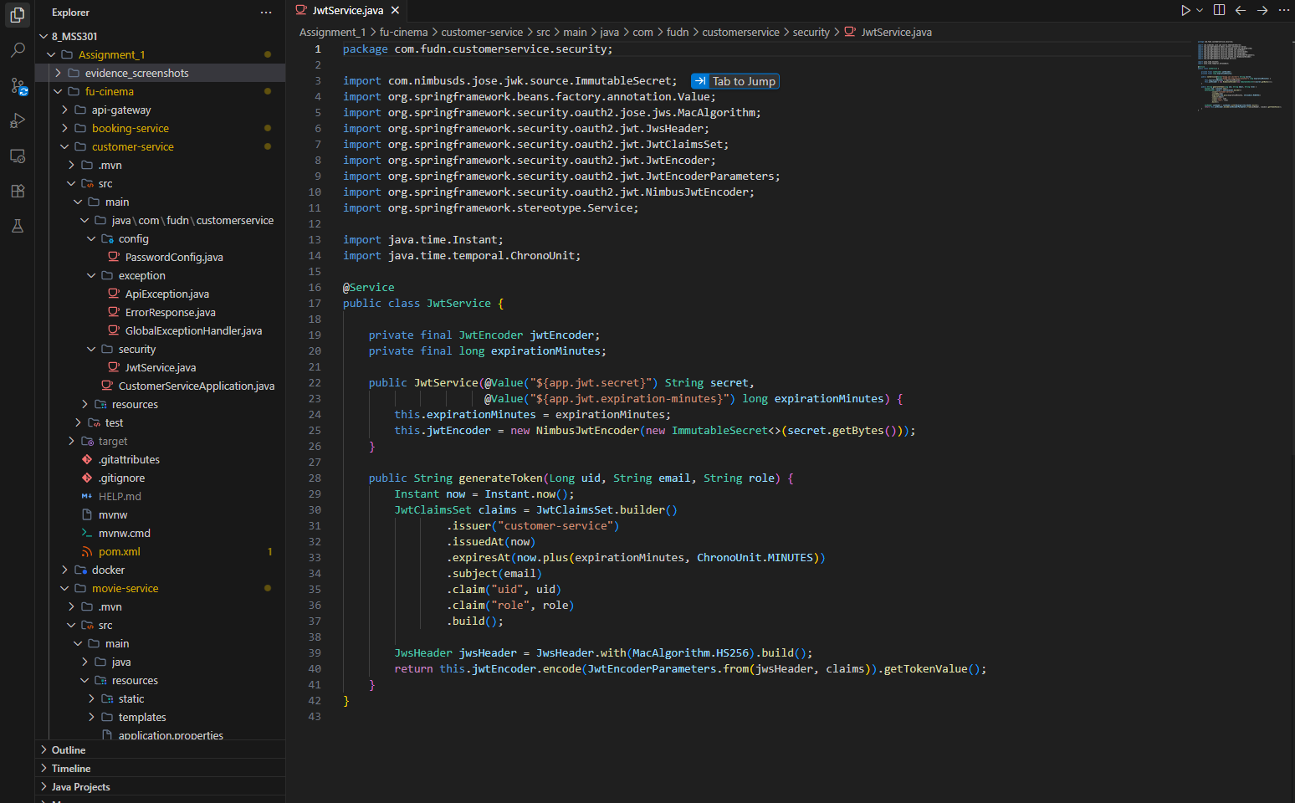
Commit: feat(customer): add JwtService to sign HS256 access tokens

TODO 1.4: Implement login for admin and customers
Chụp hình kết quả:
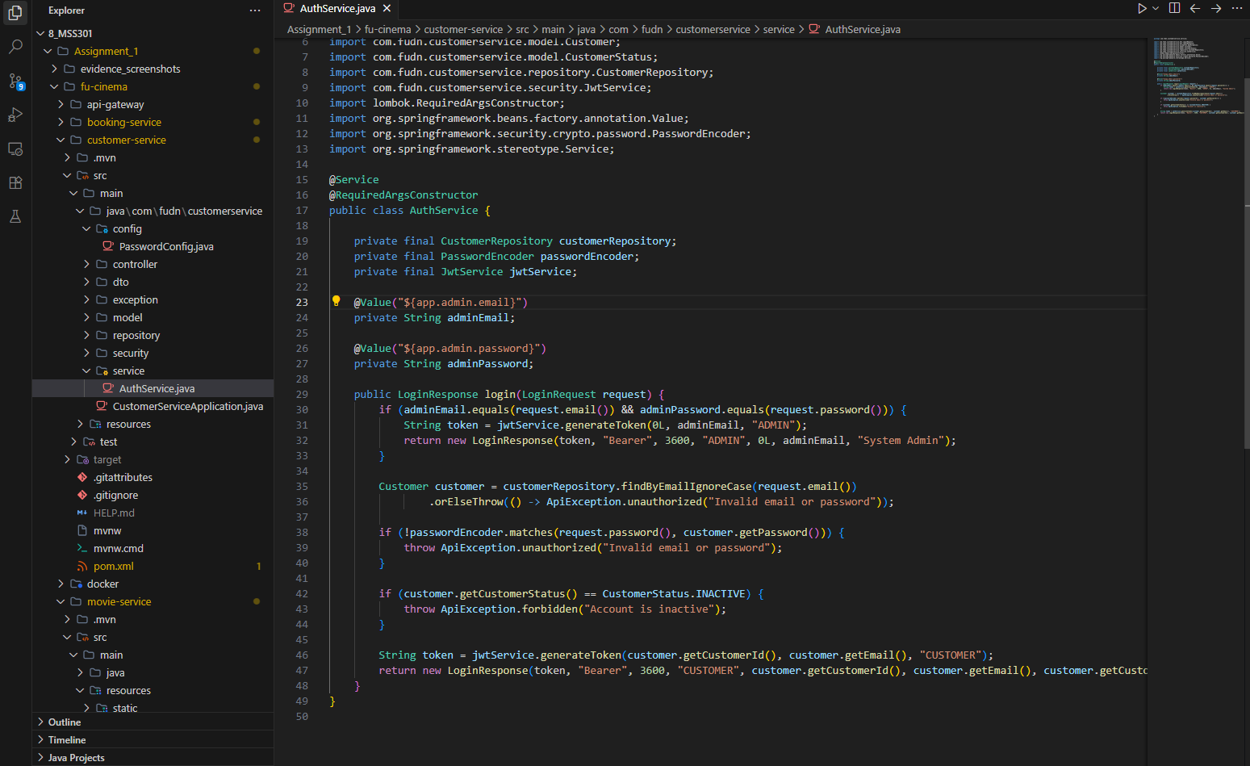
Commit: feat(customer): implement login for admin and customers

TODO 1.5: Expose post /api/auth/login
Chụp hình kết quả:
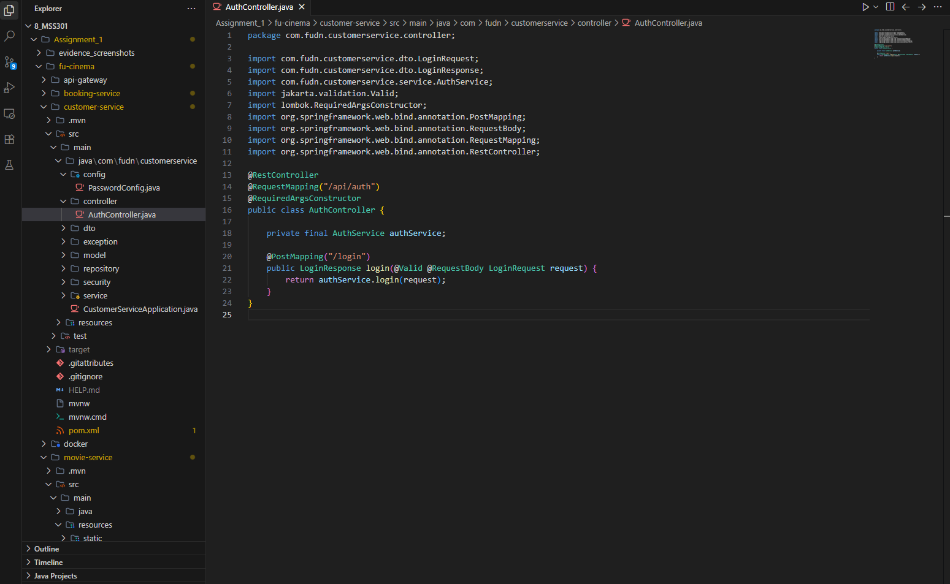
Commit: feat(customer): expose POST /api/auth/login

F2 – Customer Profile & Validation

TODO 2.1: Add t-sql migrations with nvarchar and unicode seed data
Chụp hình kết quả:
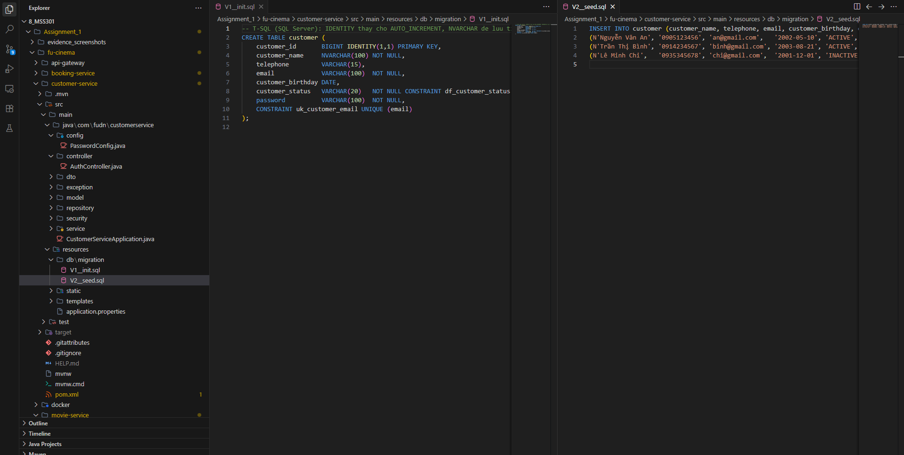
Commit: feat(customer): add t-sql migrations with nvarchar and unicode seed data

TODO 2.2: Add customer entity and repository
Chụp hình kết quả:
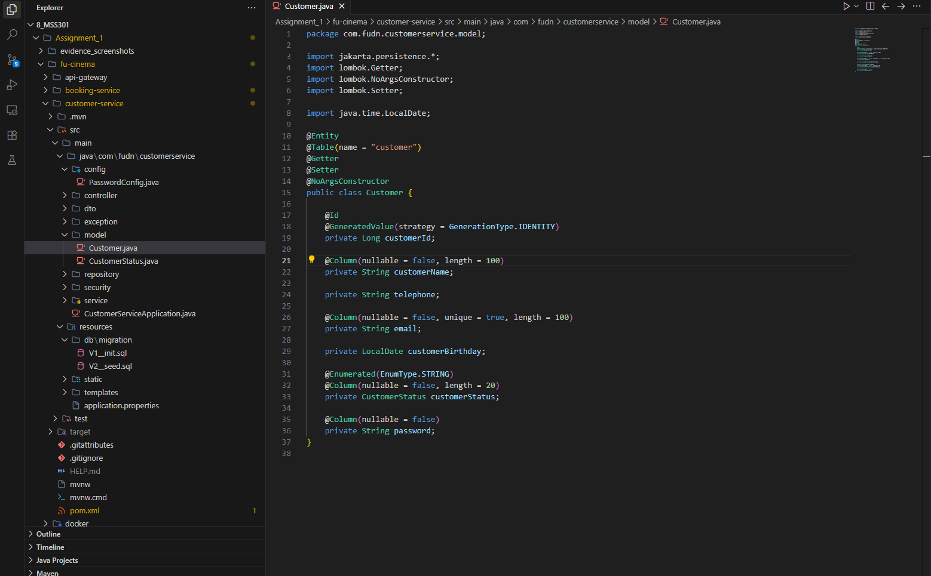
Commit: feat(customer): add Customer entity and repository

TODO 2.3: Add register, profile and password dtos with validation
Chụp hình kết quả:
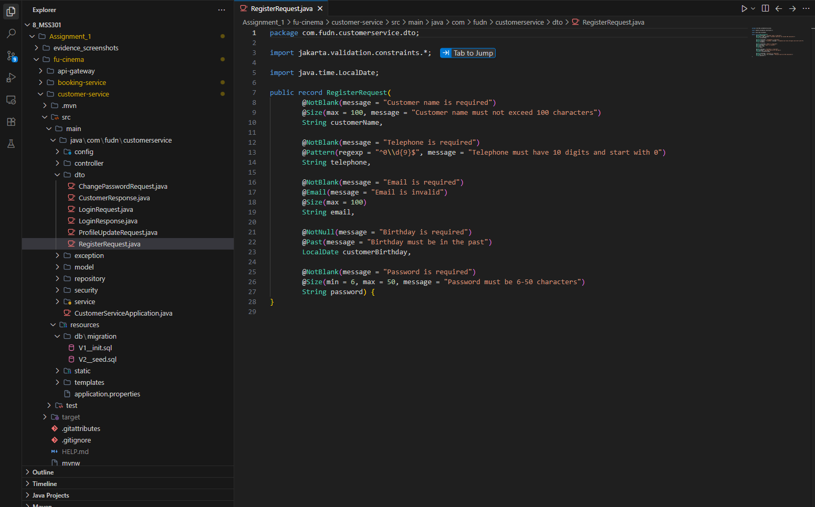
Commit: feat(customer): add register, profile and password DTOs with validation

TODO 2.4: Implement customer registration with unique email
Chụp hình kết quả:
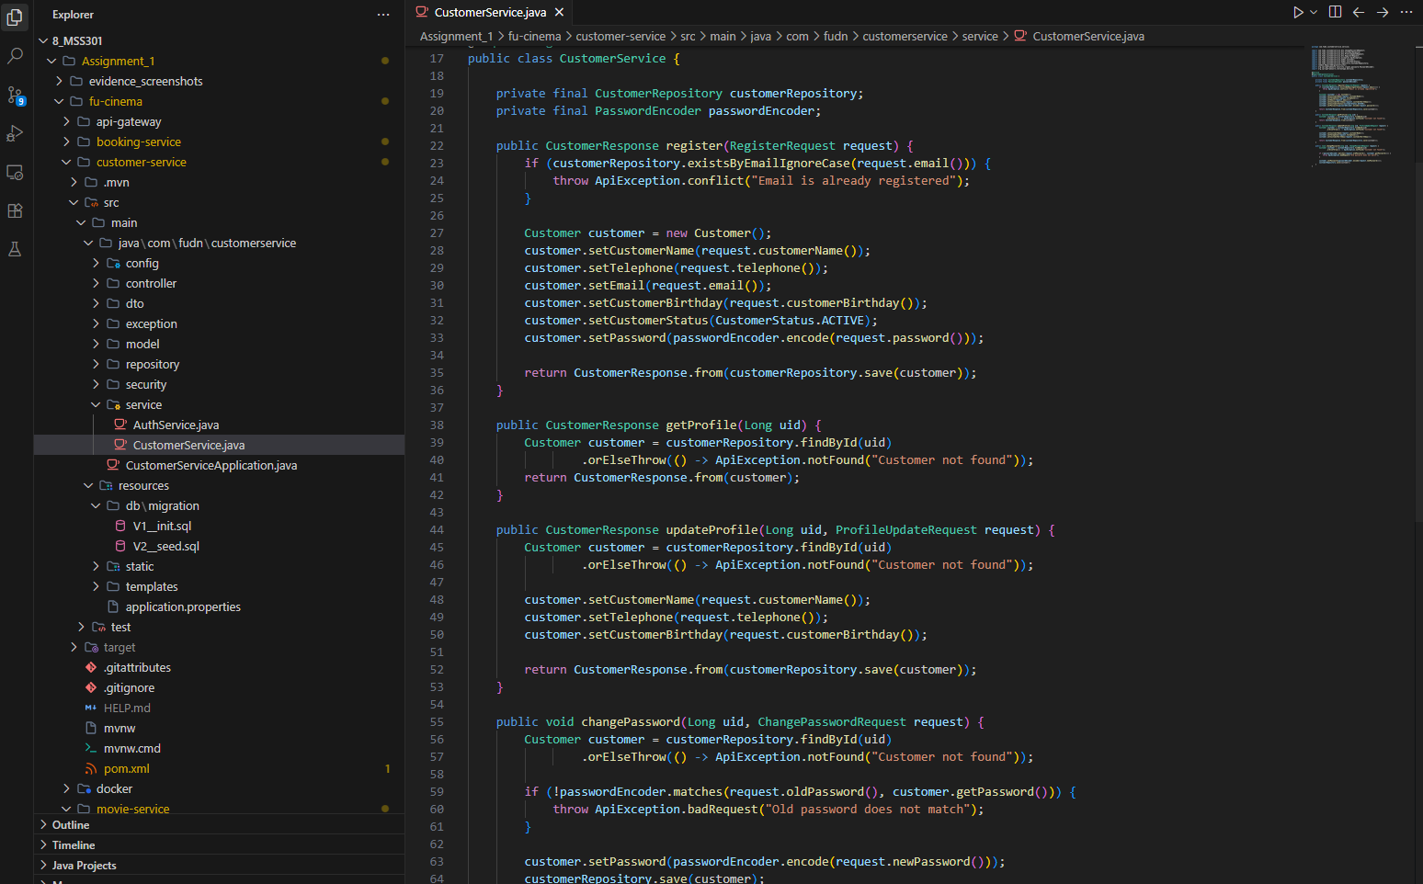
Commit: feat(customer): implement customer registration with unique email

TODO 2.5: Implement view, update profile and change password
Chụp hình kết quả:
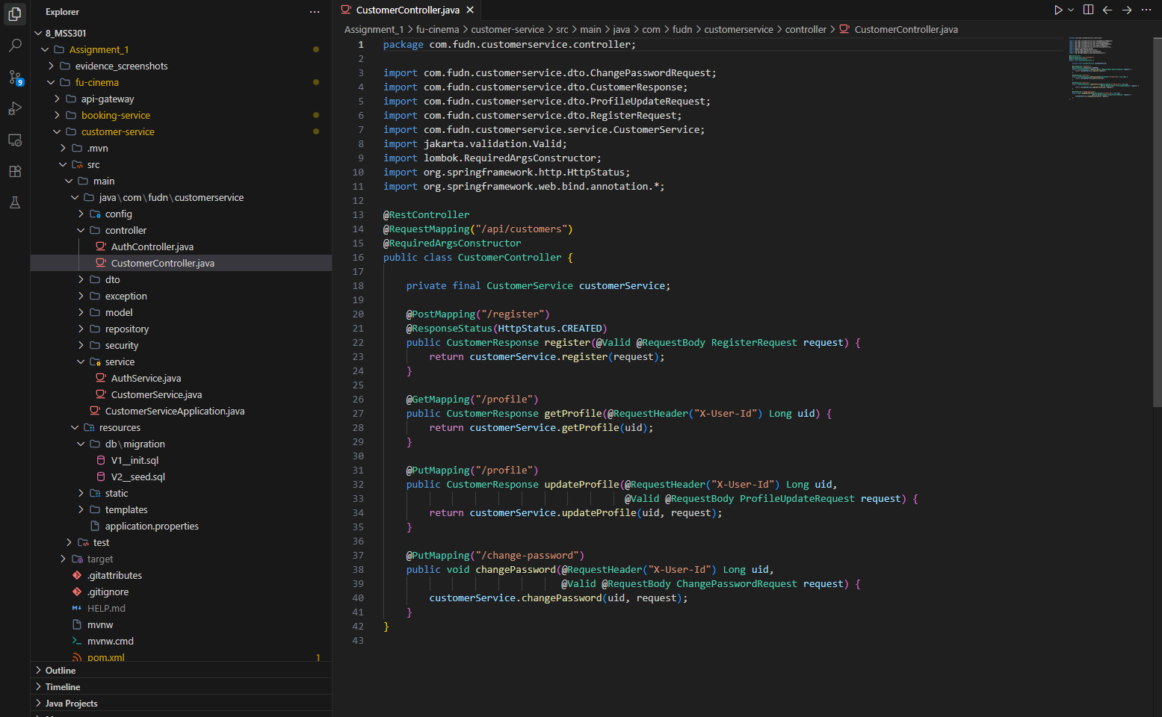
Commit: feat(customer): implement view, update profile and change password

TODO 2.6: Expose register and /me endpoints
Chụp hình kết quả:
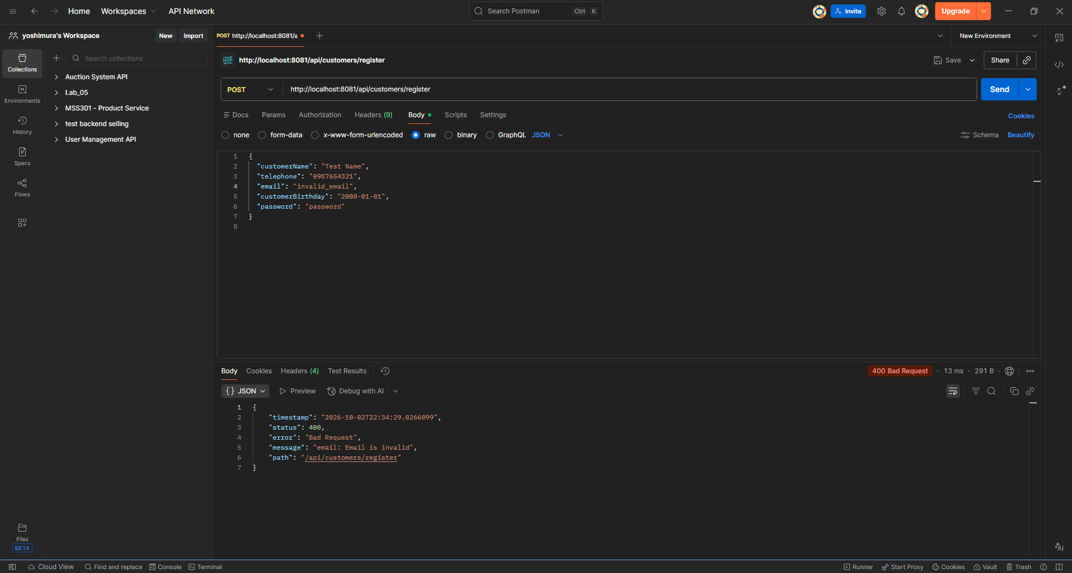
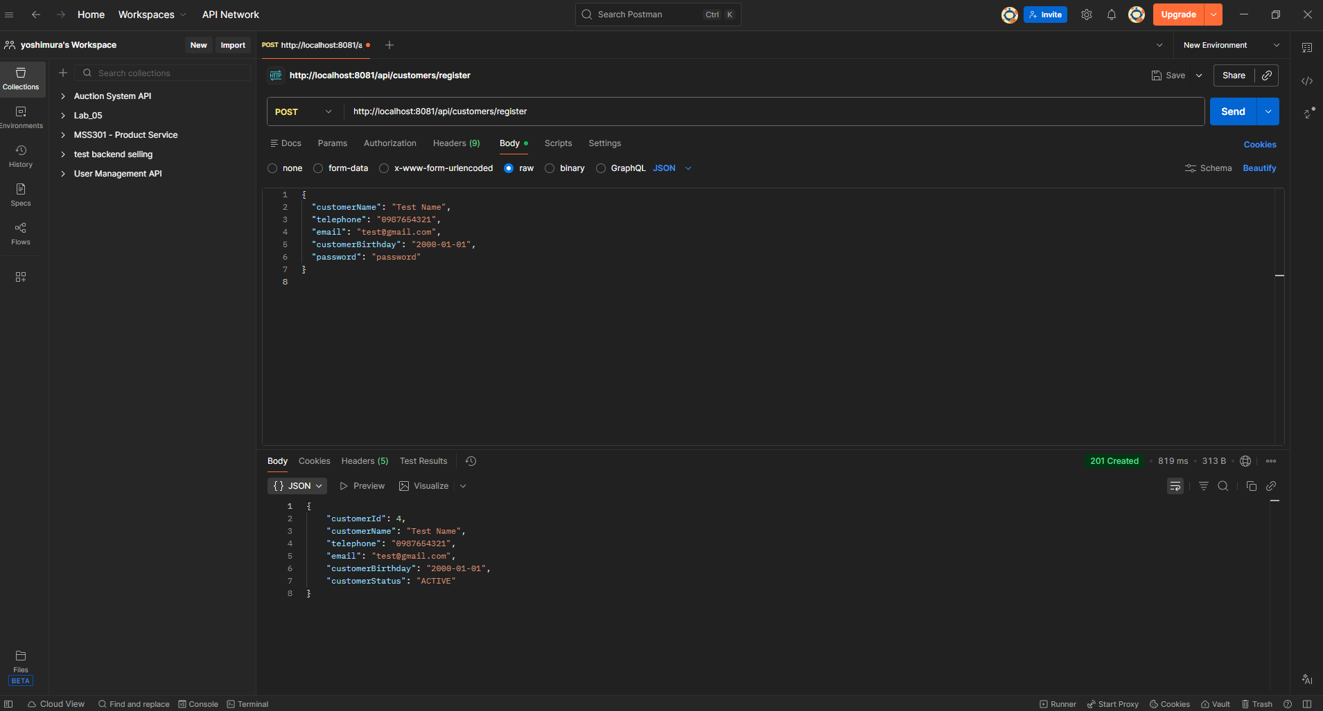
Commit: feat(customer): expose register and /me endpoints

F3 – Admin Customers

TODO 3: Add admincustomerrequest dto
Chụp hình kết quả:
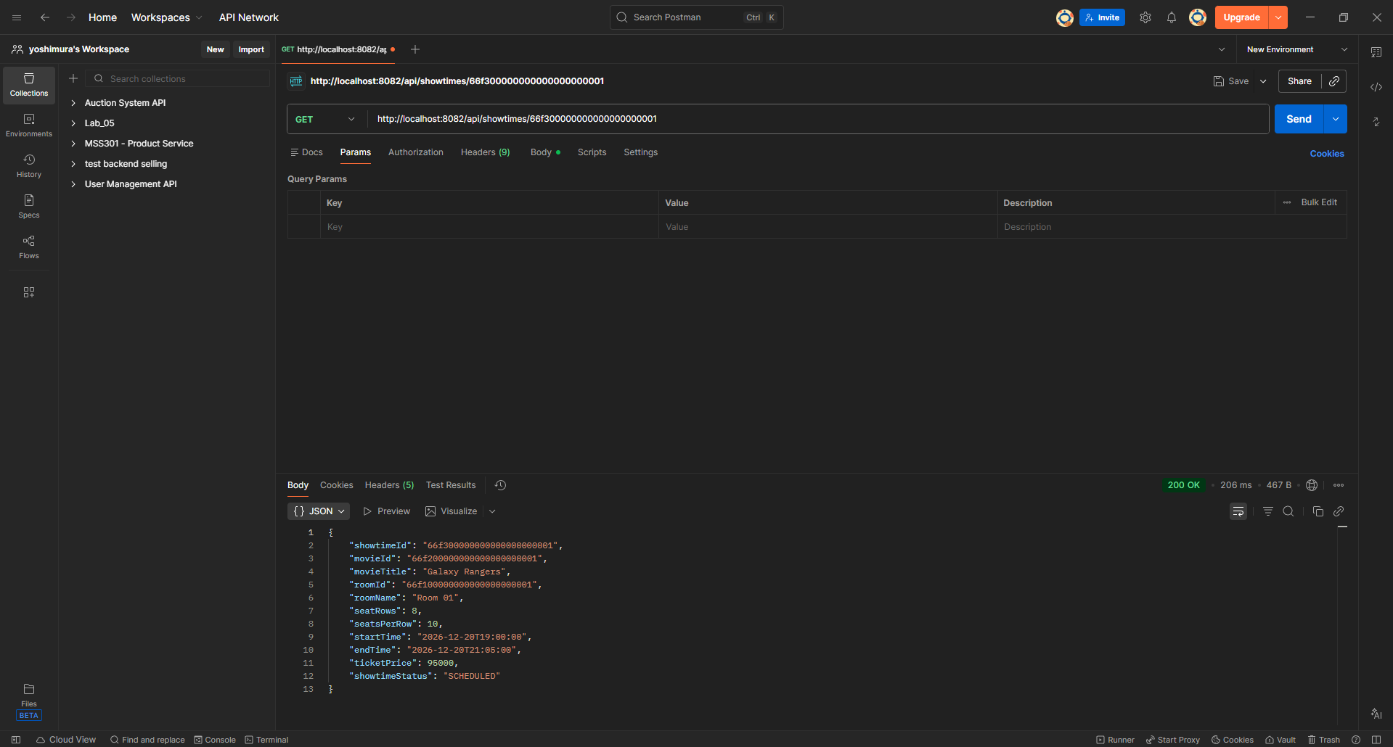
Commit: feat(customer): add AdminCustomerRequest DTO

TODO 3.1: Add admincustomerrequest dto
Chụp hình kết quả:
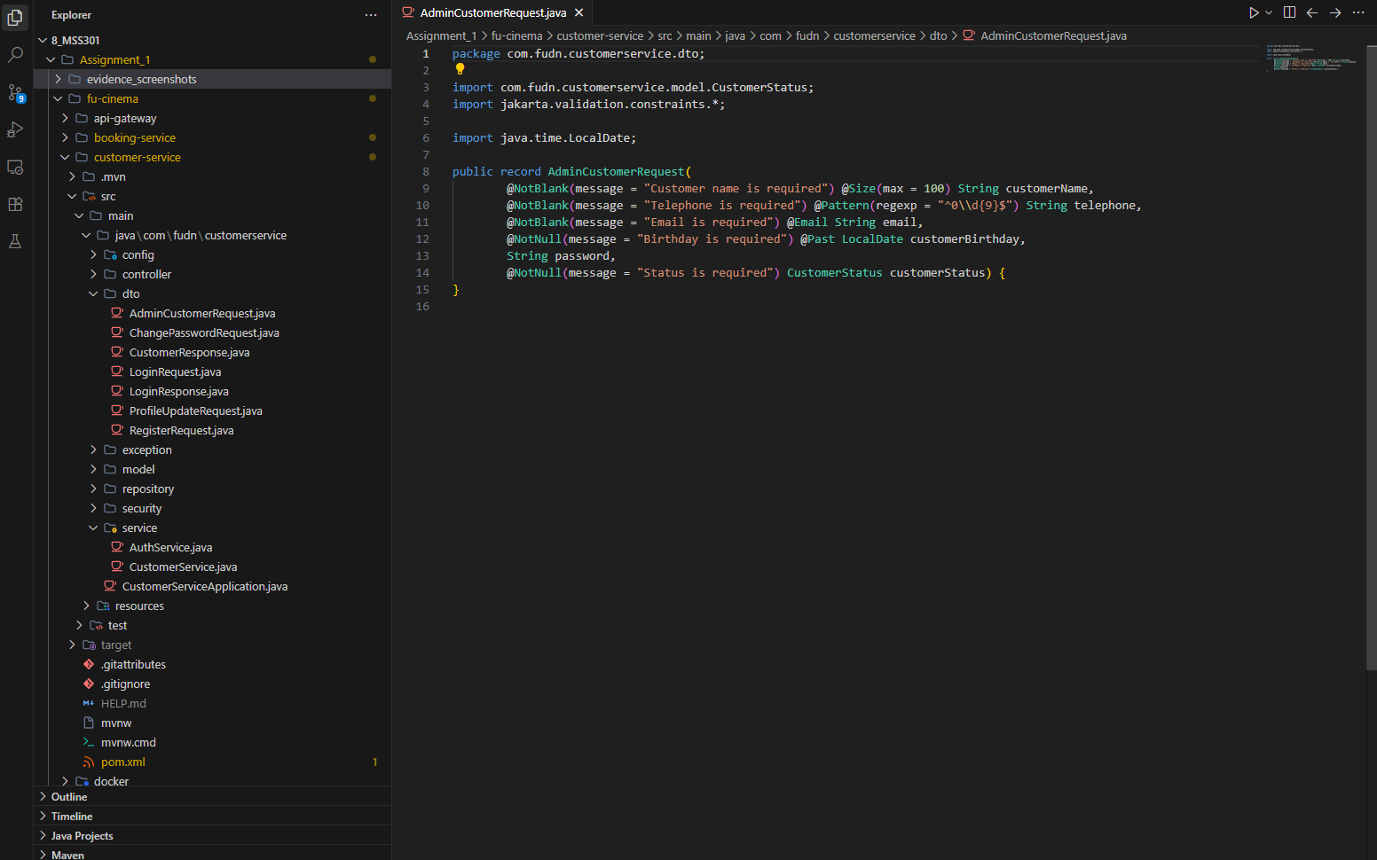
Commit: feat(customer): add AdminCustomerRequest DTO

TODO 3.2: Implement admin customer search and crud with soft delete
Chụp hình kết quả:
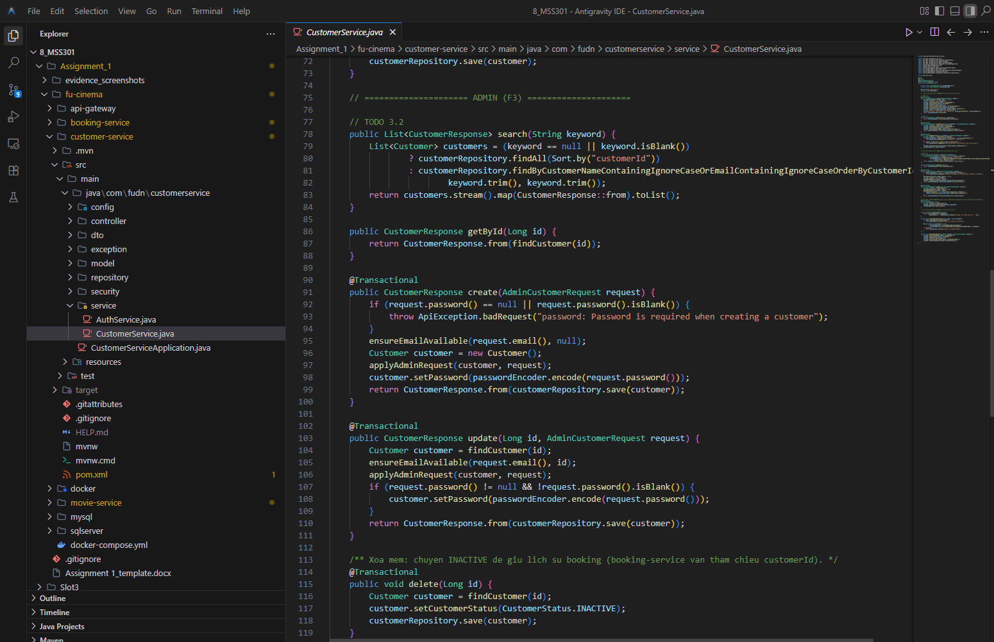
Commit: feat(customer): implement admin customer search and crud with soft delete

TODO 3.3: Expose admin customer crud endpoints
Chụp hình kết quả:
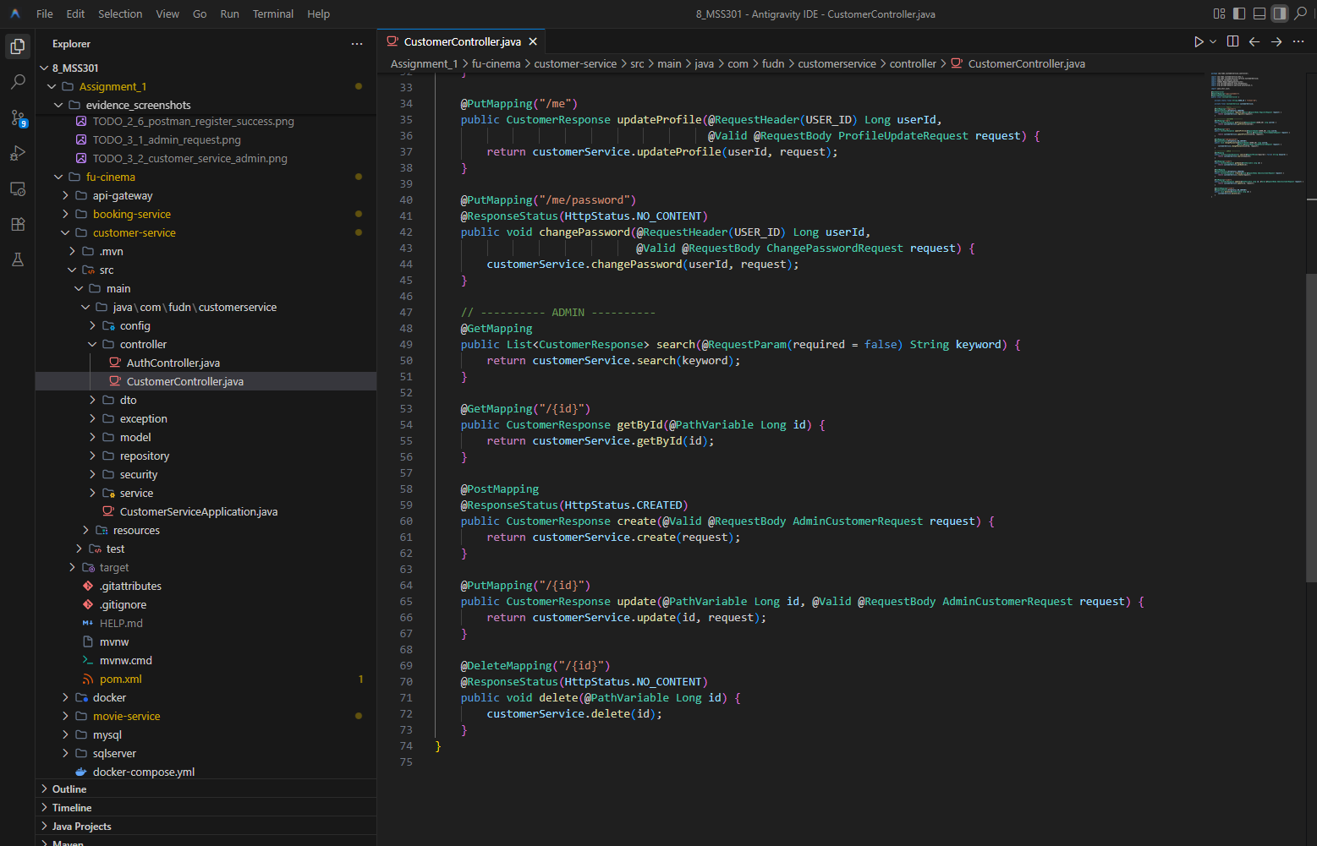
Commit: feat(customer): expose admin customer crud endpoints

F4 – Genre & Room

TODO 4.1: Add dataseeder for genres, rooms, movies and showtimes
Chụp hình kết quả:
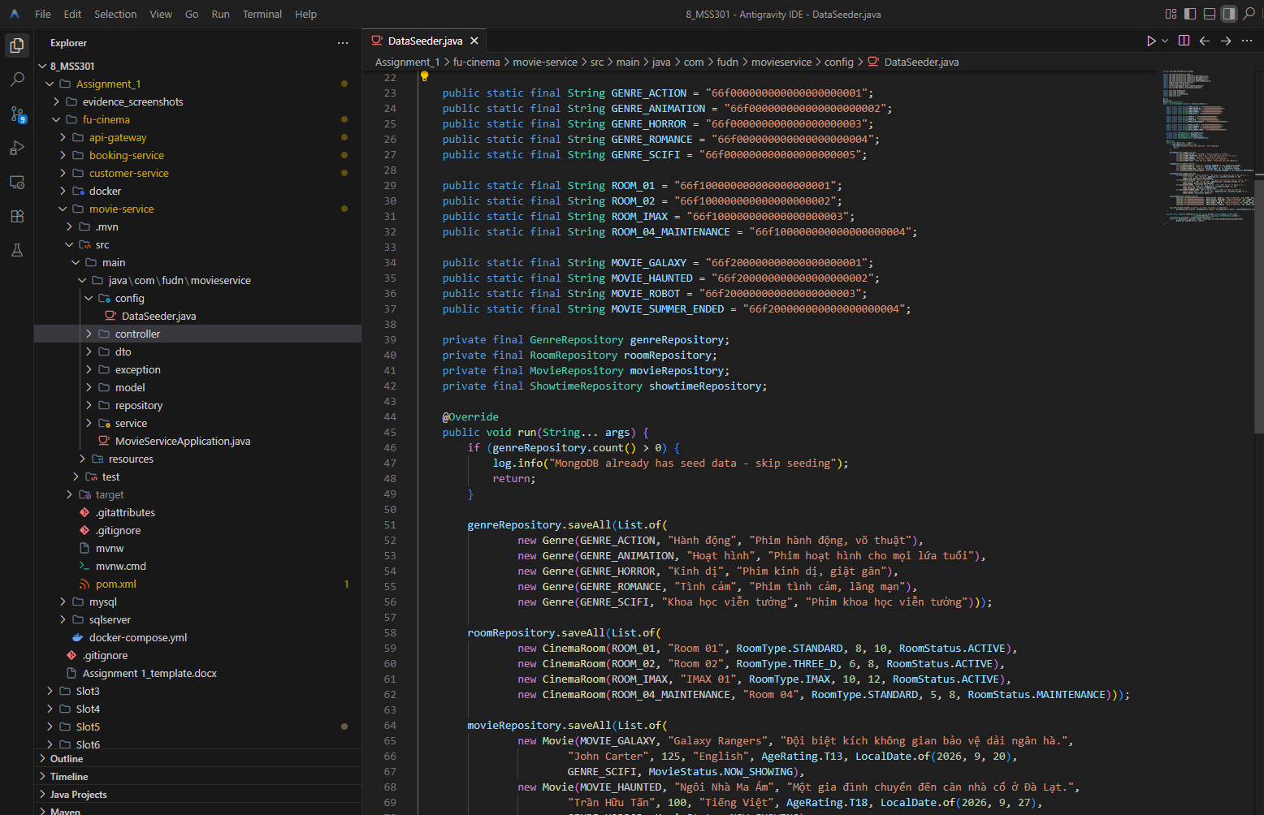
Commit: feat(movie): add DataSeeder for genres, rooms, movies and showtimes

TODO 4.2: Add genre and cinemaroom documents with unique indexes
Chụp hình kết quả:
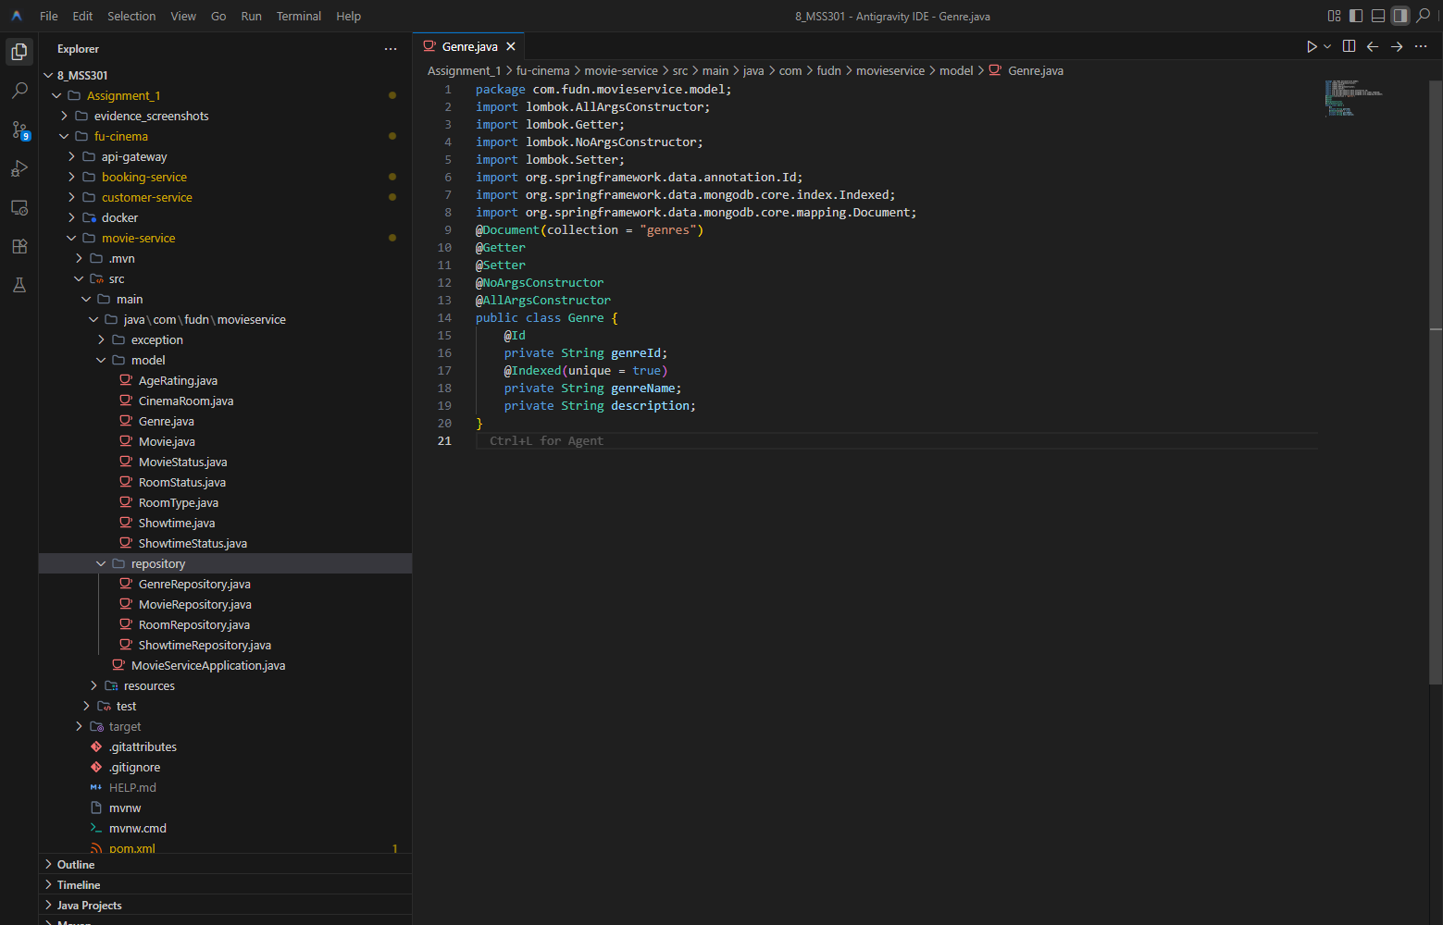
Commit: feat(movie): add Genre and CinemaRoom documents with unique indexes

TODO 4.3: Implement genre and room services with delete guards
Chụp hình kết quả:
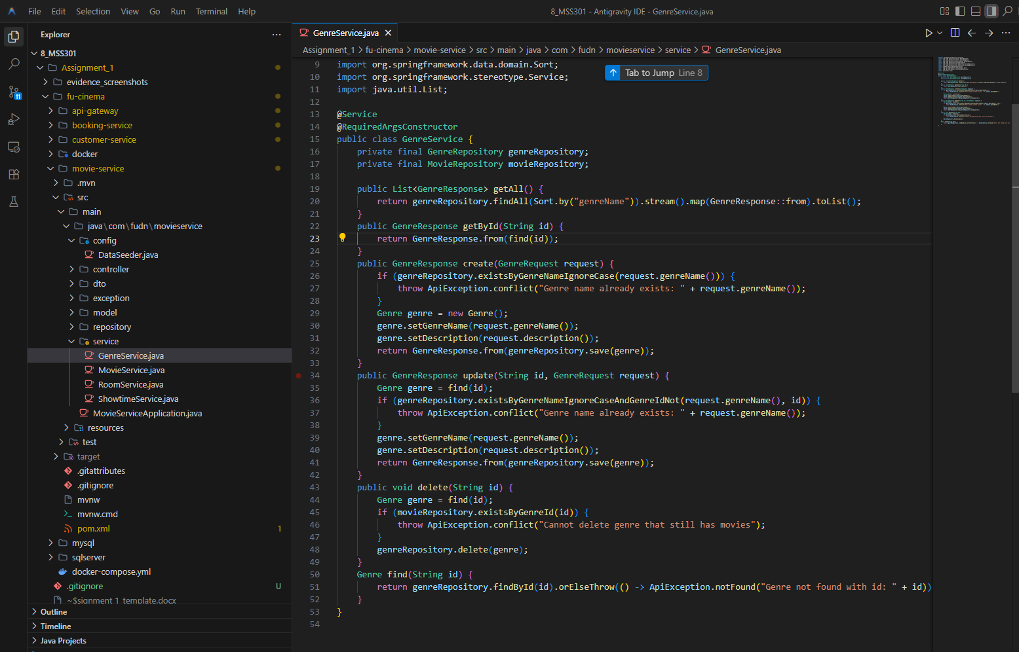
Commit: feat(movie): implement genre and room services with delete guards

TODO 4.4: Expose genre and room endpoints
Chụp hình kết quả:
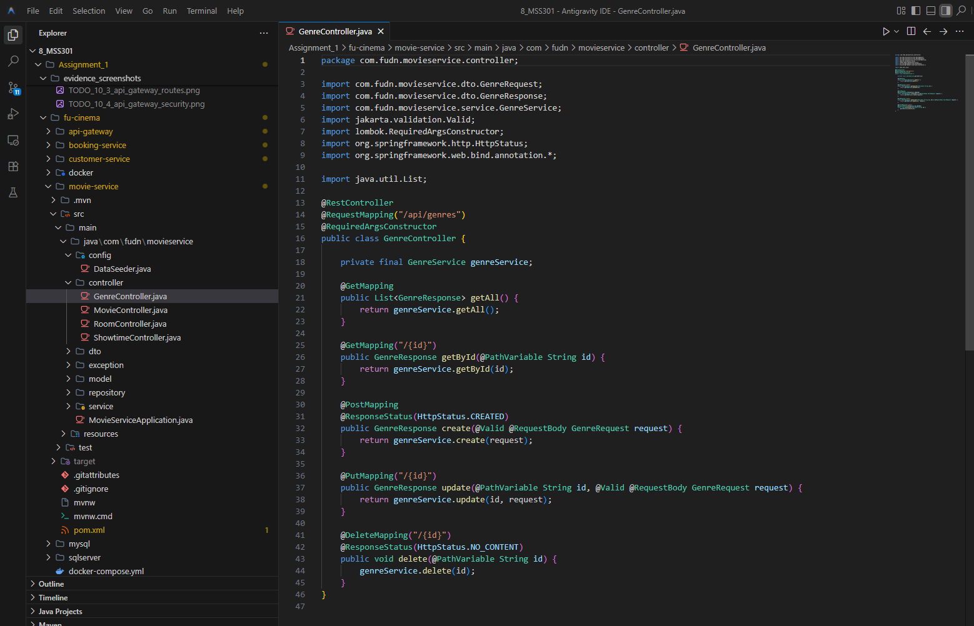
Commit: feat(movie): expose genre and room endpoints

F5 – Movie CRUD & Search

TODO 5.1: Add movie document referencing genre id
Chụp hình kết quả:
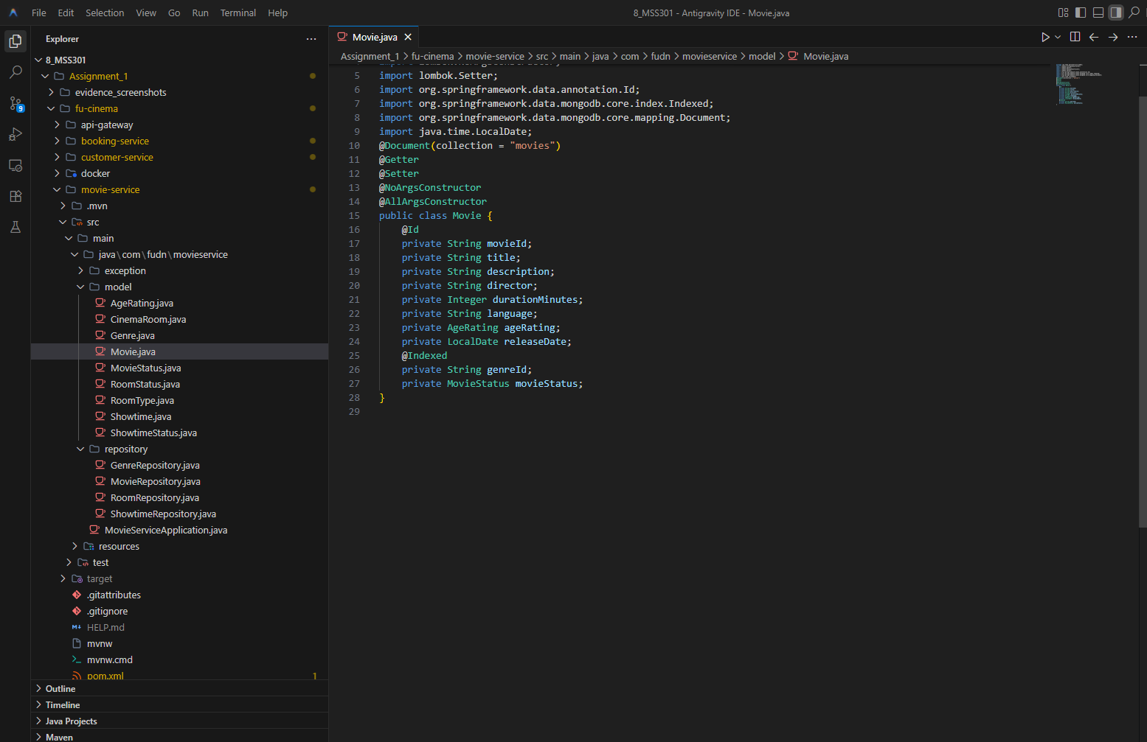
Commit: feat(movie): add Movie document referencing genre id

TODO 5.2: Search movies with mongotemplate criteria
Chụp hình kết quả:
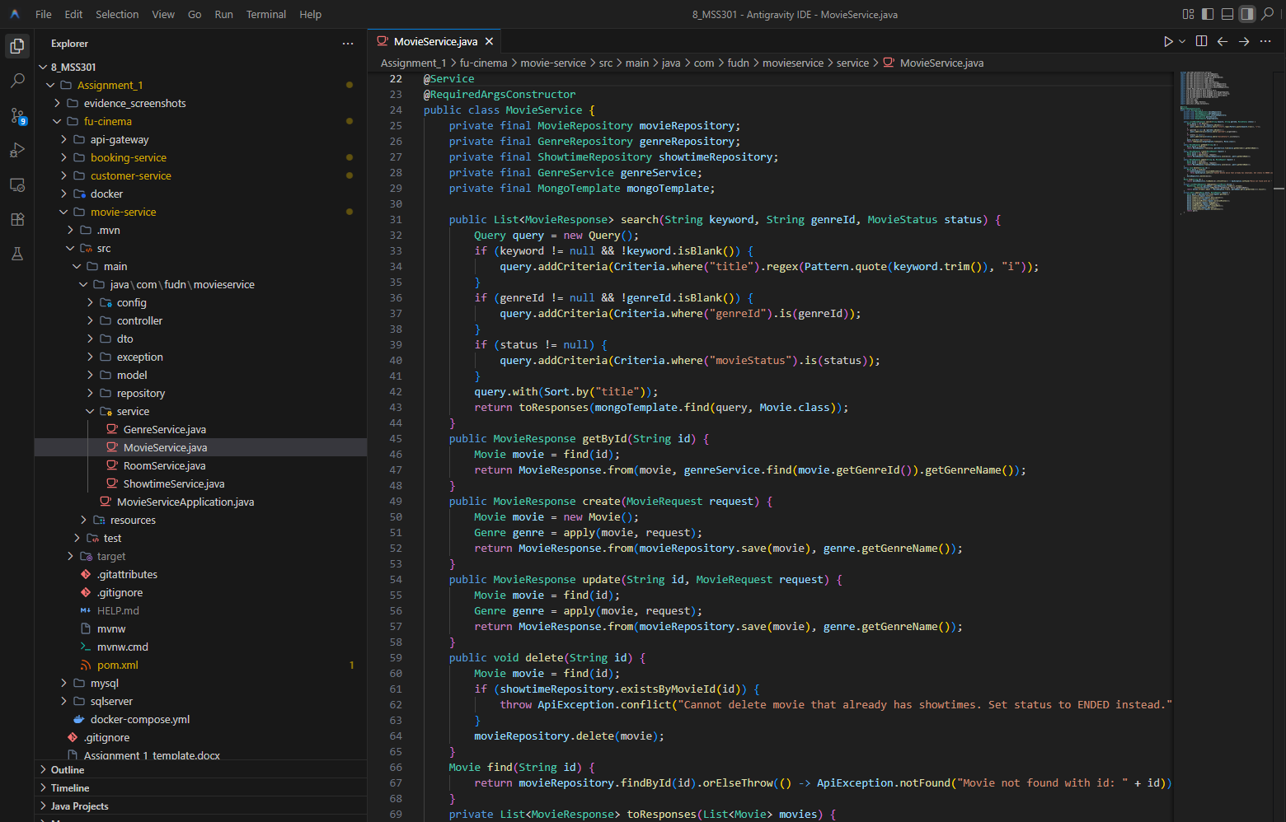
Commit: feat(movie): search movies with MongoTemplate criteria

TODO 5.3: Implement movie crud with genre existence check
Chụp hình kết quả:
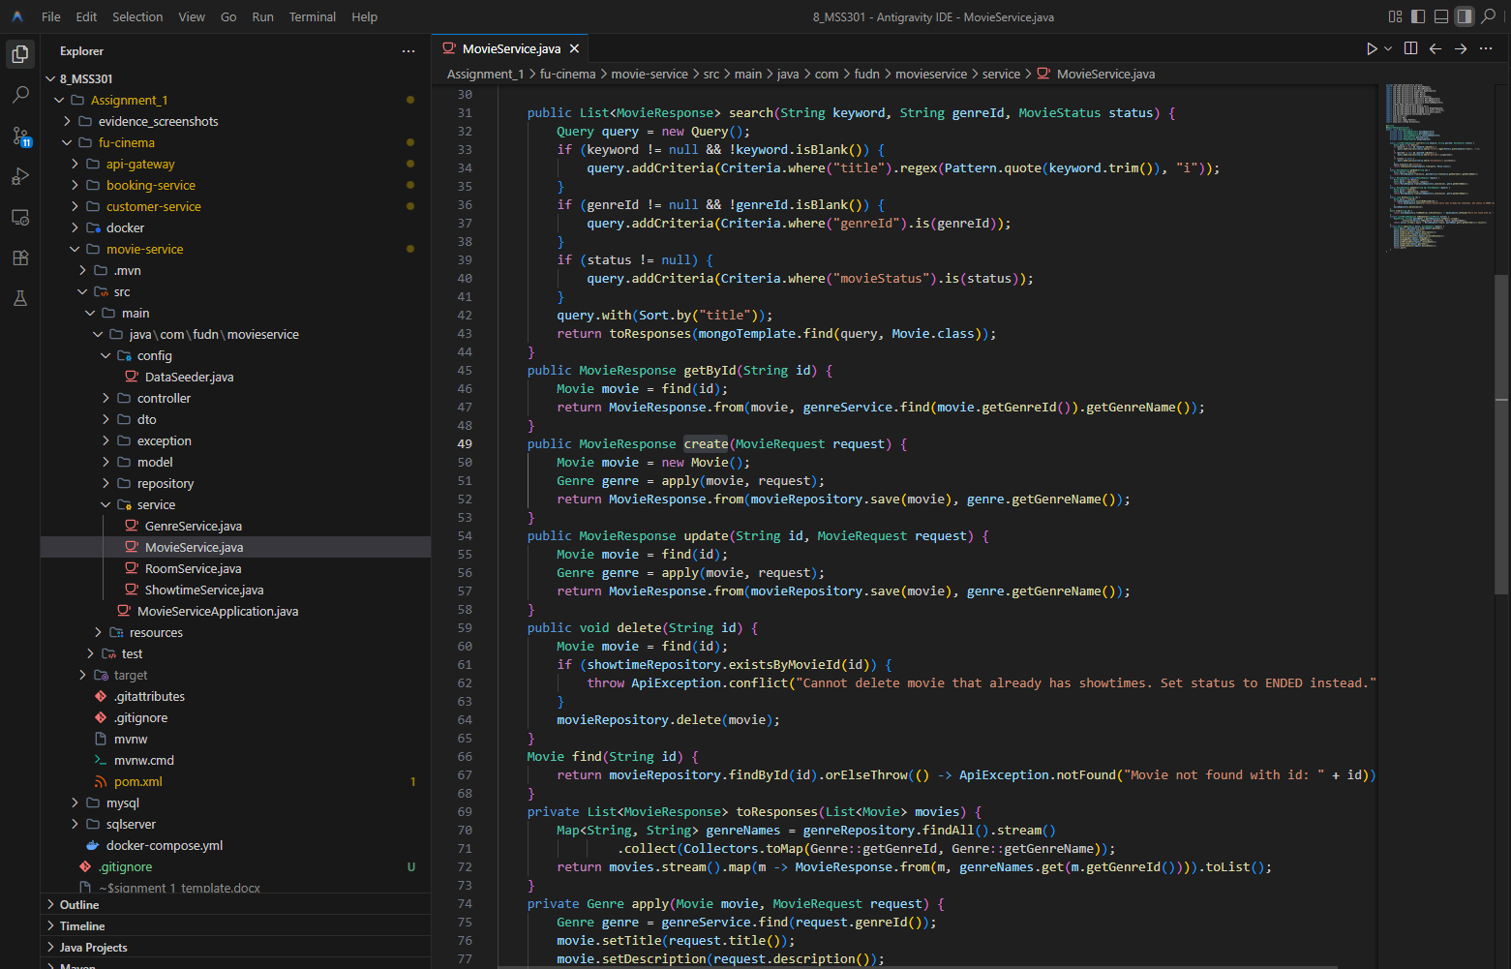
Commit: feat(movie): implement movie crud with genre existence check

TODO 5.4: Expose movie endpoints
Chụp hình kết quả:
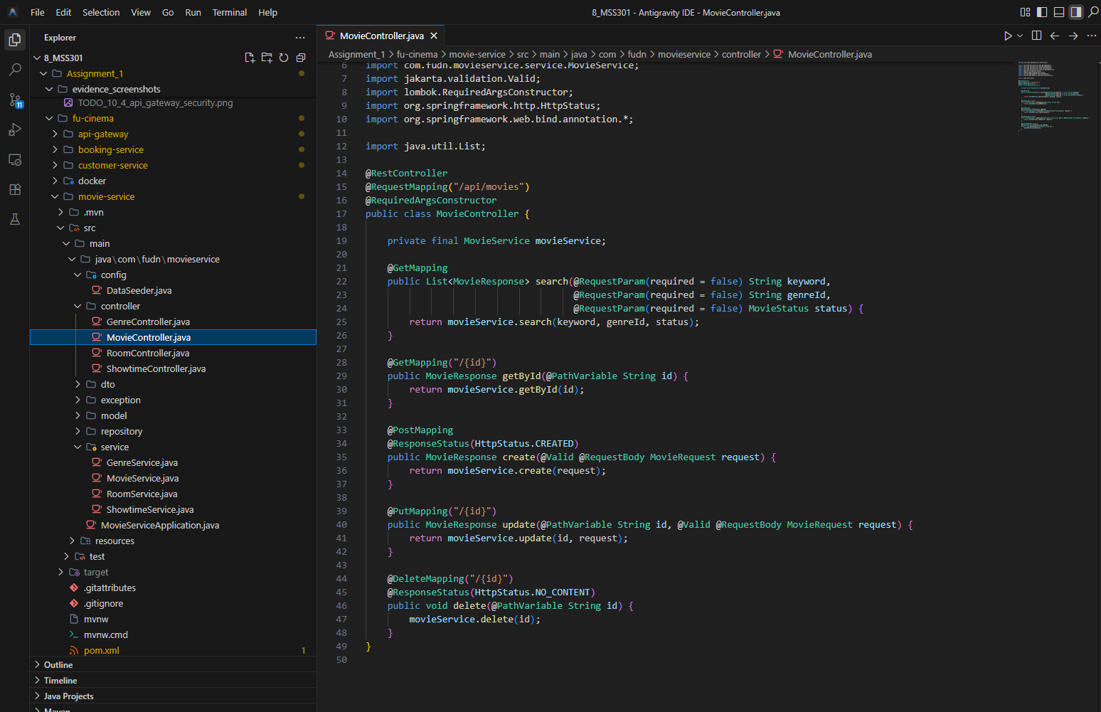
Commit: feat(movie): expose movie endpoints

F6 – Showtime & Validation

TODO 6.1: Add showtime document with decimal128 price
Chụp hình kết quả:
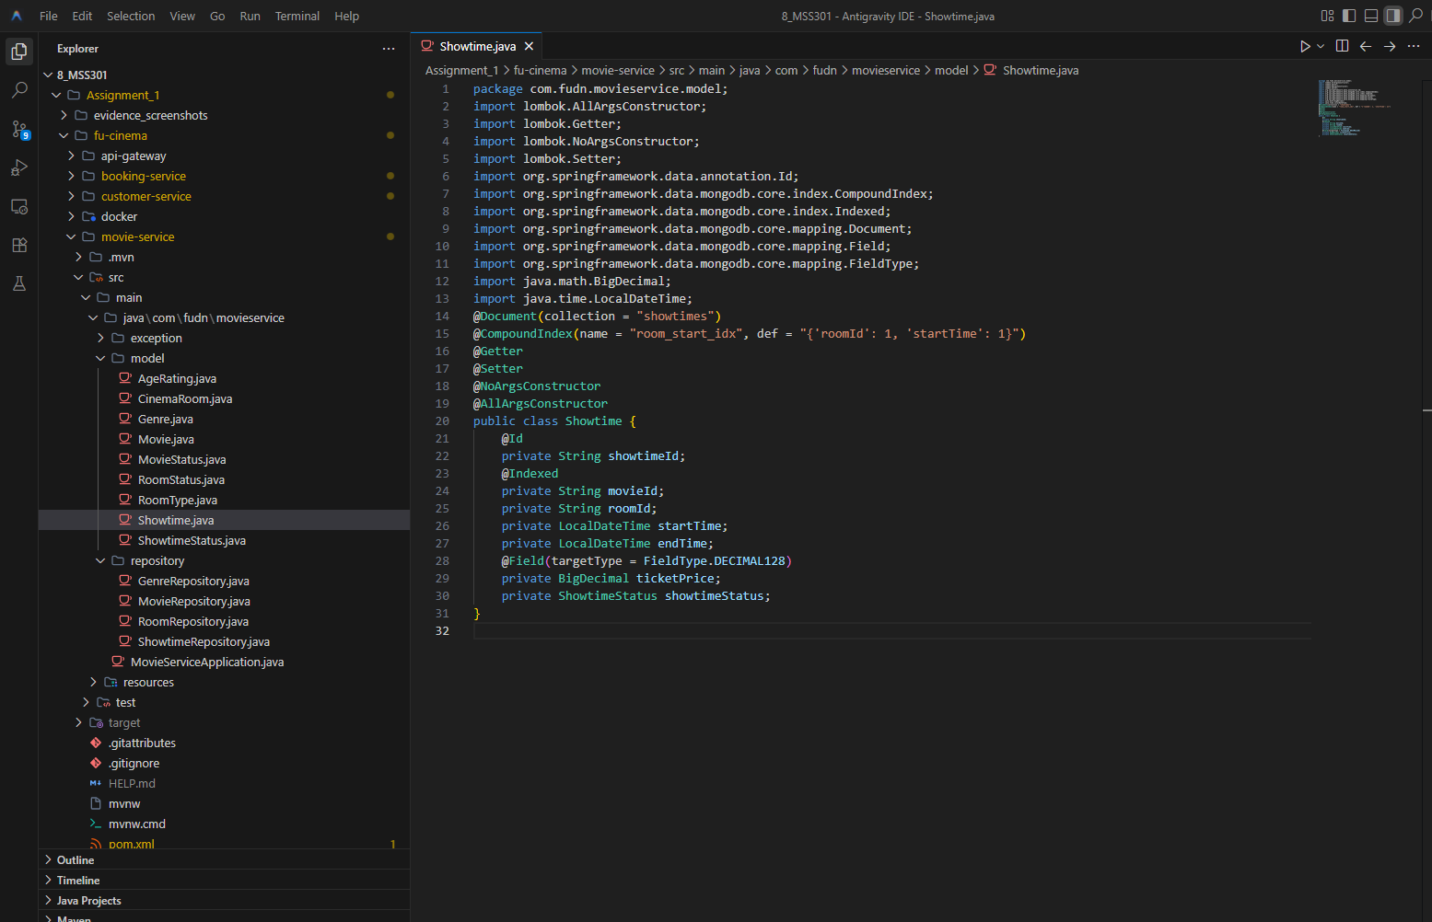
Commit: feat(movie): add Showtime document with decimal128 price

TODO 6.2: Add derived query counting overlapping showtimes
Chụp hình kết quả:
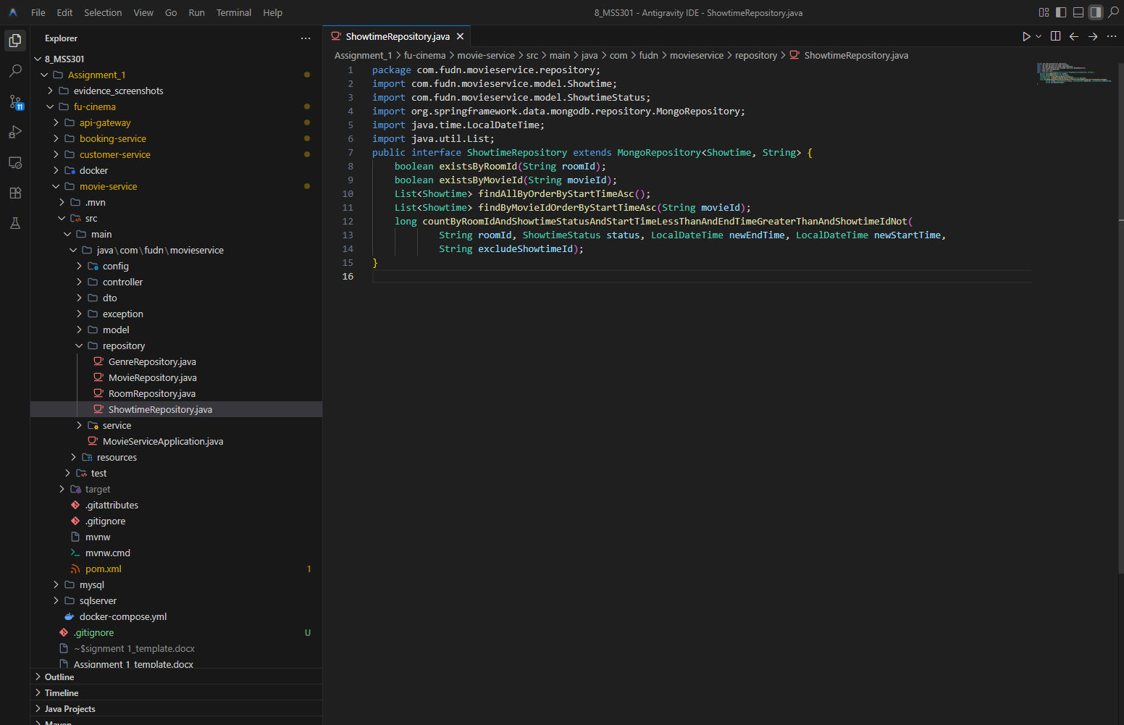
Commit: feat(movie): add derived query counting overlapping showtimes

TODO 6.3: Validate and schedule showtimes with computed end time
Chụp hình kết quả:
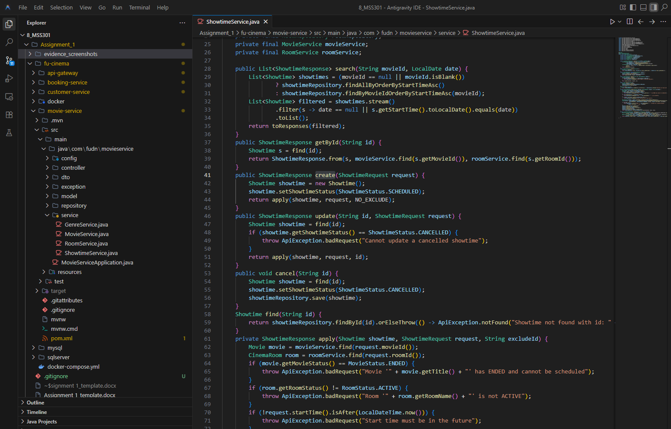
Commit: feat(movie): validate and schedule showtimes with computed end time

TODO 6.4: Implement showtime cancel and search by movie and date
Chụp hình kết quả:
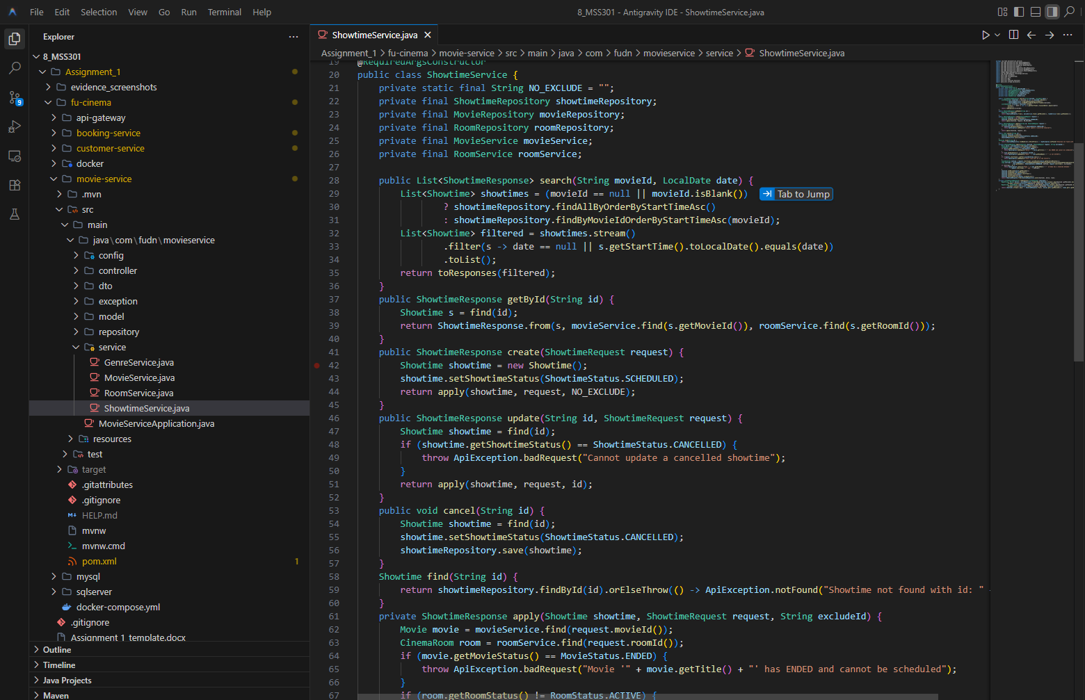
Commit: feat(movie): implement showtime cancel and search by movie and date

TODO 6.5: Expose showtime endpoints
Chụp hình kết quả:
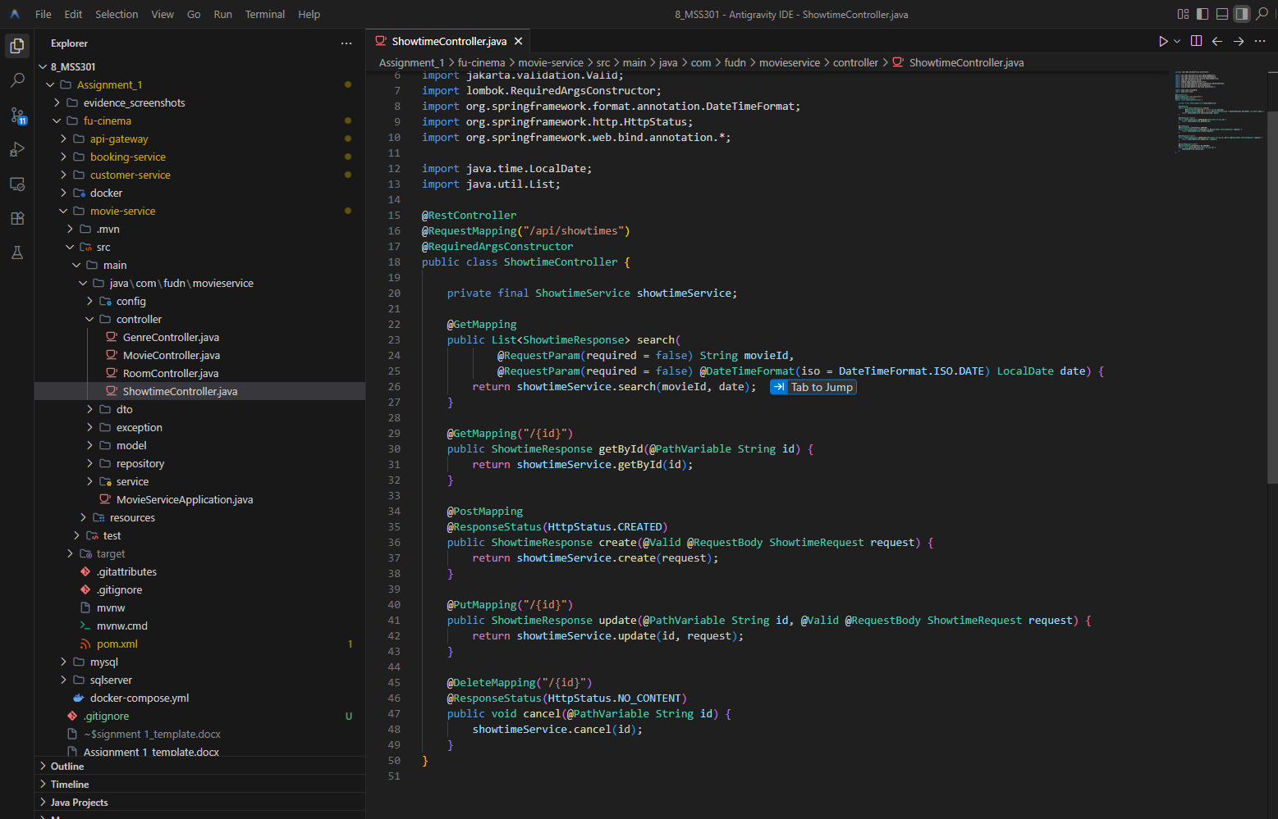
Commit: feat(movie): expose showtime endpoints

F7 – Booking (OpenFeign & Transaction)

TODO 7: Add openfeign and spring cloud bom
Chụp hình kết quả:
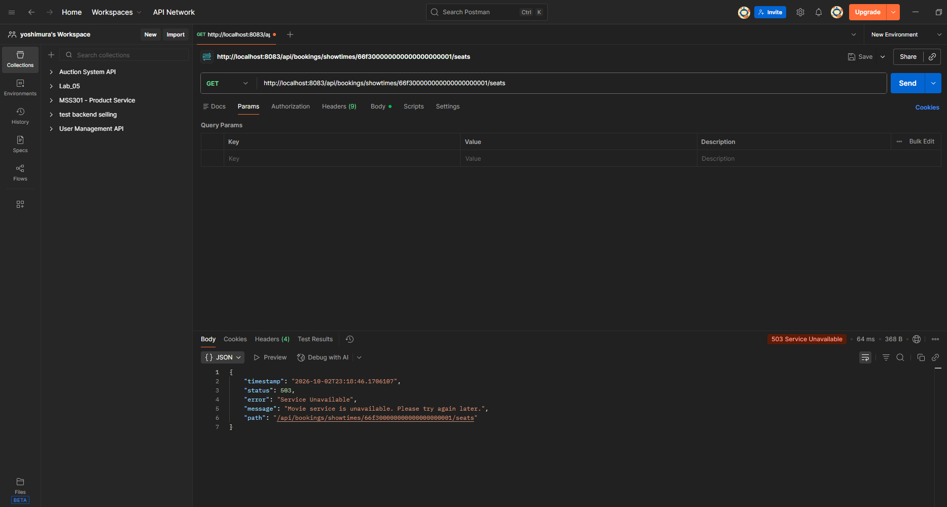
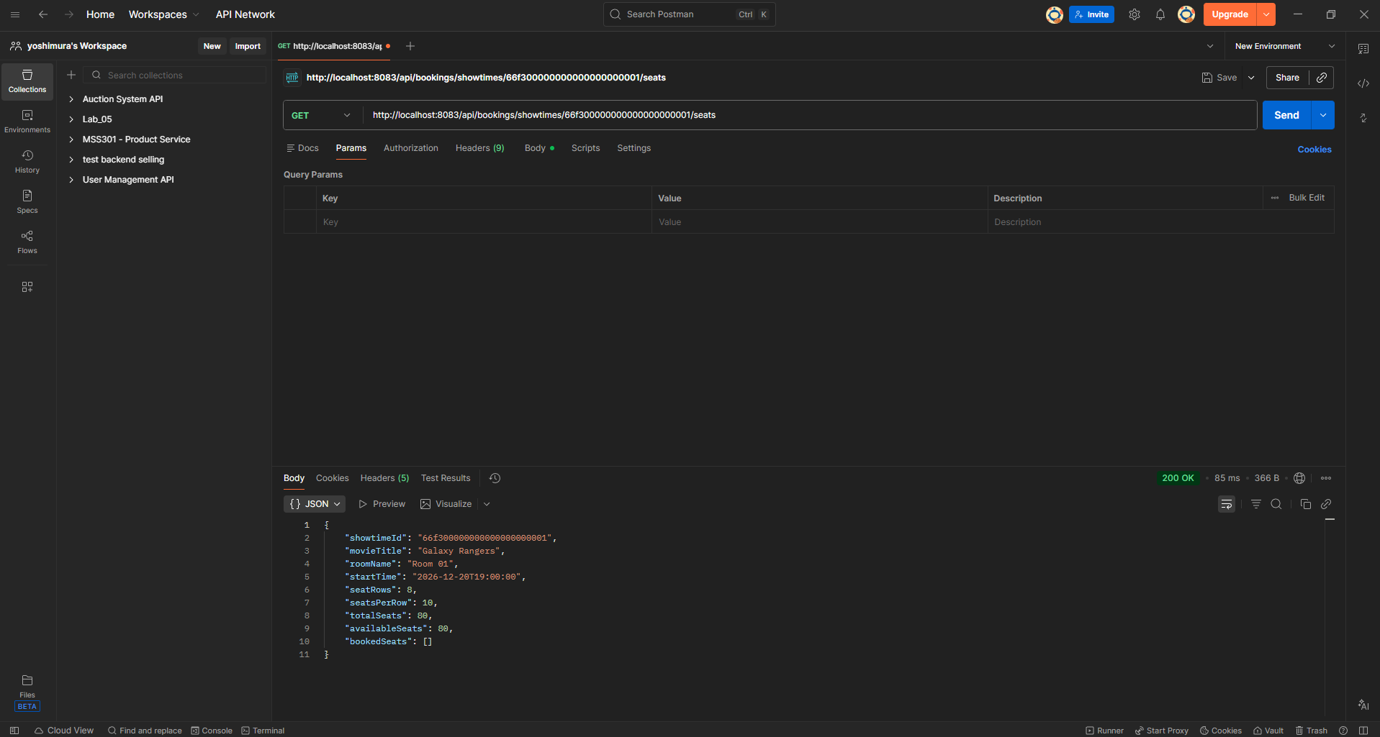
Commit: build(booking): add openfeign and spring cloud bom

TODO 7.1: Add openfeign and spring cloud bom
Chụp hình kết quả:
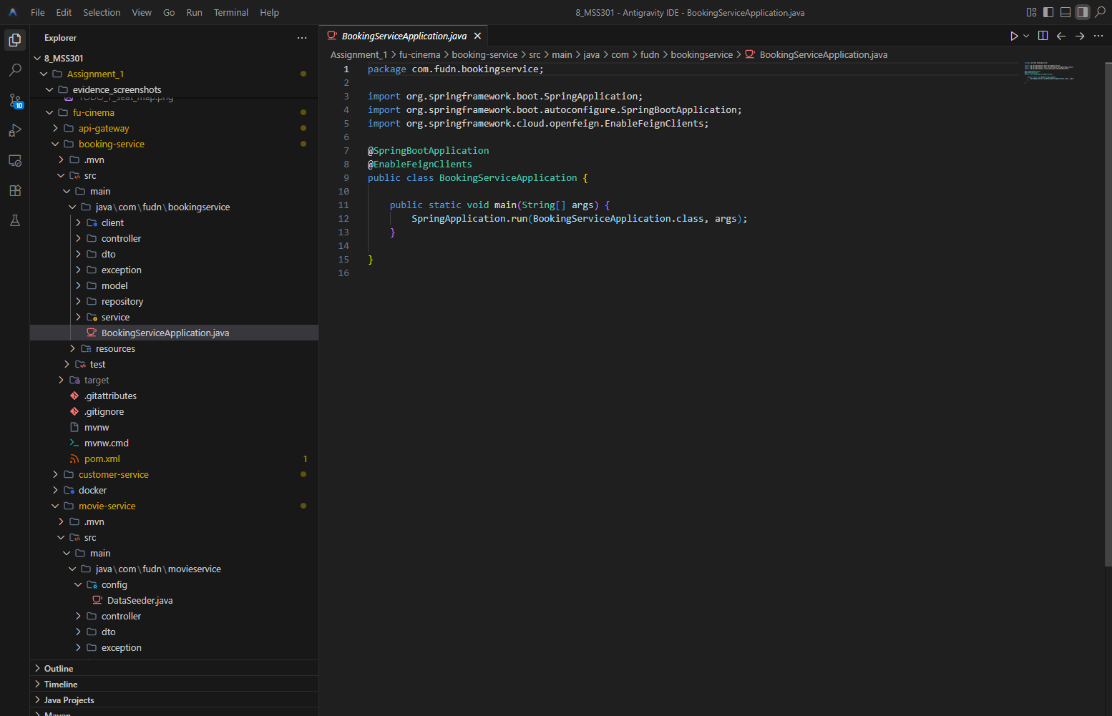
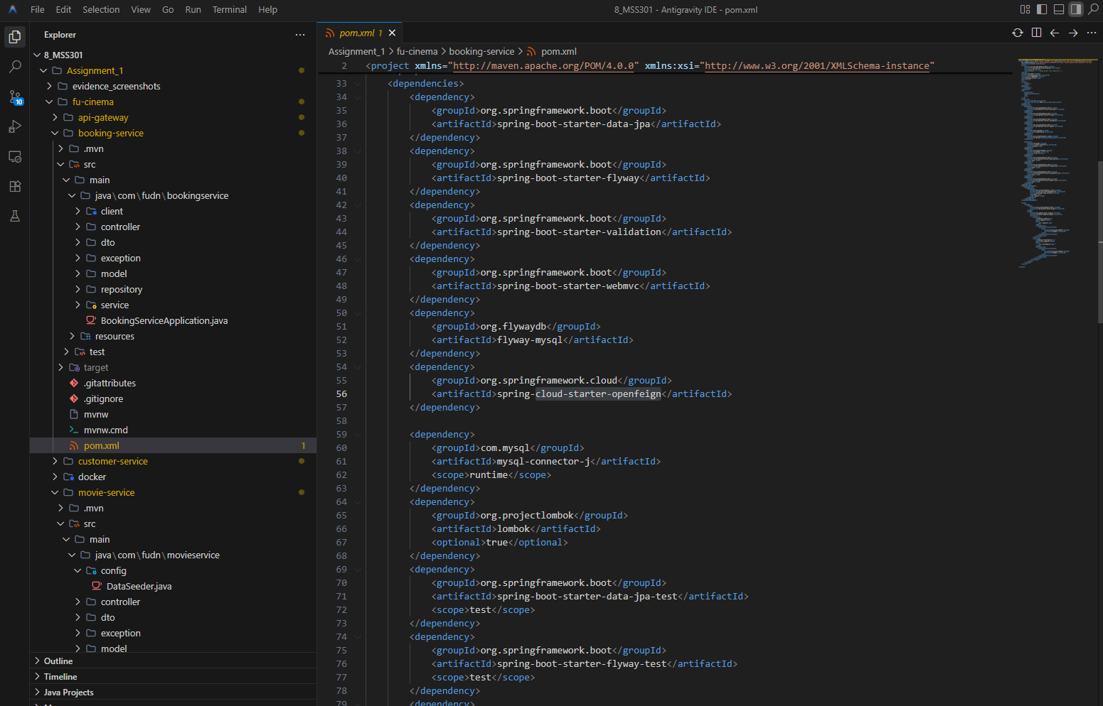
Commit: build(booking): add openfeign and spring cloud bom

TODO 7.2: Add mysql migration with varchar object id columns
Chụp hình kết quả:
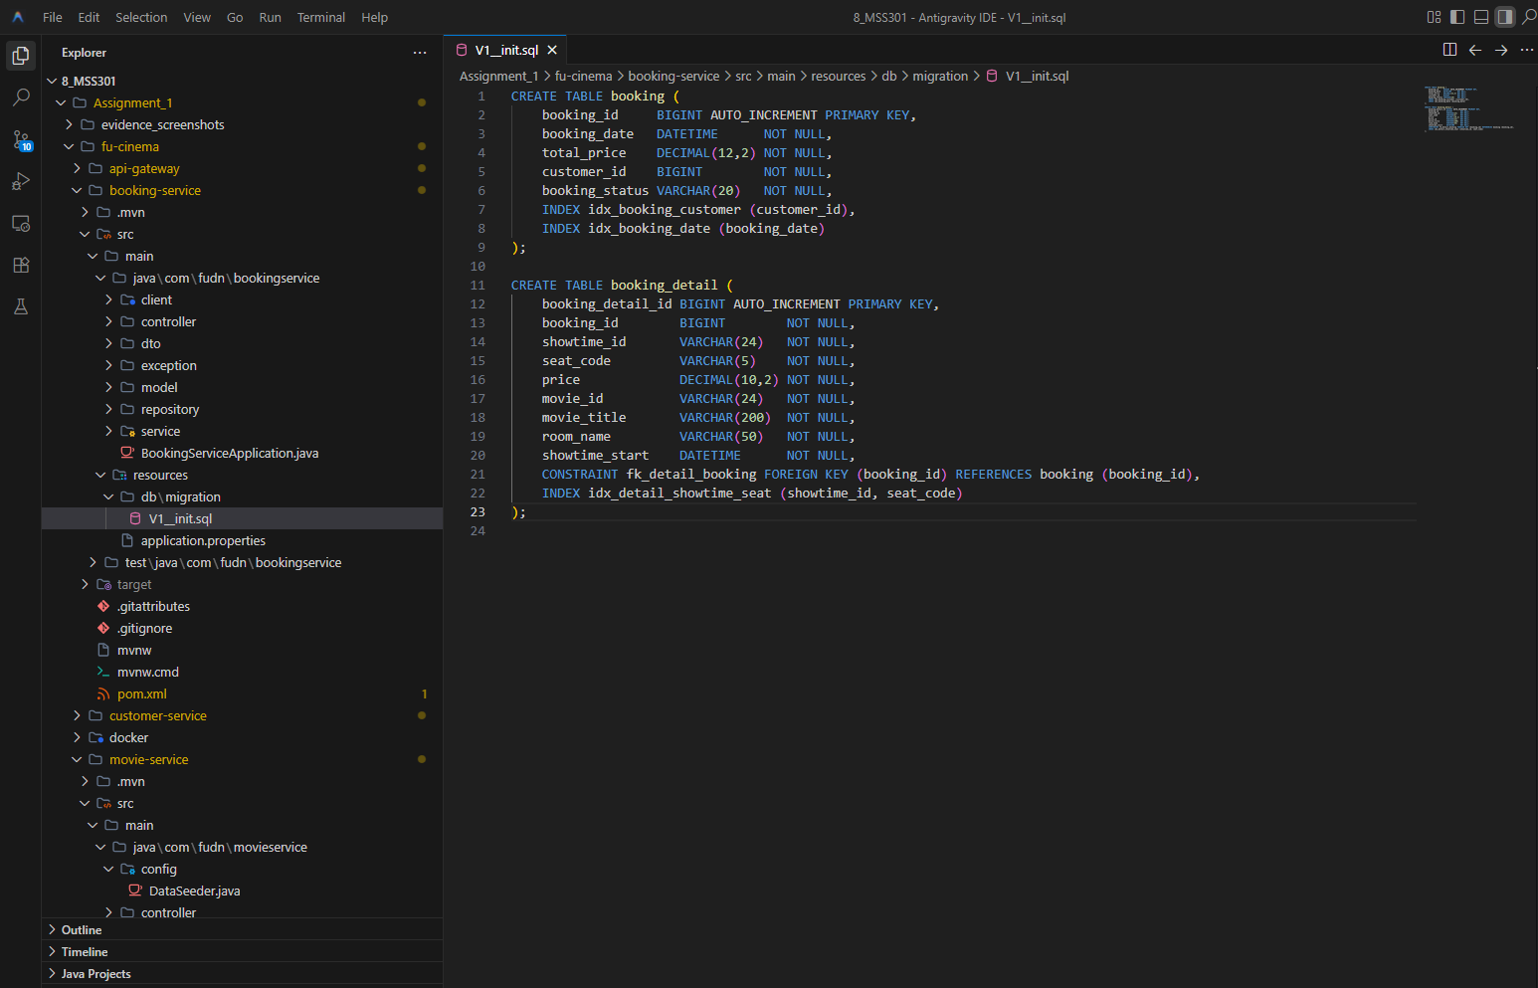
Commit: feat(booking): add mysql migration with varchar object id columns

TODO 7.3: Add booking and bookingdetail entities
Chụp hình kết quả:
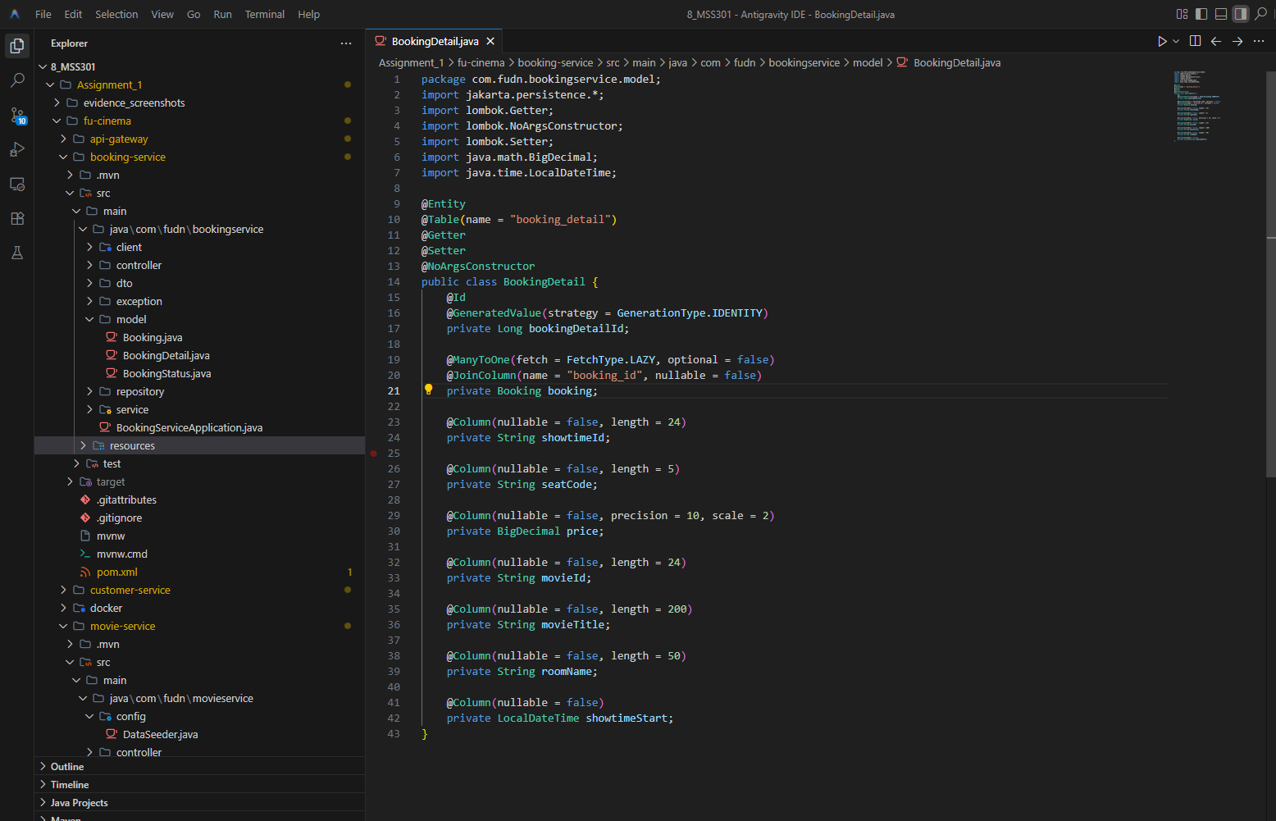
Commit: feat(booking): add Booking and BookingDetail entities

TODO 7.4: Add movieclient feign client with string showtime id
Chụp hình kết quả:
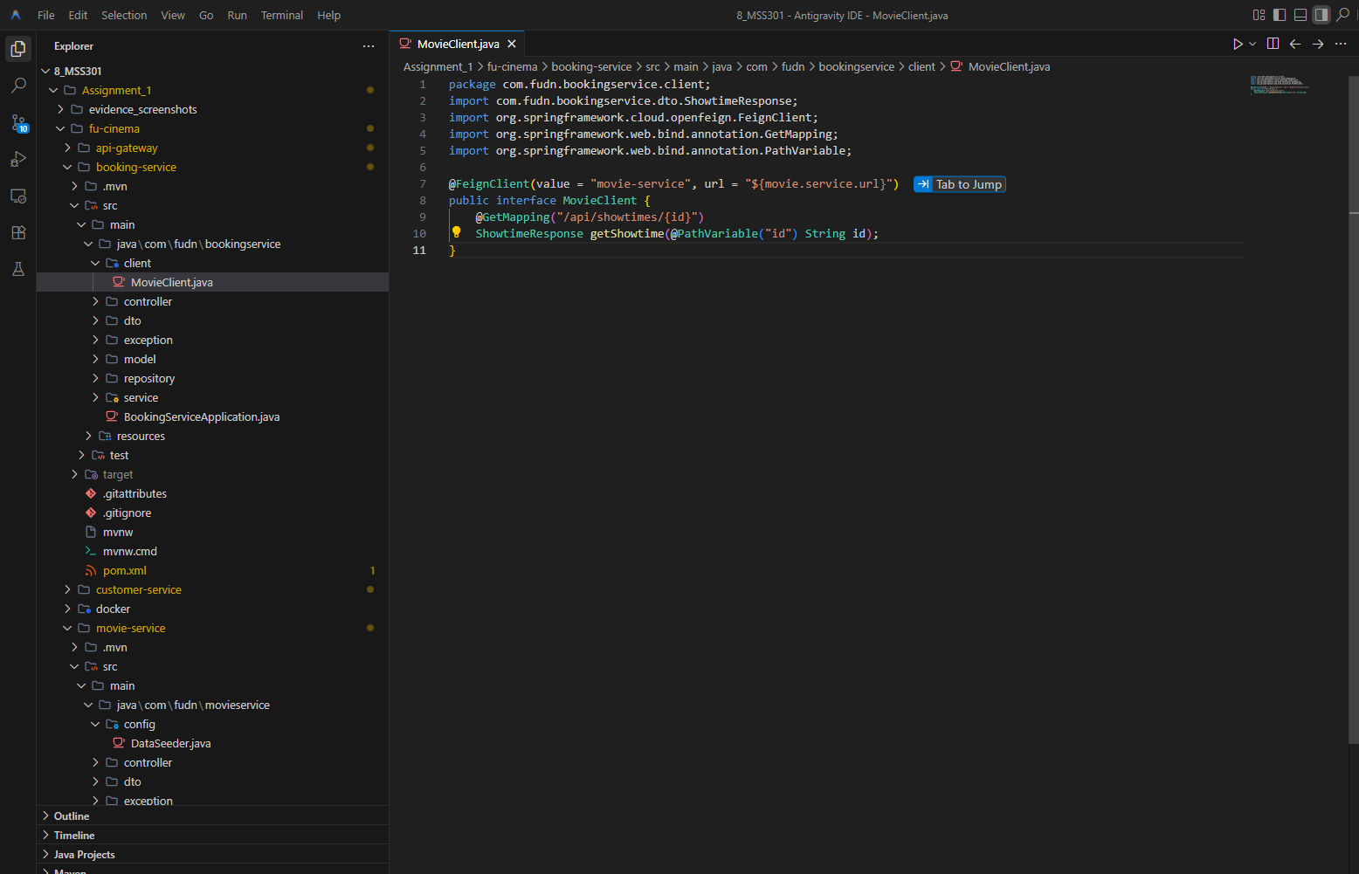
Commit: feat(booking): add MovieClient feign client with string showtime id

TODO 7.5: Implement booking creation with seat validation
Chụp hình kết quả:
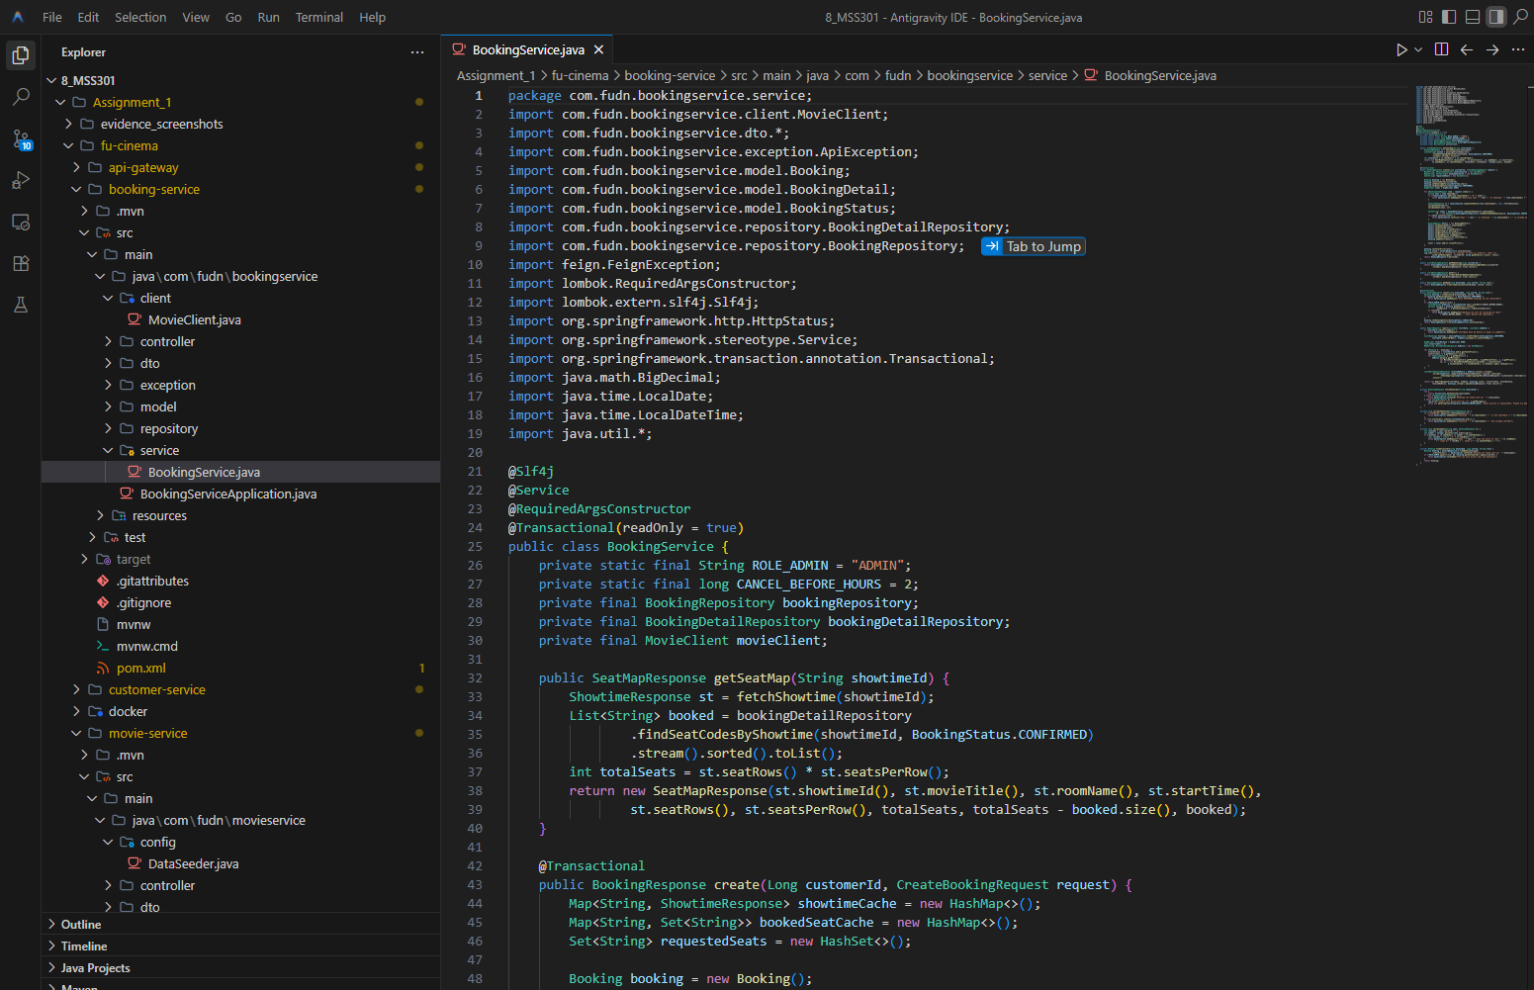
Commit: feat(booking): implement booking creation with seat validation

TODO 7.6: Add seat map for a showtime
Chụp hình kết quả:
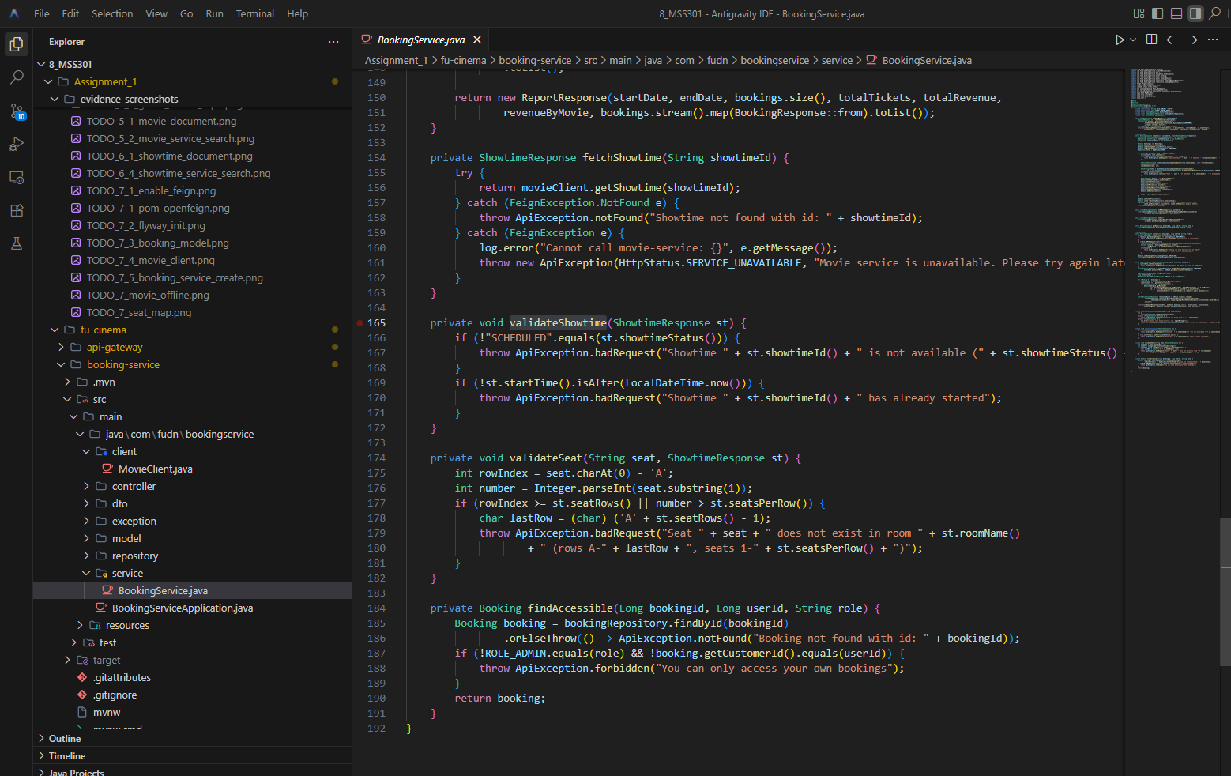
Commit: feat(booking): add seat map for a showtime

TODO 7.7: Expose create booking and seat map endpoints
Chụp hình kết quả:
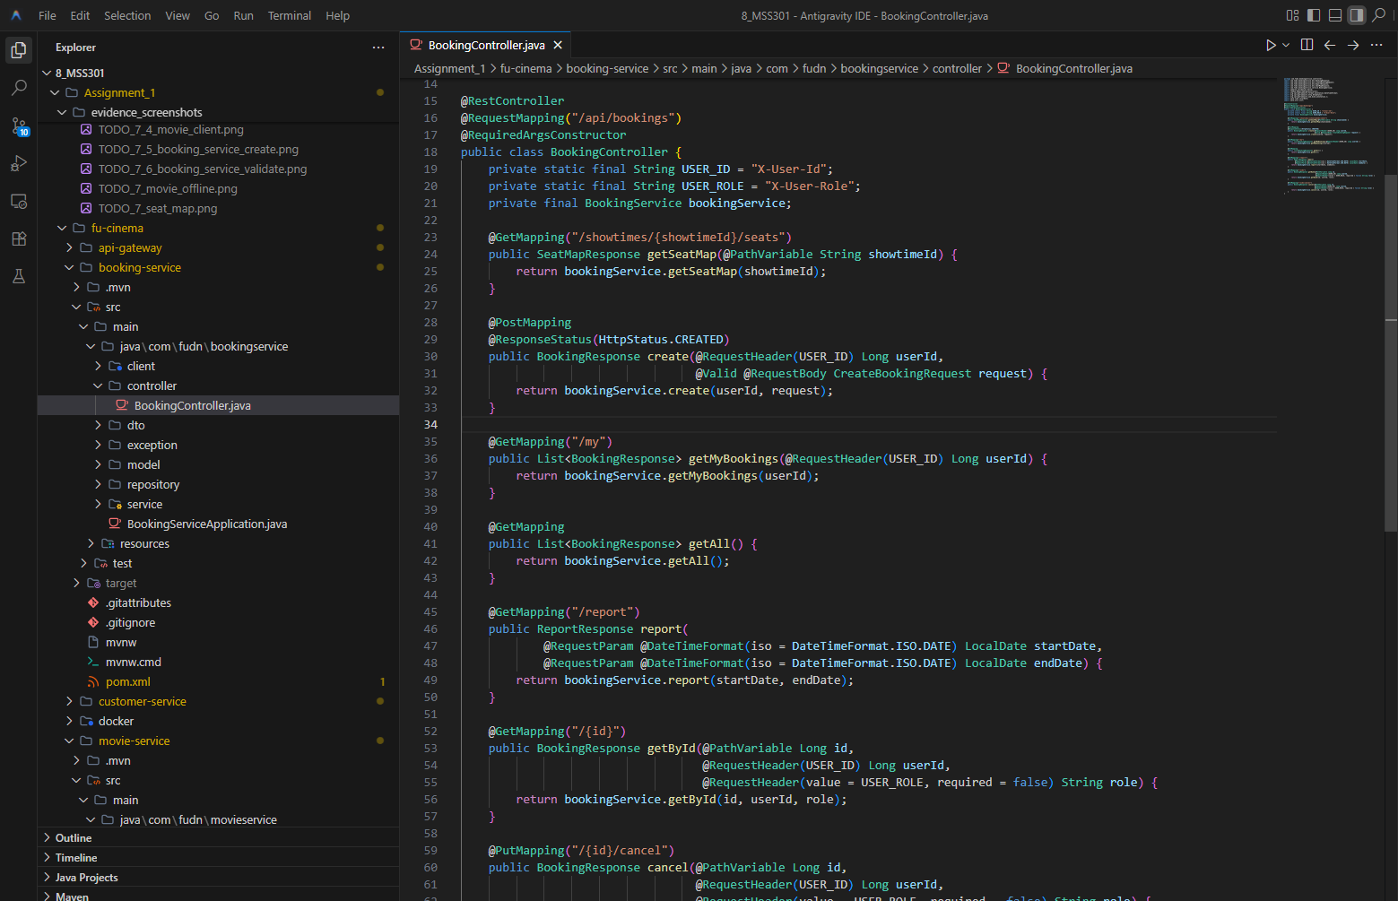
Commit: feat(booking): expose create booking and seat map endpoints

F8 – Booking History & Cancel

TODO 8.1: Add customer booking history sorted by date
Chụp hình kết quả:
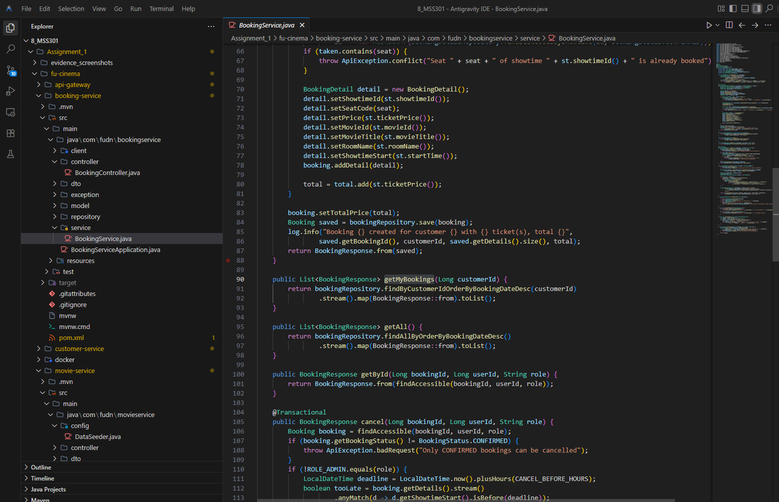
Commit: feat(booking): add customer booking history sorted by date

TODO 8.2: Restrict booking detail to owner or admin
Chụp hình kết quả:
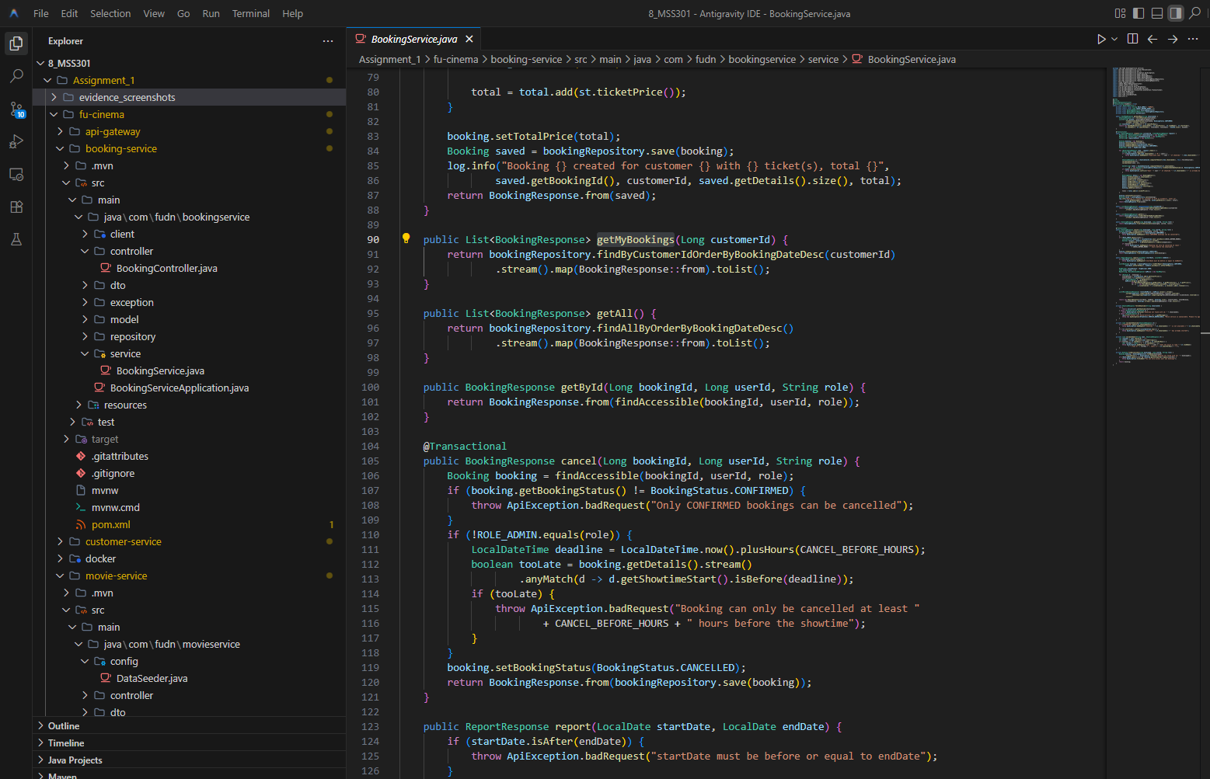
Commit: feat(booking): restrict booking detail to owner or admin

TODO 8.4: Expose history, detail, cancel and admin list endpoints
Chụp hình kết quả:
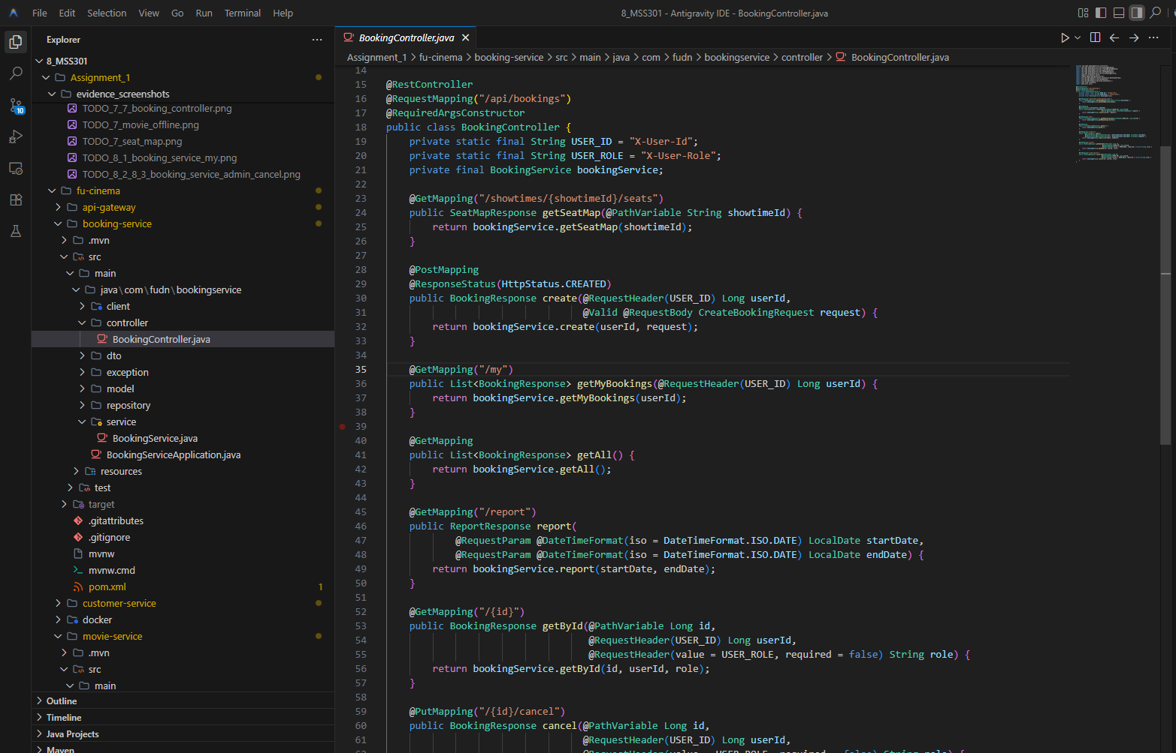
Commit: feat(booking): expose history, detail, cancel and admin list endpoints

F9 – Booking Report

TODO 9.1: Add report query by booking date range
Chụp hình kết quả:
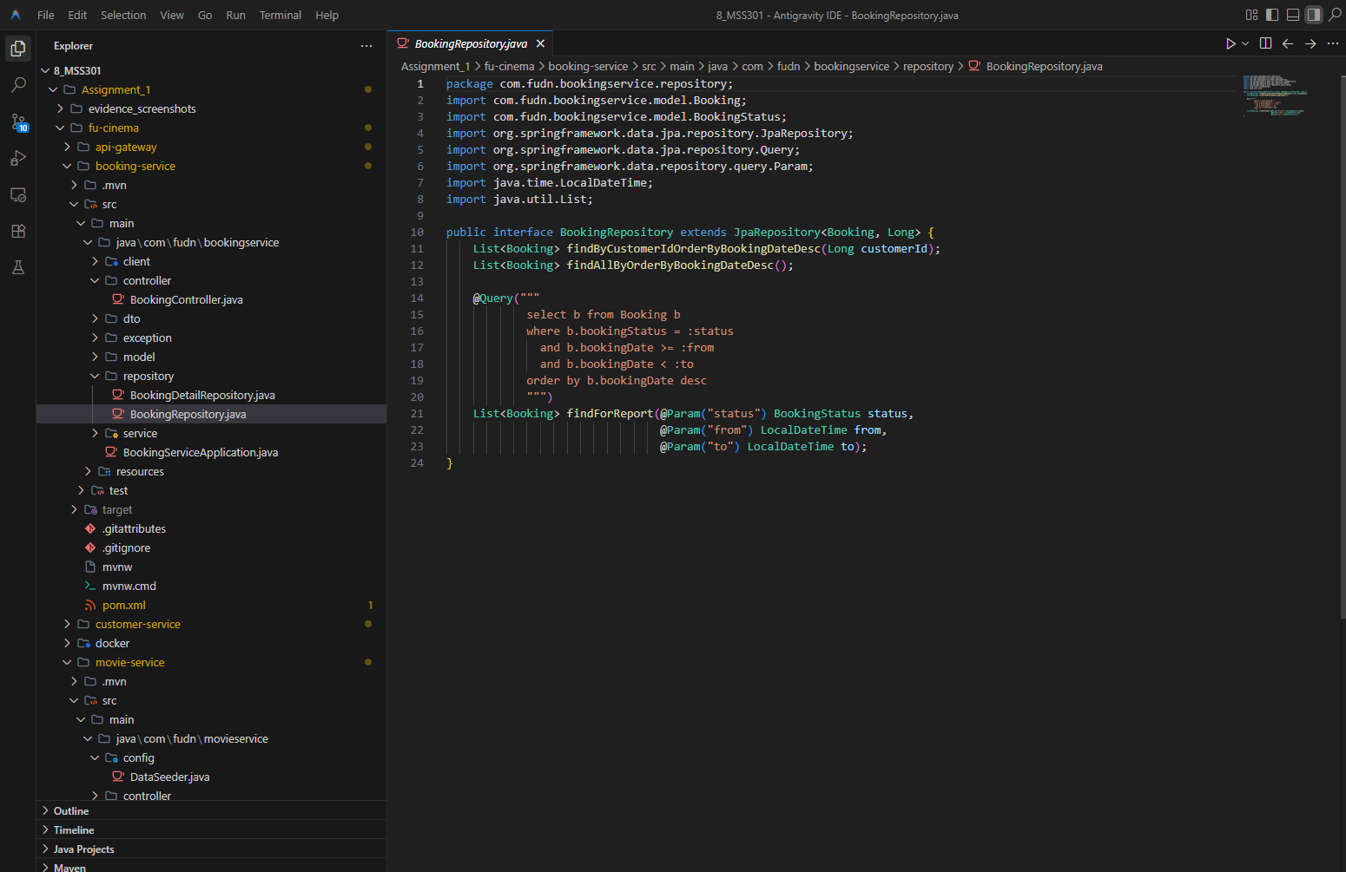
Commit: feat(booking): add report query by booking date range

TODO 9.2: Implement revenue report sorted descending
Chụp hình kết quả:
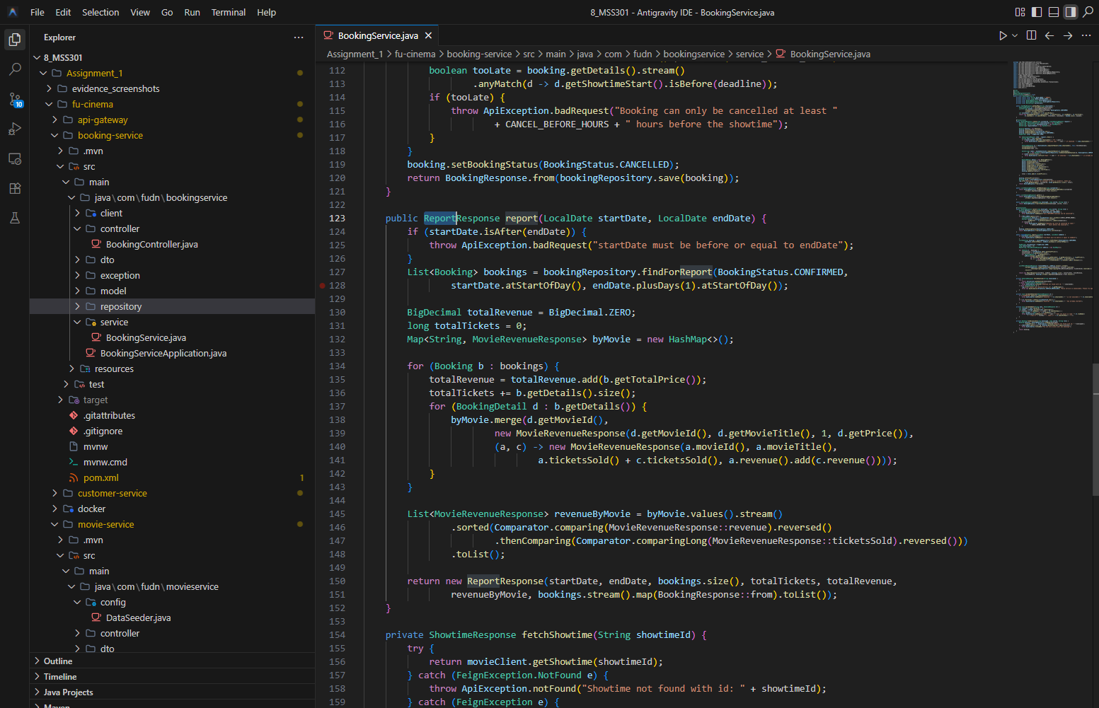
Commit: feat(booking): implement revenue report sorted descending

TODO 9.3: Expose get /api/bookings/report
Chụp hình kết quả:
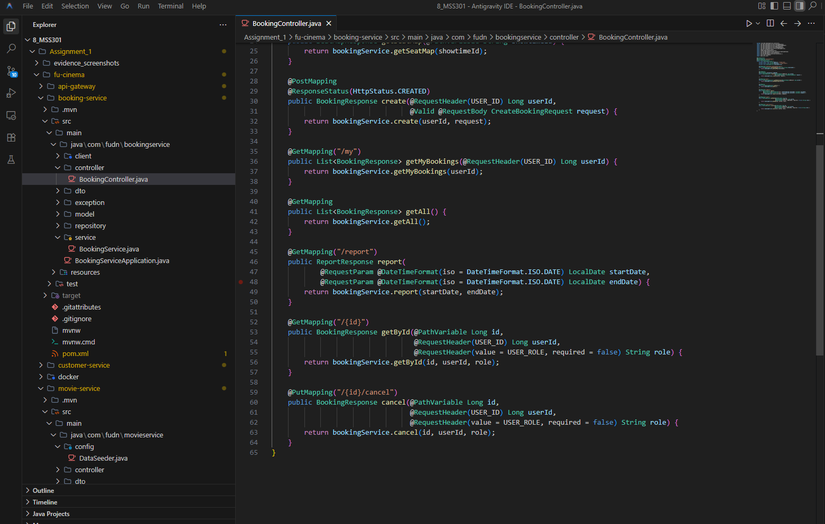
Commit: feat(booking): expose GET /api/bookings/report

F10 – API Gateway & Security

TODO 10.1: Configure service urls and jwt secret
Chụp hình kết quả:
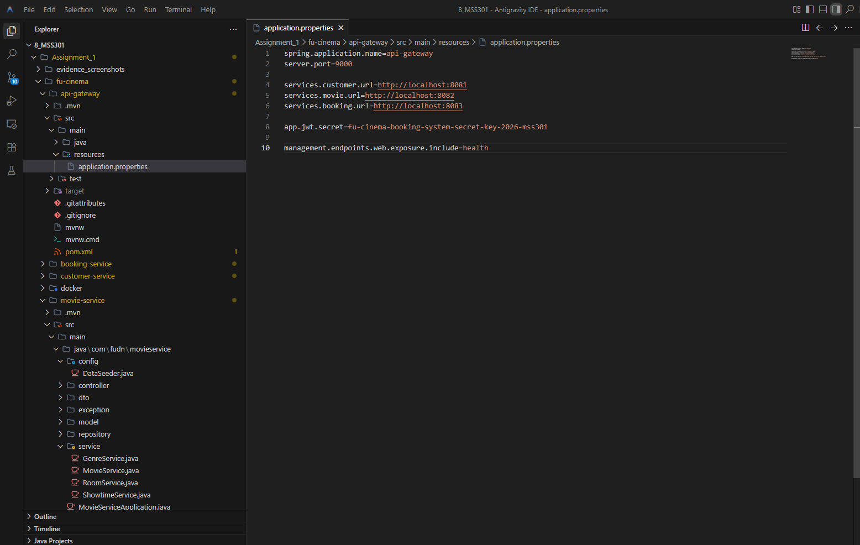
Commit: chore(gateway): configure service urls and jwt secret

TODO 10.2: Forward user context headers from jwt
Chụp hình kết quả:
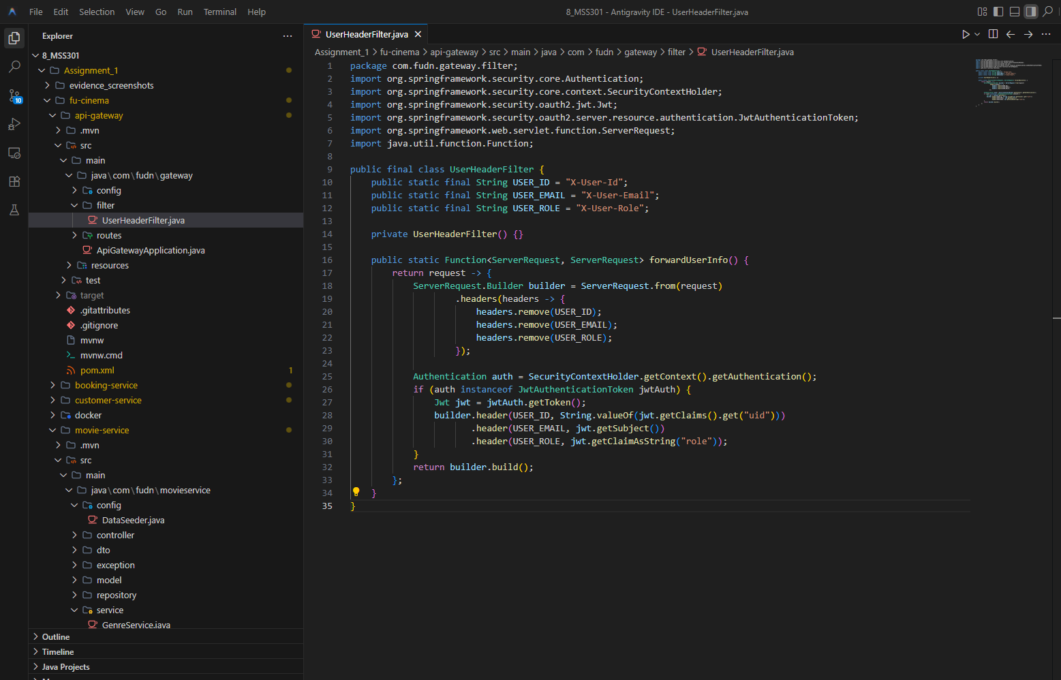
Commit: feat(gateway): forward user context headers from jwt

TODO 10.3: Add routes for customer, movie and booking services
Chụp hình kết quả:
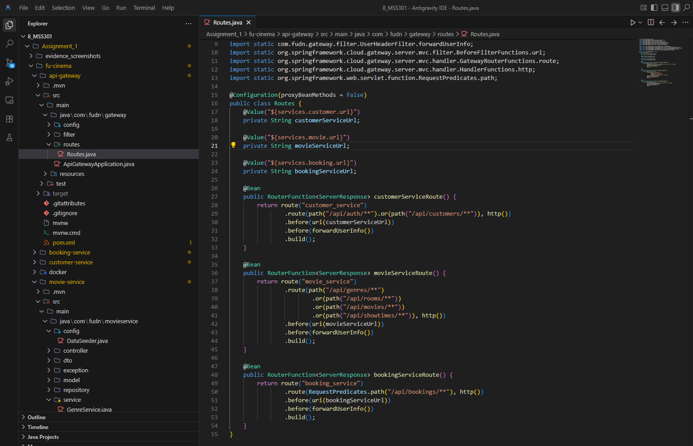
Commit: feat(gateway): add routes for customer, movie and booking services

TODO 10.4: Secure endpoints with jwt and role-based rules
Chụp hình kết quả:
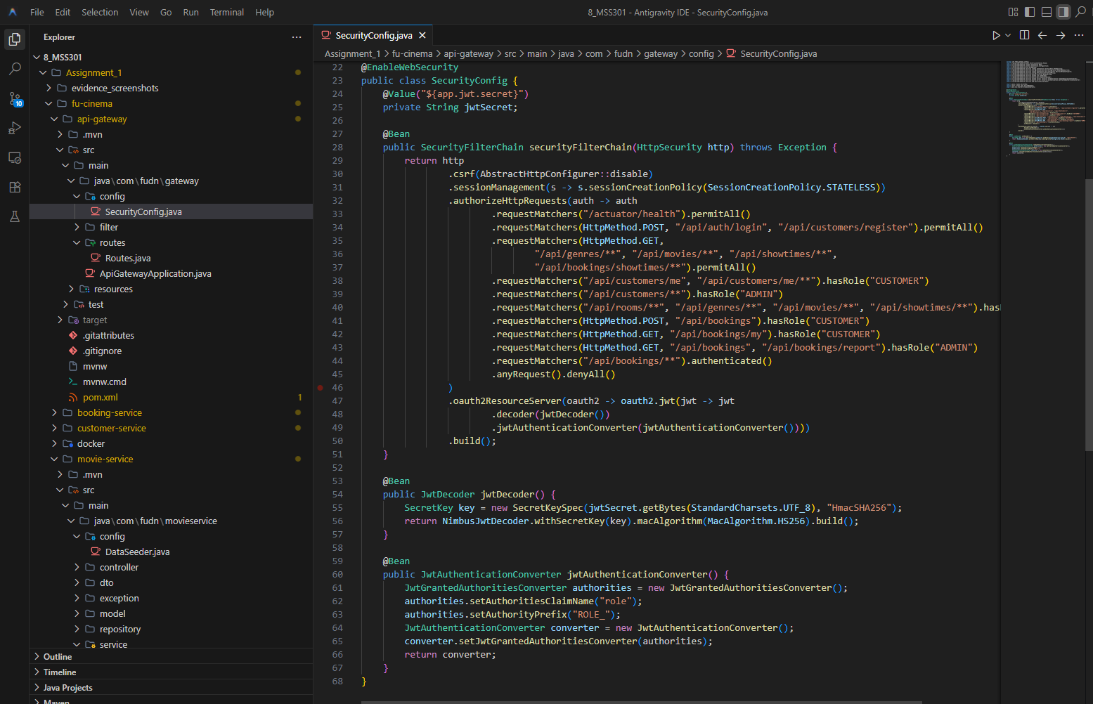
Commit: feat(gateway): secure endpoints with jwt and role-based rules

F11 – Postman Test Runner

TODO 11: Add local environment
Chụp hình kết quả:
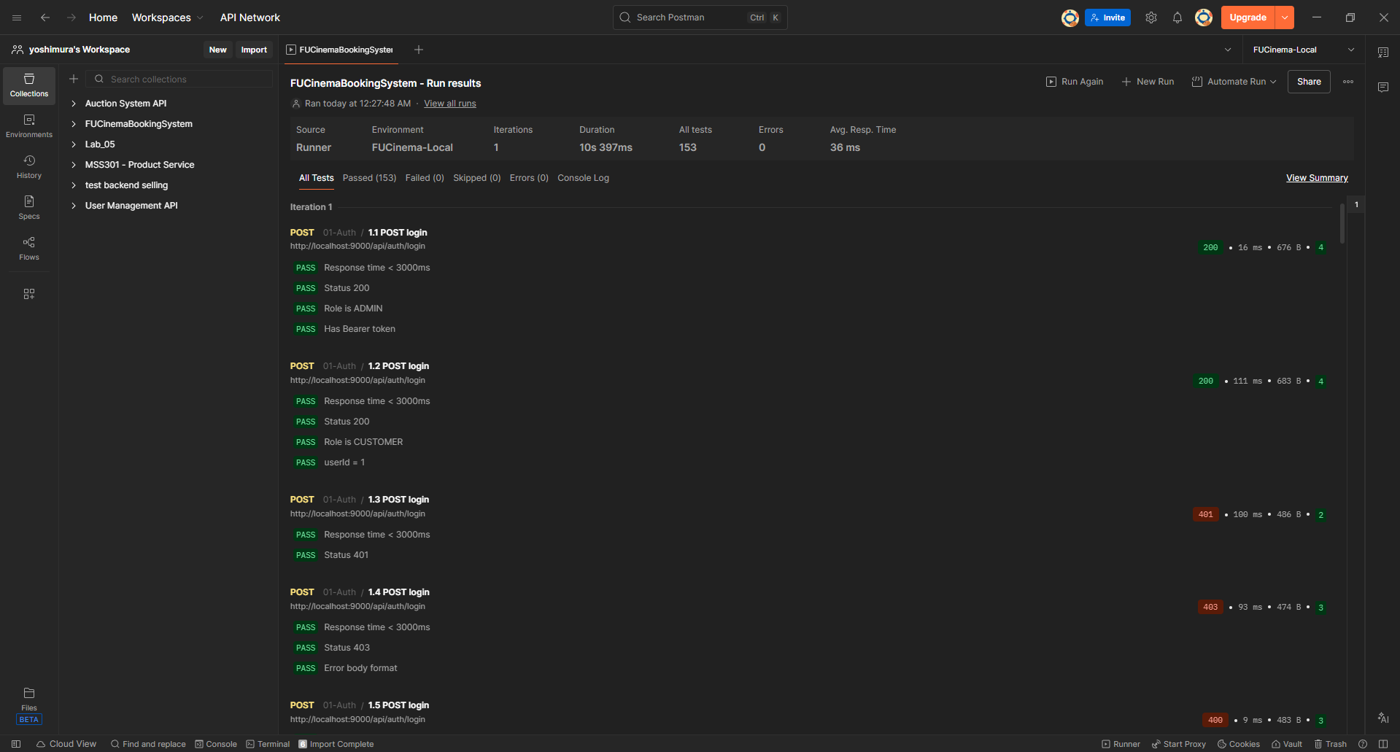
Commit: test(postman): add local environment

