EE C147 Final Project

Tyler Adair
University of California, Los Angeles
SID: 604917650

Abstract

The purpose of this experiment was to design, validate, and test different neural network architectures to classify movements of different subjects from EEG data. These architectures focused on CNN, RNN, and CNN-RNN hybrids and their effectiveness on the given dataset. Factors such as the depth, filter size, use of regularization, and data augmentation were also added to boost the test accuracy of multiple architectures. Overall, in addition to finding that CNN and CNN-RNN hybrids can perform particularly well on this dataset, it was found that data augmentation was a key factor in improving train, validation, and test accuracy of various architectures.

Introduction
The architectures that were pursued were centered around Convolutional Neural Networks (CNNs) and Recurrent Neural Networks (RNNs). Specifically, these architectures were used to test the importance of using the strengths of each architecture in correctly classifying motor-imagery tasks of multiple subjects. Additionally, as first shown by Hu [1], CNN-RNN hybrids were implemented to test its effectiveness at capturing temporal properties of the EEG data.

Computational Access
This experiment was run locally on Jupyter Notebook, using Python 3.6 and Keras. There was no access to a GPU, which affected the speed and flexibility at which these models could be tested.

CNN Architectures
CNNs are often very adept in image classification tasks, particularly due to their ability to capture spatial locality within their convolutional layers. This experiment tests its ability to do the same with temporal data. Two architectures were proposed: a shallow CNN with one convolutional layer and a deeper CNN with four convolutional layers. CNNs with even more layers were attempted, with negative effects on the test accuracy and computational time compared to the four-layer CNN.

RNN Architectures
RNNs often are used because of ability to processing inputs of any length, account for past information during the current time step, and sharing weights across time steps. In theory, these layers should be useful in maximizing the usefulness of the EEG’s temporality in classifying the different movements. Long-term short-memory networks (LSTMs) and gated recurrent units (GRUs) were tested to see its performance as a singular network.

Hybrid Architectures
As mentioned in the introduction, recent work has been performed to test the effectiveness of a CNN-RNN hybrid architecture in capturing temporal data better than a standard RNN. Therefore, multiple hybrid architectures were tried and tested in this experiment, stacking an LSTM or GRU after the input is passed through a shallow CNN.

Regularization
Each of the architectures applied regularization principles to improve its validation and test accuracy. Batch normalization and dropout was used after convolutional layers, and dropout was used after recurrent layers. Additionally, the number of epochs and weight regularization was used to as other forms of regularization on these architectures.

Hyperparameters
In addition to regularization, the hyperparameters were tuned to help improve the validation accuracy. The learning rate, filter size, number of filters, dropout rate, and recurrent dropout rate were tuned where necessary.

Data Augmentation
After testing the architectures on the original dataset, data augmentation was applied to help with the size of the EEG data, with the prospect of given the models more data to train with in order to produce better validation and test accuracy. Techniques such as subsampling, introducing noise, and maxpooling were used.

Results
Shown below are the results of the architectures, using the original data and the augmented data:

 | 1-Layer CNN | 4-Layer CNN | LSTM | GRU | CNN-LSTM | CNN-GRU
Original Data | 0.4953 | 0.5305 | 0.2393 | 0.2619 | 0.4470 | 0.4470
Augmented Data | 0.5949 | 0.6495 | N/A | N/A | 0.6608 | 0.6151
Figure 1: Table of Test Accuracy on NN Architectures using original or augmented data
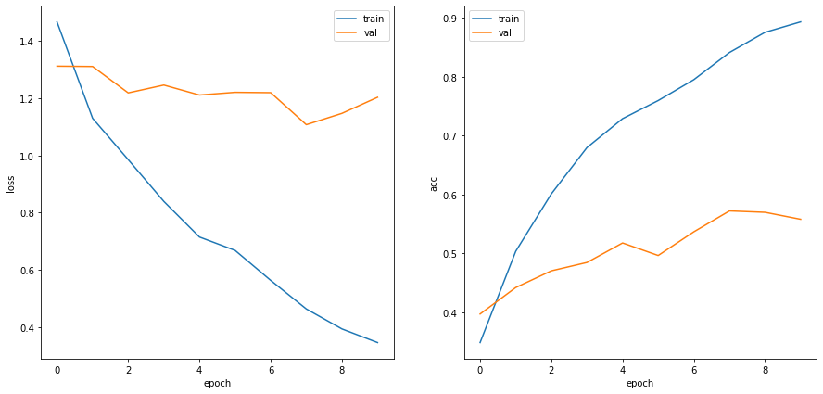
Figure 2: Plots of Loss and Accuracy for LSTM Architecture using Original Dataset
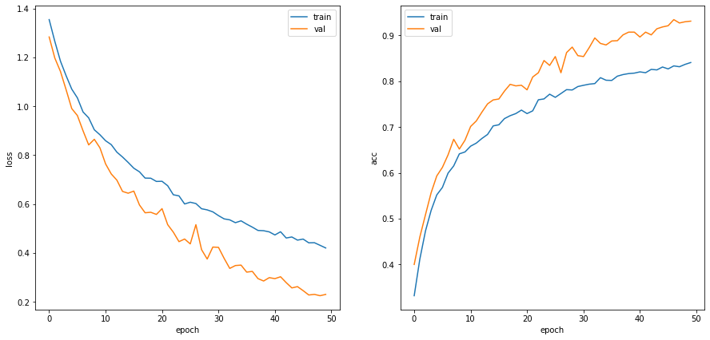
Figure 3: Graphs of Loss and Accuracy for CNN-LSTM Architecture using Augmented Data

Architecture Results
Initially, the models were trained on the original dataset, resulting in substandard results. The CNN architectures performed much better than the simple RNN architectures. In fact, the LSTM and GRU performed worse than simply guessing the movement randomly. Due to this, when data augmentation was performed, the RNN architectures were excluded from testing.
The CNN-RNN hybrid architectures didn’t perform very well on the original dataset. This is most likely due to the dataset being small, which makes the deeper network quite tough to learn. It was hypothesized that performing data augmentation would allow these architectures to have enough data to train and perform well.

Data Augmentation Results
As said in Section 1.7, subsampling, introducing noise, and maxpooling were used on the original dataset. Adding noise and then subsampling not only produces a larger dataset, but a dataset that can help the architectures generalize better to the test data. As shown in Figure 2, after 50 epochs, the CNN-LSTM architecture performed much better using the augmented data than the original data. It is shown from Figure 2 that, when trained using the augmented dataset, all of the architectures improved in test accuracy by at least 10%.

Discussion

  - Comparing Architectures
Comparing the CNN vs. RNN vs. CNN-RNN architectures, the performance of each was quite dictated on the size and distribution of the data.
First, the RNN architecture failed to learn features of the original dataset, leading to test accuracies that were subpar (less than 25% for both LSTM and GRU). A possible issue with the RNN could be its slow computation, difficulty of accessing information far in the past, and inability to consider data in the future in relation to the current time step.
Second, the CNN architectures showed decent potential to have good performance, posting test accuracies of up to 65% if trained enough with augmented data. While CNNs are commonly known as good models for image classification, where capitalizing on spatial locality is quite important, these architectures performed decently on temporal data. This could infer that CNNs not only capture spatial locality, but temporal locality as well, albeit in a fixed scale (filter size) that requires more weights to train.
Third, the CNN-RNN architectures performed quite well when given the augmented data, with the CNN-LTSM model outputting the highest test accuracy out of the tested models (66%). The reason for this is still a researched topic, but can be inferred to be that comparing these two neural network ideas produce a model that can capture temporal locality better than a CNN or RNN alone.

  - Importance of Data Augmentation
Seeing the substantial increase in test accuracy due to augmenting the data clearly highlights the possibilities of creating good models even with small datasets that may not be able to fully represent the population distribution. As discussed in Section 2, the 1-Layer CNN, 4-Layer CNN, CNN-LSTM, and CNN-GRU were trained using either the original or augmented dataset, and the improvement in test accuracy from one to the other was quite significant.
Most prominently, the test accuracy for the CNN-LSTM and CNN-GRU increased by 22% and 17%, respectively. After learning the possibilities of improving test accuracy through regularization, tuning hyperparameters, and other methods learned in the course, seeing such an increase in performance from data augmentation was incredible. While it is not completely clear which of data augmentation methods (subsampling, noise introduction, maxpooling) was most critical in the performance boost, the results show the importance of such a method for this learning task.

  - Further Testing
If given more time and possibly a GPU, some ways to experiment further would be to try training with more epochs (possibly into the thousands) to see how performance may increase with more training time. As shown in Figure 3, the test accuracy does not look like it has flattened, so continued testing might increase the test accuracy even more.
Additionally, further testing of deeper CNN-RNN architectures, both by adding convolutional layers and/or by cascading recurrent layers, could lead to better results.
Lastly, considering even more options for filter size, pooling filter size, etc., is something that can always be experimented with to improve the results of these models.

- Conclusion
In conclusion, the experiment began as an attempt to compare the performances of CNN and RNN architectures in this EEG data classification task. The CNN-RNN architecture was introduced as another option, and combined with data augmentation, produced better results than the other models. While regularization and hyperparameter tuning improved performance slightly, data augmentation overwhelmingly improved test accuracy. With more testing, deeper networks can be trained and tested to see how these models can best identify motor imagery classification.

References
- Hu Y, Wong Y, Wei W, Du Y, Kankanhalli M, Geng W (2018) A novel attention-based hybrid CNN-RNN architecture for sEMG-based gesture recognition. PLoSONE13(10):e0206049. https://doi.org/10.1371/journal.pone.0206049

