**Detecting Unusual Changes and Increased Systematic Risk in Time-Series Data**

**Yoshimasa (Yoshi) Satoh, CFA**

<https://www.linkedin.com/in/yoshimasa-satoh-cfa-84b6b92b/>

*The author explains and implements financial turbulence, which was introduced by Kritzman and Li in 2010, in this paper. The implemented Financial Turbulence Index (FTI) can be used for detecting unusual absolute and/or relative changes of a time-series data such as asset price returns. The FTI can be calculated for changes in any group of time-series data you may choose. The FTI does not need any estimates or future forecasts as inputs; the FTI only needs historical realized changes. Unrealized and generated data based on hypothesis can be used as inputs though. When the FTI value spikes, namely, detects unusualness of a set of changes, the following phenomena are mathematically observed: [A] an extreme positive or negative change in a single variable compared to the historical norm (i.e., historical average and standard deviation), and/or [B] the divergence of historically correlated changes of multiple variables and/or the convergence of previously uncorrelated changes of multiple variables. The FTI is expected to have an explanatory power at any circumstances if parameters, such as lookback time periods for [1] moving average of changes, a set of standard deviation, and correlations, [2] moving average of the calculated FTI, and [3] calculating the percentile rank of the moving-average of the FTI, are pre-set appropriately.*

*The FTI can be further decomposed into the Magnitude Surprise Index (MSI) and the Correlation Surprise Index (CSI), which were introduced by Kinlaw and Turkington in 2014, The former MSI evaluates the impact from [A], that is, unusualness of individual data series; on the contrary, the CSI gauges the effect of [B], i.e., unusualness of correlations amongst multiple data series. The author elaborates on and implements both of these indices as well. A change of a variable can be in either absolute or relative terms. For instance, either daily absolute returns of a single investment instrument or daily excess/relative returns of a single investment instrument against a benchmark (e.g., a total market index) can be used.*

*Furthermore, the author explains and implements another separate method for inferring systematic risk from changes in multiple time-series data (changes in asset prices for example). The level of systematic risk is evaluated by calculating the absorption ratio (AR), which was introduced by Kritzman et al. in 2011. It is equal to the fraction of a set of each data series’ total variance explained (=absorbed) by a finite number of eigenvectors (principal components); the number of eigenvectors is often 1/5th=20% of the number of variables in time-series data based on a heuristic justification. A high AR value implies that changes of variables in time-series data are relatively combined/compact as its total variance can be explained/absorbed by using only a small number of eigenvectors. When variables are compact in mathematical space, they are more fragile because shocks propagate more quickly and broadly. A low AR value suggests that variables are less tightly coupled and therefore more resilient to external shocks.*

*A compact variables space does not always lead to a huge change in a variable or variables, but most significant changes in variables, especially asset returns in financial markets, have been preceded by spikes in the AR. This suggests that spikes in the AR are a near necessary, but not sufficient, condition for extreme changes in time-series variables.*

*The author implanted all the metrics in this paper in the Python programming language and shared them on GitHub. Please visit and see:*

<https://github.com/yoshisatoh/Stat/tree/main/FTI_AR>

<https://github.com/yoshisatoh/Stat/blob/main/FTI_AR/readme.txt>

**1. The Financial Turbulence Index (FTI)**

**1.1. Introduction**

The FTI can be used for any time-series data of changes in variables, and one of the most significant use cases are portfolio management and trading in financial markets.

The ultimate goal of both portfolio optimization theories in academics and portfolio optimization practices in the financial industry is to optimally allocate currency amount or risk budget among various investment instruments. A portfolio optimization (e.g., simple traditional mean-variance, full-scale with a search algorithm, Black-Litterman) is a process to keep a portfolio in better shape (i.e., higher expected return-to-risk efficiency with lower estimation error) than any other options; there are usually some hard or soft constraints such as upper limit of estimated risks or incurred loss. Optimization criteria include maximizing a utility function with an expected absolute (or relative) return as a reward, a penalty for an absolute (or relative) risk (e.g., volatility), and a transaction cost penalty. An expected return-to-risk efficiency, such as Shape Ratio or Information Ratio, can be selected as a utility to maximize. Some other financial risk measures which are derived by a scenario analysis, for instance, could also be considered.

As written above, optimization criteria combine, directly or indirectly, expected returns as well as the return's dispersion (ex-ante risk). Most importantly, returns, risks (typically volatilities - standard deviation of asset returns), and correlations among allocated assets / individual investment instruments have to be stationary to achieve full portfolio optimization effect as expected.

An inconvenient and cold truth is that asset owners (investors) and managers cannot expect consistent average returns, volatilities, and correlations to be realized over long periods of time. If you see a specific and short time horizon, this is not always the case as these numbers dynamically fluctuate. Portfolios are often sub-optimal or even inappropriate because of the changes in a pattern of returns and volatilities/correlations as a result; portfolios could be less diversified and more concentrated, at least in the specific time frame. Moreover, if you mistakenly assume the world goes back to the original static state and mean-reversion always works forever, you would miss structural changes. In reality, there are both cyclicality (seasonality) and structural trend in this world.

Even worse, a temporarily underperforming portfolio due to a short-term cyclicality could get terminated by a sense of disappointment before regaining the incurred loss; nobody has an infinite time horizon and a sure prospect for the future world economy and markets. Holding period returns can be dramatically reduced by untimely drawdowns because the world economy including financial markets can never be stationary. It typically moves around the four states: 1) a steady, low-volatility state characterized by accelerating economic growth and risk-on market conditions, 2) a mid-volatility state characterized by decelerating economic growth, 3) a panic-driven, high-volatility state characterized by accelerating economic contraction and risk-off market conditions, and 4) a mid-volatility state characterized by decelerating economic contraction.

It should be noted that realized returns, risks, and correlations change more frequently and significantly than a rigid policy framework for a strategic asset allocation expects. A strategic asset allocation is based on a belief in cyclicality (seasonality) and mean-reversion of markets and it requires rebalancing back to its static policy weights. Many investors have been reluctant to deviate from strategic portfolios backed by a basic belief in mean-reversion; they are concerned about explicit and implicit expenses of implementing allocation changes and a lack of confidence for successful tactical allocation changes to enhance investment performance. On the other hand, the recent proliferation of low-cost and high-liquidity investment products such as ETFs, index funds, futures, forwards, and other derivatives allow for efficient changes through overlays in allocations. Smart institutional investors are looking for ways to intelligently and unemotionally restructure their portfolios in response to regime shifts in the financial markets.

**1.2. Definition and Interpretation of the Financial Turbulence Index (FTI)**

Kritzman and Li (2010) introduced the measure of financial turbulence, including its derivation, empirical properties, and usefulness.1 It was originally developed to detect financial market turbulence from asset allocation, portfolio construction, and risk management perspectives.

The author defines the financial turbulence divided by the number of variables (e.g., investment instruments) N as the Financial Turbulence Index (FTI):

${FTI}_{t}=\frac{\left(y_{t}-μ_{t}\right){Σ_{t}}^{-1}{\left(y_{t}-μ_{t}\right)}^{'}}{N}$ (1)

where

${FTI}_{t}=$ A FTI value at a particular time period *t* (scalar)

$y_{t}=$ Changes of variables for period t (1×N vector)

$μ_{t}=$ Moving average of historical changes at a period t (1×N vector) (*)

$Σ_{t}=$ Covariance matrix of moving average of historical changes at a period t (N×N vector) (*)

**N** = Number of variables

(*) In a case study to be presented later, the author chose a moving average window of 20-day (~ weekdays per month) without decay.

The higher the FTI, the more turbulent the current status is. The FTI evaluates the degree of unusualness, in which changes of variables, given their historical patterns of behavior, behave in an uncharacteristic fashion.

A pair of **(yt - μt)** terms capture extreme negative or positive changes of each variable compared to the historical norm and are located on both sides of **Σt-1**, which is an inverse matrix of a covariance of historical changes in variables. This inverse matrix of a covariance **Σt-1** works as a standardization term by historical patterns of volatilities and correlations. To put it differently, the characteristic deviations are scaled by the covariance matrix **Σt**. The FTI is a measure for standardized differences in each variable (pair) by standard deviations of changes (not differences in absolute changes) and directions of changes (positive or negative).

Additionally, Kinlaw and Turkington (2014) showed a case of a single variable to understand the financial turbulence in an intuitive way.2 Similarly, if we consider a case of a single variable here, the FTI, the equation (1), is simply equal to the squared z-score of the variable change, as shown in the equation (2).

FTI for a single variable $=\frac{1}{1}\left(y_{1,t}-μ_{1}\right){\left({σ_{1,t}}^{2}\right)}^{-1}\left(y_{1,t}-μ_{1}\right)={\left(\frac{y_{1,t}-μ_{1,t}}{σ_{1,t}}\right)}^{2}={\left(z_{1,t}\right)}^{2}$ (2)

**1.3. Empirical Features of the Financial Turbulence Index (FTI) in Financial Markets**

In financial markets, variables are often investment instruments, and changes of variables are returns of the investment instruments.

By definition, FTI values gets higher by [A] extreme returns (ups and downs) of individual instruments compared to the historical norm and [B] decoupling of historically correlated instruments and coupling of previously uncorrelated instruments. Empirically, it coincides with [C] lower return-to-volatility for risky assets and [D] a deteriorated diversification effect for an entire portfolio with a static allocation, and [E] high persistence of turbulence. It is also accompanied by [F] other miscellaneous phenomena, such as, excessive risk aversion, herding behavior of investors and asset managers, appreciation of safer assets, and illiquidity (trades strongly biased toward one-direction, selling or buying).

These features, [A], [B], [C], [D], [E] and [F] in turbulent periods explain why many investors who believed their portfolios were well diversified suffered catastrophic losses during crisis periods, for example, the Global Financial Crisis in 2007–2008. Rather than only relying on a static historical norm to optimize portfolios and manage risk, investors should use conditional measures that take into account the behavior of individual investments during turbulent periods. A portfolio should be differently constructed in a turbulent period, an extremely stable period, and other periods in between, respectively, to improve performance (i.e., return-to-risk efficiency) of a portfolio in the long run.

Concerning [C], liquid risky assets (e.g., listed stocks, G10 currencies) are usually severely impacted than illiquid ones (e.g., mortgage backed securities, private assets). It is said that as subprime mortgage fell in value during the Global Financial Crisis, some bigger players were likely to have been hit by the losses and were required to sell its more liquid portfolios to raise capital for margin calls of highly leveraged investments. Investor withdrawals of illiquid investments worsened the situation. Since the subprime mortgage market is relatively illiquid, they thus turned to more liquid components of their overall portfolios—publicly traded securities. Losses hammered market participants with similar trades and triggered fresh rounds of liquidation.

Regarding [E], although we may not be able to anticipate the initial onset of financial turbulence, once it begins, it usually continues for weeks, months, even a year, as the markets need time to digest and react to the events causing the turbulence.

Thus, if investors could dynamically increase/decrease ex-ante estimated risk of a total portfolio by implementing a dynamic tactical allocation, i.e., move in and out of markets, based on the degree of the FTI, it could improve long-term portfolio performance (i.e., return-to-risk efficiency) after costs.

Here is the beauty of the FTI. First, it can be calculated for any set of liquid assets with frequent historical returns. Second, it captures interactions among combinations of investments in addition to the magnitude of the investment returns. The FTI is a single value to gauge unusualness of the market as a whole. If we look at correlations of N variables, we have to review (N2-N)/2 elements, which is a half of non-diagonal elements of covariance matrix. What if we have N=10 variables? A half of non-diagonal elements are 45. What about N=20? It will be 190. It easily becomes unmanageable as it increases exponentially. Third, rather than directly dealing with the FTI itself, an absolute measure, we can calculate the %FTI, the percentage rank of moving average of the FTI for a certain period of time, which is a relative measure. If the world becomes more turbulent on a continuing basis, the absolute value threshold of the FTI for separating turbulent periods from non-turbulent periods will eventually rise. With %FTI, we can avoid this increases of absolute threshold in the FTI. It could capture both cyclical seasonality and structural trends depending on time period window parameters chosen. These features are quite a contrast to currently popular indicators, such as, implied volatilities in liquid option markets (e.g., VIX), yield spreads, and so on.

It should be noted that the FTI is not meant to offer a reliable estimate of when and how an extreme event will occur; rather, as a coincide index based on realized returns without forecasts, it gives a more reliable estimate of the consequences of such an extreme event. A turbulent period may arrive unexpectedly, but it does not immediately subside; it does tend to sustain for a certain period of time. The FTI keeps tracking of the sustained turbulent period and detect when it comes in and goes away.

**1.4. The Magnitude Surprise Index (MSI) and The Correlation Surprise Index (CSI)**

Kinlaw and Turkington (2014) extend Kritzman and Li’s study (2010) by disentangling the volatility and correlation components of financial turbulence to derive a measure of correlation surprise.2

Similarly, the author defines the Correlation Surprise Index (CSI) and the Magnitude Surprise Index (MSI) as follows:

$CSI=\frac{FTI}{MSI}$ (3)

$FTI=$ The FTI at a particular time period *t* (scalar)

$MSI=$ The Magnitude Surprise Index (MSI) at a particular time period *t* (scalar)

MSI is equal to the FTI, which is given in equation (1), where all off-diagonal elements in the covariance matrix are set to zero. This ‘correlation-blind’ financial turbulence measure captures magnitude surprises of [A] as in the section 1.3., but ignores whether co-movement is typical or atypical. Since the CSI is the FTI divided by the MSI, the CSI is expected to evaluate the component [B] directly and investigate whether or not co-movement is typical. Apparently, the FTI contains both the components [A] and [B].

**2. The Absorption Ratio (AR)**

**2.1. Introduction**

The author explains and implements another separate method for inferring systematic risk from changes in multiple data series (changes in asset prices for instance). The level of systematic risk is evaluated by calculating the absorption ratio (AR). It is equal to the fraction of a set of each data series’ total variance explained (=absorbed) by a finite number of engenvectors, which is typically 1/5th=20% of the number of variables in time-series data based on a heuristic justification. A high AR value implies that changes of variables in time-series data are relatively combined/compact. When variables are compact in mathematical space, they are more fragile because shocks propagate more quickly and broadly. A low AR value suggests that variables are less tightly coupled and therefore more resilient to external shocks.

**2.2. Definition and Interpretation of the Absorption Ratio (AR)**

Kritzman et al. (2011) introduced a measure of implied systemic risk called absorption ratio, which equals the fraction of the total variance of a set of asset returns explained or “absorbed” by a fixed number of eigenvectors.3 The absorption ratio captures the extent to which markets are tightly coupled. When markets are tightly coupled, namely, the absorption ratio is higher, they are more fragile in the sense that negative shocks propagate more quickly and broadly than when markets are loosely linked. This is because total variance can be explained/absorbed by using only a small number of eigenvectors (principle components).

The author uses the same definition by Kritzman et al. (2011) and calls it as the Absorption Ratio, AR in short:

$AR=\frac{\sum_{i=1}^{n}{{\left(σ_{Ei}\right)}^{2}}}{\sum_{j=1}^{N}{{\left(σ_{j}\right)}^{2}}}$ (4)

where

$AR=$ The Absorption Ratio

$N=$ number of variables (e.g., investment instruments)

$n=$ number of eigenvectors, typically an integer of (N*0.20)

${\left(σ_{Ei}\right)}^{2}=$ variance of the *i*th eigenvector (*)

${\left(σ_{j}\right)}^{2}=$ variance of the *j*th variable (*)

(*) In a case study to be presented later, the author chose a moving average window of 20-day (~ 1 month) without decay.

The first eigenvector is a linear combination of variable weights that explains the greatest fraction of the variables’ total variance. The second eigenvector is a linear combination of variable weights orthogonal to the first eigenvector that explains the greatest fraction of remaining variance of variables, that is, variance not yet explained or “absorbed” by the first eigenvector. The third eigenvector and beyond are identified in the same way. They absorb the greatest fraction of leftover variance and are orthogonal to preceding eigenvectors. These n eigenvectors together explain the total variance of the variables; if the fraction of the total variance of a set of N variables explained or “absorbed” by a finite set of the n eigenvectors gets higher, then variables are considered to be unified, highly vulnerable to negative shocks, and thus fragile, showing a high degree of systemic risk.

**2.3. Empirical Features of the Absorption Ratio (AR) in Financial Markets**

The AR has some empirical features: [A] most significant risky asset market drawdowns, financial crises/contagions were preceded by spikes in the AR, [B] risky assets appreciated significantly in the wake of sharp declines in the AR, and [C] the AR can be considered as an early warning signal of market stress because it evaluates how fragile markets are. It does not necessarily mean that it can accurately forecast when and how market drawdowns happen. Rather, a spike in the AR is a near necessary condition for a significant drawdown, just not a sufficient condition. A high AR value is merely an indication of market fragility to negative shocks; we need other metrics, if any, to precisely evaluate when and how shocks are caused and markets actually collapse as a result. However, it is outside the scope of this paper.

The beauty of the AR is as follows. First, it can be calculated for any set of liquid investments with frequent historical returns while not forecasting anything; this is the same as the FTI. Second, it can continuously track sources of systemic risk which are likely to change from period to period. Although n eigenvectors are statistically derived, these vectors have various economic exposures embedded in many investments. Rather than identifying and interpreting a particular source of risk and betting on it, the AR is a measure to evaluate whether or not certain sources of a systemic risk with the highest explanatory power at a particular time period are becoming more or less significant. Generally speaking, the estimation of systemic risk is extremely challenging because it is directly unobservable, and even its impact on asset prices is often uncertain. The AR accounts for the importance of a set of investments’ contribution to a systemic risk, whereas other metrics, e.g., correlations, do not.

A compact variables space from the AR perspective does not always lead to a huge change in valuation of an investment instrument, but most significant changes in variables, especially negative risky asset returns in financial markets, have been preceded by spikes in the AR. This suggests that spikes in the AR are a near necessary, but not sufficient, condition for extreme changes in time-series variables.

**3. A Hypothetical Case Study**

**3.1. Time-Series Data**

The author generates the following sample data, rather than real market data, to clearly illustrate how the FTI, %FTI, MSI, CSI, and AR can be calculated.

**Table 1. Raw time-series data (before replacing some A data by extreme returns)**

|  |  |  |  |
| --- | --- | --- | --- |
| **Column** | **A (*4)** | **B** | **C** |
| **Day (*1)** | 1,250 | 1,250 | 1,250 |
| **Mean** | **(*2)** 0.10/(250)^0.50 | **(*5)** | **(*6)** |
| **SD** | **(*3)** 0.20/(250)^0.50 | **(*5)** | **(*6)** |

**(*1)** Total number of time-series data points in days

**(*2)** Mean of daily returns. Days per annum is considered to be 250 here. That is, the average annual return is 0.10 = 10%.

**(*3)** Standard deviation of daily returns. The annualized standard deviation is 0.20 = 20%.

**(*4)** This time-data series is generated by using NumPy, a library for the Python programming language. numpy.random.normal is used together with numpy.random.seed(1).

**(*5)** Bt = 1.05 * At + (a random value from a normal distribution with the mean=0 and standard deviation=0.01 per annum)

**(*6)** Ct = 0.95 * At + (a random value from a normal distribution with the mean=0 and standard deviation=0.01 per annum)

After generating time-series data as above, the following extreme returns are added only to certain days of A’s return series.

**Table 2. Extreme returns to replace time-series data At in a certain day**

|  |  |
| --- | --- |
| **Days (*7)** | **At** |
| 500-519 | **(*8)** At - 6 SD |
| 750-769 | **(*9)** At*(-1) |
| 1,000-1,019 | **(*10)** At*(-1) - 6 SD |

**(*7)** Day starts from 0, and then move on to 1, 2, 3, …, and 1,249.

**(*8)** Six standard deviation of daily returns (a fixed amount) is subtracted from a certain day’s return At.

**(*9)** Signs of returns for each day is inverted; if a return of A for a certain day t (At) is positive (negative), then it is inverted to negative (positive).

**(*10)** Signs of returns for each day is inverted. Furthermore, six standard deviation of daily returns is further subtracted.

Simply put, A, B, and B are almost perfectly correlated during the period excluding the days 500-519, 750-769, and 1,000-1,019. The calculated FTI, %FTI, MSI, CSI, and AR are expected to detect [A] and [B] as in the following table:

**Table 3. Extreme returns to detect**

|  |  |  |
| --- | --- | --- |
| **Days** | Unusual  [A] extreme returns of At | unusual  [B] decoupling of historically correlated A and B/C |
| 500-519 | Yes (negative) | Yes (because of negative returns of A) |
| 750-769 |  | Yes (because of inverted returns of A) |
| 1,000-1,019 | Yes (negative) | Yes (both of the above) |

**3.2. Results and Analysis**

As shown in Figure 1, time-series data A has significant drawdowns from the day 500 to 519. Signs of daily returns from the day 750 to 769 are simply inverted, so it is not distinguishable from the figure as daily returns are randomly distributed in the first place. Some of daily returns from the day 1,000 to 1,019 are amplified to a detectable level in negative territory.

**(yt - μt)** terms are presented in Figure 2. The results of A similarly detect signals in the days 500-519 and 1,000-1,019, respectively. It shows a huge drop as daily returns **yt** are lower than the previous 20-day mean-average of **μt**. On the contrary, it bounces back and keeps the high level from the day 520 to 539 (1,020-1,039) as daily returns **yt** get back to normal while 20-day mean-average of **μt** is still impacted by the lower returns in the recent past.

Standard deviation of 20-day daily return, $σ_{j}$ terms where j = A, B, or C are shown in Figure 3. The results of A show two spikes in the days 500-519 and 1,000-1,019, respectively.

As in Figure 4, 20-day correlations are almost 1.00 for every pair excluding the days 500-519, 750-769, and 1,000-1,019 where extreme returns are observed for A. Unlike previous measures, correlations (A vs B, A vs C) certainly indicate a huge change even during the days 750-769.

**Figure 1. Raw Time-Series Data**

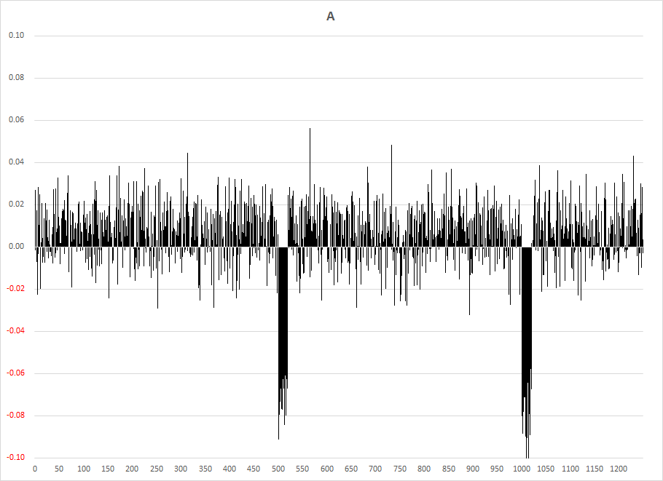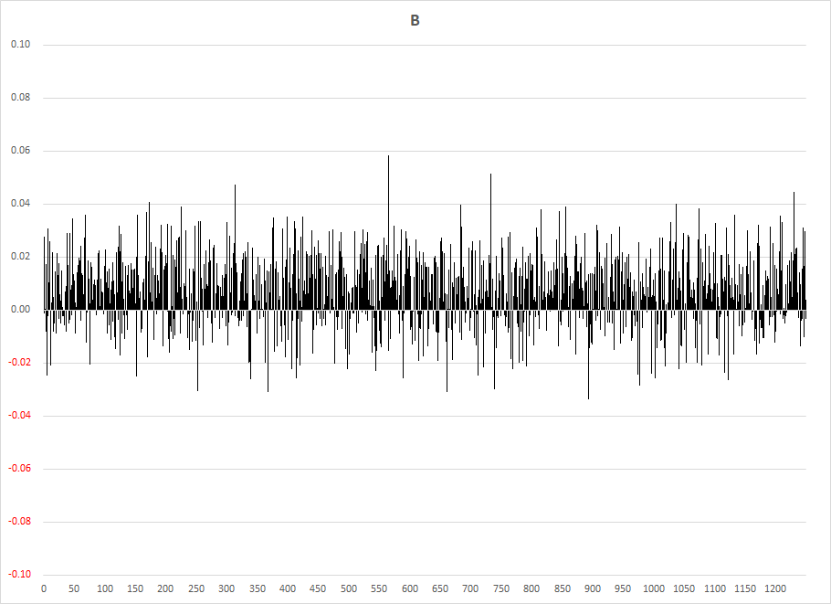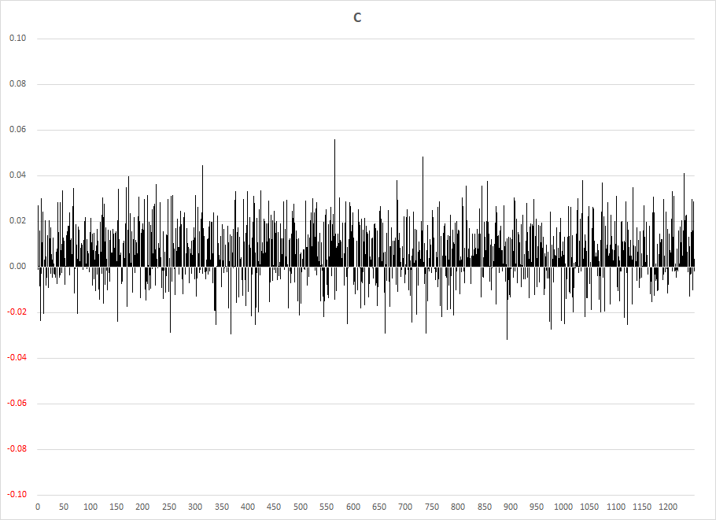

**Figure 2. yt-μt**

**Figure 3. σt**

**Figure 4. Correlations**

As in Figure 5, raw FTI values show many spikes not only for the days 500-519, 750-769, and 1,000-1,019, but also for other periods. This is mainly because the FTI has a high sensitivity and detects unusualness not only in meaningful signals but also in random noises. Look-back parameters have to be appropriately set for real-world data.

**Figure 5. FTI**

As in Figure 6, 60-day moving average of raw FTI values are calculated. Then the 120-day percentile rank is calculated as in Figure 7. The latter percentile rank shows higher percentile ranks (i.e., unusual state based on the percentile rank of FTI values for a certain time period) due to extreme returns of A for the days 500-519, 750-769, and 1,000-1,019.

**Figure 6. FTI, 60-day moving average**

**Figure 7. %FTI, 120-day percentile rank**

**Figure 8. MSI, 20-day moving average**

**Figure 9. CSI, 20-day moving average**

Figure 8 and 9 show 20-day moving average of the MSI and CSI, respectively. The latter CSI values present some of correlation surprises, but the author strongly recommends to use real-world data, not extreme and unrealistic data in this paper, for evaluation of usefulness of these metrics.

In this paper, generated time-series data A, B, and C are extremely highly correlated except for the specified days 500-519, 750-769, and 1,000-1,019. Thus, during the specified unusual periods, the AR values drop from 1.00 as only one (n = int(0.20*N) = int(0.20*3) = int(0.60) = 1) eigenvector (principle component) cannot explain all the variance.

**Figure 10. AR**

**Conclusion**

The author explained and implemented the FTI and the AR. The former evaluates the level of unusualness of time-series data while the latter gauges the level of systemic risk amongst time-series data.

Samuelson [1998] offered the dictum that the stock market is “micro efficient” but “macro inefficient.”4 That is, the efficient markets hypothesis works much better for individual stocks than it does for the aggregate stock market. The Samuelson dictum states that markets are relatively micro-efficient because a smart investor (asset manager) who spots mispriced securities trades to exploit the inefficiency and the inefficiency is corrected as a result. However, when an aggregation of securities, such as an asset class, is mispriced and a smart investor trades to exploit it, that action is insufficient to revalue the entire asset class. Macro-inefficiencies typically require an exogenous shock to jolt many investors to trade in concert in order to revalue an entire asset class. Hence, macro-inefficiencies persist sufficiently long for investors to act on them.

It should be warned that like any other market-timing strategies/models, if there are enough adopters who constantly use metrics in this paper, it will become a self-fulfilling prophecy in that it will cause its own crashes. We saw the stock market crash on October 19, 1987 by portfolio insurance, and extraordinary quant factor drawdowns at virtually the same time (the quant liquidity crunch) early in August 2007. Furthermore, as more people follow these metrics, it will be hard to differentiate yourself from others and become less valuable. However, these metrics are considered to remain valuable for some time, because it is unlikely that everyone will always follow them and allocate assets accordingly. Finally, evaluating crowdedness of metrics has been, and always will be, important.

**Notes**

The material presented is for informational purposes only. The views expressed in this paper are the view solely of the author and are subject to change; moreover, the views do not necessarily represent the official views of the author’s employer.

1. See Kritzman and Li (2010)
2. See Kinlaw and Turkington (2014)
3. See Mark Kritzman, Yuanzhen Li, Sébastien Page, and Roberto Rigobon (2011)
4. See Samuelson (1998)

**References**

Kritzman, Mark, and Yuanzhen Li. 2010. “Skulls, Financial Turbulence, and Risk Management.” *Financial Analysts Journal*, Vol. 66, No. 5 (2010), pp. 30-41.

<http://www.cfapubs.org/doi/abs/10.2469/faj.v66.n5.3>

Kinlaw, Will, and David Turkington. 2014. “Correlation Surprise.”, *Journal of Asset Management,* Vol. 14, 6(2014), pp. 385-399.

<https://link.springer.com/article/10.1057/jam.2013.27>

Kritzman, Mark, Yuanzhen Li, Sébastien Page, and Roberto Rigobon. 2011. “Principal Components as a Measure of Systemic Risk.” *The Journal of Portfolio Management*, Jul 2011, 37 (4), pp. 112-126

<https://doi.org/10.3905/jpm.2011.37.4.112>

Samuelson, Paul A. 1998. “Summing Up on Business Cycles: Opening Address.” In *Beyond Shocks: What Causes* *Business Cycles*, edited by C. Jeffrey, Fuhrer, and Scott Schuh, Boston: Federal Reserve Bank of Boston, 1998.

The author implanted all the metrics in this paper in the Python programming language and shared them on GitHub. Please visit and see:

<https://github.com/yoshisatoh/Stat/tree/main/FTI_AR>

<https://github.com/yoshisatoh/Stat/blob/main/FTI_AR/readme.txt>