**“My Title Goes Here (22 pt Calibri Bold)”**

**Speaker’s Name Goes Here (18pt Calibri Bold)**

***Speaker’s Affiliation Goes Here (14pt Calibri Bold, Italics)***

**ABSTRACT (14 pt Calibri Bold)**

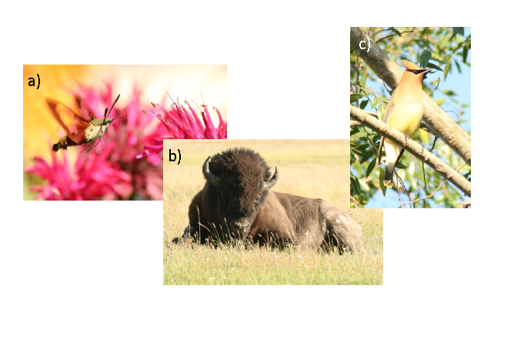The abstract for your talk goes here. It should be 14pt Calibri NOT BOLD with a justified left and right margin. References may be included (and are encouraged) using format[1] as shown. Margins should be 1 inch top, bottom, and right margin and a 1.25 inch left margin.[2] Colorful pictures, data, figures, tables, etc. are all welcome. Line spacing is 1.5. Not sure what else to tell you other than have fun and please try to follow the guidelines as best as you can because Dr. Scully plans to make a book containing all the abstracts so that we have a record of this year’s Summer School activities!! The final abstract (1 page) should be submitted as a .pdf file to iqse@tamu.edu. Thank you for your efforts on this!!

**Figure**: Captions should be 11pt Calibri and single spaced, justified left and right margins. a) Hummingbird moth (Indiana, 2008); b) Bison (Wyoming, 2009); c) Cedar waxwing (Texas, 2006).

c)

1. First footnote
2. Second footnote