**Kelompok** : Anden wano 1127050010

Krisna agung suanda 1210705071

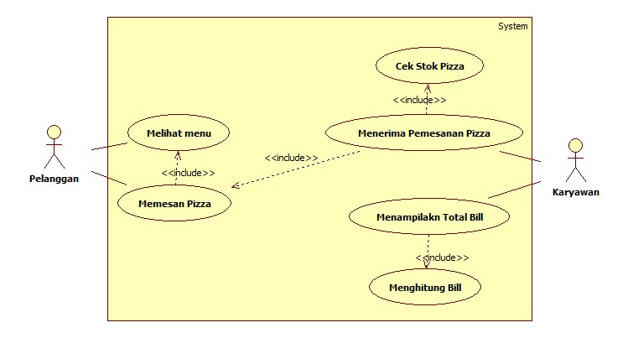**PIZZA**

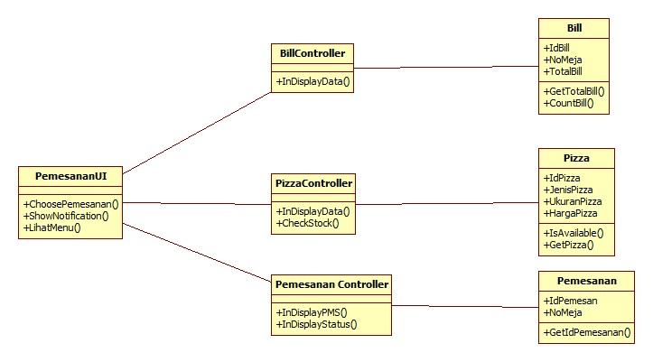

1. **Sequence Diagram Melihat menu**

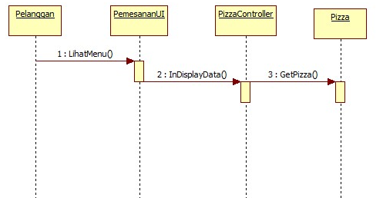

1. **Sequence Diagram Memesan Pizza**

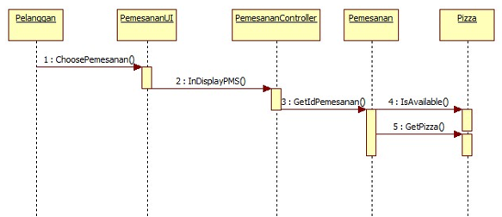

1. **Sequence Diagram Menerima Pemesanan Pizza**

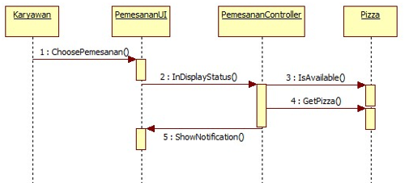

1. **Sequence Diagram Cek Stok Pizza**

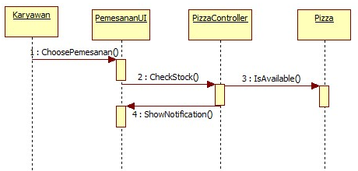

1. **Sequence Diagram Menampilkan Bill**

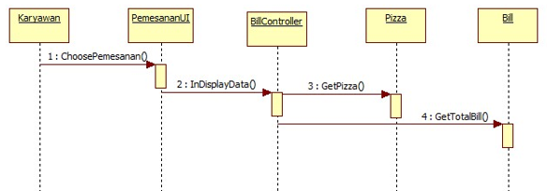

1. **Sequence Diagram Menghitung Bill**

