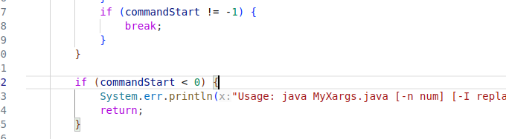The above screenshot can be fixed by simply returning inside of the first if statement

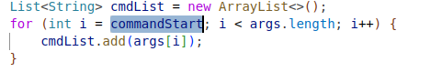

this above screenshot, where the command start is highlighted is super stupid, starting from -1 and java some fucking how isn’t throwing a temper tantrum. Bro if this was C it would retard yell at you wtf man.



Literally replace every instance of execList with cmdList. Nothing special about having to make YET ANOTHER VARIABLE

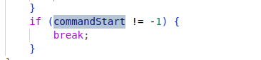

this is such a stupid way of doing things. The loop literally continues until it hits something that is not within the spec of myxargs, and THEN it sets this stupid flag and goes through it once again 🤦