**Name: yosof khairy hasan**

**BIN: 1057**

**Year: preparatory**

**Topic: computer architecture**

**Application brief:**

Computer architecture is a science or a set of rules stating how computer software and hardware are joined together and interact to make a computer work. It not only determines how the computer works but also of which technologies the computer is capable. Computers continue to be a major part of our lives, and computer architects continue to develop new and better programs and technologies. That’s why I have chosen this topic to talk about.

**Screenshots:**

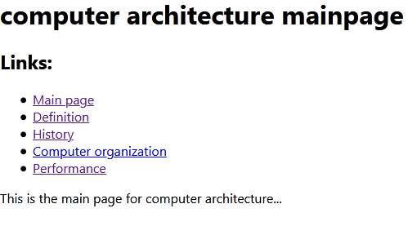

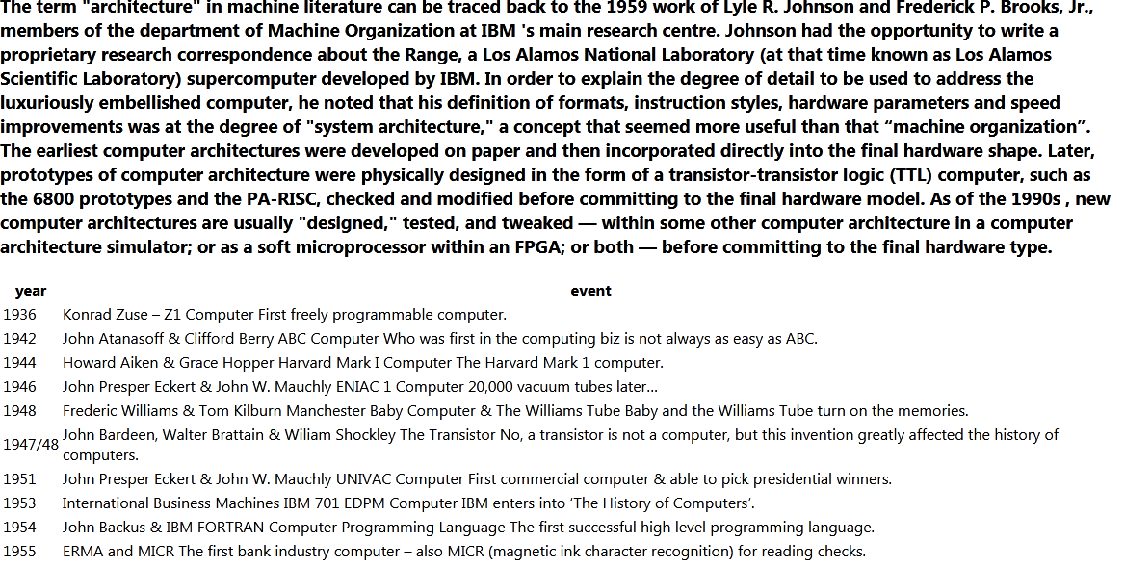

**Source code:**

<html>

<body>

<h1>computer architecture mainpage</h1>

<h2>Links:</h2>

<ul>

<li> <a href="mainpage.html">Main page</a> </li>

<li> <a href="definition.html">Definition</a> </li>

<li> <a href="history.html">History</a> </li>

<li> <a href="computerorganization.html">Computer organization</a> </li>

<li> <a href="performance.html">Performance</a> </li>

</ul>

This is the main page for computer architecture...

</body>

</html>