**DS Urbanisation (G2)**

**Trinome : Yosra Dridi**

**Sinda Ben Marzouk**

**Bochra Feki**

We created a restful web service that exposes two XML endpoints :

* **dayOfWeek :**

Schema:

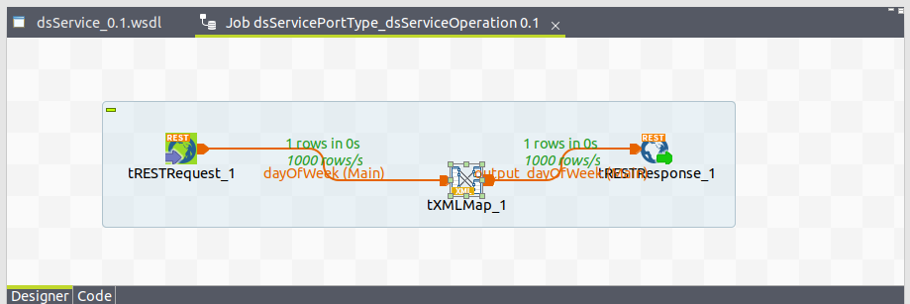

Request Body:

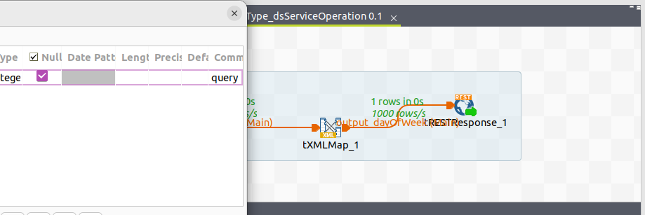

Expression :

Aucune description disponible.

Execution :

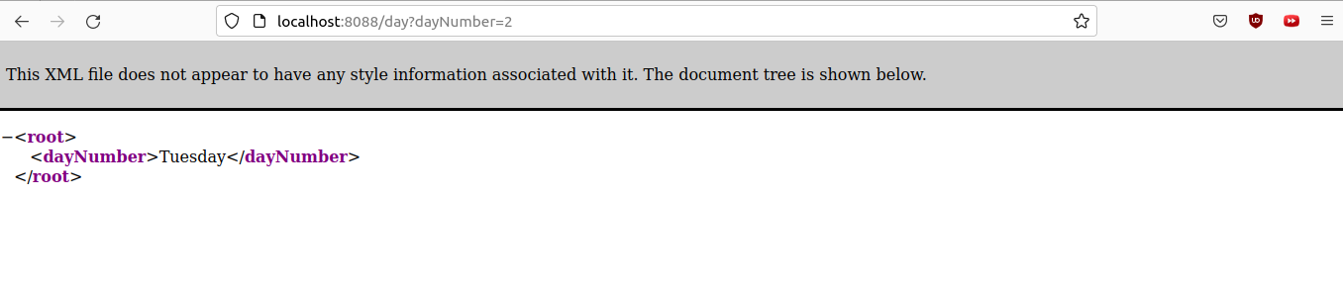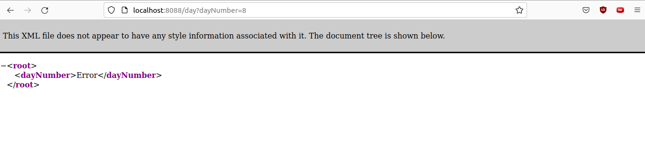

* **monthOfYear**

Talend Schema:

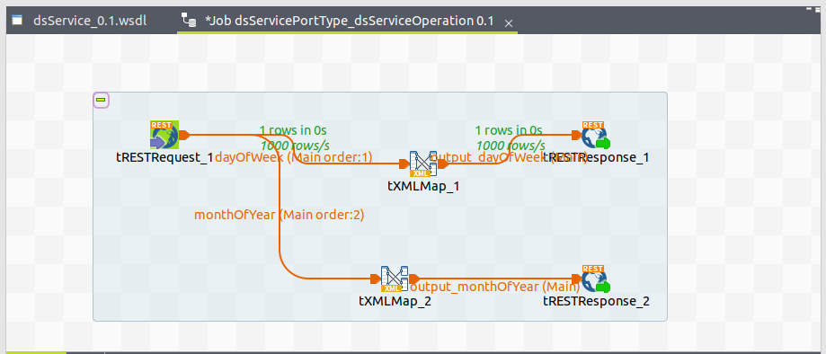

Request Configuration :

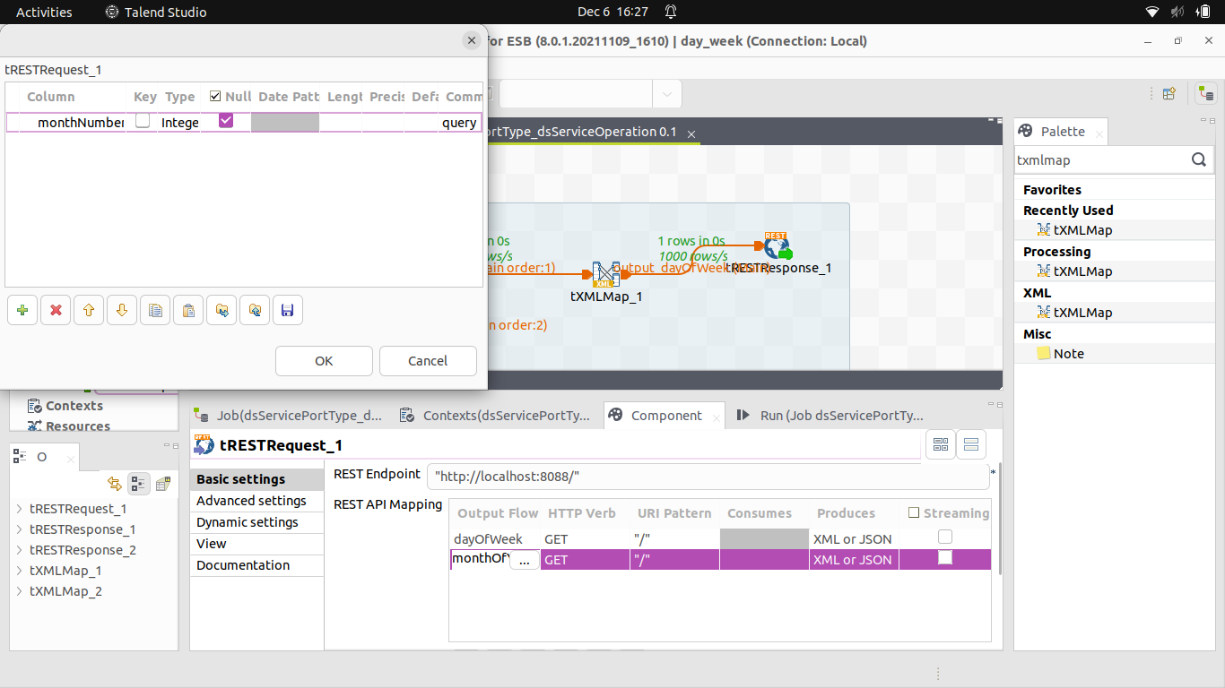

Expression:



Execution :

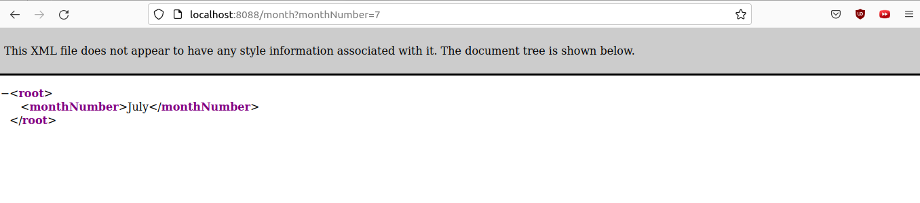

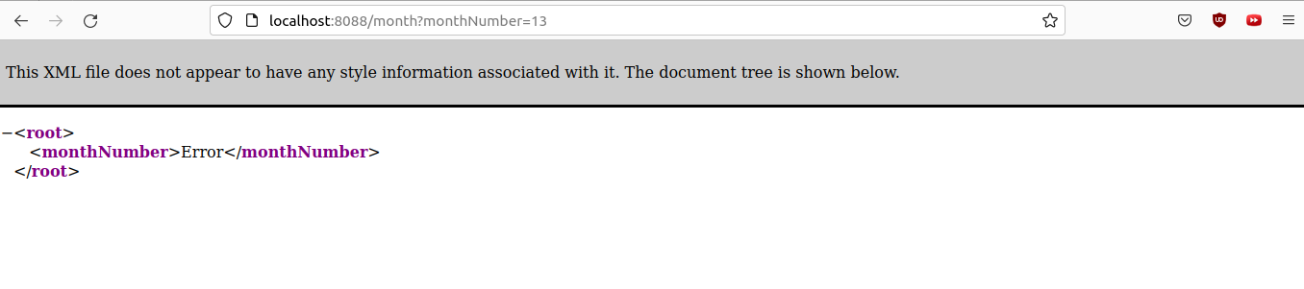

* **RAML API Description :**

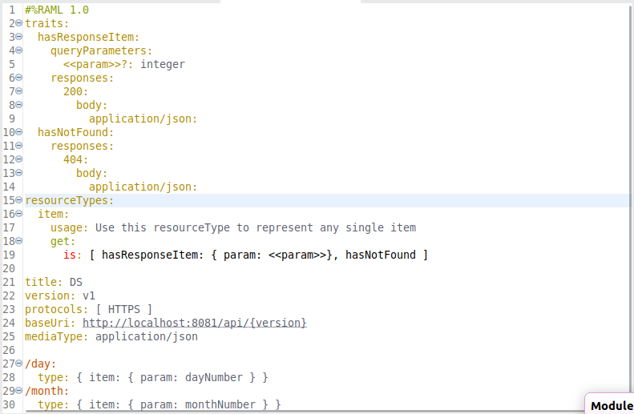

* **The API with Anypoint Studio that calls the endpoints dayOfWeek and monthOfYear**

Flow :

We used the Scatter-Gather component which is a routing event processor that processes a Mule event through different parallel processing routes that contain different event processors. Each route receives a reference to the Mule event and executes a sequence of one or more event processors.

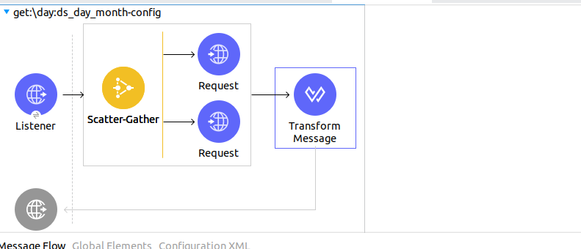

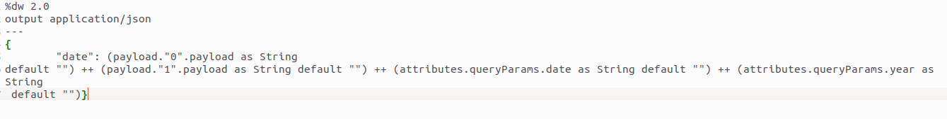The JSON Response:

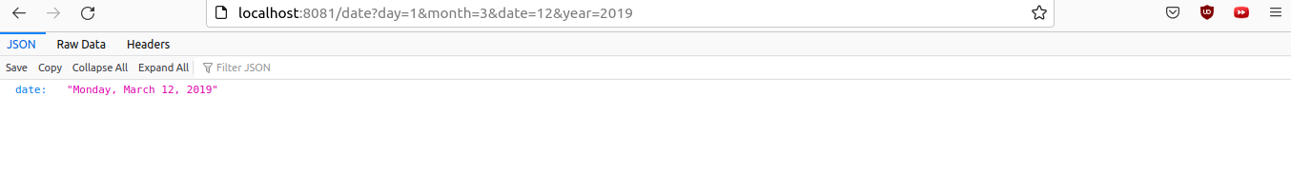Execution :