HIGHER INSTITUTE OF COMPUTER SCIENCE AND COMMUNICATION TECHNOLOGIES – SOUSSE

المعهد العالي للإعلامية وتقنيات الاتصال سوسة

Final Year Internship Report
Presented for the completion of the bachelor’s Degree in Information and Communication Technologies
Specialization: Telecommunications
Digital Platform for Real Estate Management

Prepared by:
Roua Aouididi
Yosra Ben Hmida

Academic Supervisor: Moez Hachem
Professional Supervisor: Firas Kacem


Host society

Academic Year: 2024/2025
Higher Institute of Computer Science and Communication Technologies Sousse ISITCOM
Tel/Fax: +216 73 37 15 71 / +216 73 36 44 11

Signatures of supervisors

ISITCOM
I authorize the students to submit their internship report in preparation for their defense.
Academic Supervisor: M. Moez Hachem

Date
………………
Signature and stamp
…………………

I authorize the students to submit their internship report in preparation for their defense.
Professional supervisor: M. Firas Kacem
Signature and stamp
…………………

DUNDIL
Date
………………

Abstract

This final year project, which is completed as a requirement for the Higher Institute of Computer Science and Communication Technologies' (ISIT'COM) Applied License degree in Telecommunications, includes developing a website focused to the field of real estate.
Users can publish and search real estate listings on this online platform. To help with listing writing, an artificial intelligence component has been incorporated, increasing the postings' precision and quality.
Additionally, the website offers a chat area for users and makes it easier to connect with industry experts.
Keywords: Real estate, listing publication, ReactJS, NodeJS, MongoDB.

Résumé

Ce projet de fin d'année, réalisé dans le cadre de l'obtention de la Licence Appliquée en Télécommunications de l'Institut Supérieur des Sciences et Technologies de l'Information et de la Communication (ISIT'COM), comprend le développement d'un site web axé sur le domaine de l'immobilier.
Les utilisateurs peuvent publier et rechercher des annonces immobilières sur cette plateforme en ligne. Pour aider à la rédaction des annonces, un composant d'intelligence artificielle a été intégré, augmentant la précision et la qualité des publications.
De plus, le site web propose une zone de discussion pour les utilisateurs afin de faciliter la connexion avec des experts du secteur.
Mots-clés : Immobilier, publication d'annonces, ReactJS, NodeJS, MongoDB.

Dedications
My endlessly beloved mother “Dhekra”
"It's not for nothing that God placed paradise under the feet of mothers." You are a source of unending kindness and a representation of unconditional love. Even in the most trying times, you have always supported me and encouraged me to continue my studies, advance in life, and have trust in me May the God of all power keep you safe, offer you good health, a long and peaceful life, and endless joy.
My Father, My Greatest Strength “Khmais”
I am happy to dedicate this success to my father, who always hoped of this day.
He made sure I had access to excellent schooling and established in me the value of responsibility from a young age. His principles, teachings, and love still serve as my guide at all times. This achievement is not only mine; it is also his. May God protect his soul and give him peace for ever and ever. Dad, I love you so much and you will always have a place in my heart.
Brother, My Endless Support “Yasser”
I appreciate you being there for me no matter what. You were there for me at all times, offering me support, sage advice, and encouragement. You have been more than just a brother; you have been a real protector, a confidante, and a source of support. I was given courage by your presence, hope by your words, and love by your acts of kindness. I am so happy that you are in my life.
To the Friends I Hold Closest to My Heart
I dedicate this work to you with my best wishes for success and happiness. Last but not least, I want to express my gratitude to everyone who helped us finish our final task successfully.
My partner, Roua, and my loyal friend, Ranim, deserve a special thank you for their persistent support, continuous encouragement, and positive vibes throughout this adventure.
Yosra
Dedications
To the mother I love without end “Amel”
Mom, I don’t have enough words to say how much I love you. You are the heart of my life. You gave me everything and never asked for anything back. You helped me with patience, supported me in every way. You believed in me, even when I didn’t believe in myself. This success is yours too. Thank you for being everything to me.
To the support of my life, Dad “Salem”
Dad, you have always been my strong support. You cared more about my happiness than your own. You made choices for me and never asked for anything. You were always there, helping me, guiding me, even when I didn’t ask. Your love helped me become who I am today. This success is yours too. Thank you for being such a great father.
To my wonderful family
Thank you all for your love and support. You have always been by my side. I’m lucky to have a family like you.
To all my friends, with love
Thank you to everyone who stood by me in good and hard times. You made the journey easier and more beautiful.
To Yosra
You were with me every step my bestie and my PFE partner. You supported me, believed in me, and never let me feel alone. I’m truly lucky to have shared this journey with you. Thank you for everything.
To Salah
Thank you so much from my heart. Your support helped me get through a very hard time. You helped me move forward and believe in myself again. Your friendship really changed everything. To both Yosra and Salah, Thanks to you , this journey was never lonely. You were my quiet strength, and I’m so grateful.
Roua
Thanks
To our academic supervisor, Mr. Moez Hachem,

Having you as our academic advisor was a true advantage.
We genuinely appreciate your generosity and honesty in offering to manage our work. I had a great time working under your direction.
You have been a smart teach and a helpful guide for us on this trip, always greeting us with a smile and genuine interest.
Everyone around you respects and admires you for your exceptional personal characteristics and clear professional expertise.
We were motivated to keep focused and give it our all at every turn by your support and helpful advice.
Additionally, we would like to sincerely thank all of the instructors and personnel at the Higher Institute of Computer Science and Communication Technologies for their assistance during our academic careers.
Finally, we would like to express our gratitude in advance to the jury members who will be assessing our finished project.

Table of Contents
Introduction
Chapter 1: General Framework
1 Introduction 11
2 Presentation of the host organization 11
3 Project Context 12
4 Preliminary study 12
4.1 Description of the Existing Situation 13
4.1.1 Zillow 13
4.1.2 Tecnocaza 13
4.2 Criticism of the Existing Situation 14
4.2.1 Zillow: 14
4.2.2 Tecnocaza: 14
4.3 Proposed Solution 15
4.3.1 Addressing the Limitations of Zillow: 15
4.3.2 Solutions for Tecnocaza’s Limitations 15
5 Project Management Methodologies 15
5.1 Existing Methodologies 15
5.1.1 Scrum Methodology 15
5.1.2 Extreme Programming (XP) Methodology 16
5.1.3 Rational Unified Process (RUP) Methodology 16
5.1.4 2TU P Methodology 16
• Iterative and incremental: Each stage builds upon the previous one. 16
• Risk-driven: Proactively controls integration and misalignment risks. 16
• User-centered: Puts the requirements of the user first. 16
• UML-based: UML-based system modeling. 16
• Modular architecture: one that is divided into modules for ease of maintenance and adaptability. 16
5.2 Comparative Study of Different Methodologies 16
5.3 Selection of Methodologies 17
5.4 Justification for Choice 17
6 Generic Gant Diagram 17
7 Conclusion 18
Sprint 0: Analysis and specification of needs
1 Introduction 19
2 Actor identification 19
3 Requirements Assessment 19
3.1 Functional Requirement 20
3.2 Non-Functional Requirements 20
4 Work Environment 21
4.1 Back-End Development Environment 21
4.2 Front-End Development Environment 22
5 Chosen Technologies: 22
6 Project Architecture 22
6.1 Software architecture 22
6.2 Physical architecture 23
7 Project management with “Scrum” 24
7.1 Product Backlog 24
7.2 Overall Use Case Diagram 26
7.3 Overall Class Diagram 27
8 Sprint Planning 27
9 Work environment 28
9.1 Hardware Environment 28
9.2 Software Environment 28
9.2.1 Visual Studio Code 28
9.2.2 Trello 28
9.2.3 Postman 29
10 Conclusion 29
Sprint 1: Authentication and client-agent contact management
1 Introduction 29
2 Backlog: 29
3 Specific analysis: 30
3.1 User Authentication: 31
3.1.1 Use case Diagram: 31
3.1.2 Textual Description of the Use Case: 32
3.1.3 Sequence Diagram: 33
3.1.4 Class Diagram: 34
3.1.5 Class Diagram description: 34
4 Implementation: 34
4.1 Authentication interface 34
4.2 Client-agent contact management: 35
4.2.1 Use case Diagram: 35
4.2.2 Textual Description of Use Case 36
4.2.3 Sequence Diagram: 39
4.2.4 Class Diagram: 40
4.2.5 Description Class Diagram: 40
5 Implementation: 41
5.1 Appointment Scheduling Interface 41
6 Conclusion: 42
Sprint 2: Manage Favorites, View History and Archive Property
1 Introduction: 43
2 Backlog: 43
3 Specific analysis: 43
3.1 Use Case Diagram: 44
3.2 Description of Use Case: 45
3.3 Sequence Diagram: 47
3.4 Class Diagram: 48
3.5 Description Class Diagram: 48
4 Implementation: 48
4.1 Property Search Interface 48
5 Conclusion: 49
Sprint 3: Manage Favorites, View History and Archive Property
1 Introduction: 50
2 Backlog: 50
3 Specific analysis: 50
3.1 Use Case Diagram: 51
3.2 Description of Use Case: 52
3.3 Sequence Diagram: 56
3.4 Class Diagram: 57
3.5 Description Class Diagram: 57
4 Implementation: 58
4.1 Interface Add Favorites 58
4.2 Conclusion: 58
1 Conclusion 59
2 Perspectives 60

List of Figures

Figure 1 : Logo "Dundil" 12
Figure 2 "Zillow interface" 14
Figure 3 “Tecnocasa interface" 14
Figure 4 - Logo MongoDB 21
Figure 5 "NodeJS Logo" 22
Figure 6 "React Logo" 23
Figure 7 "MVC Architecture" 24
Figure 8 "Application architecture" 25
Figure 9 "Overall Use Case Diagram" 27
Figure 10" Overall Use Case Diagram" 28
Figure 11": Sprint Planning with Trello" 28
Figure 12"VSCode Logo" 29
Figure 13 "Trello Logo" 29
Figure 14 "Postman logo' 30
Figure 15 "Use Case Diagram – Authentication" 32
Figure 16 "Sequence Diagram for Login" 34
Figure 17"Class Diagram for Sprint1" 35
Figure 18 "login interface" 36
Figure 19"UseCase Diagram for Contact an Agent" 36
Figure 20"Sequence Diagram of Schedule an Appointment" 40
Figure 21"Class Diagram for client-agent contact management " 41
Figure 22 " Appointment Scheduling Interface" 42
Figure 23"UseCase for Sprint 2" 45
Figure 24 "Sequence Diagram of property research" 48
Figure 25"Class Diagram of the Sprint 2 " 49
Figure 26"Property Search Interface" 50
Figure 27"UseCase for Sprint 3" 52
Figure 28 "Sequence Diagram for Add to Favorites" 57
Figure 29 "Class Diagram for Sprint 3" 58
Figure 30"Interface Add Favorites" 59

List of Tables

Table 1 Identity Card "DUNDIL" 13
Table 2 "Comparative study between different methodologies" 17
Table 3 "User Stories for the Real Estate Platform" 26
Table 4 summarizes our work schedule which consists of three Sprint Table 4 "Sprint Plan" 28
Table 5 "Sprint 1 Backlog Board" 30
Table 7"Description of the Authentication In use case" 33
Table 8"Textual Description of the Contact an Agent UseCase" 37
Table 9"Description of Schedule an Appointment UseCase" 38
Table 10 "Description of Became a partner UseCase" 38
Table 11 "Description of Reply to User UseCase" 39
Table 12"Backlog Table of Sprint 2" 44
Table 13"Description of Property Management UseCase" 46
Table 14"Description of the Property Posting UseCase" 47
Table 15"Description of Property research UseCase " 47
Table 16"Backlog Table of Sprint 3" 51
Table 17 "Textual Description of Add to Favorites UseCase" 53
Table 18"Description of the View My Favorites use case" 53
Table 19 "Textual Description of the Notification System UseCase" 54
Table 20 "Description of the View all clients history use case" 54
Table 21 "Description for the Achieve Property UseCase" 55
Table 22 "Description of the Achieve/Modify Property UseCase" 55
Table 23 "Description to View all History" 56

INTRODUCTION

Today, every field is exploiting technology, but the real estate sector is particularly one where people as well as agencies are taking advantage of digital solutions. In addition, artificial intelligence (AI) is growing exponentially as it enables clients to find properties more quickly and effectively.

We were tasked by our company, <Dundil >, to create an intelligent real estate website that facilitates the act of buying, selling, and renting of homes and other spaces. The project's objective is to use AI traits and new web technology to simplify the real estate process.

Three sprints are used to structure the development process:

Sprint 1 includes managing client accounts, contacting agents, and user signup and login.
Sprint 2 takes care of the managing, posting and search properties.
Sprint3 allows users to see their activity history, archive properties and add favorites.

The goal of this platform is to offer all real estate market users with a simple and expert experience.

Chapter 1: General Framework

Introduction
This chapter will introduce the host organization and the context in which the work was conducted in order to provide the project's overall structure. We'll go on to examine the current market, stressing the shortcomings of the available solutions and the benefits of our suggestion. We will conclude by outlining the platform's functional and non-functional requirements.

Presentation of the host organization
Our internship was carried out within the company “DUNDIL”, which has the logo illustrated in figure 1 which we will present below.

Figure 1 : Logo "Dundil"

“DUNDIL” is an expert in finding and obtaining talent. The organization assists in connecting qualified individuals, particularly senior developers, with companies that require particular capabilities.” DUNDIL” offers chances in a variety of industries, including IT and web development, and concentrates on remote work.
The company leverages technology and modern sourcing strategies to meet market needs. It also stands out for its commitment to sharing useful resources through its digital channels (social media, newsletters, blogs).
Table 1 below presents the main information concerning “DUNDIL”:

Table 1 Identity Card "DUNDIL"
Name | Dundil
Project Manager | Firas Kacem
Address | Gamaoun Building, Akouda Sousse
Sector of Activity | Recruitment, Talent Acquisition, Remote Work Specialization Sourcing, Placement of IT Talent
Phone | +216 54 133 050
Email | contact@dundill.com
Website | https://dundill.com

Project Context
Offering modern technologies that enable real estate agencies to digitize their operations is becoming crucial in light of the real estate industry's increasing need for intelligent solutions and the digital evolution of the industry.
As a part of this, “DUNDIL” gave us the task of creating a website for a real estate company that includes artificial intelligence-based functionality. The objective is to offer a
user-friendly and effective platform for real estate agents wishing to effectively publish and maintain their listings as well as for clients wishing to purchase or rent a property.

Preliminary study
When creating our solution, an initial evaluation was carried out to determine whether real estate platform solutions already existed. This analysis enabled us to:
- Identify the anticipated fundamental features (such as contact forms, filters, and property search).
- List the major drawbacks of the platforms that are now in use, such as their complicated interface, limited modification, and lack of AI implementation.
- Address areas that could use innovation, especially the use of AI to make property searches and recommendations more relevant.
- Our choice to create a customized solution that satisfied the agency's unique requirements and provided a modern user experience was supported by this study.

Description of the Existing Situation
This project's primary goal is to create a web application that facilitates online property searches and transactions. Users will be able to interact with real estate agents, schedule virtual tours, and safely browse property listings using this app. The objectives are to reduce the logistical challenges associated with in-person property visits and to meet users' demands for easy access to property information.

Zillow
Mortgage calculators, virtual tours, online property listings, and safe channels of contact between buyers, sellers, and real estate agents.
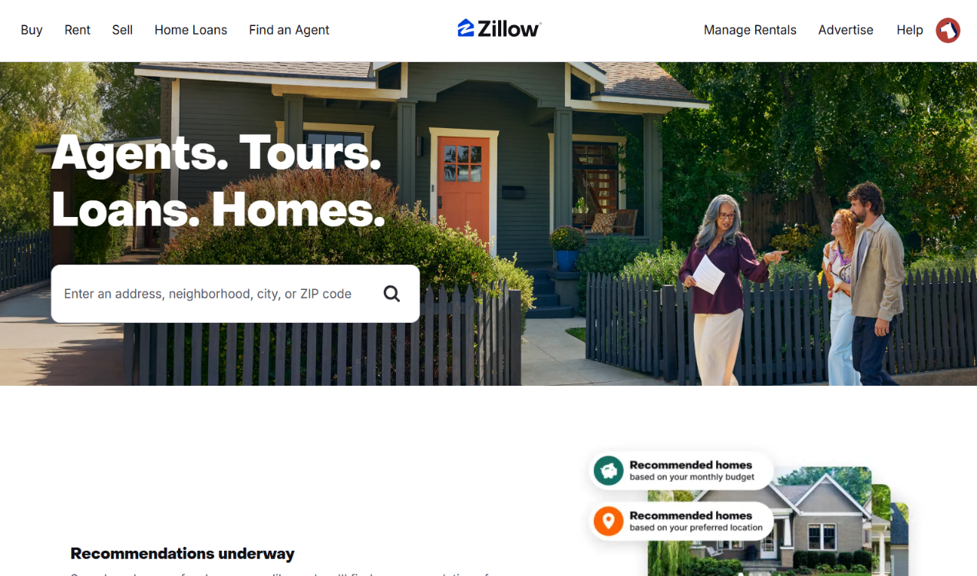
Figure 2 "Zillow interface"

Tecnocaza
focused on enhanced search filters for personalized property recommendations, smart home connectivity, and high-tech property solutions.
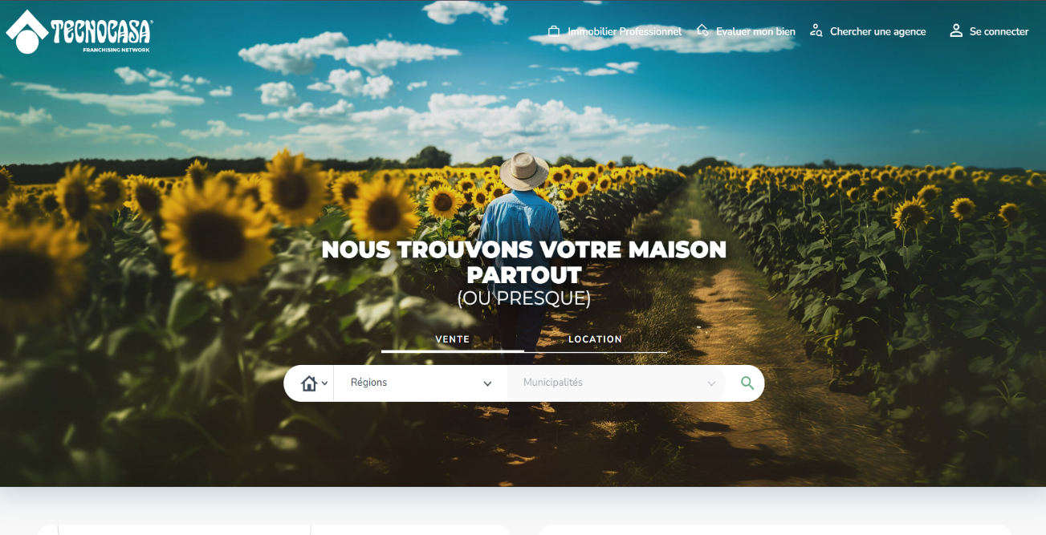
Figure 3 “Tecnocasa interface"

Criticism of the Existing Situation

Zillow:
- Benefits:
Zillow makes it simpler for people to view properties from a distance by offering a comprehensive platform for virtual tours and property searches. Buyers and sellers may find properties more quickly thanks to the user-friendly design and sophisticated search criteria.
- Limitations found:
Limited Localization: Due to its primary concentration on the U.S. market, Zillow is not as accessible to users from other countries. Lack of Specialized Listings: Particular sectors like smart homes and premium real estate are poorly served by the platform.

Tecnocaza:
- Benefits:

To appeal to tech-savvy buyers, Tecnocaza provides advanced property search options like high-tech property solutions and smart home connections.
The software enhances the entire property search experience by offering personalized recommendations based on user preferences.
- Limitations found:
Limited Geographic Coverage: The user base of Tecnocaza is limited because its services are not generally accessible in all areas.
Complex Interface: Users who are not tech-savvy may find the platform's complex functions difficult.

Proposed Solution

Addressing the Limitations of Zillow:

User-Friendly and Clear Interface: Users from various places and backgrounds can access with ease thanks to a simple and accessible design.
Secure Email-Based Authentication: Using secure login procedures to protect user data improves platform integrity and confidence.

Solutions for Tecnocaza’s Limitations

Geographic Expansion: By collaborating with nearby real estate companies and utilizing cloud-based technology, extend services to new areas.
Advanced Filtering Features: Simplify the platform’s UI by adding guided tutorials and configurable dashboards for a better user experience.
Enhanced Security with Email Authentication: Ensuring data protection requires respect to specific information privacy standards and secure user authentication.

Project Management Methodologies
Examining different current technology and work practices is crucial to ensuring appropriate organization throughout the project's development.

Existing Methodologies

Scrum Methodology
IT projects benefitting greatly from the agile project management approach known as Scrum, which divides work into roughly 30-day sprints and prioritizes tasks while closely monitoring deadlines.
The Scrum Master plays a key role by facilitating communication and helping teams progress efficiently. Transparency and communication are fundamental principles in this approach.

Extreme Programming (XP) Methodology
The foundation of Extreme Programming (XP) is development methodology that prioritizes continuous testing and short cycles. The objective is to start with a working product and progressively improve its level of excellence.
Quick prototype production and validation at every level guarantee adaptability and flexibility to user requirements.

Rational Unified Process (RUP) Methodology
The four primary stages of the RUP (Rational Unified Process) development methodology are as follows:
Inception: Determining the project's concept and assessing the required materials.
Elaboration: Creating the architectural blueprint and meticulous planning.
Construction: Product development, testing, and completion.

2TUP Methodology
Based on the Unified Process (UP), the 2TUP (2 Track Unified Process) approach separates technical and functional factors before combining them. It has a Y-shaped development cycle.
Important traits consist of:

Iterative and incremental: Each stage builds upon the previous one.

Risk-driven: Proactively controls integration and misalignment risks.

User-centered: Puts the requirements of the user first.

UML-based: UML-based system modeling.

Modular architecture: one that is divided into modules for ease of maintenance and adaptability.

Comparative Study of Different Methodologies
The following table highlights the positive features and drawbacks of the Scrum, XP, RUP, and 2TUP approaches:

Table 2 "Comparative study between different methodologies"
Methodology | Strengths | Weakness
Scrum | Flexible, fast, updates priorities, adapts well to needs | Difficult to achieve "DONE" in software projects, team size dependency
XP | Iterative, risk-focused, improves code quality | Requires experts, costly to customize
RUP | Risk management, architecture-based approach | Complex process, high customization cost
2TUP | Separation of technical/functional aspects, efficient risk management | Limited documentation, lack of clarity in initial phase

Selection of Methodologies
After analyzing various approaches, we have chosen Scrum for project management. This method enables us to:
Ensure transparency: A common language is defined for the team.
Maintain detailed planning: Provides an overall project view and precise short-term tracking.
Adapt the project to needs: Requirements are adjusted based on changing demands and unforeseen challenges.
This approach optimizes teamwork and ensures efficient project development.

Justification for Choice
Using Scrum provides several advantages, including:
- An incremental approach that allows us to deliver functional versions progressively.
- Better risk management through frequent reviews and continuous adjustments.
- Increased flexibility that facilitates adaptation to changes and new requirements.
Due to these benefits, Scrum proves to be the most suitable methodology for our project, ensuring effective tracking and enhanced productivity within the team.

Generic Gant Diagram
The Gantt chart could be a broadly utilized apparatus in venture administration. It gives a visual representation of the advance of different venture errands over time.
In our case, the venture is organized into three primary discharges, each composed of a few sprints taking after the Scrum technique.
The taking after figure outlines the Gantt chart, which traces the timeline and advance of each sprint over the project's lifecycle, from beginning examination to last conveyance.

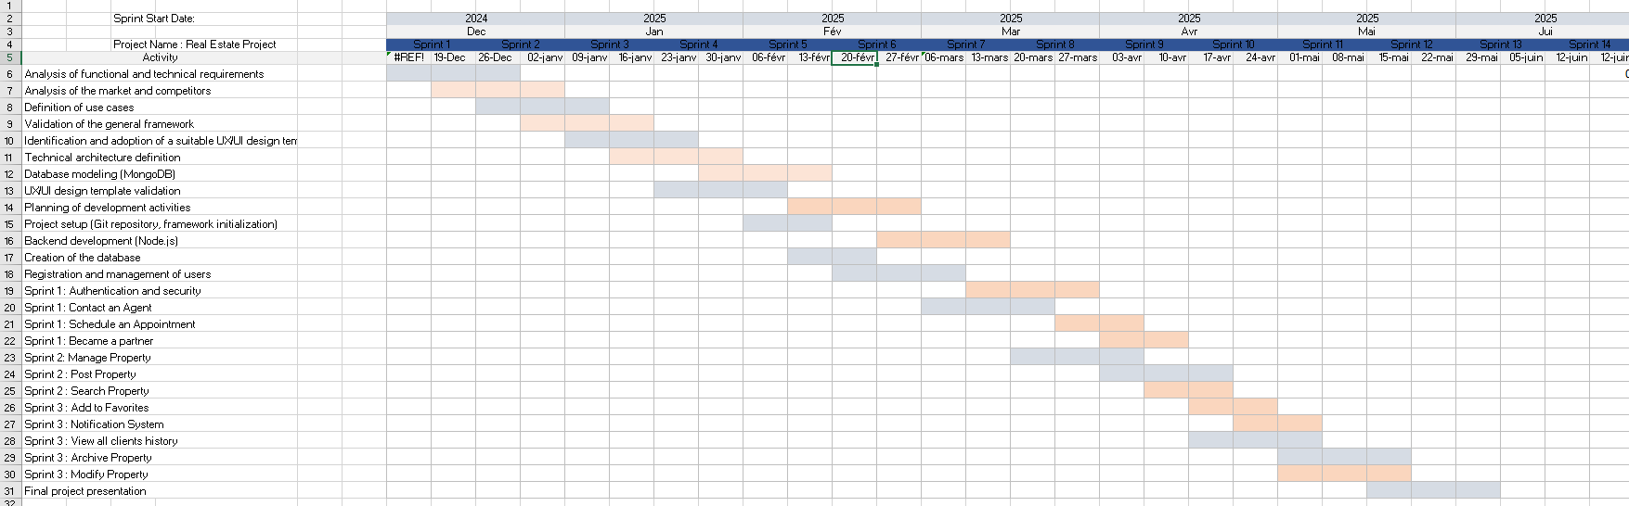

Conclusion
This chapter introduced the initiative by outlining the host organization and the context. We examined the current state of affairs in order to determine the drawbacks of popular solutions like Tecnocasa and Zillow. This investigation led to the proposal of a novel solution. The best project management approach was chosen after a number of them were compared. Lastly, a standard Gantt chart was used to organize the next phases.

Sprint 0: Analysis and Specification of Needs

Introduction
In the last chapter, we decided to create our web application for a real estate brokerage using the Scrum technique. The planning and architecture phase, which is the initial stage of this approach, is an essential step that has a direct impact on the outcome of every successive sprint.
During this phase, you may clearly envision the finished product, determine the responsibilities of users (clients, administrators, and real estate agents), and define the primary features of the system. Both the initial sprint planning and the initial backlog are established using these components.
In view of the project's functional and non-functional requirements, we will also discuss the technologies and tools that were selected for the application's development.

Actor identification
The following are the various actors that have direct interactions with our application:
- Client (or Service Requester)
- Real Estate Agent
- Administrator

Requirements Assessment
Our project's goal is to analyze, build, and implement a web portal specifically for a real estate brokerage.
Our suggested solution must satisfy a number of demands and specifications that were noted throughout the design stage. The creation of an effective, safe, and user-friendly system for both clients and real estate agents will be based on these requirements.

Functional Requirement
The functions that the web application for an estate agency must provide to its users will be explained in this section. Meeting fundamental requirements for site administration, user interaction, listing search, and property management is the aim.
- Authentication: To securely access their own zone, clients, real estate agents, and the administrator need to enter their login and password.
- Search and browsing of listings: A variety of factors, including property type, location, price, number of rooms, and more, can be used by visitors to search for properties (apartments, homes, etc.).
- Property detail display: A comprehensive page with a description, images, prices, and the relevant agent's contact details is included with every ad.
- Adding and managing listings: Listings of properties for sale or rent can be added, edited, or archived by real estate agents.
- Contacting a real estate agent: Agents and clients can communicate via a contact form.
- Client account creation: To be able to schedule visits, add properties to favorites, and save searches, visitors can register.
- User management: In addition to viewing the user list, the administrator can change user roles (client, real estate agent, and admin) and activate or deactivate accounts.
- Statistics and dashboards: The administrator has access to data on user activity, website visits, and published listings.

Non-Functional Requirements
- Non-functional criteria specify the application's expected features and technical limitations.
- Simplicity: For all user profiles, the interface needs to be clear, simple, and intuitive.
- Responsiveness and performance: Fast search and listing display reaction times and seamless navigation are essential features of the system.
- Security: Secure authentication, encryption, and defense against cyberattacks are necessary to safeguard user interactions and personal data.
- Accessibility: The website needs to work with a variety of browsers and be responsive on tablets and phones.
- Scalability: Over time, the system should be able to grow to accommodate more users and listings.

Work Environment
This section focuses on analyzing various programming languages, frameworks, and technological tools in order to make informed decisions for the development of our real estate web platform.

Back-End Development Environment
Despite being invisible to users, the back-end is an essential component of a web project. The website would be nothing more than an empty surface without it.
The back-end can be divided into two fundamental parts:
A Database (where the application’s data is stored) :
- MongoDB: C++ was used to create the document-oriented database system MongoDB. It doesn't need a preset data schema and is made to scale over several machines. It is a good option for handling user profiles, appointments, and real estate listings because of its adaptability and simplicity of use.


Figure 4 - Logo MongoDB

- A server: To manage server-side logic, we employ a mix of technologies, frameworks, and libraries. The following is a summary of these technologies:
Chosen technologies:

- Node.js: An event-driven, open-source JavaScript runtime designed for scalable network applications is called Node.js. It has built-in modules, such as http, that enable the establishment of HTTP servers. Node.js is a low-level environment that enables server-side JavaScript code execution.

Figure 5 "NodeJS Logo"
- Express.js: The most widely used Node.js web application framework is called Express. It offers a simple yet adaptable framework for creating reliable web apps and APIs. Express is perfect for our real estate project since it streamlines back-end logic, middleware integration, and routing.

Figure 6 "ExpressJS Logo"

Front-End Development Environment
The visual part of a website that users view and interact with on their displays is referred to as the front-end. Our goal is to create a web application with responsive and contemporary technology for the front-end of our real estate agency platform. An outline of the selected framework is provided below.

Chosen Technologies:
- React.js: In 2013, Facebook developed the open-source, free JavaScript library React. Its primary use is in creating single-page-applications (SPAs) with dynamic elements that respond to changes in data (state). Because React solely focuses on the View layer of the MVC architecture, we can create reusable user interface components, manage user interaction, and show real-time updates like filtering real estate listings, keeping favorites, or processing form submissions.

Figure 6 "React Logo"

Project Architecture

Software architecture
Building a extend as large-scale as our own requires broad inquire about to recognize a strong design and auxiliary methodology that genuinely underpins the versatility of the stage, whereas too optimizing it to realize crest execution.
In this segment, we display the design chosen for our venture, which is based on the MVC (Model-View-Controller) design. This structural demonstrate permits for a clear division of concerns, making the application more viable, adaptable, and effective.
- Model-View-Controller (MVC):
The MVC (Model-View-Controller) design pattern divides an application into three main components: Model, View, and Controller.
- Model: The Model represents the data to be displayed in the view. It consists of a collection of classes that define the business logic (business model and data model). It also defines business rules concerning how data can be modified and managed.
- View: The View represents the user interface components such as XML, HTML, etc. It displays the data received from the controller as output. In the MVC pattern, the View observes the Model for any state changes and updates the display accordingly. The Model and View interact using the Observer pattern.
- Controller: The Controller is responsible for handling incoming requests. It processes user input via the Model and sends the appropriate response to the View. It typically acts as a mediator between the View and the Model.
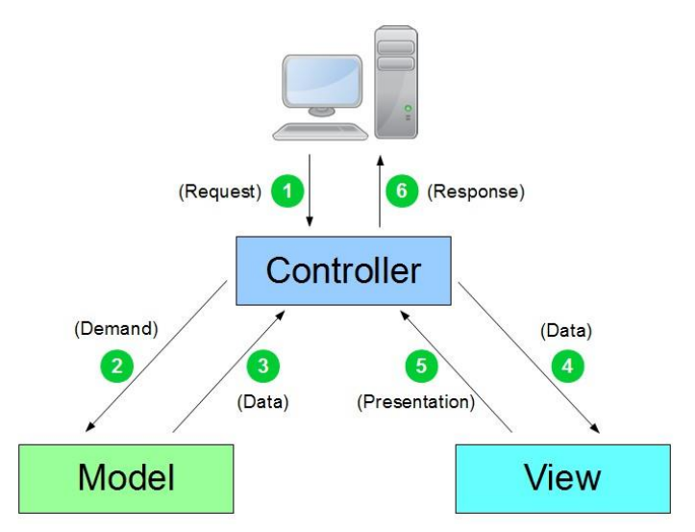
Figure 7 "MVC Architecture"

Physical architecture
The design of our application is based on the MVC (Model-View-Controller) show. Our client layer (See) will be created utilizing JavaScript, HTML, and CSS, with ReactJs as the chosen system. This layer is what clients associated with to get to the functionalities of our application.
The trade rationale layer (Controller) will be actualized utilizing NodeJs and ExpressJs. This layer acts as the application server and serves as the communication bridge between the client layer and the database layer. It serves HTML pages to the user's gadget, acknowledges HTTP demands, and gives the fitting reactions.
Our database layer (Demonstrate) will be fueled by MongoDB. Typically, where all the vital information required for the operation of our application will be put away.
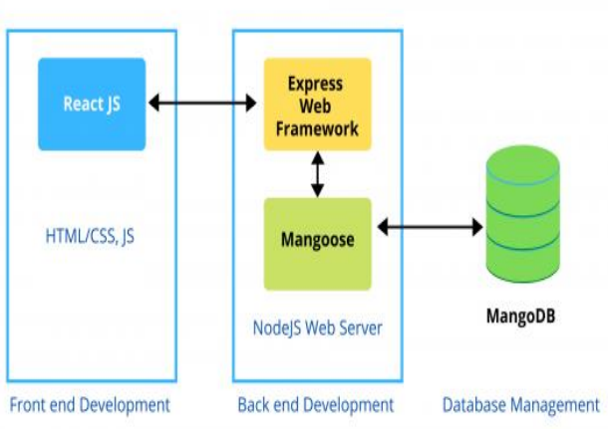
Figure 8 "Application architecture"

Project management with “Scrum”

Product Backlog
The Item Excess could be a list of all the most highlights we need in our genuine bequest stage. These highlights are composed as client stories, which portray what the client needs.
Each client story incorporates:
- ID: A number to recognize the story.
- User Story: A short declaration describing the user's objectives
- Description: A brief description of the feature.
- Priority: Indicates the feature's level of importance (High, Medium, Low).
- Role: The role that users play in the story.
In this table, we appear the list of client stories we arranged for our genuine bequest application.
Table 3 "User Stories for the Real Estate Platform"
ID | User Story | Description | Priority | Role
1 | Authentication | Log in to my account to access my information. | High | User
2 | Signup | As a new Client, I need to make an account to use the platform. | High | User
3 | Search a property | Client can search for properties using filters. | High | Client
4 | Show property details | Client can see the detailed information of a property. | High | Client
5 | Add to favorites | Client wants to add a property to my favorites. | Medium | Client
6 | View my favorites | Client wants to see my list of favorite properties. | Medium | Client
7 | Post a property | Client can post his property. | High | Client
8 | Contact an Agent | Client can contact a real estate agent to became a partner. | High | Client
9 | Schedule an  appointment | As Client, I can make an appointment to visit a property | High | Client
10 | View their own history | Clients have access to their personal activity history. | Medium | Client
11 | View history of all clients | Rea Estate Agents can view the history of all clients. | Medium | Real Estate Agent
12 | Add a property | As a real estate agent, I want to add some property to the platform | High | Real Estate Agent
13 | Modify a property | Real Estate and Client can edit the information of a property | High | Real Estate Agent, Client
14 | Archive the property | The property has been moved to the archive by the Real Estate Agent | High | Real Estate Agent
15 | Manage Agents | An Administrator can manage agents | High | Administrator
16 | Manage Clients | An Administrator can manage users | High | Administrator
17 | View history of all clients | Admin can view the history of all clients. | High | Administrator
18 | Archive/Modify a property | Admin wants to archive or edit the properties listed by Agents | High | Administrator
19 | Manage Notifications | As a notifications system, send notifications based on the Client’s criteria. | Low | Notification System

Overall Use Case Diagram
The specification of features related to the product backlog of our solution is defined by the overall use case diagram:
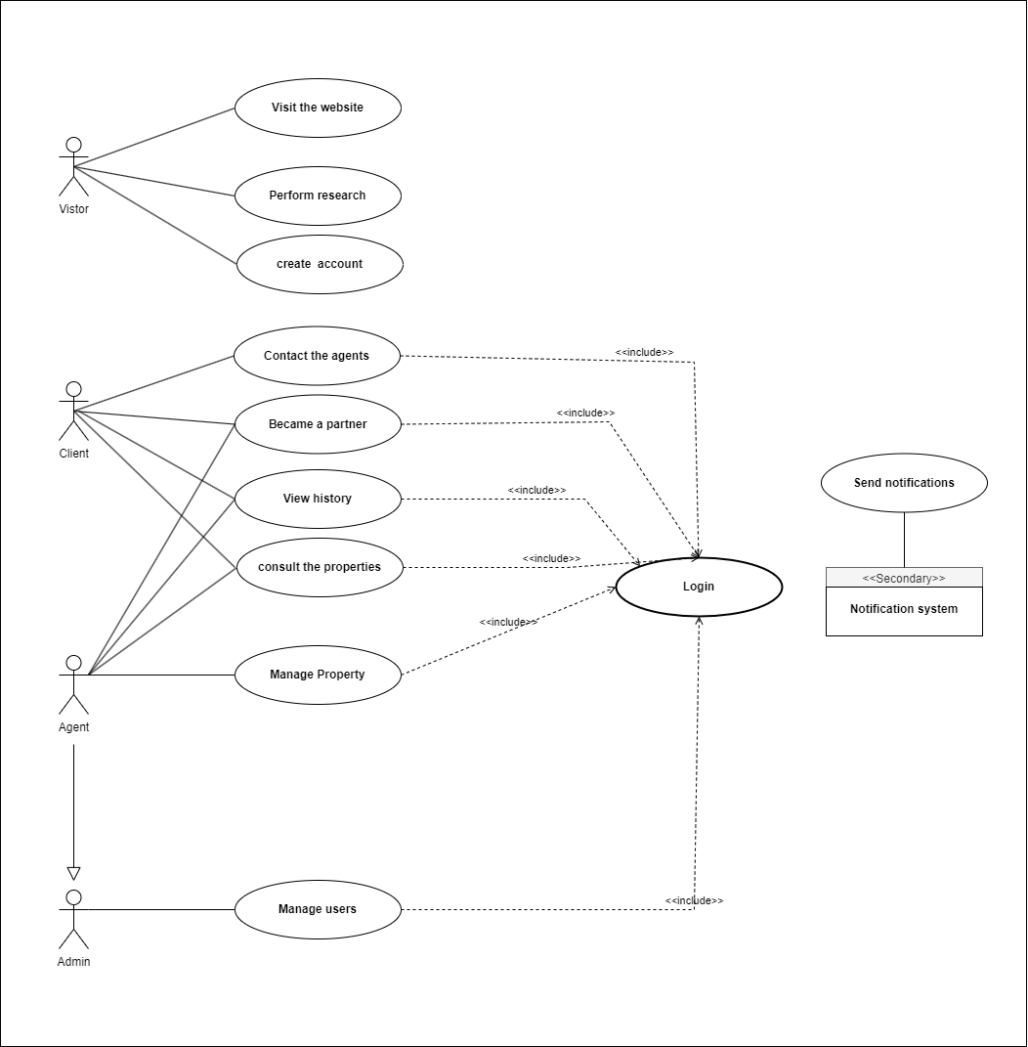
Figure 9 "Overall Use Case Diagram"

Overall Class Diagram
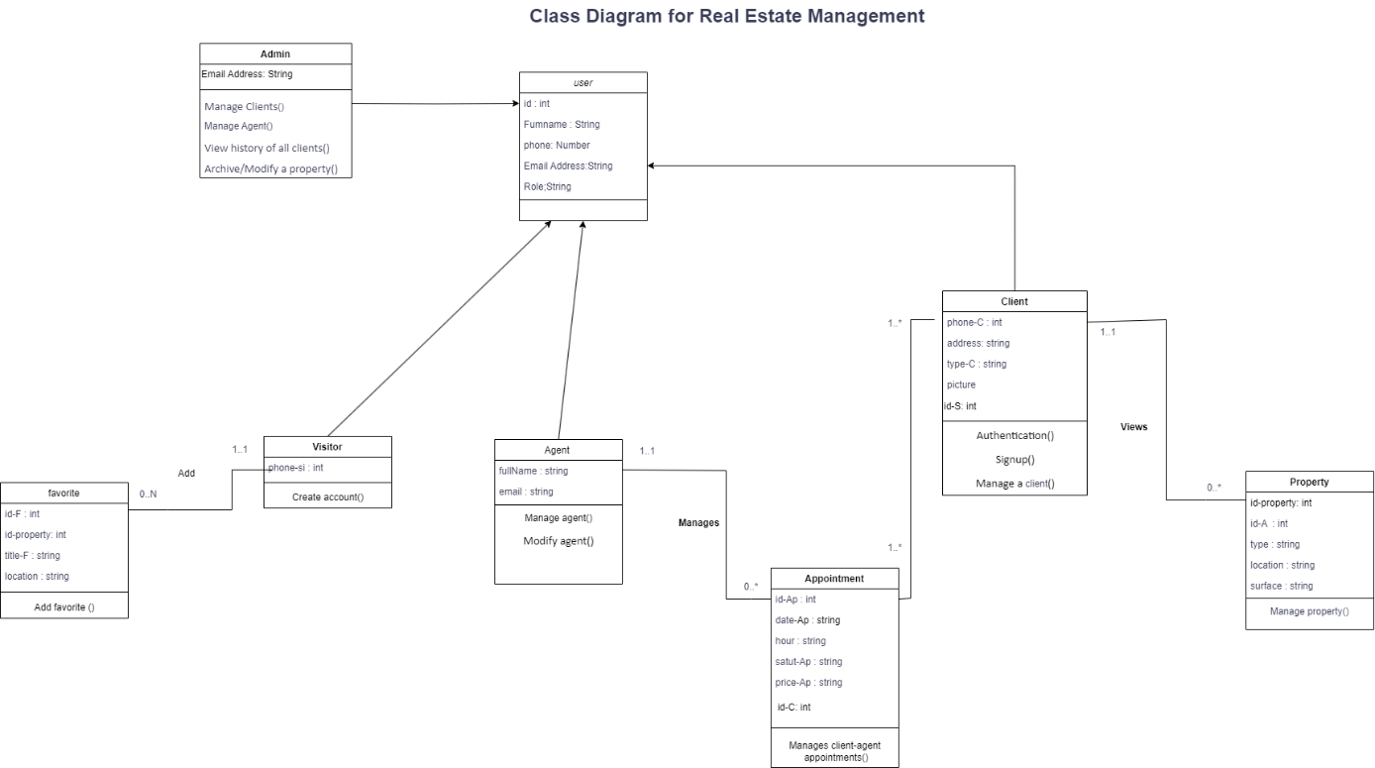
Figure 10" Overall Use Case Diagram"

Sprint Planning
Table 4 summarizes our work schedule which consists of three Sprint Table 4 "Sprint Plan"
Manage Property
Post Property
Search Property
Sprint 2

Manage Favorites
View History
Archive Property
Sprint 3

Signup/in
Manage Client
Contact Agent
Sprint 1

Figure 11 shows work planning in the form of sprints using the Trello tool.

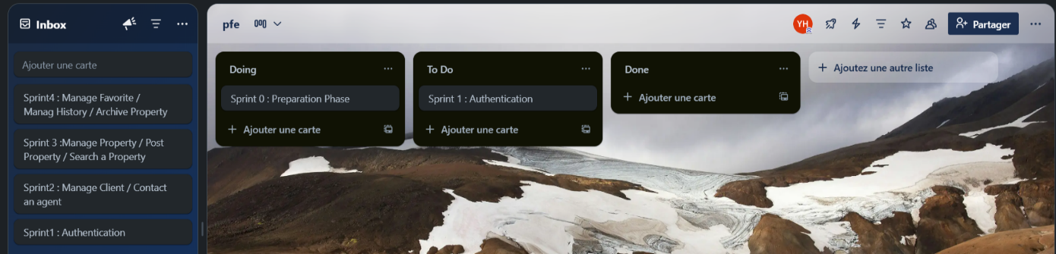
Figure 11": Sprint Planning with Trello"

Work environment
In this section, we present the software and hardware environment we used.

Hardware Environment
- Computer: Lenovo
- Processor: Intel i5
- RAM: 4GB
- Operating System: Windows 11.

Software Environment
In this paragraph, we will discuss the software we used for the design, development, testing, and hosting of our web platform.

Visual Studio Code
Visual Studio Code was introduced at the Build developer conference in April 2015 as a free and open-source code editor. Figure 25 shows the Visual Studio Code logo.


Figure 12"VSCode Logo"

Trello
Trello is an online project management tool launched in September 2011, inspired by Toyota's Kanban method. It is based on organizing projects into boards that list cards, each representing a task. Figure 26 shows the Trello logo.

Figure 13 "Trello Logo"

Postman
It is a testing tool. One of its most powerful features is its ability to run automated tests on your requests. Figure 27 shows the Postman logo.

Figure 14 "Postman logo'

Conclusion
In this chapter, we conducted a needs analysis that gave us a clearer vision of our topic and highlighted the different Sprints of our project as well as the technologies used.

Sprint 1: Authentication and client-agent contact management

Introduction
Sprint 1 focuses on two main features: user authentication and client-agent contact management. We begin with the planning phase, shown through the sprint’s product backlog. Then, we present the analysis with a basic conceptual study, including use case and sequence diagrams. Finally, we show the developed interfaces, which allow users to log in securely and contact real estate agents easily through the platform.

Backlog:
Table 5 "Sprint 1 Backlog Board"

ID | User Story | Description | Priority | Role
1 | Authentication | Log in to my account to access my information. | High | User
2 | Signup | As a new Client, I need to make an account to use the platform. | High | User
3 | Manage Clients | An Administrator can manage users | High | Administrator
4 | Schedule an appointment | As Client, I can make an appointment to visit a property | High | Client
5 | Contact an Agent | Client can contact a real estate agent to became a partner. | High | Client

Specific analysis:
The primary features created in Sprint 1 are described in this section. It displays a use case diagram for client-agent communication and user login. Additionally, we provide short,
acceptable summaries of key use cases and explain each stage of the system's operation with sequence diagrams.

User Authentication:

Use case Diagram:
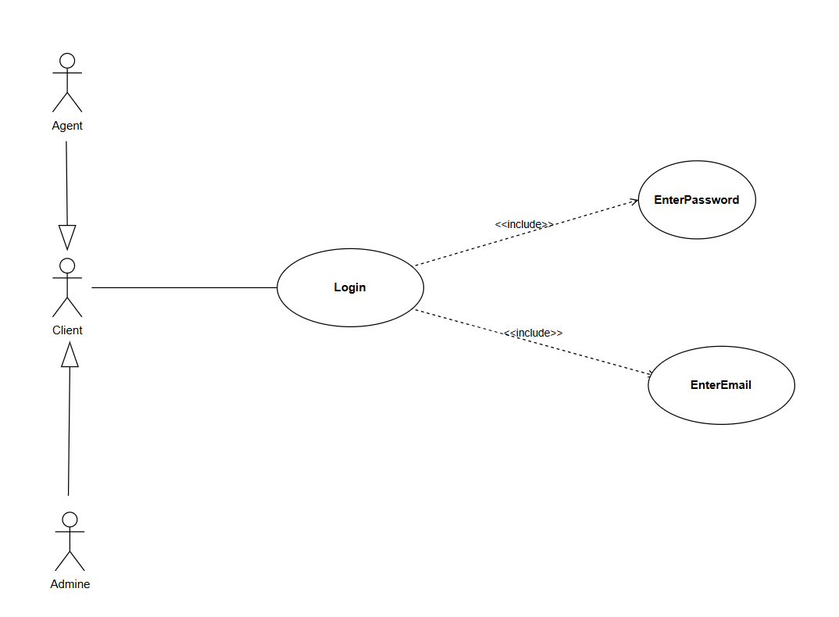
Figure 15 "Use Case Diagram – Authentication"

Textual Description of the Use Case:
To make our use case diagram more readable, UML designers recommend the use of a technique called textual use case description.
Table 7"Description of the Authentication In use case"
Use Case | Log In
Actors | Client, Real Estate Agent, Admin
Exceptions | Execption1: Authentication error – the system displays an error message if the email or password is incorrect.  Execption2: Required fields are empty – the system displays an error message next to each empty field.
Main Scenario | The actors enter their email and password.  The actors click the “Login” button.  The system verifies the email/password combination.  If the credentials are correct, the system redirects to the homepage.
Postcondition | The actor is successfully authenticated
Precondition | The actor must have an existing account

Sequence Diagram:
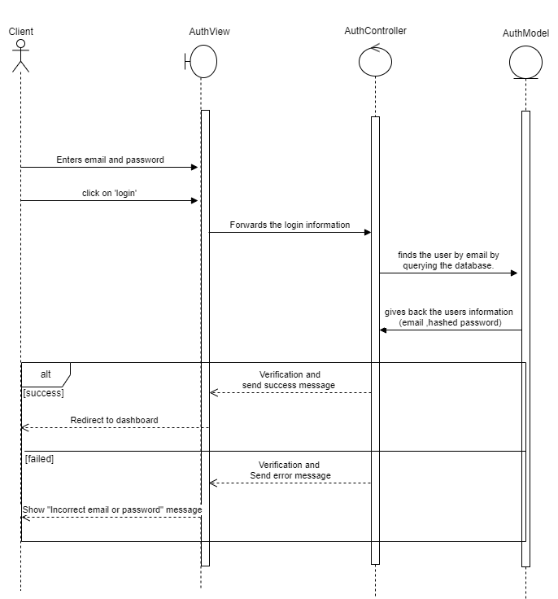
Figure 16 "Sequence Diagram for Login"

Class Diagram:

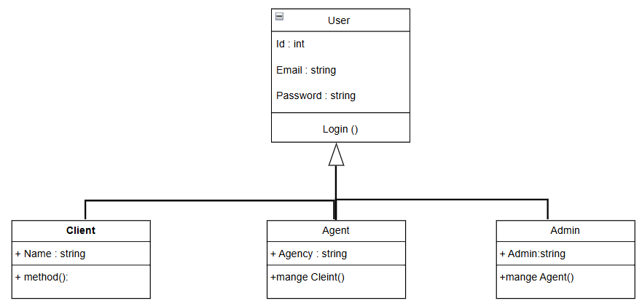
Figure 17"Class Diagram for Sprint1"

Class Diagram description:
In this system, all users can log in using the main User class, which stores their ID, email, and password. From this main class, there are three types of users: the Client, who has a name and can use the system; the Real Estate (RE) Agent, who works for an agency and can manage clients; and the admin, who can manage the agents. Even though each user type has a different role, they all share the basic features from the User class.

Implementation:

Authentication interface
The user needs to submit their password and email address in order to authenticate. Our platform's authentication interface is shown in Figure 18.

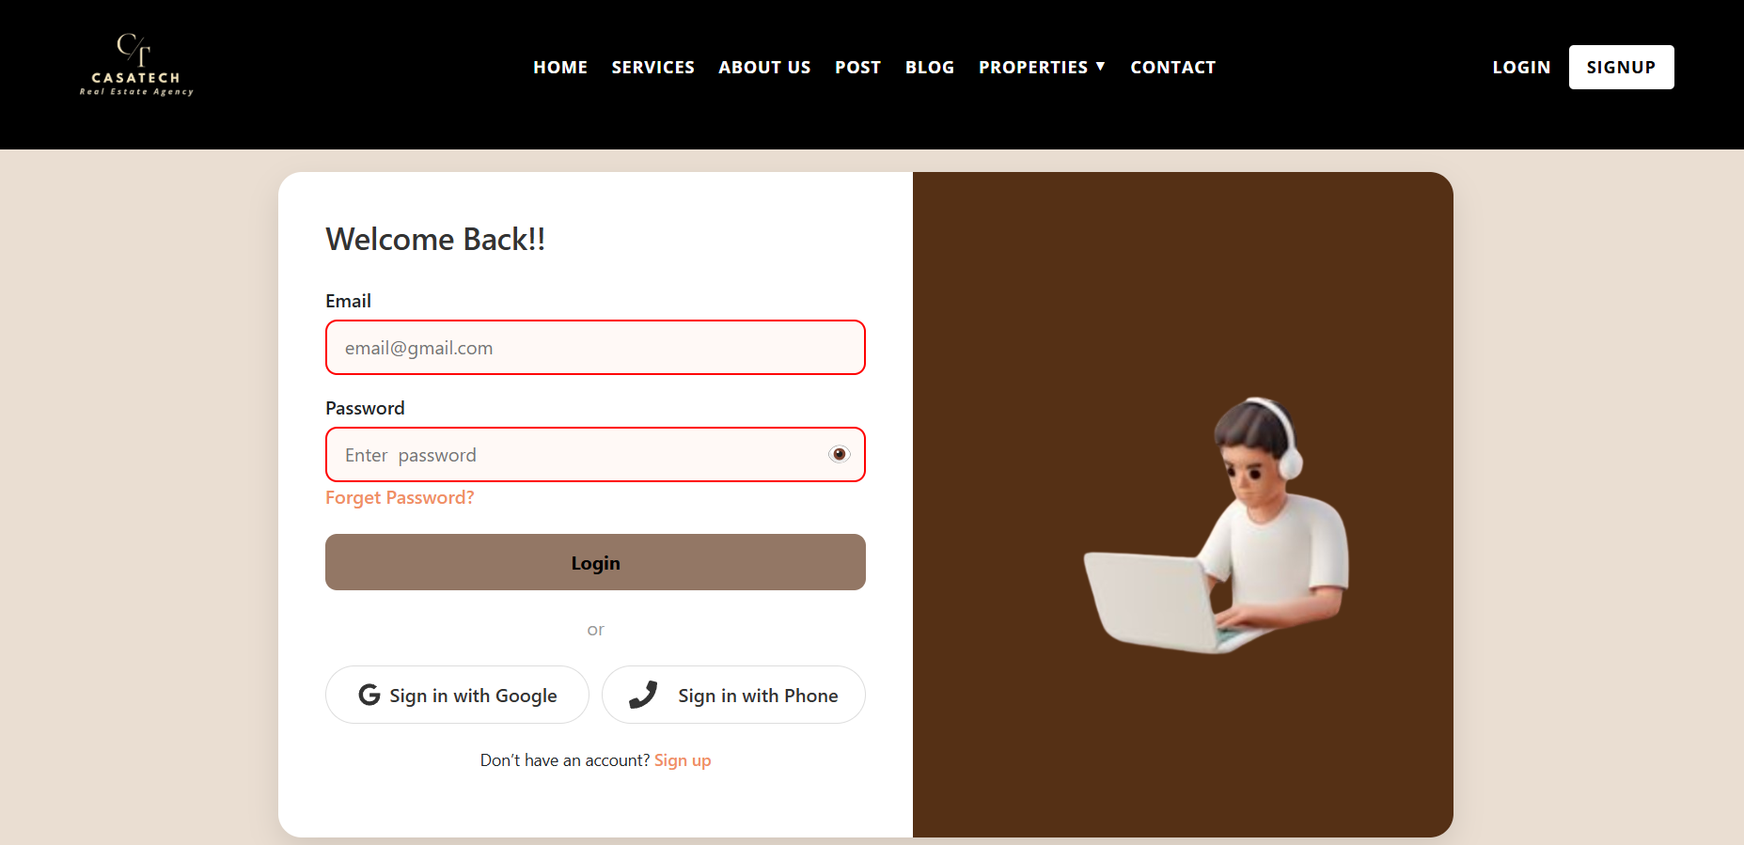
Figure 18 "login interface"

Client-agent contact management:

Use case Diagram:

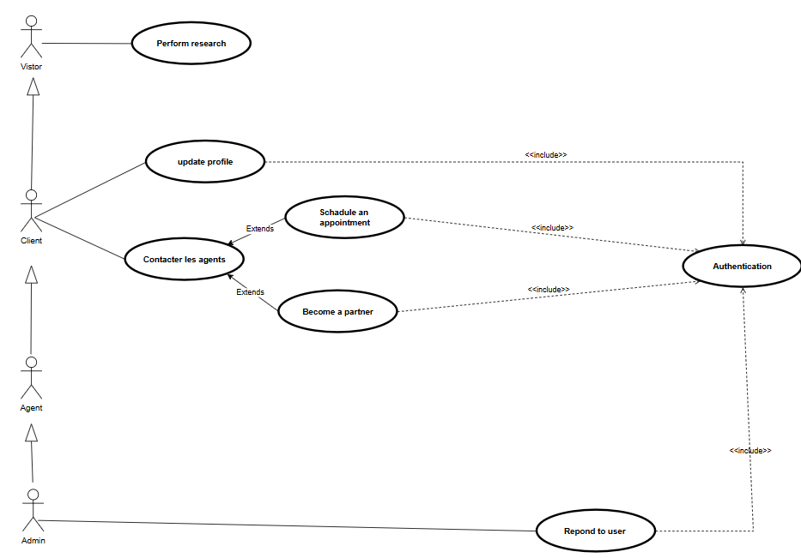
Figure 19"UseCase Diagram for Contact an Agent"

Textual Description of Use Case
To make our use case diagram more readable, d designers propose the use of a technique called textual description of use cases.

Table 8"Textual Description of the Contact an Agent UseCase"
Use Case | Contact the Agent
Actors | Client
Before it starts | The Client is viewing a property or profile.
After it's done | A message is sent to the admin
Steps | 1. Click "Contact "  2. Fill in the form  3. Click "Send"  4. The admin gets the message
More options | May also include "Schedule Appointment «or "Become a Partner".
Errors | Form not complete → show error message.

Table 9"Description of Schedule an Appointment UseCase"
Use Case | Schedule an Appointment
Actors | Client
Before it starts | Visitor must be logged in
After it's done | An appointment is saved and sent to the admin
Steps | 1. Choose a date and time  2. Click "Book"  3. System confirms it
More options | Can be part of "Contact "
Errors | Time not available → show another option

Table 10 "Description of Became a partner UseCase"
Use Case | Become a Partner
Actors | Client
Before it starts | Visitor must be logged in
After it's done | Request is sent to the agent
Steps | 1. Fill in the partnership form  2. Click "Send"  3. Agent is notified
More options | Can be part of "Contact "
Errors | Missing information → show error

Table 11 "Description of Reply to User UseCase"
Use Case | Reply to User
Actors | Admin
Before it starts | Admin must be logged in
After it's done | A message is sent to the user
Steps | 1. Admin opens the user message  2. Writes a reply  3. Sends it
Needs login | Yes
Errors | Invalid or missing info → show message

Sequence Diagram:

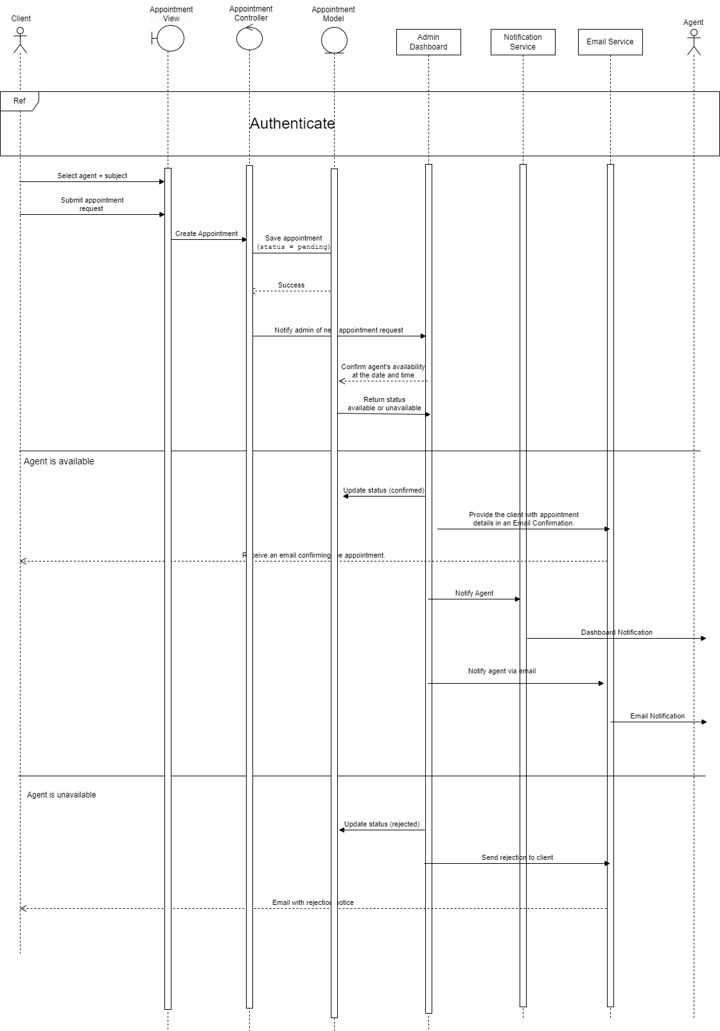
Figure 20"Sequence Diagram of Schedule an Appointment"

Class Diagram:
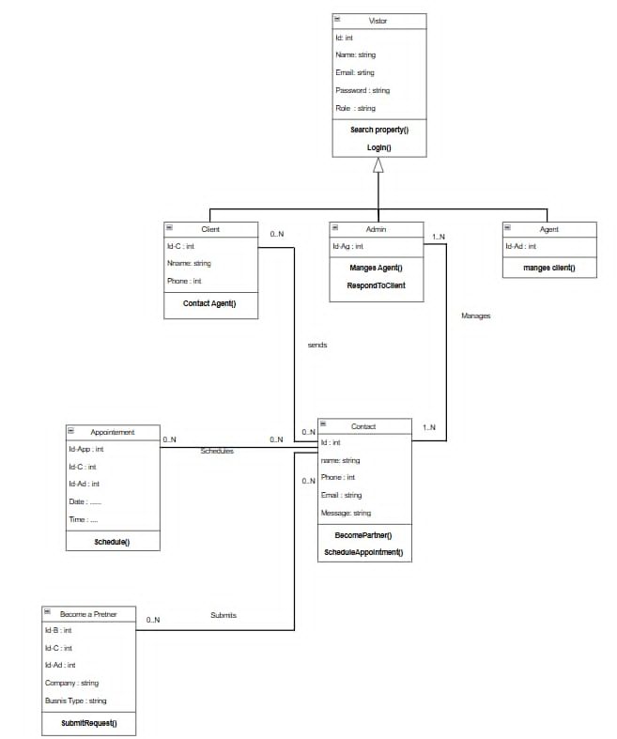
Figure 21"Class Diagram for client-agent contact management "

Description Class Diagram:
This class diagram shows how a property management system works. It includes different types of users, like clients, admins, and agents. All users are based on a main user type that stores basic info like name, email, and role.
Clients can search for properties, book appointments with agents, and ask to become business partners. Agents manage these appointments and requests. They also respond to clients and handle schedules.
The system keeps track of each appointment, including the date, time, and who is involved. When someone wants to become a partner, they give their company name and type of business.
Overall, the diagram explains how clients (property seekers) and agents (property managers) interact in a system that manages user accounts, appointments, and partnership requests.

Implementation:

Appointment Scheduling Interface
Clients are able to schedule an appointment with a pre-selected agent using this interface.
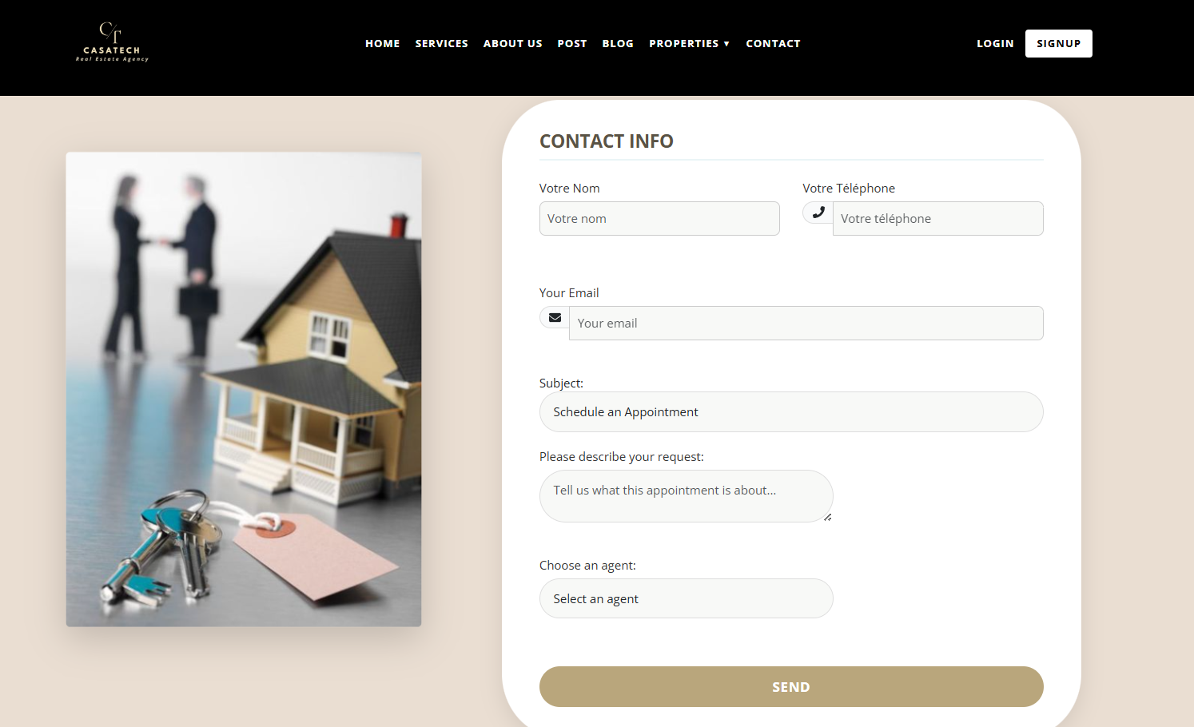
Figure 22 " Appointment Scheduling Interface"

Conclusion:
In Sprint 1, we focused on two main features: user authentication and client-agent contact.
We started by planning the sprint with a backlog that listed all the important tasks. Then, we explained how the system should work using use case diagrams, text descriptions, and sequence diagrams.
We created the login system, so users like clients, agents, and admins can log in safely. We also built the part where clients can contact agents, book appointments, or ask to become partners.
This sprint helped us build the base of our platform. The features we completed are working well and are ready to be improved in the next sprints.

Sprint 2: Manage Property, Post Property,

Search Property

Introduction:
In Sprint 3, we worked on important features for managing and posting properties. Clients can now search for properties using filters and see property details. They can also post their own properties. Real estate agents can add and edit property information. Administrators can manage both agents and clients. These features help make the platform more useful for everyone.

Backlog:
Table 12"Backlog Table of Sprint 2"
ID | User Story | Description | Priority | Role
1 | Search a property | Client can search for properties using filters. | High | Client
2 | Show property details | Client can see the detailed information of a property. | High | Client
3 | Post a property | Client can post his property. | High | Client
4 | Add a property | As a real estate agent, I want to add some property to the platform | High | Real Estate Agent
5 | Modify a property | Real Estate and Client can edit the information of a property | High | Real Estate Agent, Client
6 | Manage Agents | An Administrator can manage agents | High | Administrator
7 | Manage Clients | An Administrator can manage users | High | Administrator

Specific analysis:
In Sprint 2, we worked on three main features: Manage Property, Post Property and Search Property. With Manage Property, users can see their listed properties and update or delete them if needed. This helps them keep their listings correct.
The Post Property feature lets users add a new property by filling out a form with details like location, price, and pictures. This makes it easier for owners or agents to share their properties.
With Search Property, users can find properties by using filters such as price, type, and location. This helps them quickly find the right property.

Use Case Diagram:
Use case diagrams show how users interact with the system. They help make sure the software does what users need. Figure X shows the use case diagram for Sprint 3, which includes posting, managing, and searching for properties.
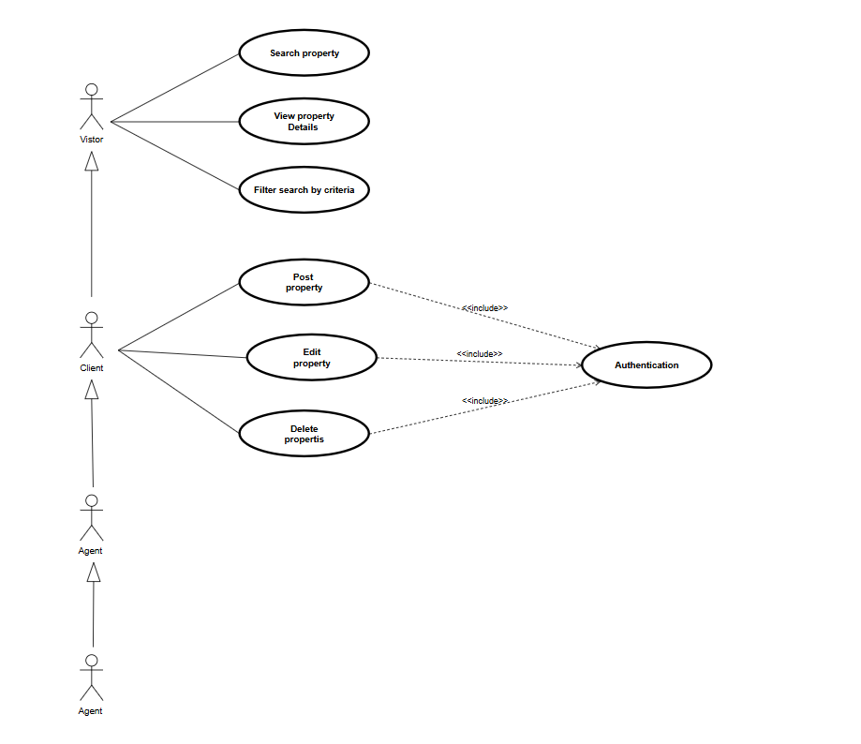
Figure 23"UseCase for Sprint 2"

Description of Use Case:
To make the use case diagram easier to understand, we used a method called textual description of use cases. In Sprint 2, we worked on three main features: Manage
Property, Post Property, and Search Property. Each one is explained in a table that shows who uses it, the steps they follow, what happens before and after, any errors that can happen, and extra options. This helps everyone understand how the system works and makes it easier to share ideas between the team and others.

Table 13"Description of Property Management UseCase"
Use Case | Manage Property
Actors | Client
Before it starts | The client is logged in and has posted properties
After it's done | The property is updated or deleted successfully
Steps | 1. Open “Properties”  2. Select a property  3. Choose to edit or delete it  4. Save changes or confirm deletion
More options | View property details or update images
Errors | Not logged in → redirect to login  No permission → show error message

Table 14"Description of the Property Posting UseCase"
Use Case | Post Property
Actors | Client
Before it starts | The client is logged in
After it's done | The property is saved and listed
Steps | 1. Click “Post”  2. Fill out the form (title, location, price, images)  3. Click “Submit”  4. Property appears in listings
More options | Upload multiple images
Errors | Missing data → show validation error  Not logged in → redirect to login page

Table 15"Description of Property research UseCase "
Use Case | Search Property
Actors | Visitor, Client, Agent
Before it starts | The user opens the homepage or search section
After it's done | Matching properties are displayed
Steps | 1. Enter keywords or use filters (type, location, price)  2. Click “Search”  3. View list of results
More options | Click a property to view more details
Errors | No matching properties → show "No results found" message

Sequence Diagram:
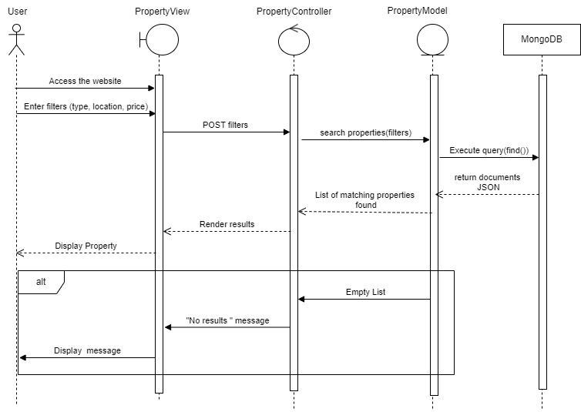
Figure 24 "Sequence Diagram of property research"

Class Diagram:
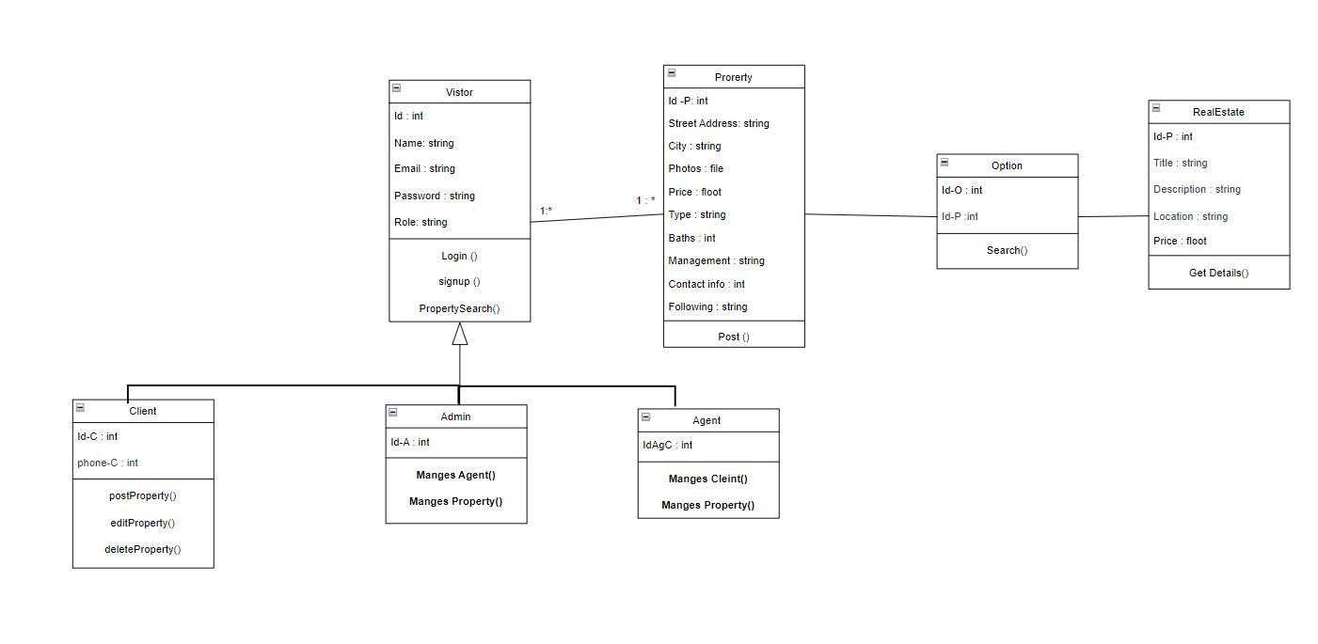
Figure 25"Class Diagram of the Sprint 2 "

Description Class Diagram:
The analysis class diagram shows the main classes and their relationships in a real estate web application. The system has users such as Visitors, Clients, Agents, and Admins. A Visitor can search for properties and log in. A Client can post, edit, or delete property listings. An Agent manages clients and properties, while an Admin manages both agents and properties. Properties are described in detail in the Post class, which includes address, city, photos, price, and contact info. The Search class helps filter properties by criteria like type, location, and price range. Each Post is linked to a Price class, which includes subscription information. The diagram shows how the roles and actions are connected in the system to support property listing, searching, and user management.

Implementation:

Property Search Interface
Clients can use this interface to enter keywords to search for properties and browse the user-friendly listings that are displayed.

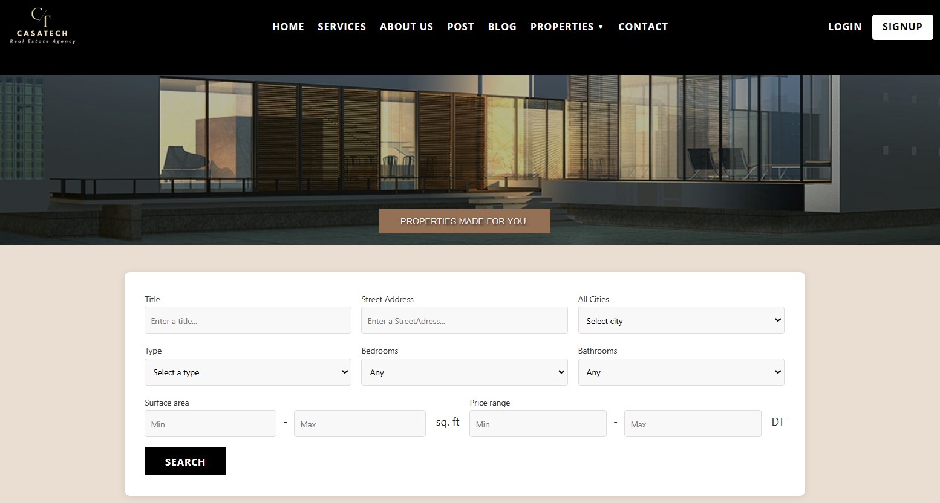
Figure 26"Property Search Interface"

Conclusion:
Sprint 2 focused on implementing three core features: Manage Property, Post Property, and Search Property. These functionalities enable users to easily add, update, delete, and search for properties on the platform, significantly improving user experience.
A key enhancement in this sprint is the integration of AI for automatic validation. Clients can now post properties directly without waiting for agent or admin approval. The system uses AI to verify property details before publication, accelerating the process and making it more efficient.
The sprint also involved thorough planning, including use case diagrams, detailed step-by-step descriptions, and class diagrams. This structured approach helped build a robust, user-friendly system and laid a strong foundation for future enhancements and smarter real estate services.

Sprint3: Manage Favorites,
View History and Archive Property

Introduction:
During Sprint 3, we worked on improving the user experience and making the platform more personalized. Clients can now add properties to their favorites and find them easily later. The new view history feature lets users see the properties they visited before. We also added an archive property option so users can hide or save properties they are no longer interested in. These improvements make the platform easier to use, more organized, and more helpful for everyone.

Backlog:
Table 16"Backlog Table of Sprint 3"
 | User Story | Description | Priority | Role
1 | Add to favorites | Client wants to add a property to my favorites. | Medium | Client
2 | View my favorites | Client wants to see my list of favorite properties. | Medium | Client
3 | View their own history | Clients have access to their personal activity history. | Medium | Client
4 | View history of all clients | Rea Estate Agents can view the history of all clients. | Medium | Real Estate Agent
5 | Archive the property | The property has been moved to the archive by the Real Estate Agent | High | Real Estate Agent
6 | View history of all clients | Admin can view the history of all clients. | High | Administrator
7 | Archive/Modify a property | Admin wants to archive or edit the properties listed by Agents | High | Administrator
8 | Manage Notifications | As a notifications system, send notifications based on the Client’s criteria. | Low | Notification System

Specific analysis:
In Sprint 3, we worked on three main features: Manage Favorites, View History, and Archive Property.
With Manage Favorites, users can save properties they like and view them later. This helps them keep track of the best options without having to search again.
The View History feature shows users the list of properties they have visited before. This makes it easy for them to go back to a property they already saw without starting a new search.
The Archive Property feature lets users hide properties they are no longer interested in. This helps keep their view clean and focused only on active or relevant listings.
These features improve the overall user experience by making the platform more personal, organized, and easier to use.

Use Case Diagram:
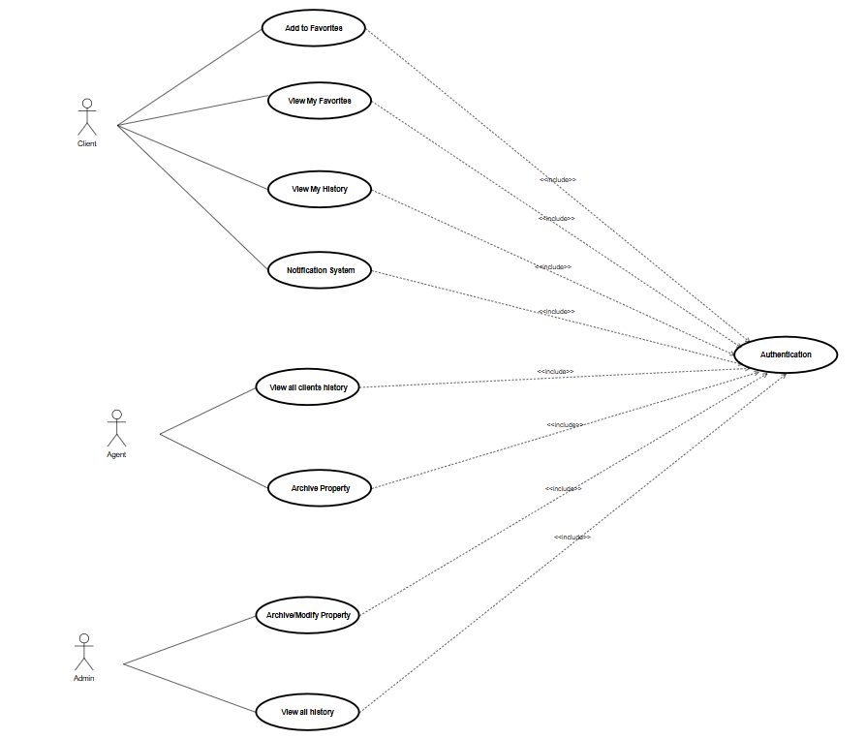
Figure 27"UseCase for Sprint 3"

Description of Use Case:

Table 17 "Textual Description of Add to Favorites UseCase"
Use Case | Add to Favorites
Actors | Client
Before it starts | Client is logged in and viewing a property listing
After it's done | Property is saved in the client’s favorites list
Steps | 1. Click the “Add to Favorites” button  2. System saves property to the client’s profile
More options | Client can view saved properties in “My Favorites”
Errors | Already favorited → show message “Already in favorites”

Table 18"Description of the View My Favorites use case"
Use Case | View My Favorites
Actors | Client
Before it starts | Client is logged in
After it's done | System displays list of favorite properties
Steps | 1. Go to the “Favorites” section  2. System fetches saved properties
More options | Click on a property to view details
Errors | No favorites yet -> show “No properties saved yet”

Table 19 "Textual Description of the Notification System UseCase"
Use Case | Notification System
Actors | Client
Before it starts | Client is logged in
After it's done | Notifications are shown or updated
Steps | 1. Click the notification icon  2. View system messages
More options | Notifications can be marked as read
Errors | No new notifications
Table 20 "Description of the View all clients history use case"
Use Case | View all clients history
Actors | Agent
Before it starts | Agent is logged in
After it's done | Client activity logs are displayed
Steps | 1. Agent opens “Client History” section  2. System fetches and displays data
More options | Filter by client or activity type
Errors | No activity records found

Table 21 "Description for the Achieve Property UseCase"
Use Case | Archive Property
Actors | Agent
Before it starts | Agent is logged in
After it's done | Property is hidden from public listings
Steps | 1. Select property  2. Click “Archive”  3. Confirm action
More options | View archived properties
Errors | Property not found → show error message

Table 22 "Description of the Achieve/Modify Property UseCase"
Use Case | Archive/Modify Property
Actors | Admin
Before it starts | Admin is logged in
After it's done | Property is updated or archived
Steps | 1. View property list  2. Choose “Archive” or “Modify”  3. Save changes
More options | Undo or restore previous version
Errors | Invalid data → show form validation errors

Table 23 "Description to View all History"
Use Case | View All History
Actors | Admin
Before it starts | Admin is logged in
After it's done | Complete system-wide history is displayed
Steps | 1. Go to “System History” section  2. Filter logs by date/user/action
More options | Export history log
Errors | No history available

Sequence Diagram:
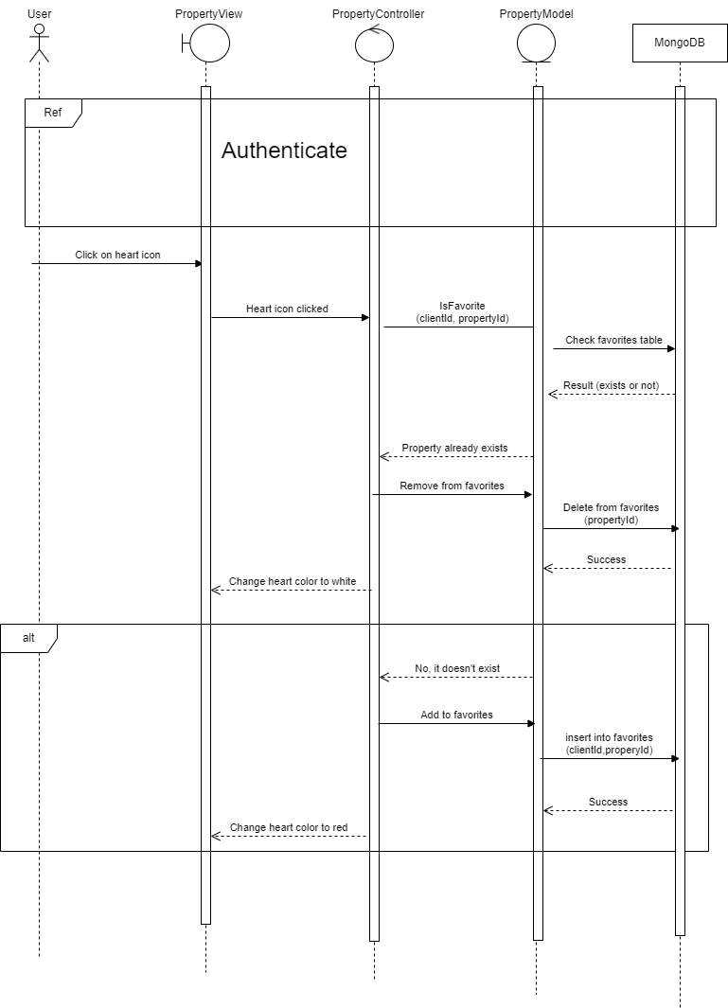
Figure 28 "Sequence Diagram for Add to Favorites"

Class Diagram:
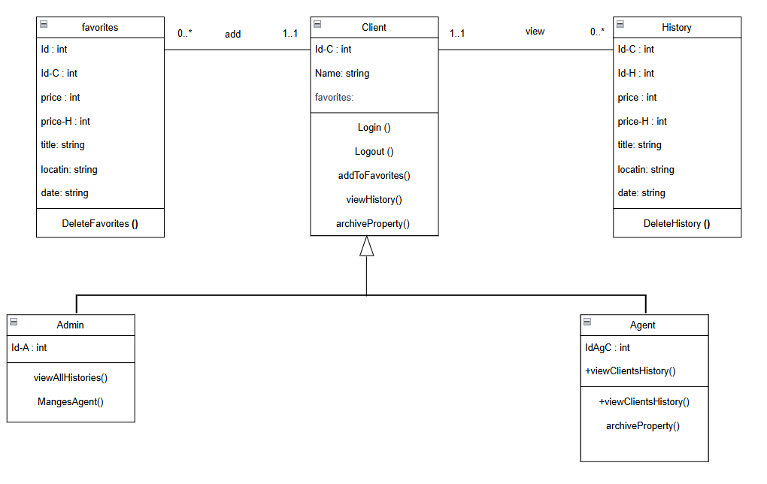
Figure 29 "Class Diagram for Sprint 3"

Description Class Diagram:
The analysis class diagram illustrates the main conceptual classes and their relationships in the real estate web application as defined in Sprint 3. The system includes different types of users such as Clients, Agents, and Admins. All users share common attributes and actions, such as authentication, through the base User class. A Client can search for properties, add or remove properties from their favorites, view their interaction history, and receive notifications. An Agent can view clients' search history and has the authority to archive property listings when needed. Admins have higher-level control over the system and can archive or modify any property and access system-wide history.
The Property class represents individual listings and contains key attributes such as title, location, price, and status (e.g., active or archived). Clients can interact with these properties through the Favorite class, which allows them to save and manage listings they are interested in. The History class tracks user actions for reference and accountability, while the Notification class ensures users are kept informed about important updates or actions. The analysis diagram demonstrates how the different user roles are interconnected with core system functions such as property management, history tracking, and notification delivery to support a complete real estate platform workflow.

Implementation:

Interface Add Favorites
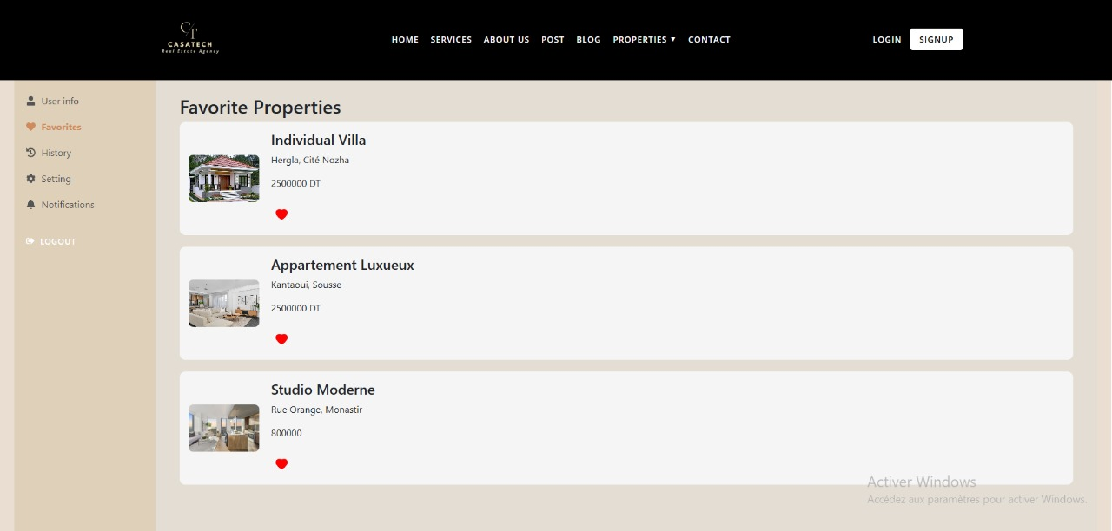
Figure 30"Interface Add Favorites"

A property can be added to the client's list of favorites by clicking the "heart" button. They can quickly store and return to homes that capture their interest in this way, saving them from having to do the search again later.

Conclusion:
The analysis class diagram provides a clear and structured representation of the key concepts and user roles in the Sprint 3 phase of the real estate web application. It identifies the main classes, such as User, Property, Favorite, History, and Notification, and shows how they interact to support essential functionalities like property listing, user account management, search history tracking, and system notifications.
By distinguishing between different types of users—Clients, Agents, and Admins—the diagram effectively models their specific responsibilities and permissions within the system. This clear separation of concerns ensures maintainability, scalability, and security in the application. Overall, the analysis class diagram serves as a foundation for transitioning into system design and implementation by offering a high-level overview of the system’s behavior and structure
General Conclusion and Perspectives

The creation of a smart web platform specifically for the real estate sector was the main goal of this final project, which was finished as part of the Higher Institute of Computer Science and Communication Technologies' (ISIT'COM) Applied License in Telecommunications program. The major objective was to use digital innovation to develop a modern solution that simplifies the buying, selling, and renting of real estate.
The website was made with both individuals and professionals in thoughts, making it simple for users to create and review real estate listings. The use of artificial intelligence (AI) to help with posting editing and enhance listings, making them more readable and visually appealing, is one of its primary characteristics. Additionally, the website has a chat function that facilitates faster and more efficient communication between users and real estate agents.

The project was divided into three sprints and produced with the Scrum methodology:
Sprint 1: Focused on user registration, login, and contact with agents.
Sprint 2: Managed property posting, editing, and searching.
Sprint 3: Allowed users to track their activity history, save favorite properties, and archive listings.
In terms of technology, the platform was constructed with modern technologies like ReactJS, NodeJS, and MongoDB, ensuring a dynamic and scalable web application.
Despite completing the platform's primary objectives, we still have a lot of suggestions for how to make it even better. Some complex features were not finished due to limitations on time, but we would like to add them later. These consist of:
-Using React Native, create a mobile version of the app to expand its user base.
-Increasing the application of AI, for instance in chatbots and tailored real estate advice.
-Allowing for multilingual support to increase the platform's user base.
-Incorporating geolocation to assist users in locating nearby properties.

We had an excellent chance to work closely with others, use our academic knowledge in a practical situation, and develop our soft and technical skills through this project. Additionally, it was an excellent learning opportunity that exposed us to the newest online technology, project management techniques, and professional tools.

