1. **To download the needed software**

Download java jdk8

<http://www.oracle.com/technetwork/java/javase/downloads/jdk8-downloads-2133151.html>

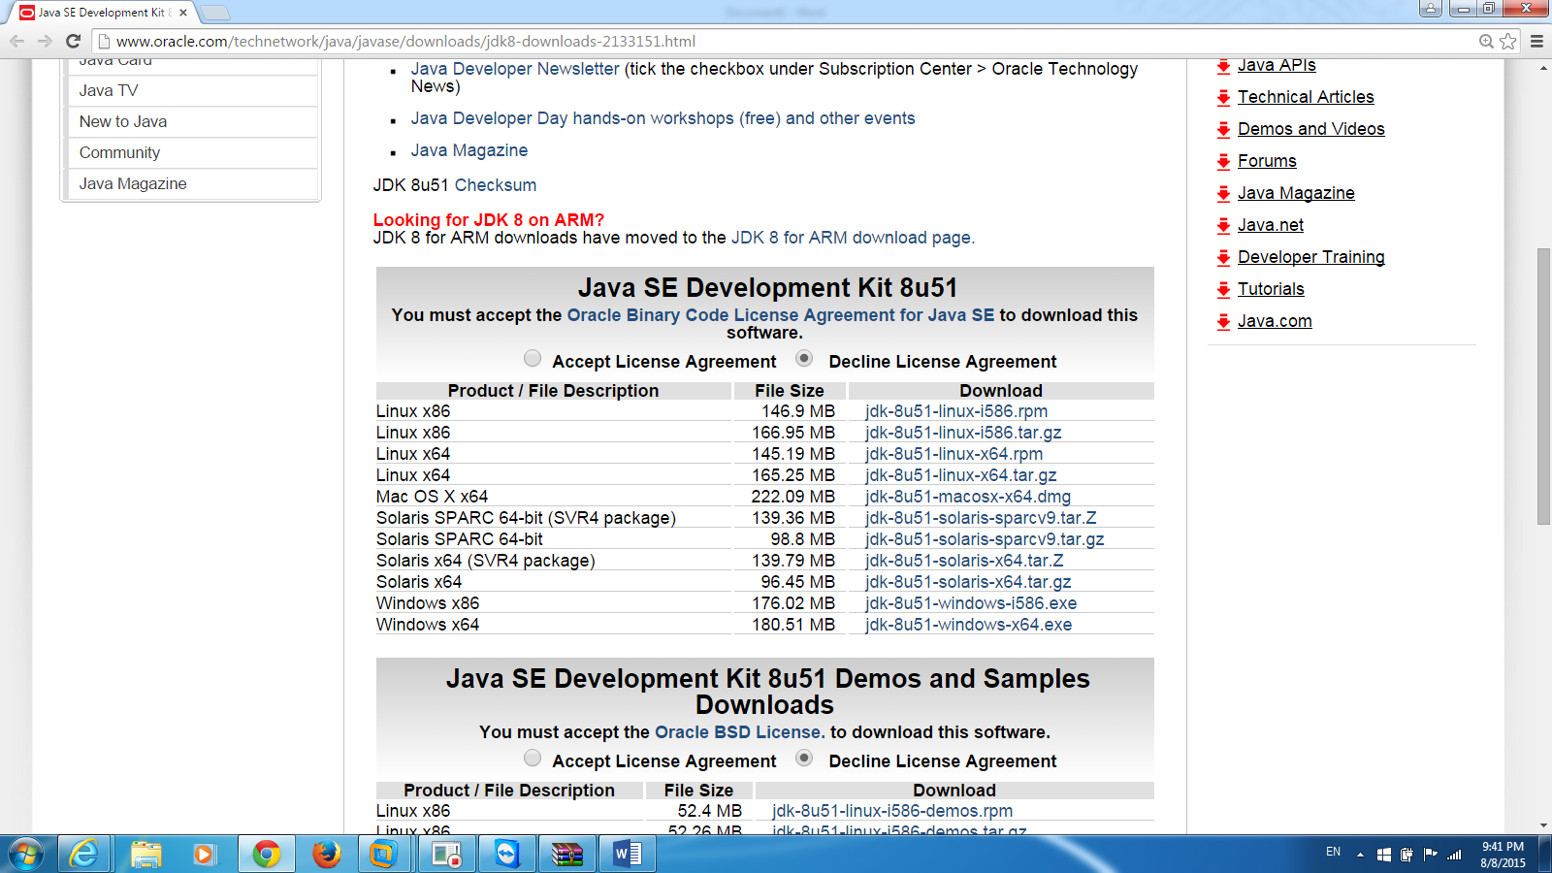

Download nutch:

<http://archive.apache.org/dist/nutch/1.9/apache-nutch-1.9-bin.tar.gz>

Download solr:

<http://archive.apache.org/dist/lucene/solr/4.10.4/solr-4.10.4.tgz>

**Download Ubuntu 14**

<http://www.ubuntu.com/download/desktop>

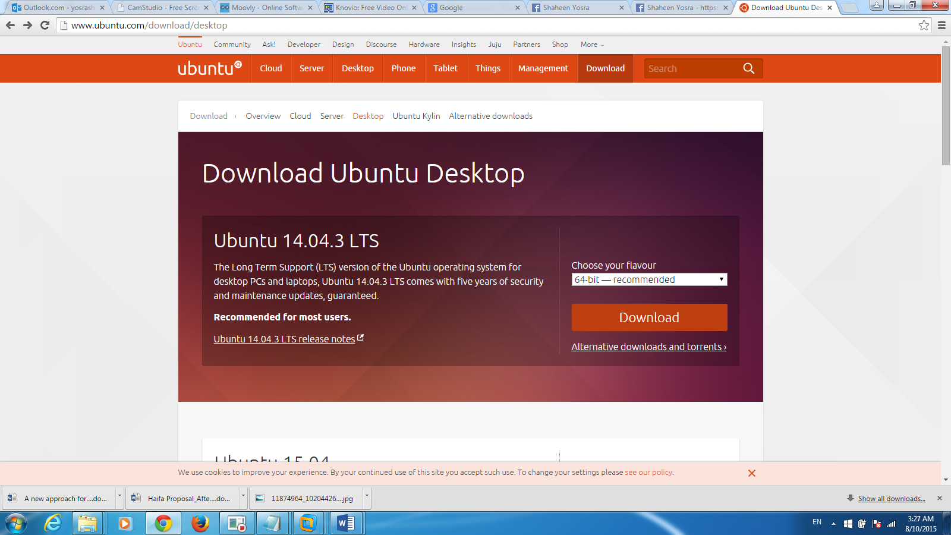

**Click on download**

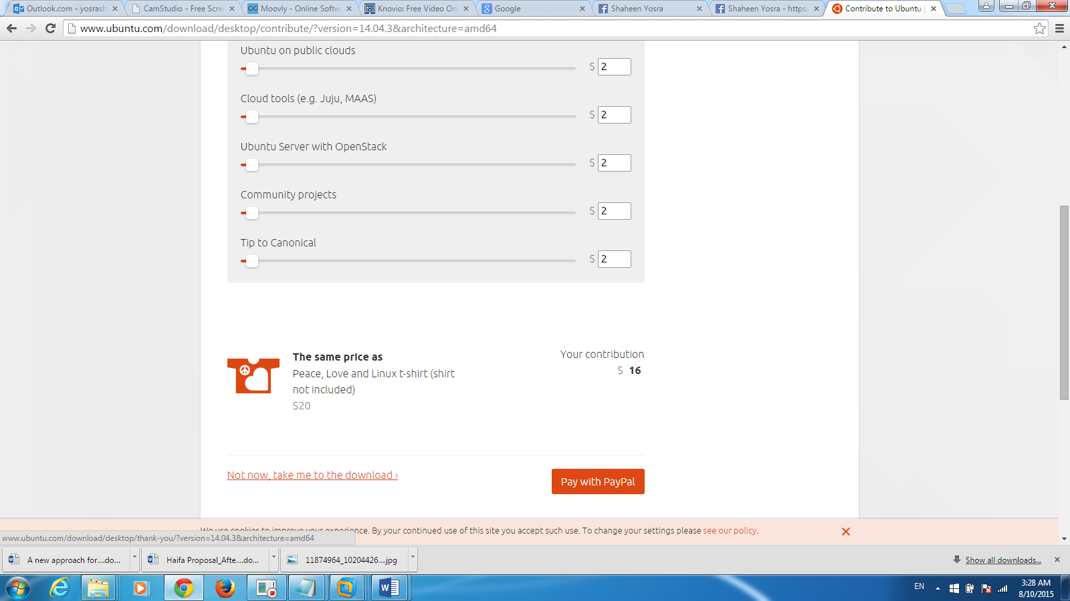

**Click on not now take me to download**

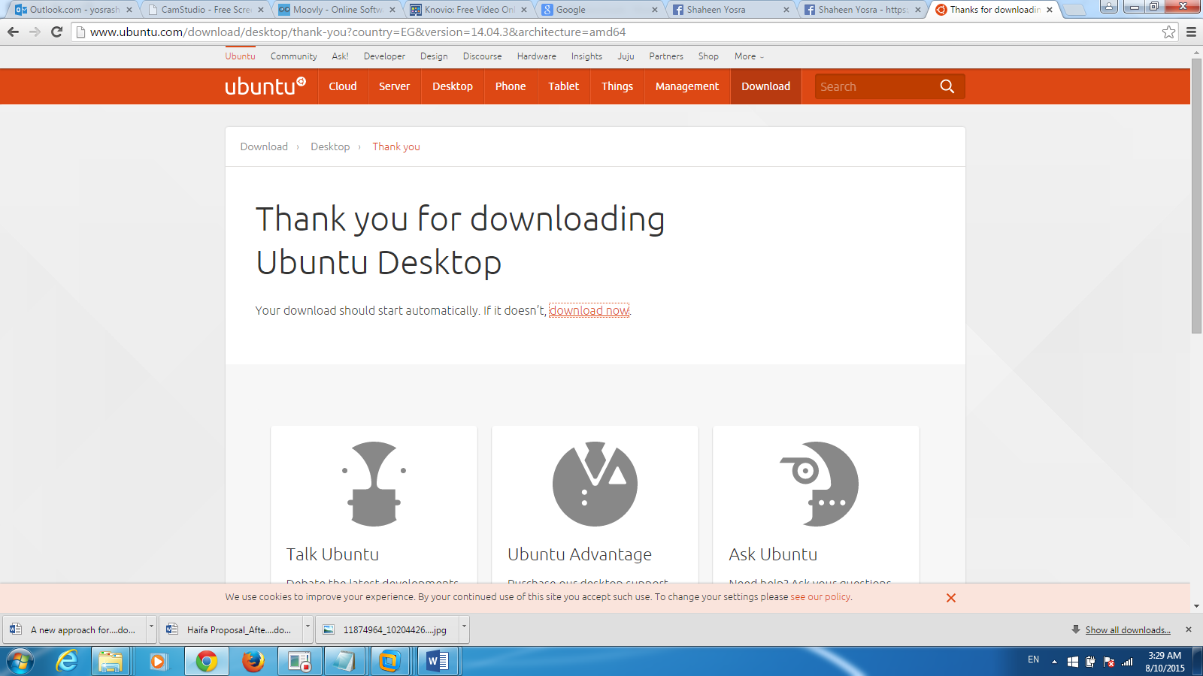

**Choose download now**

**Download vmware program**

**http://www.4shared.com/file/HJiEYOl5ce/VMware-workstation-full-901-89.html**

**Download vmware Keygen**

[**http://www.4shared.com/rar/OMARu9ybba/VMware_Workstation_90_Keygen_-.html**](http://www.4shared.com/rar/OMARu9ybba/VMware_Workstation_90_Keygen_-.html)